FortiGate Logging Documentation

FortiGate Logging Summary
The FortiGate firewall is connected to a FortiSwitch, which provides network connectivity to the Splunk server. A full-tunnel SSL VPN is configured to allow remote access exclusively for users who belong to the designated VPN user group. The domain controller is integrated with the FortiGate as an LDAP authentication server to manage user verification and access control. 2FA is enforced using Fortitoken or SMS messages.
Security services such as Intrusion Prevention, Antivirus, DNS filtering, and Web filtering are applied to the VPN policy using the default FortiGuard profiles. Network access is restricted so that only traffic originating from the SSL VPN interface can communicate with the internal server subnet. Connections coming from countries that are apart of the GEO_BLOCK address are denied.
The FortiGate is configured to forward logs to the Splunk Enterprise server via Syslog. The Windows firewall on the Splunk server is configured to permit inbound Syslog connections on port 514 and LDAP on 389. Within Splunk, the logs are indexed under the FortiGate index. A custom Splunk dashboard visualizes VPN login activity around the world, displaying login attempts by country on an interactive map.

Network Architecture
Screenshot: 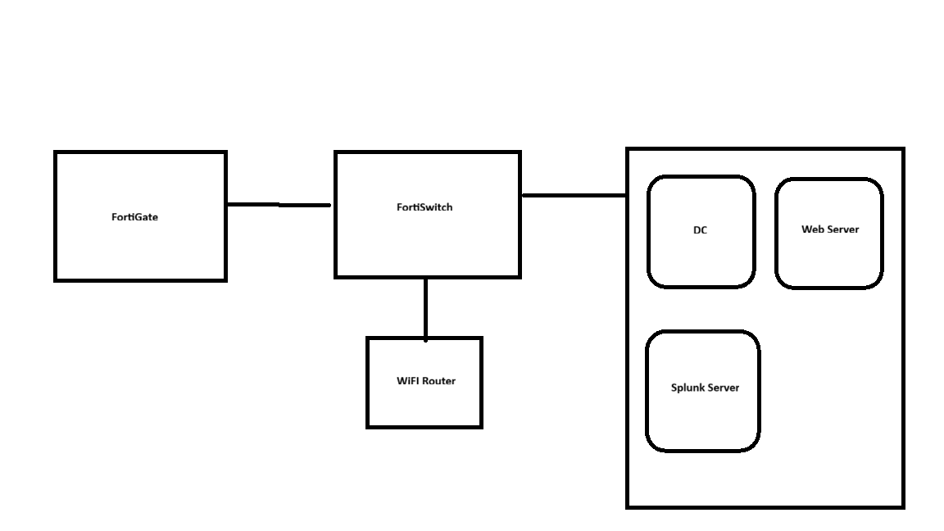

Security Policies
- VPN Setup:
config firewall policy
edit 1
set uuid c8a71a2c-54be-51e9-fa7a-858f83139c70
set name "SSL_VPN_to_Server"
set srcintf "ssl.root"
set dstintf "port1"
set srcaddr "SSL VPN"
set dstaddr "Server Subnet"
set action accept
set schedule "always"
set service "ALL"
set utm-status enable
set av-profile "default"
set webfilter-profile "default"
set ips-sensor "default"
set dlp-sensor "default"
set dnsfilter-profile "default"
set ssl-ssh-profile "certificate-inspection"
set logtraffic all
"Allow SSL VPN users to access internal server with FortiGuard security profiles applied"
next

edit 2
set uuid b1f91b0a-7a12-5ad1-ecaa-902faef78e44
set name "Block_GEO"
set srcintf "ssl.root"
set dstintf "port1"
set srcaddr "GEO_BLOCK"
set dstaddr "all"
set action deny
set schedule "always"
set service "ALL"
set logtraffic all
set comments "Block connections from GEO_BLOCK countries"
next
end
-Window Firewall Configuration
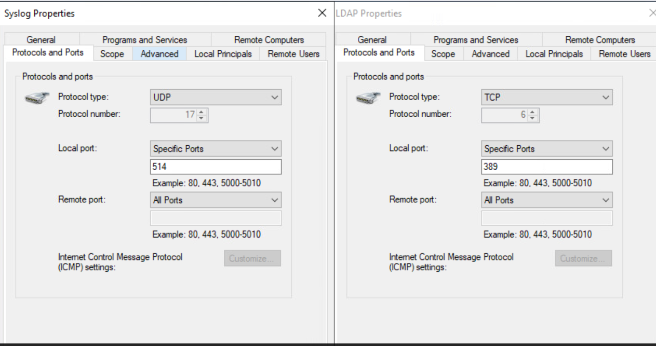
Splunk Visualization
Screenshot: 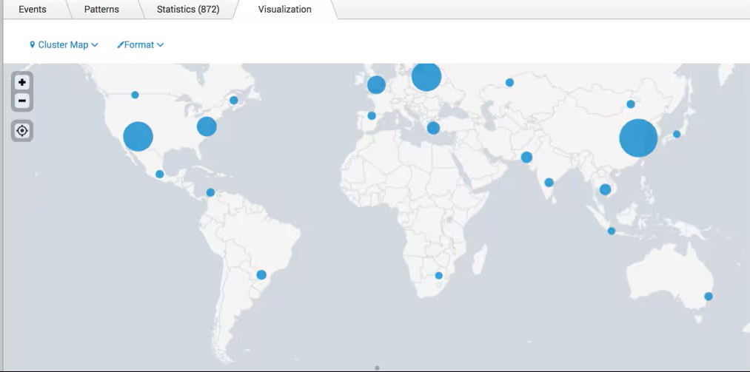

Conclusion / Observations
Possible Improvements:
- Implement VLAN segmentation to further isolate network traffic. Currently, data is routed only to subnets or IP addresses defined on the firewall. Introducing VLANs for specific types of traffic would enhance segmentation and allow more granular control over which VLANs can communicate with each other.
- Integrate SAML authentication with Office 365 to strengthen user authentication. Establishing an identity provider (IdP) and service provider (SP) relationship with an Office 365 tenant would allow users to authenticate using their Microsoft accounts. Compared to SMS messages or FortiToken, restricting authentication to Microsoft Authenticator provides stronger security. Additionally, leveraging cloud-based identity management helps protect VPN credentials and prevents compromised Active Directory passwords from being used for remote access.
- Deploy an IDS/IPS on the server to monitor the network adapter for abnormal or suspicious activity originating from the internet or VPN connections.
- Enable host posture checks for connecting devices to ensure that endpoints meet basic security requirements, such as running up-to-date operating systems and having an active antivirus installed.
- Restrict VPN access to the latest FortiClient version to ensure that only clients using current, secure software are able to authenticate to the FortiGate.

