**Title: Using Virtual Reality to Teach the Fundamentals of Primitive Data Types, Variables, and Logic Statements in Python**

**Connor Murdock, Alan Oliver, David Torres, Tylor Rowe**

[**Cmurdock2@ggc.edu**](mailto:Cmurdock2@ggc.edu)[**aoliver14@ggc.edu**](mailto:aoliver14@ggc.edu)[**dtorres7@ggc.edu**](mailto:dtorres7@ggc.edu)[**trowe7@ggc.edu**](mailto:trowe7@ggc.edu)

**Dr. Rahaf Barakat and Dr. Cengiz Gunay, School of Science and Technology,**

**Georgia Gwinnett College**

**Abstract**

Variables are the most fundamental tools in programming, yet when it is time to teach new programmers about them, the analogy often used is “putting a value into a box to store for later use.” This project aims to let students do just that; manipulate and store physical values inside of a variable box and use those variables to solve logic puzzles in the form of “if statements” through the power of virtual reality. This project was created by Connor Murdock, Alan Oliver, David Torres, and Tylor Rowe, members of the Technology Ambassadors Program (TAP) at Georgia Gwinnett College. TAP promotes technology to all academic levels in hopes to attract novice or undecided students to technological career paths. Our game, “Project Python VR” was developed in the Unity game engine for use with a VR headset (Oculus Quest). A non-VR version was also provided to accommodate all participants attending online or in person. The goal of the game is to help visualize the assigning and manipulation of varying datatypes through different exercise puzzles. All problems presented are shown in Python syntax, an easy to learn and understand programming language. After completing our game, participants would be able to assign values to a variable, manipulate values with addition and multiplication, read and understand various if statements, and understand the distinctions between four primitive data types (Integer, Float, Boolean, and String).

**Introduction**

The Technology Ambassadors Program (TAP) is designed to get more people interested in the field of Science Technology Engineering and Math (STEM) through the creation of Projects to teach non-tech students’ useful skills in a fun way. TAP seeks to increase diversity in the field of technology by attempting to reach out to underrepresented minorities and women to increase their representation in technology fields. In the program students organize themselves into groups and create projects which are presented to entry level classes as well as middle school and high school students. For students enrolled in TAP, we learn valuable skills like teamwork, time management, problem solving skills, presentation skills, as well as many others that most college classes do not provide.

**Methods**

Our team created a game called Project Python VR using Unity to create a virtual reality experience to teach the basics of programming. The objective of the game is to fix a spaceship by solving the coding problem. We used if statements and simple manipulation of variables to create our levels. All the coding questions are based on Python syntax because it is a high-level programming language that is easy to understand for beginners. To keep our game practical for a classroom setting, we also made an online PC version of the game so that we could have everyone participate if they had a reason to not use the VR such as epileptic seizures or motion sickness.

**Results**

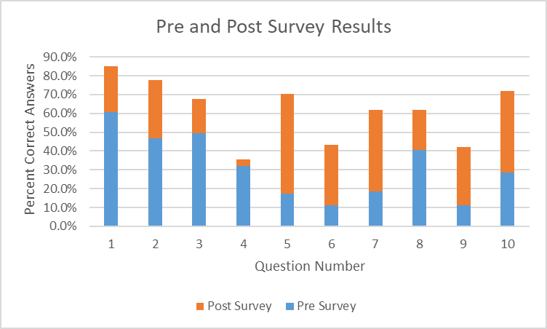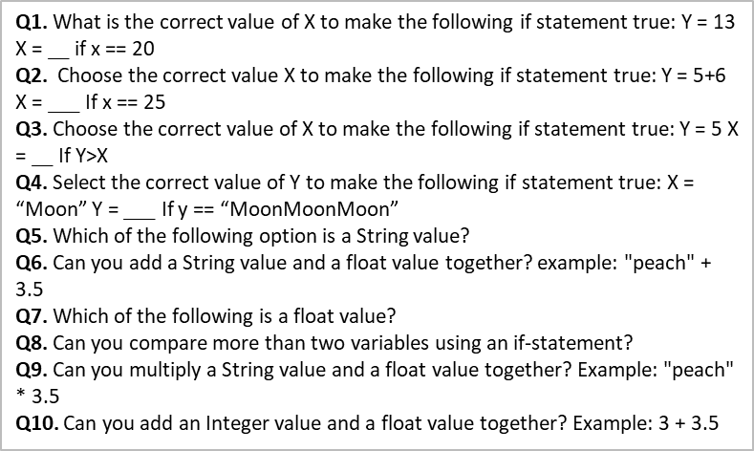Each of the students in our workshop took a pre-survey before playing the game and a post-survey after playing so we could measure how effective we were at teaching them about our chosen topics. Based on these surveys I would say we were remarkably successful in instructing the students with our game and on average over all questions and workshops we had a 30.53 percent increase in correct answers on the coding-based questions in the survey.

**Technologies used**

**Virtual Reality** is a computer-generated simulation of a three-dimensional image or environment that can be interacted with a headset or other devices. It was used in tandem with Unity Game Engine to create a game to teach participants about fundamentals of programming within the Python Programming Language. A WebGL version was co-developed for those who are uncomfortable with VR.

**Technologies:** Oculus Quest VR Headset and Controllers, Unity Game Engine, WebGL, Python Programming Language