### Data Model

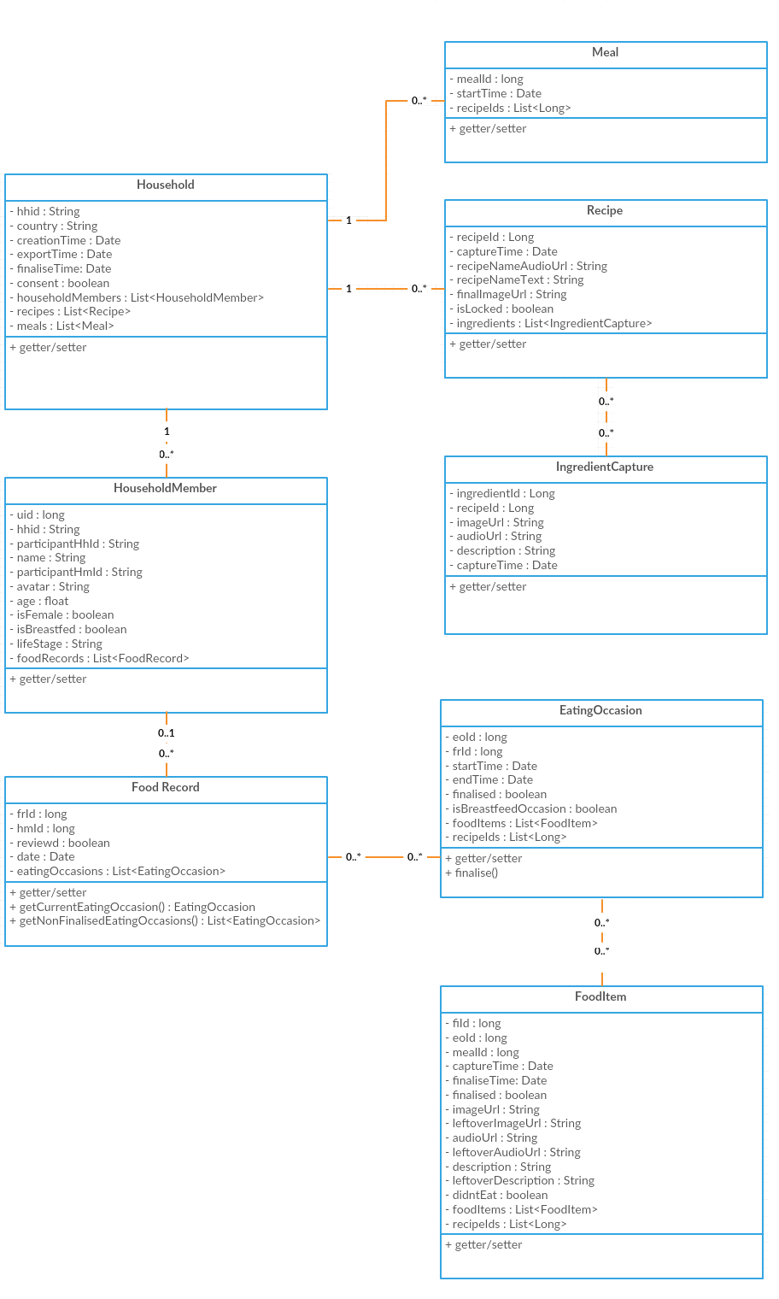

### App as-is

### 

### Cook

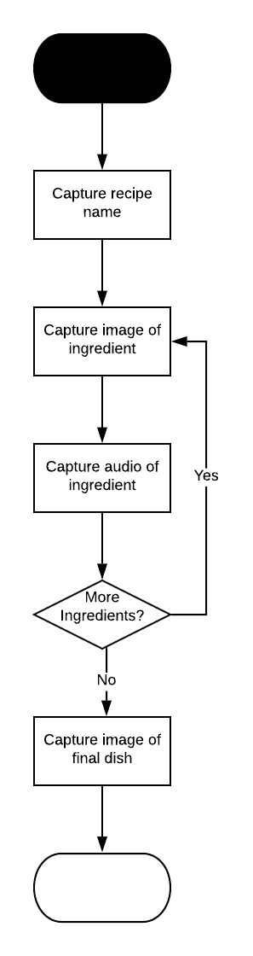

### Breastfeed

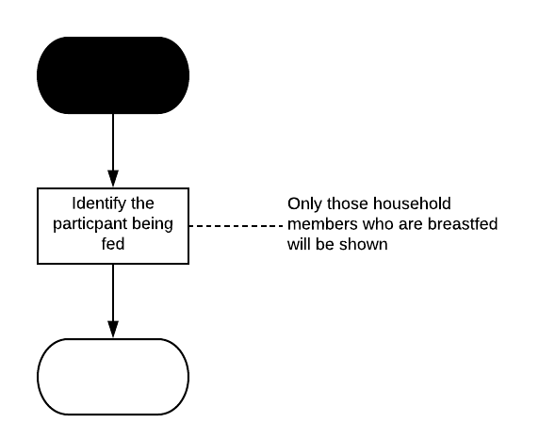

### Eat – Shared

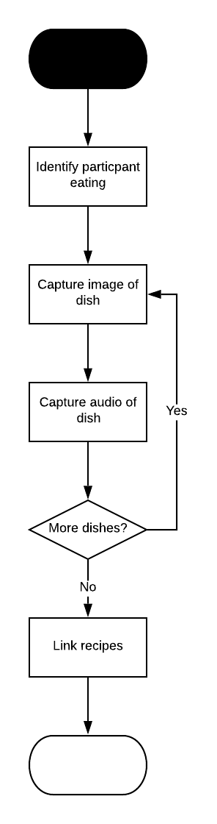

### Eat – Individual

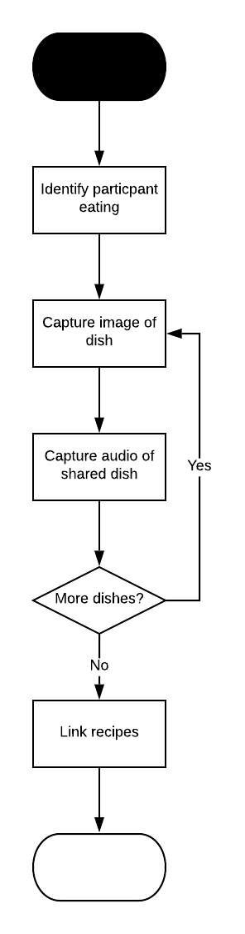

### Finalize Eat

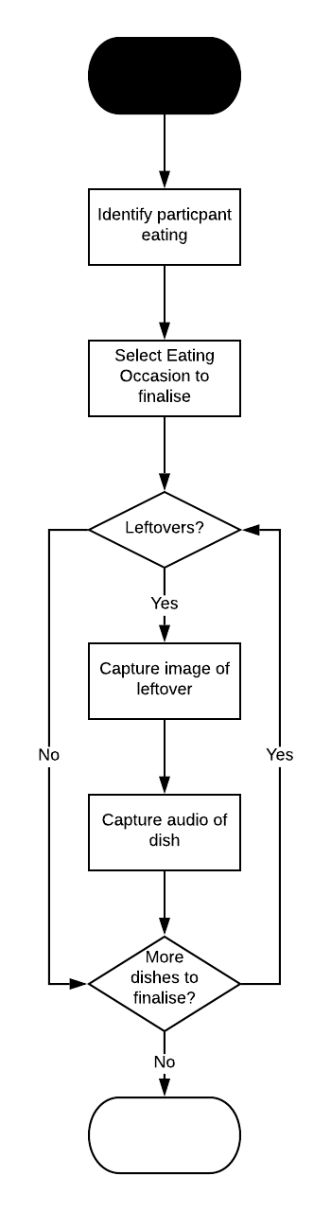

### Overview

