**Kart Souls**

**Goal**

Simple.

Defeat your opponents in a three-lap race to the death!

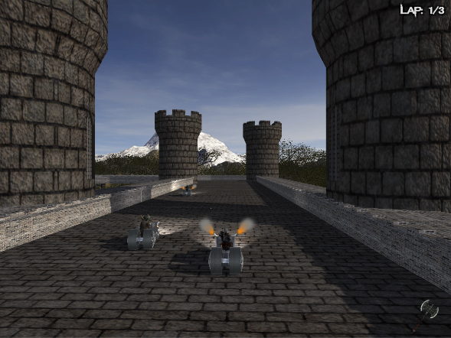 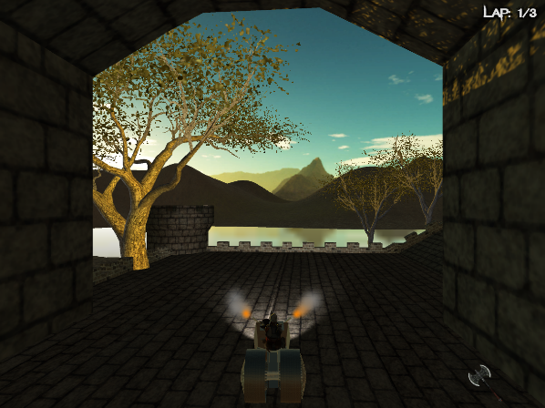

**How to Play**

**Accelerate**.………. or “W”



**Brake**………………….. or “S”



**Steering**………………. or “A” for left and “D” for right



**Drift**………………………. or Left Shift



**Pause**………………….. or Escape



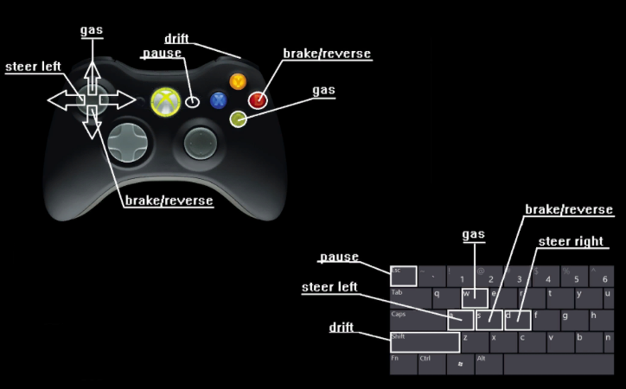 By: Josh Brown

Connor Eaves

Hussam Nadeem

Christopher Waldon