UNO Game Documentation

CSCI 3132 Group Project - November 2016

The Game “UNO”

UNO is a card game for 2-10 players that uses a unique deck of 108 cards. The objective of the game is to be the first one to empty your hand by playing cards onto the discard pile. When the game starts, 7 cards are dealt to all players, and one card is placed face-up to start the discard pile. The player to the dealer’s left (usually) gets to go first, and players take turns in (initially) clockwise order. Players must play cards onto the discard pile according to the rules of the game. The game is typically played over multiple rounds, where being the first one to empty your hand gets you the points for that round.

Rules:

* The player must play a card that matches the top card on the discard pile by number, colour or word.
* If the player has no matches or chooses not to play a card, they must draw a card. If the drawn card can be played, play it.
* If a player has no cards left in their hand they win the round. They get points for each card left in all of their opponent’s hands. Different cards are worth different amounts of points.

Action Cards:

* **Skip:** Next player in sequence has to skip their turn.
* **Reverse:** Turn order is now reversed. If currently clockwise it is now counterclockwise, and vice versa.
* **Draw Two:** When a person plays this card, the next player must draw 2 cards, and has to skip their turn.
* **Wild Card:** Can be played on top of any card, the player get to choose what colour is to be played next.
* **Wild Draw Four:** Works just like a wild card, except that the next player needs to draw 4 cards and skip their turn. This card can only be played if the player cannot match the card on top of the discard pile by its colour. This card can still be played if you can match the number, however.

Additionally, there are unique circumstances if the first card put onto the discard pile at the start of the game is an action card:

* **Skip** or **Draw Two:** The player to the dealer’s left no longer starts first (and must draw two cards for a ‘draw two’), the player after them clockwise goes first instead.
* **Reverse:** The dealer goes first, and the turn order starts as counterclockwise.
* **Wild Card:** The player to the dealer’s left gets to choose the first colour to be played. Play begins normally afterwards (the player to the dealer’s left still goes first).
* **Wild Draw Four:** This card must be shuffled back into the deck, and another card must be flipped to start the discard pile instead.

Our Game

For the most part, our program accurately simulates the game of UNO. Through a text interface, the user plays a round of UNO against a variable number of computer players (1 to 5). Whenever it is their turn, the player is shown the cards currently in their hand, and is shown which cards are possible to play. The user chooses a card to play by entering a number. The computer player’s moves and any action card occurrences are described to the player until it is their turn again.

There are a few minor differences that should be noted about our program:

* The user always plays first.
* The first card on the discard pile will never be an action card.
* The program only simulates a single “round” of UNO, and does not keep track of points. You play as many rounds as you want, however. The game just does not keep track of wins or points.

All other aspects of the game are accurately simulated.

Domain Model



Use Case Diagram



Class Diagram

Screenshots

1. Choose number of players and then game starts

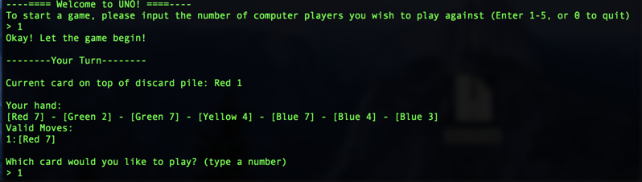

1. AI plays cards

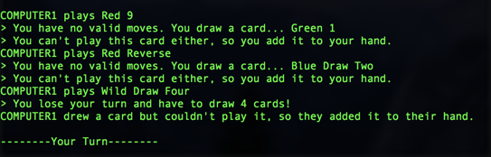

1. Play draw two card

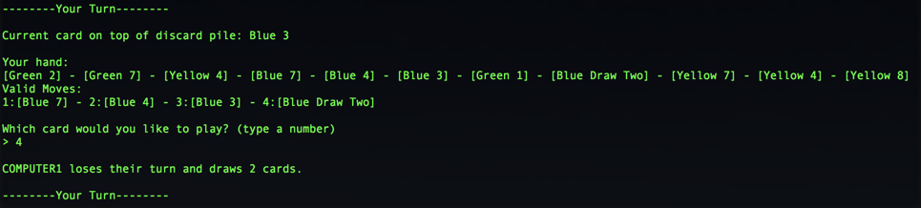

1. Play wild card

