📊 BI Consulting Portfolio
Client: AdventureWorks
Consultant: Connor Gaskill
Course: IT420 – Business Intelligence
Date: December, 2025

📑 Table of Contents
- Front Matter
- Executive Summary
- 1. Data Audit & Initial Assessment (Week 1)
- 2. ETL Foundations & Data Cleaning (Week 2)
- 3. Warehouse Design & Schema Draft (Week 3)
- 4. OLTP vs OLAP Rationale (Week 4)
- 5. Executive Report Packet (SSRS – Static) (Week 5)
- 6. Interactive Reports (SSRS – Drill-Down & Parameters) (Week 6)
- 7. Baseline Dashboard (Power BI) (Week 7)
- 8. Storytelling Dashboard (AdventureWorksDW2022) (Week 8)
- 9. Multi-Page Executive Dashboard (Week 9)
- 10. Predictive Insights Dashboard (Week 10)
- 11. Final Handoff: Consulting Portfolio & Presentation (Week 11)
- Back Matter
- Final Recommendations for the Client
- Reflection on Professional Growth

📄 Executive Summary
Executive Summary – Business Intelligence
Over the course of the last 10 weeks, our goal has been to establish a reliable, actionable business intelligence (BI) framework for analyzing sales, customer, and product performance. This initiative included auditing existing data, designing a data warehouse, and building interactive dashboards to guide decision-making across the organization.
Data Audit and Preparation
Our first step was a thorough review of the current sales, customer, and product data. We identified inconsistencies, missing values, and invalid entries that compromised reporting accuracy. To address these issues, we implemented cleaning and transformation processes, quarantining bad data and normalizing inputs. This ensured that subsequent analyses would be based on trustworthy, consistent information.
Data Warehouse and BI Design
To enable fast, reliable reporting, we designed a star schema data warehouse. The central FactSales table stores measurable data such as quantity and revenue, while linked dimension tables (customers, products, dates) provide descriptive context. This OLAP-based design improves query performance, simplifies report building, and reduces the risk of overloading operational systems.
Dashboards and Analytics
We built a series of interactive dashboards in Power BI to visualize trends, monitor KPIs, and support strategic decisions:
- Sales and Product Insights: Highlight top-performing product categories and individual products, enabling focused marketing and inventory strategies.
- Customer Analytics: Track new customer growth, demographic trends, and purchasing behavior.
- Regional Performance: Compare sales across countries and provinces, identifying areas for expansion or increased focus.
- Predictive Insights: Segment customers into six clusters based on purchase value and frequency, revealing high-value opportunities, at-risk segments, and targets for upselling or loyalty programs.
Key Outcomes
The BI solution provides the client with:
- Accurate, reliable data for reporting and analysis
- Faster query performance and simplified report creation
- Actionable insights into sales trends, customer behavior, and product performance
- Strategic guidance for retention, marketing, and investment decisions
Moving forward, this framework positions the organization to make informed, data-driven decisions efficiently, while scaling analytics capabilities as business needs evolve.

Week 1 – Data Audit & Initial Assessment
Deliverables: Data Audit Memo, initial SQL imports.
Key Findings:
Source:
The data appears to have come from a sales table with references to a customer and product tables.
Format:
The data is not being recorded consistently. Certain values are recorded using numbers and letters in the same table (i.e. fifty vs 50 in the sales table).
Quality:
The data contains invalid entries such a negative quantities in the sales table and customer IDs that appear to be invalid.
Risks:
The problems present in the data make it unreliable to collect accurate sales totals or create necessary reports. These inconsistencies could lead to problems with SEC compliance and audits from the IRS if not handled.
Recommendations:
My team will begin to clean the data, quarantining bad data into separate tables. We will prepare audit forms for your team to attempt to save data that is missing from the database.
While we work on fixing the data we have, we should begin normalizing the ways we input data by limiting manual entry, automating certain data (such as dates), and restricting what data is permissible to be passed into the system (numbers instead of letters for amounts).

Evidence:
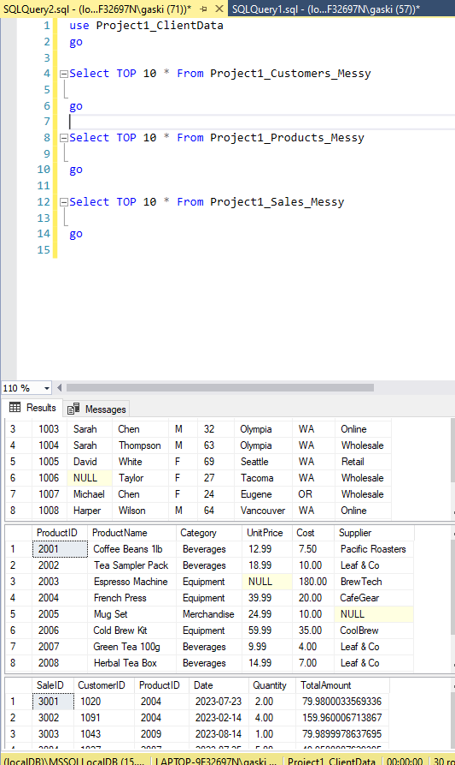

Week 2 – ETL Foundations & Data Cleaning
Deliverables: SSIS ETL package, cleaned staging tables.
Key Actions:
After combing through the data in the products, customers, and sales tables I would like to share some insights.
Each table contained null, or empty, values which is concerning for two main reasons:
- 1) Where is this data being stored if at all? The potential loss of this data can be detrimental to operations and accurate business intelligence.
- 2) The holes left in this data can be hazardous to company systems if not handled properly.
While I am unable to fix the first problem (auditing team, be ready), I have come up with a solution for the second. I have settled on several placeholder values that are easily identifiable and can be easily integrated into the current system without disrupting reports.
While auditing the keys in the sales table, I came across a few product IDs that do not match anything we have in our system. This could have happened for many reasons, but I will leave it to the auditing team to figure out if these products still exist in the company and we will proceed from there. Once we establish if these products are still in use, I will have more to share on this.
Other than the major issues discussed above, I am continuing to fix spelling and capitalization inconsistencies as I come across them. As I mentioned before, these errors compromise the integrity of the database and make reports less reliable. As we move forward, I expect to update the applications we use to utilize more automation and validate input before it reaches the database. This way these errors will be much less likely to occur again.

Evidence:
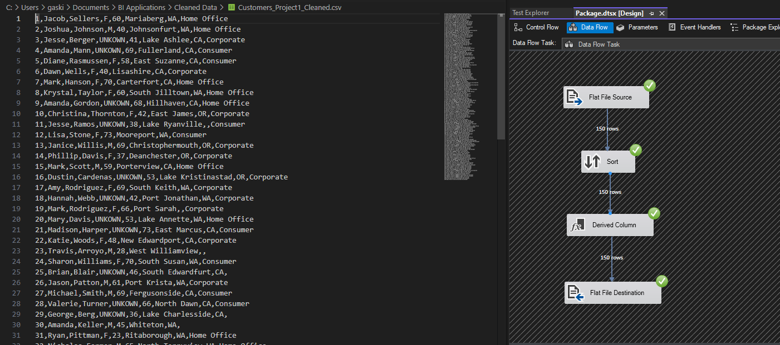
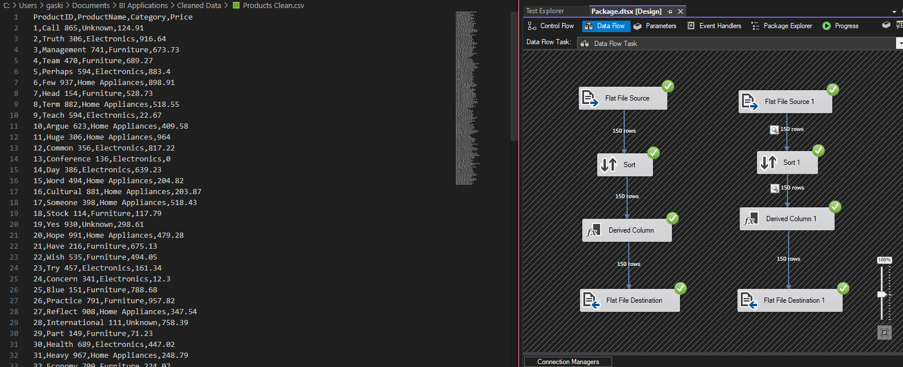
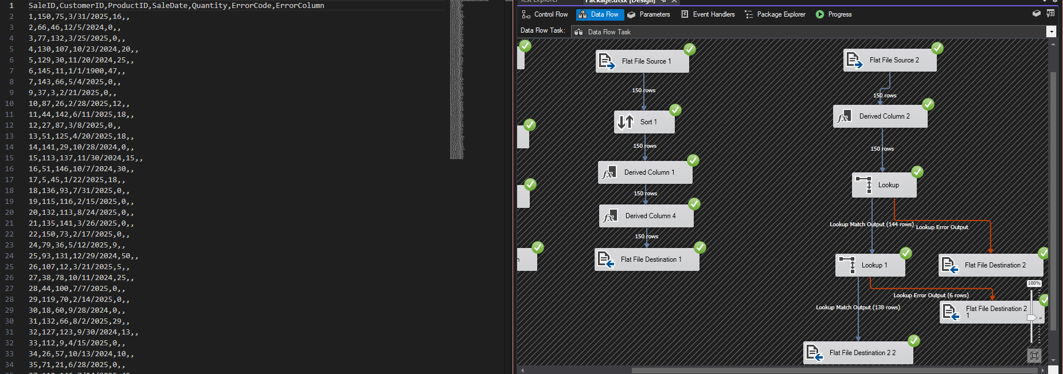

Week 3 – Warehouse Design & Schema Draft
Deliverables: Star Schema DDL + ERD diagram.
Fact & Dimension Tables:
- DimCustomer includes names and regions.
- DimProduct has names, categories, and unit prices.
- DimDate covers months, quarters, and years.
- FactSales includes the quantity, total sale amount, and foreign keys pointing to the other tables.
Evidence:
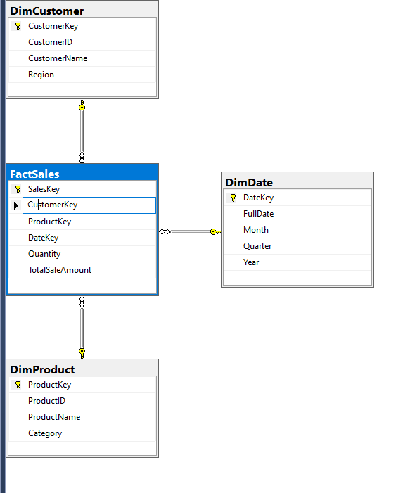

Week 4 – OLTP vs OLAP Rationale
Deliverable: Written memo comparing OLTP vs OLAP.
Key Point:
This week focused on comparing operational (OLTP) and analytical (OLAP) systems to highlight their impact on reporting and performance. OLTP handles daily transactions efficiently but is not optimized for analysis, while OLAP supports historical trend analysis through a star schema design with a central fact table and linked dimension tables. Performance testing confirmed that OLAP enables faster queries, simpler report creation, and reduced system load. The recommendation is to continue building the OLAP warehouse to provide accurate, scalable, and efficient business intelligence for decision-making.
Evidence:
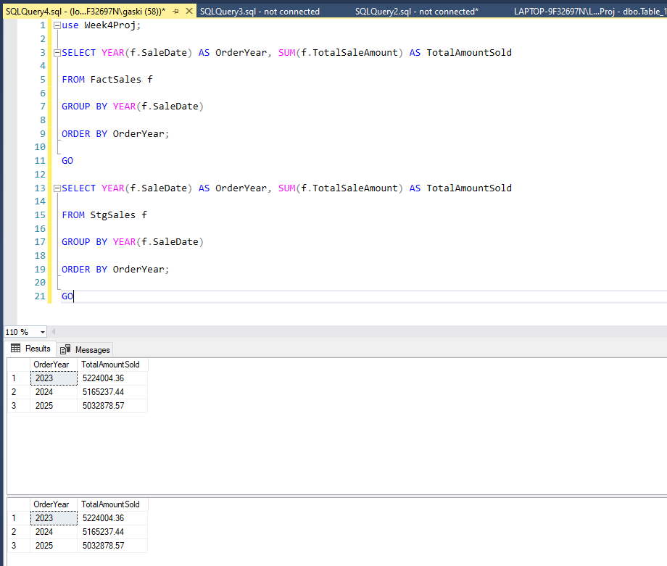

Week 5 – Executive Report Packet (SSRS – Static)
Deliverables: SSRS `.rdl` files + PDF report packet.
Highlights:
After reviewing the latest sales reports, I’ve put together two visuals that highlight our current performance trends. The first report, Sales by Category, shows that Electronics continue to lead overall revenue by a wide margin, confirming where most of our business value is concentrated. The second report, Top Ten Products by Revenue, breaks this down further showing that smartphones and other premium electronics dominate individual sales performance.
These insights help us focus marketing and inventory strategies where they’ll have the most impact and ensure we continue supporting the products driving most of our revenue.
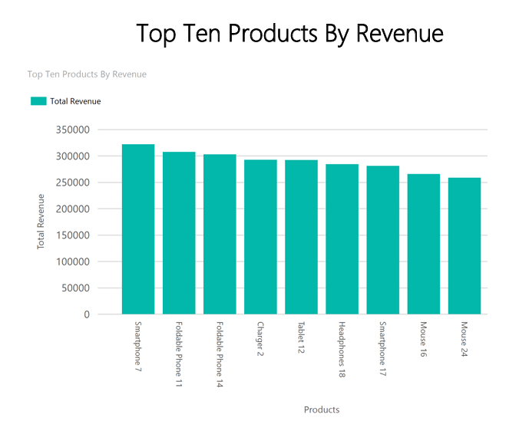
Evidence:
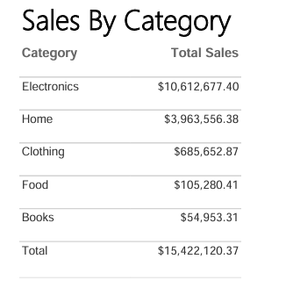

Week 6 – Interactive Reports (SSRS)
Deliverables: Drill-down and parameterized SSRS reports.
Example:
Interactive features like drill-down and drill-through add value by letting executives start with high-level summaries and quickly explore the details behind the numbers. Parameterized filters make it easy to focus on specific regions, time periods, or product categories, ensuring insights are tailored to strategic priorities. Dynamic and sortable visuals help highlight trends and outliers at a glance, supporting faster, data-driven decisions. These features make reports both actionable and efficient for leadership.
Evidence:
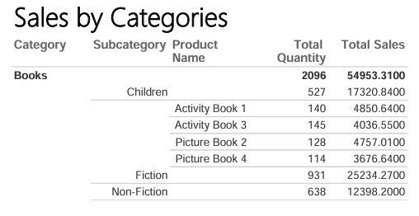

Week 7 – Baseline Dashboard (Power BI)
Deliverables: First Power BI dashboard (`.pbix`, PDF).
Content:
- Region and year slicers
- Sales by Country and Sales by Month pie charts
- Sales vs Goal KPI
Reflection:
I’ve updated the Power BI report with a clean set of visuals that give us an at-a-glance read on how we’re tracking. You’ll now have Year and Region slicers, a KPI card showing Actual Sales vs Target (with variance %), plus two pie charts breaking out Sales by Product Category and Sales by Month. These visuals should make it easier to see where we’re beating plan, where we’re falling short, and which categories or seasons are carrying the load, without having to dig through pages of tables.
Unlike a full report packet that we’d send out monthly with every detail and footnote, this dashboard is built for quick morning check-ins and leadership meetings.
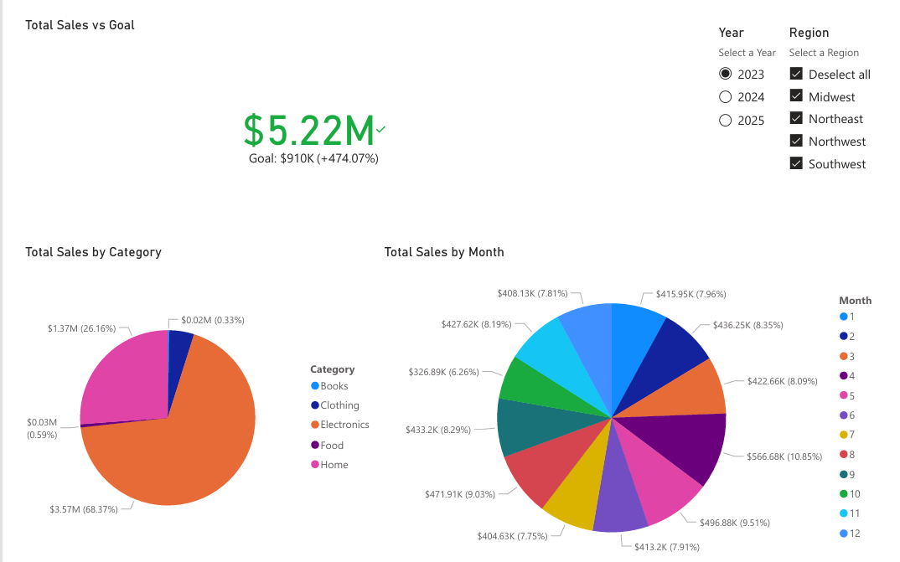
Evidence:

Week 8 – Storytelling Dashboard (AdventureWorksDW2022)
Deliverables: Enhanced dashboard (`.pbix`, annotated PDF, video walkthrough).
Focus:
Customer growth trends and their impact on average sales per customer and total sales.
Story Arc:
For this dashboard, I chose to highlight the following information:
- Total customers
- Average spending per customer
- Total sales
If we look at the visual elements on the page, the pie chart shows customer count by country and the line chart shows new customers over time.
I selected the pie chart visual to act as both a filter (select a country to filter the entire report by that country) and to highlight how large our customer base is in each country.
The line chart shows our customer growth over time and can be filtered by region (pie chart) or by year (slicer).
There is a narrative at the top of the page which will automatically summarize and generate insights based on the filters that are applied to the report.
The goal of this report is to show how our customer base changes over time and how that affects our total revenue. By filtering the data, we can see our total customers and average spending per customer fluctuate, revealing key spending patterns we should consider.

Evidence:
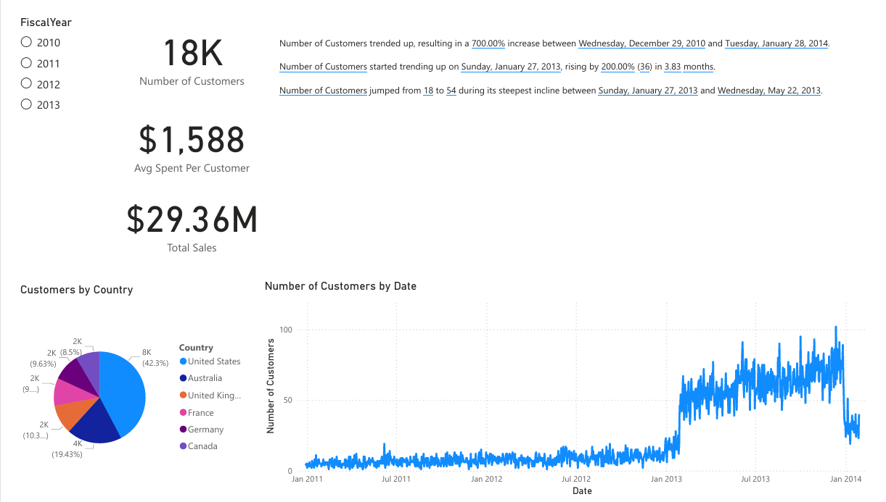

Week 9 – Multi-Page Executive Dashboard
Deliverables: Multi-page dashboard (`.pbix`, PDF packet).
Pages: Executive Overview, Region, Customer, Product
Navigation: Executive Overview (Home) Region Customer Product
Evidence:
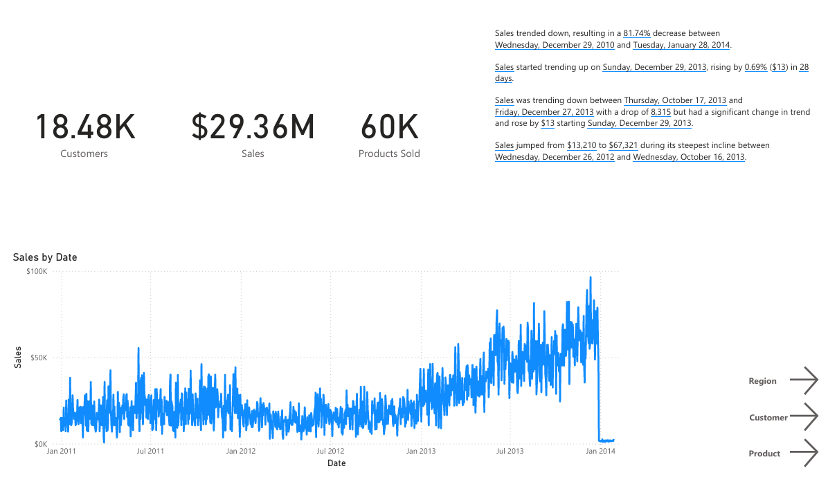
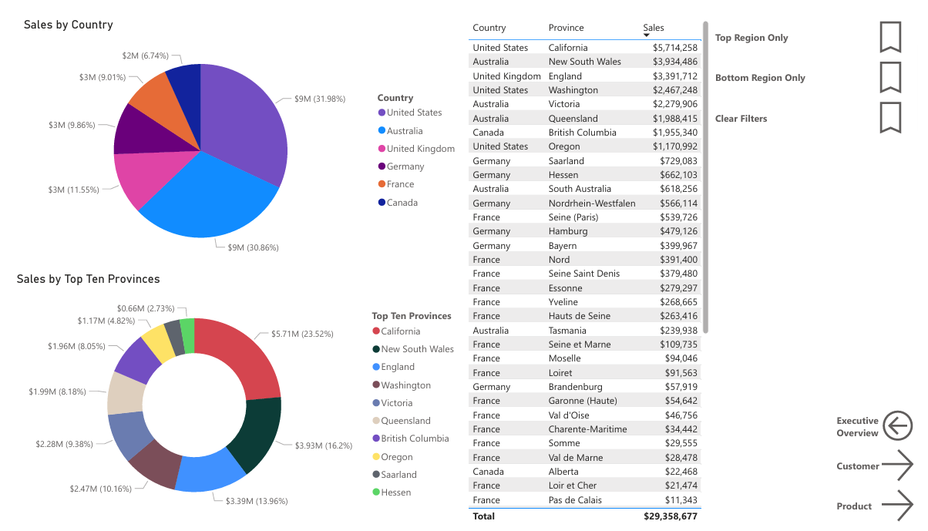
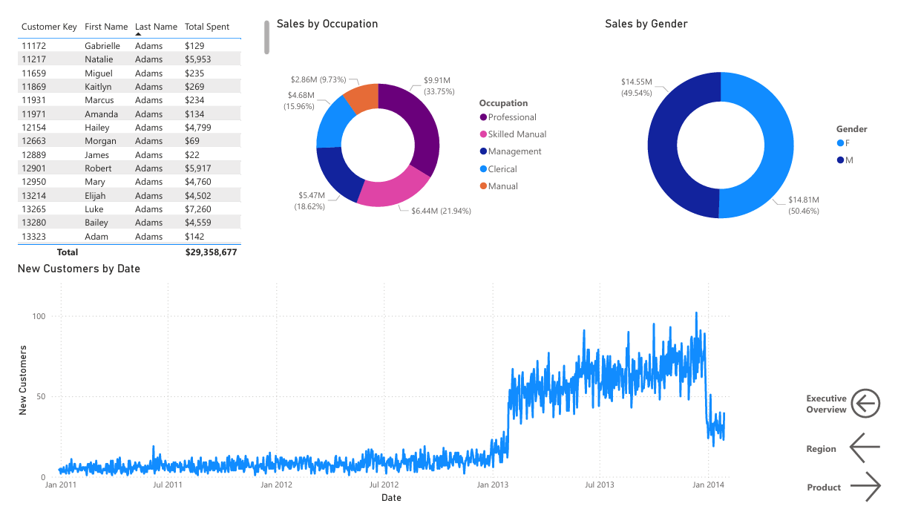
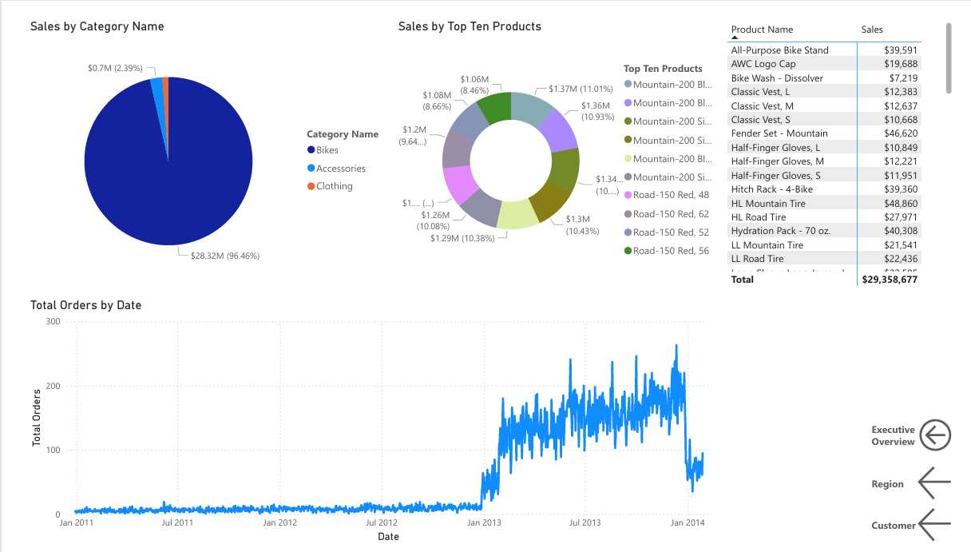

Week 10 – Predictive Insights Dashboard
Deliverables: Dashboard with clustering + classification (`.pbix`, PDF).
Clustering and classification:
- Very Low Value, Moderate Frequency (10,711 customers) – A large segment that purchases regularly but at low value, suggesting potential for upselling or bundling.
- Very High Value, Very Low Frequency (358 customers) – High-value customers with infrequent purchases; targeted engagement could increase repeat business.
- Low Value, Moderate Frequency (3,975 customers) – Customers with moderate purchasing habits; opportunities exist to increase average spend.
- Moderate Value, Moderate Frequency (2,453 customers) – Steady contributors to revenue; could be nurtured to move into higher-value segments.
- High Value, Low Frequency (891 customers) – Valuable but infrequent customers; retention and engagement strategies are recommended.
- Very Low Value, Very High Frequency (36 customers) – Frequent purchasers with low individual value; potential for promotions or loyalty programs.
Strategic Insight:
In the overview, I highlight six customer clusters ranging from very low value to very high value, combined with low to high purchase frequency. A generated narrative captures key takeaways and highlights where opportunities exist to increase revenue and improve retention. The main visual is a scatterplot of average purchase value versus purchase frequency, as it clearly illustrates the distribution of our customer segments and identifies high-potential groups.
I chose these clusters because they provide a clear view of customer behavior and help identify where marketing and sales efforts can be most effective. Filters and slicers allow the dashboard to be explored by country, supporting targeted strategy development.
Evidence:
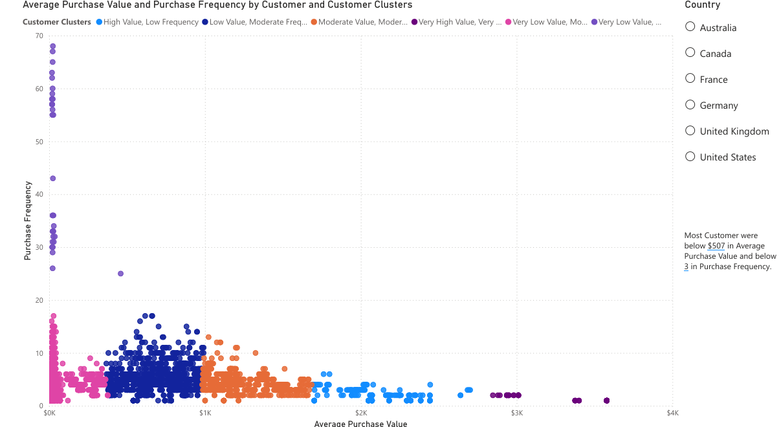

Week 11 – Final Handoff: Consulting Portfolio & Presentation
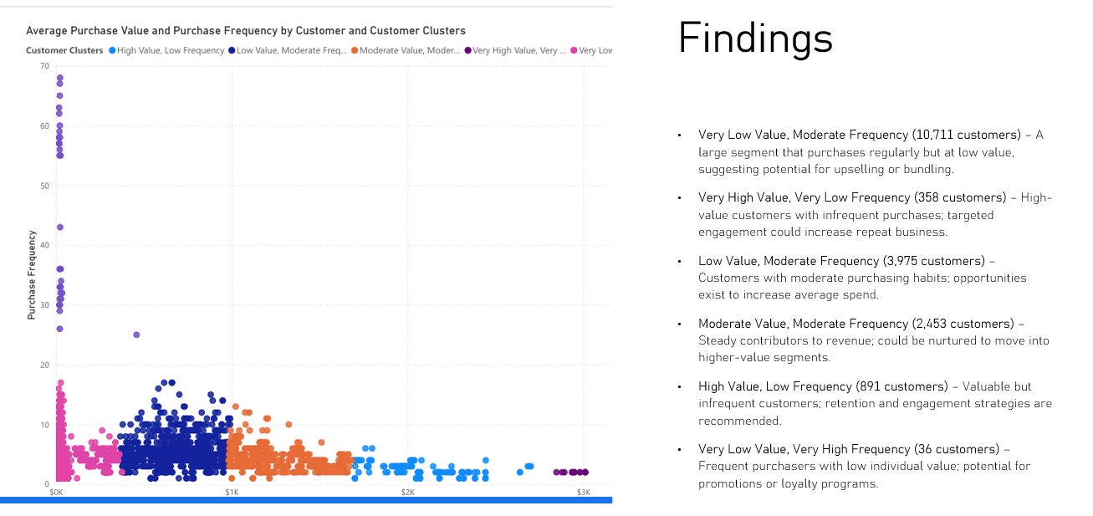
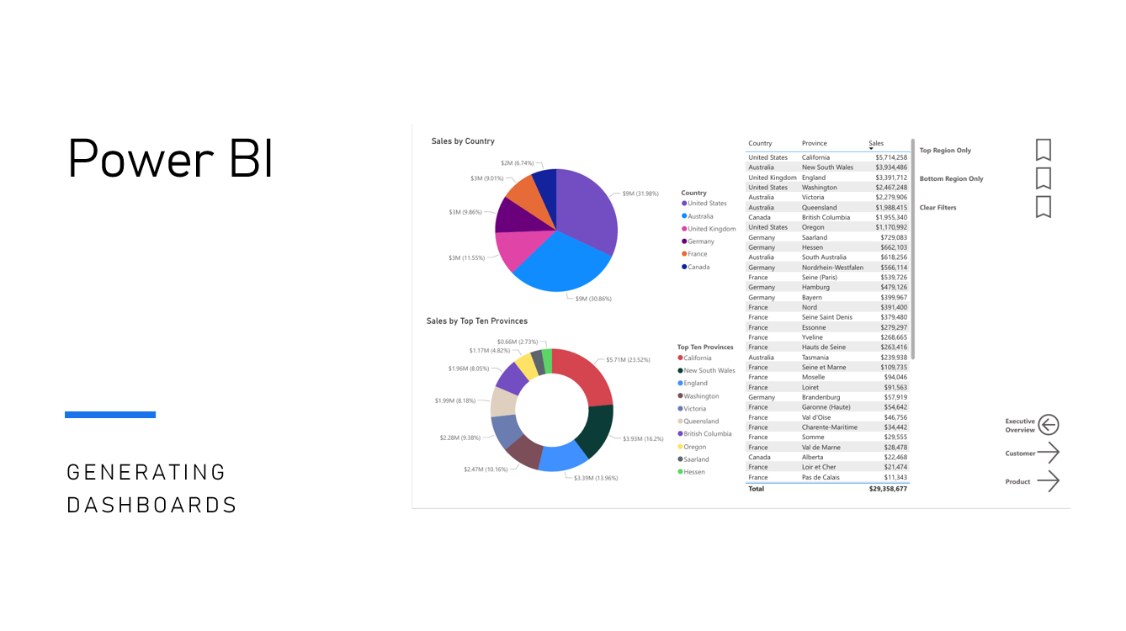
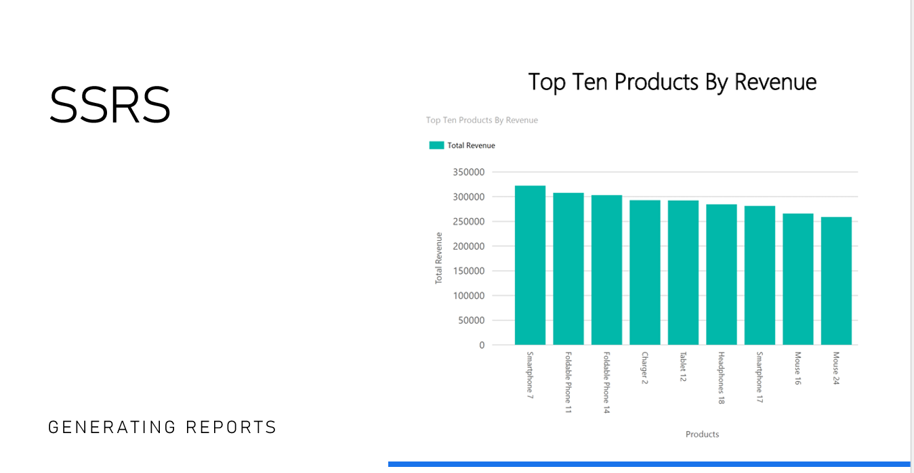
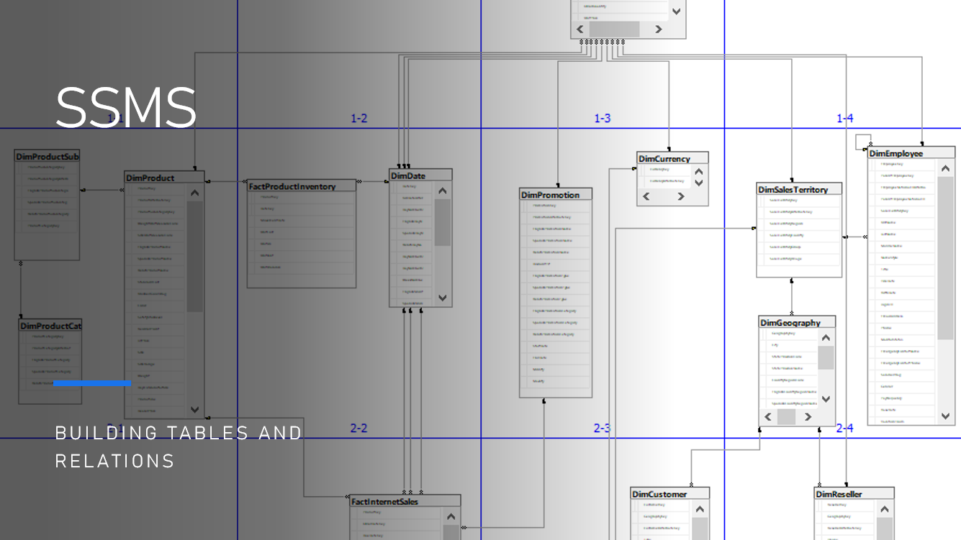
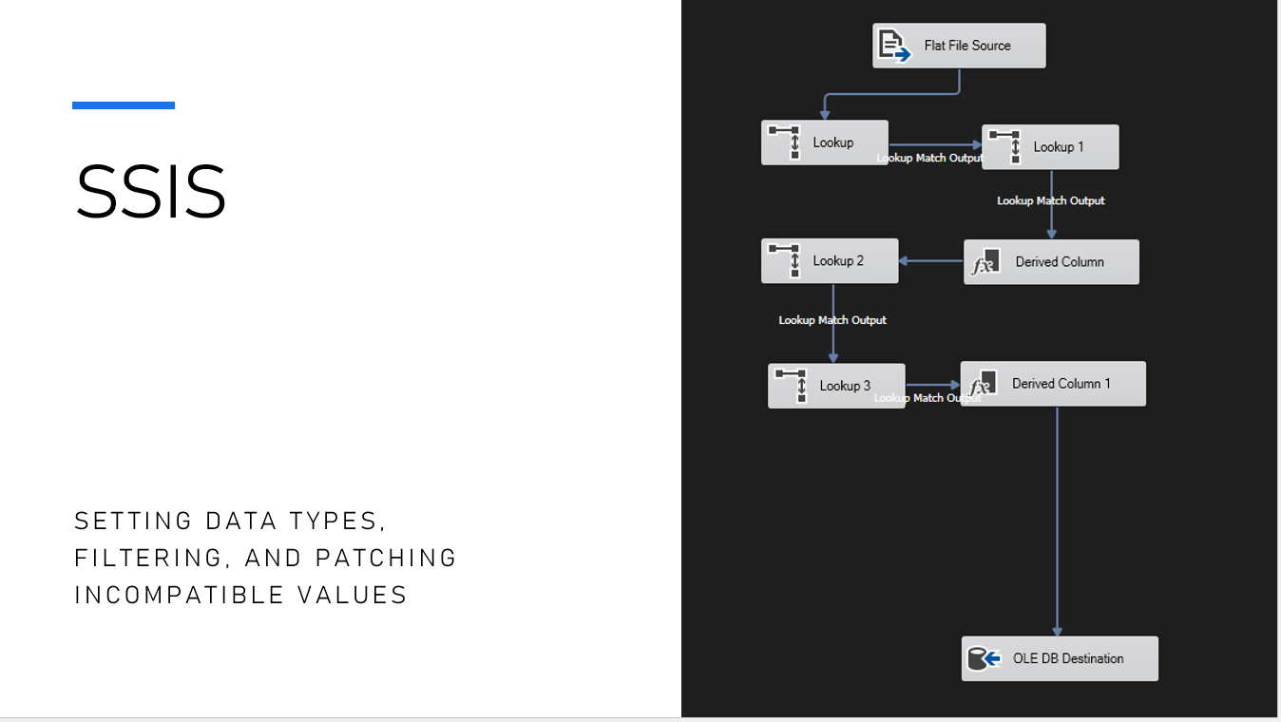
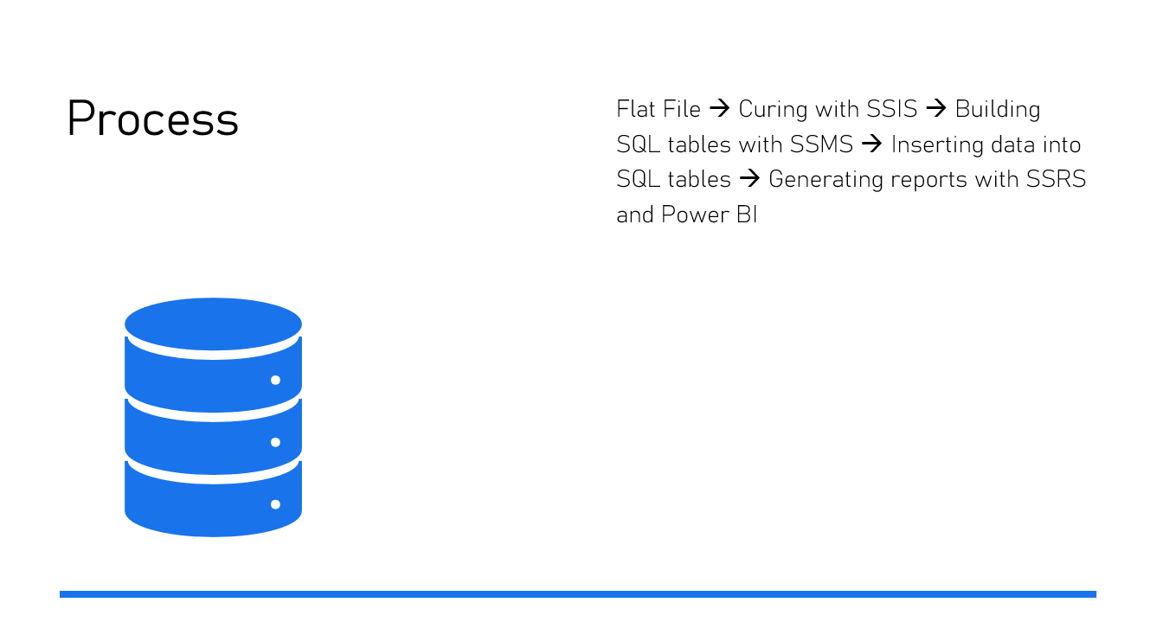

Deliverables: This portfolio document, organized artifact folder (SQL scripts, SSIS packages, SSRS `.rdl`, Power BI `.pbix`), and recorded presentation.
Evidence:

📌 Final Recommendations for the Client
- Target High-Value, Low-Frequency Customers: Implement personalized engagement campaigns, loyalty programs, or incentives to encourage repeat purchases from the “Very High Value, Very Low Frequency” and “High Value, Low Frequency” segments. These customers already generate significant revenue but are under-engaged.
- Upsell and Cross-Sell Moderate Segments: For “Moderate Value, Moderate Frequency” and “Low Value, Moderate Frequency” customers, develop bundled offers or promotions to increase average transaction value and move them into higher-value segments.
- Leverage Frequent, Low-Value Customers: The “Very Low Value, Moderate/High Frequency” segment represents a large number of regular purchasers. Introduce low-cost upsells, loyalty points, or volume discounts to increase overall revenue without alienating these loyal customers.
- Optimize Regional Marketing and Inventory: Use regional sales dashboards to identify high-performing and underperforming areas. Allocate marketing spend, inventory, and sales efforts strategically to maximize revenue and support geographic expansion.
- Monitor Product Performance and Investment: Focus resources on top-performing products and categories while identifying underperforming items that may need promotion, bundling, or discontinuation. Use BI dashboards to continually track trends and adjust strategy dynamically.

📝 Reflection on Professional Growth
Over the past ten weeks I worked through a complete BI pipeline. This included data auditing, ETL, warehouse design, reporting, dashboarding, and some basic predictive analytics. Throughout this process, I learned how to design a star schema, build ETL flows in SSIS, create both static and interactive SSRS reports, and build Power BI dashboards for different purposes.
The biggest challenge I faced was dealing with unstable and inconsistent AI-generated assignments. Many instructions assumed access to data that didn’t exist, included incompatible flat files that didn’t match the assignment, or included instructions that referred to datasets from earlier demos instead of the current lab. Because of this, almost every assignment required additional troubleshooting or rebuilding large sections on my own. It was frustrating and made the work take longer than it should have, but it also forced me to become more self-reliant. I learned to take instructions with a grain of salt, reinterpret tasks when they didn’t make sense, and research differences between the various versions of software we were using (i.e. the AI didn’t account for newer versions of Power BI or SSRS). Even though some assignments were frustrating, I ended up gaining experience working with flawed data (similar to actual BI work) where datasets lack integrity and documentation is often missing.
The software itself was another challenge. SSIS threw errors capriciously, and the only fix was to reset components or rebuild pieces of a package. SSRS had its own issues and didn’t play nice with visual studio all of the time. Even though these problems were annoying, working through them was necessary in learning how to use each application. Now I can handle the basics of SSIS, SSRS, and Power BI with much more confidence.
Looking ahead, I plan to use Power BI in my current job. Even simple dashboards will save me time and give me chances to keep improving. It will also help me prepare for a future move into an IT centered role. Overall, the course gave me a clearer understanding of the BI pipeline even with flawed or inconsistent data.

