Chapter 4

Entity-Relationship (ER) Modeling

Review Questions

- What two conditions must be met before an entity can be classified as a weak entity? Give an example of a weak entity.
Needs to have existence dependence and needs to inherit primary key of parent

Dependent cannot exist without employee

- What is a strong (or identifying) relationship, and how is it depicted in a Crow’s Foot ERD?
A solid line

- Given the business rule “an employee may have many degrees,” discuss its effect on attributes, entities, and relationships. (Hint: Remember what a multivalued attribute is and how it might be implemented.)
You would have to create a new string to store the degree values

- What is a composite entity, and when is it used?
Used to represent a many to many by having a one to many with both parents

- Suppose you are working within the framework of the conceptual model in Figure Q4.5.

Figure Q4.5 The Conceptual Model for Question 5
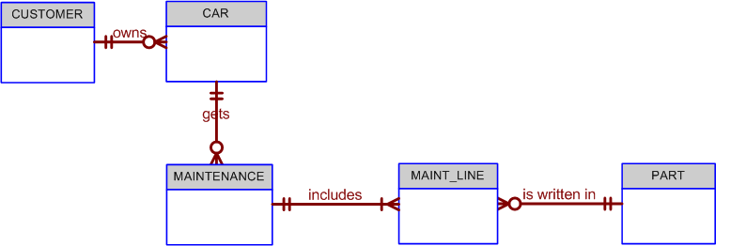

Given the conceptual model in Figure Q4.5:

  - Write the business rules that are reflected in it.
1:M customer-car 1:M car-maintenance 1:M maintenance- maint_line M:1 maint_line-Part

  - Identify all of the cardinalities.
cardinality . customer:(1,1), car(0,∞), maintenance(0,∞) maint_line (1,∞) part(0,∞)

- What is a recursive relationship? Given an example.
A recursive entity references itself

- How would you (graphically) identify each of the following ERM components in a Crow’s Foot model?

- an entity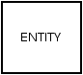
- the cardinality (0,N)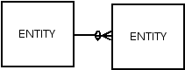
- a weak relationship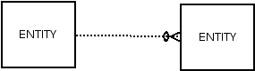
- a strong relationship

- Discuss the difference between a composite key and a composite attribute. How would each be indicated in an ERD?
A composite key is made of many keys, a composite attribute is many attributes

- What two courses of action are available to a designer when encountering a multivalued attribute?
Split it into many attributes or make a new entity

- What is a derived attribute? Give an example.
Attribute that is calculated from existing attributes

- How is a relationship between entities indicated in an ERD? Give an example, using the Crow’s Foot notation.

- Discuss two ways in which the 1:M relationship between COURSE and CLASS can be implemented. (Hint: Think about relationship strength.)
1 course can have many classes

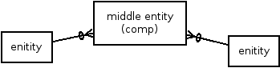
- How is a composite entity represented in an ERD, and what is its function? Illustrate the Crow’s Foot model.

- What three (often conflicting) database requirements must be addressed in database design?
Design standards, processing speed, and information requirements

- Briefly, but precisely, explain the difference between single-valued attributes and simple attributes. Give an example of each.
Simple cant be divided, single can
- What are multivalued attributes, and how can they be handled within the database design
many values
- Write the ten cardinalities that are appropriate for this ERD.

- Write the business rules reflected in this ERD.
1:M product-line M:1 order_line-order M:1 order-store 1:M store-employee 1:M employee-dependent
- What two attributes must be contained in the composite entity between STORE and PRODUCT? Use proper terminology in your answer.
Order and order_line
- Describe precisely the composition of the DEPENDENT weak entity’s primary key. Use proper terminology in your answer.
You cannot have dependent without employee
21. The local city youth league needs a database system to help track children that sign up to play soccer. Data needs to be kept on each team and the children that will be playing on each team and their parents. Also, data needs to be kept on the coaches for each team. Draw the data model described below.
Entities required: Team, Player, Coach, and Parent.
Attributes required:
Team: Team ID number, Team name, and Team colors.
Player: Player ID number, Player first name, Player last name, and Player age.
Coach: Coach ID number, Coach first name, Coach last name, and Coach home phone number.
Parent: Parent ID number, Parent last name, Parent first name, Home phone number, and Home Address (Street, City, State, and ZIP Code).
The following relationships must be defined:
- Team is related to Player.
- Team is related to Coach.
- Player is related to Parent.
Connectivities and participations are defined as follows:
- A Team may or may not have a Player.
- A Player must have a Team.
- A Team may have many Players.
- A Player has only one Team.
- A Team may or may not have a Coach.
- A Coach must have a Team.
- A Team may have many Coaches.
- A Coach has only one Team.
- A Player must have a Parent.
- A Parent must have a Player.
- A Player may have many Parents.
- A Parent may have many Players.
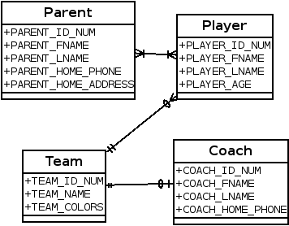

Problems

1. Use the following business rules to create a Crow’s Foot ERD. Write all appropriate connectivities and cardinalities in the ERD.
- A department employs many employees, but each employee is employed by one department.
- Some employees, known as “rovers,” are not assigned to any department.
- A division operates many departments, but each department is operated by one division.
- An employee may be assigned many projects, and a project may have many employees assigned to it.
- A project must have at least one employee assigned to it.
- One of the employees manages each department, and each department is managed by only one employee.
- One of the employees runs each division, and each division is run by only one employee.
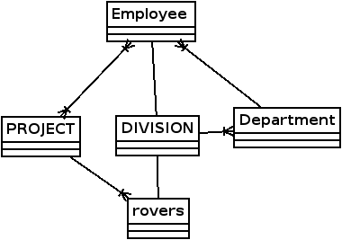

7. United Helpers is a nonprofit organization that provides aid to people after natural disasters. Based on the following brief description of operations, create the appropriate fully labeled Crow’s Foot ERD.
- Individuals volunteer their time to carry out the tasks of the organization. For each volunteer, their name, address, and telephone number are tracked. Each volunteer may be assigned to several tasks during the time that they are doing volunteer work, and some tasks require many volunteers. It is possible for a volunteer to be in the system without having been assigned a task yet. It is possible to have tasks that no one has been assigned. When a volunteer is assigned to a task, the system should track the start time and end time of that assignment.
- For each task, there is a task code, task description, task type, and a task status. For example, there may be a task with task code “101,” description of “answer the telephone,” a type of “recurring,” and a status of “ongoing.” There could be another task with a code of “102,” description of “prepare 5000 packages of basic medical supplies,” a type of “packing,” and a status of “open.”
- For all tasks of type “packing,” there is a packing list that specifies the contents of the packages. There are many different packing lists to produce different packages, such as basic medical packages, child care packages, food packages, etc. Each packing list has a packing list ID number, packing list name, and a packing list description, which describes the items that ideally go into making that type of package. Every packing task is associated with only one packing list. A packing list may not be associated with any tasks, or may be associated with many tasks. Tasks that are not packing tasks are not associated with any packing list.
- Packing tasks result in the creation of packages. Each individual package of supplies that is produced by the organization is tracked. Each package is assigned an ID number. The date the package was created, and total weight of the package is recorded. A given package is associated with only one task. Some tasks (e.g., “answer the phones”) will not have produced any packages, while other tasks (e.g., “prepare 5000 packages of basic medical supplies”) will be associated with many packages.
- The packing list describes the ideal contents of each package, but it is not always possible to include the ideal number of each item. Therefore, the actual items included in each package should be tracked. A package can contain many different items, and a given item can be used in many different packages.
- Each item that the organization provides has an item ID number, item description, item value, and item quantity on hand stored in the system. Along with tracking the actual items that are placed in each package, the quantity of each item placed in the package must be tracked as well. For example, a packing list may state that basic medical packages should include 100 bandages, 4 bottles of iodine, and 4 bottles of hydrogen peroxide. However, because of the limited supply of items, a given package may include only 10 bandages, 1 bottle of iodine, and no hydrogen peroxide. The fact that this package includes bandages and iodine needs to be recorded along with the quantity of each item included. It is possible for the organization to have items that have not been included in any package yet, but every package will contain at least one item.
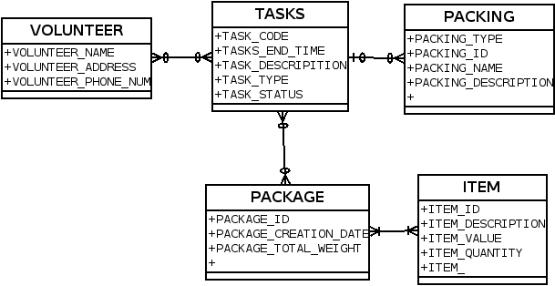

10. Luxury-Oriented Scenic Tours (LOST) provides guided tours to groups of visitors to the Washington D.C. area. In recent years, LOST has grown quickly and is having difficulty keeping up with all of the various information needs of the company. The company’s operations are as follows.
- LOST offers many different tours. For each tour, the tour name, approximate length (in hours), and fee charged is needed. Guides are identified by an employee ID, but the system should also record a guide’s name, home address, and date of hire. Guides take a test to be qualified to lead specific tours. It is important to know which guides are qualified to lead which tours and the date that they completed the qualification test for each tour. A guide may be qualified to lead many different tours. A tour can have many different qualified guides. New guides may or may not be qualified to lead any tours, just as a new tour may or may not have any qualified guides.
- Every tour must be designed to visit at least three locations. For each location, a name, type, and official description are kept. Some locations (such as the White House) are visited by more than one tour, while others (such as Arlington Cemetery) are visited by a single tour. All locations are visited by at least one tour. The order in which the tour visits each location should be tracked as well.
- When a tour is actually given, that is referred to as an “outing.” LOST schedules outings well in advance so they can be advertised and so employees can understand their upcoming work schedules. A tour can have many scheduled outings, although newly designed tours may not have any outings scheduled. Each outing is for a single tour and is scheduled for a particular date and time. All outings must be associated with a tour. All tours at LOST are guided tours, so a guide must be assigned to each outing. Each outing has one and only one guide. Guides are occasionally asked to lead an outing of a tour even if they are not officially qualified to lead that tour. Newly hired guides may not have ever been scheduled to lead any outings. Tourists, called “clients” by LOST, pay to join a scheduled outing. For each client, the name and telephone number are recorded. Clients may sign up to join many different outings, and each outing can have many clients. Information is kept only on clients who have signed up for at least one outing, although newly scheduled outings may not have any clients signed up yet.
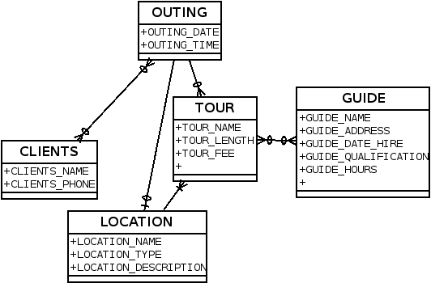
      - Create a Crow’s Foot notation ERD to support LOST operations.

      - The operations provided state that it is possible for a guide to lead an outing of a tour even if the guide is not officially qualified to lead outings of that tour. Imagine that the business rules instead specified that a guide is never, under any circumstance, allowed to lead an outing unless he or she is qualified to lead outings of that tour. How could the data model in part a) be modified to enforce this new constraint?

Case 11

11. The administrators of Tiny College are so pleased with your design and implementation of their student registration/tracking system that they want you to expand the design to include the database for their motor vehicle pool. A brief description of operations follows:

A brief description of operations follows:
- Faculty members may use the vehicles owned by Tiny College for officially sanctioned travel. For example, the vehicles may be used by faculty members to travel to off-campus learning centers, to travel to locations at which research papers are presented, to transport students to officially sanctioned locations, and to travel for public service purposes. The vehicles used for such purposes are managed by Tiny College’s Travel Far But Slowly (TFBS) Center.
- Using reservation forms, each department can reserve vehicles for its faculty, who are responsible for filling out the appropriate trip completion form at the end of a trip. The reservation form includes the expected departure date, vehicle type required, destination, and name of the authorized faculty member. The faculty member arriving to pick up a vehicle must sign a checkout form to log out the vehicle and pick up a trip completion form. (The TFBS employee who releases the vehicle for use also signs the checkout form.) The faculty member’s trip completion form includes the faculty member’s identification code, the vehicle’s identification, the odometer readings at the start and end of the trip, maintenance complaints (if any), gallons of fuel purchased (if any), and the Tiny College credit card number used to pay for the fuel. If fuel is purchased, the credit card receipt must be stapled to the trip completion form. Upon receipt of the faculty trip completion form, the faculty member’s department is billed at a mileage rate based on the vehicle type (sedan, station wagon, panel truck, minivan, or minibus) used. (Hint: Do not use more entities than are necessary. Remember the difference between attributes and entities!)
- All vehicle maintenance is performed by TFBS. Each time a vehicle requires maintenance, a maintenance log entry is completed on a prenumbered maintenance log form. The maintenance log form includes the vehicle identification, a brief description of the type of maintenance required, the initial log entry date, the date on which the maintenance was completed, and the identification of the mechanic who released the vehicle back into service. (Only mechanics who have an inspection authorization may release the vehicle back into service.)
- As soon as the log form has been initiated, the log form’s number is transferred to a maintenance detail form; the log form’s number is also forwarded to the parts department manager, who fills out a parts usage form on which the maintenance log number is recorded. The maintenance detail form contains separate lines for each maintenance item performed, for the parts used, and for identification of the mechanic who performed the maintenance item. When all maintenance items have been completed, the maintenance detail form is stapled to the maintenance log form, the maintenance log form’s completion date is filled out, and the mechanic who releases the vehicle back into service signs the form. The stapled forms are then filed, to be used later as the source for various maintenance reports.
- TFBS maintains a parts inventory, including oil, oil filters, air filters, and belts of various types. The parts inventory is checked daily to monitor parts usage and to reorder parts that reach the “minimum quantity on hand” level. To track parts usage, the parts manager requires each mechanic to sign out the parts that are used to perform each vehicle’s maintenance; the parts manager records the maintenance log number under which the part is used.
- Each month TFBS issues a set of reports. The reports include the mileage driven by vehicle, by department, and by faculty members within a department. In addition, various revenue reports are generated by vehicle and department. A detailed parts usage report is also filed each month. Finally, a vehicle maintenance summary is created each month.

Given that brief summary of operations, draw the appropriate (and fully labeled) ERD. Use the Chen methodology to indicate entities, relationships, connectivities, and cardinalities.
