Proverb

PROJECT PROPOSAL COUNSELING MANAGEMENT SOFTWARE

Connor Low

CST-451 Capstone Project Proposal

Grand Canyon University

Instructor: Professor Mark Reha

Revision: 3

Date: April 14, 2019

# ABSTRACT

There are insufficiencies in existing counseling management systems for the specialized field of biblical counseling. A software that meets the specific needs of biblical counselors to store counselee information and track counselee progress is proposed. Although the current project is focused on a single client, due to the specialized nature of biblical counseling within churches, it has potential to appeal to a larger market. This application would allow administrative and counselor users to manage caseloads of counselees. An additional function of the application would be to provide access to biblical resources that may be given to counselees. Requirements for the application will be largely influenced by the client, Pastor Jim Low. To consider the product “complete,” the application will need to support administrator users, who will manage counselees and caseloads, and counselor users, who will manage their individual caseload. The main contributors to this project will be Connor Low, the developer, and Pastor Jim Low, the client. The general schedule for development is: the planning and design phase of the project will be completed by early November; the development phase will begin in November and will have a draft ready by February, and a complete product by March; the testing phase will begin in March; and the deployment phase will be completed by mid-April.

|  |
| --- |
| History and Signoff Sheet |

Change Record

|  |  |  |
| --- | --- | --- |
| Date | Author | Revision Notes |
| September 9, 2018 | Connor | Initial draft for review/discussion |
| September 23, 2018 | Connor | Edits from Instructor Suggestions |
| April 14, 2019 | Connor | Added ER diagram for general architectural solution. |

Integrated Instructor Feedback into Project Documentation

Yes  No

Project Approval

Professor Mark Reha

# TABLE OF CONTENTS

Project Overview and Project Objectives - 5

Project Scope - 6

Project Success Measures - 7

Project High-Level Solution - 8

Project Controls - 10

Project Cost and Schedule - 12

Appendix A – References - 13

Appendix B – Copyright Compliance - 14

# Project Overview and Project Objectives

### State the Problem and Background

The counseling industry requires a lot of data to be managed. Counselors must keep track of dozens of counselees at once – their progress, personal information, meeting times, issues discussed – so it is paramount that counselees have an efficient system for managing data. While many solutions exist to satisfy these needs, biblical counseling (such as provided through a local church) has additional or different parameters requiring special attention not given by current solutions.

### Christian Worldview

While biblical and secular counselors will share methodologies and practices, their foundations are often radically different. A Christian counselor will offer different resources than a secular peer. A Christian counselor will have different goals, explanations, purposes, relationship parameters, and expectations for their counselees. Biblical counselling often only requires time, not money. While only a handful will definitely manifest as functional requirements (additional of biblical resources and subtraction of payments, for example), all these aspects deserve consideration as they could further distinguish the finished project.

### Challenges

* Client related data will need to meet certain security standards.
* The application will need to be deployed to a private server.
* The interface will need to be intuitive for a non-technical user.
* The application will run quickly; load times will be mitigated.

### Benefits and Opportunities

This application will benefit the counseling ministry at Christ’s Church, headed up by Pastor Jim Low (the client). Furthermore, this project was suggested by Pastor Low because he was not aware of any current solutions that met his job’s needs. Therefore, there is potential for a larger market in the church. Developing this initial solution for the client will allow for experimentation of features and technologies to further improve the application for potential future clients.

### Project Scope

The software will manage counselee records, storing their progress, completed forms, and assigned resources throughout the counseling process. The software will also provide basic analysis and reporting using select counselee data. The application will not be used to for scheduling, nor will it contain instances of the resources given. The application will not be used for communication between counselor and counselees. The software’s central role is to store, organize, and report data, internally.

#### Stakeholder

|  |  |  |
| --- | --- | --- |
| Stakeholder Name | Role(s) | Responsibilities |
| Connor Low | Developer | Developing |
| Jim Low | Primary client | Providing functional requirements |

#### Work Breakdown Structure

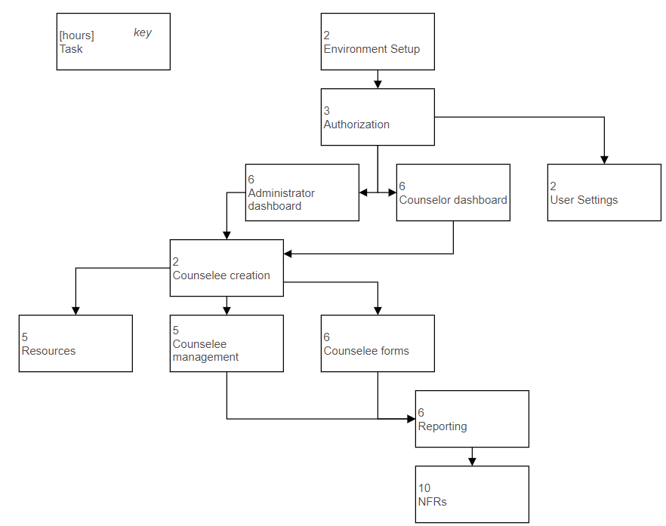

### Project Success Measures

The project will be able to replace existing physical (paper) forms used throughout the counseling process; if all need for a physical record is negated, the project is a success.

#### Project Completion Criteria

|  |
| --- |
| Criteria |
| 1 – A administrator will be able to add, modify, and remove counselees. |
| 2 – A counselor will be able to view, complete, and retrieve forms |
| 3 – A counselor will be able to sign off on a counselee to signify completion |
| 4 – A counselor will be able to view basic reports and statistics based on caseload data |

#### Project Completion Criteria

|  |  |  |  |  |  |
| --- | --- | --- | --- | --- | --- |
| Assumptions and Constraints | | | | | |
| ID | Description | Comments | Type | Status | Date Entered |
| 1 | The office’s server (deployment server) will be able to support a node.js application. |  | A | Inquiry sent to server admin. | 9/6/18 |
| 2 |  |  |  |  |  |

### Project High-Level Solution

#### Introduction

An information management system is needed to replace a current system that relies on paper documents and physical storage. Each step of the counseling process requires one or more forms to be filled out either by the counselee (Counseling Inquiry Form, PIF) or the counselor (Counseling Summary Form, Counselor’s Summary Form). It is time consuming to file documents in an organized way and an ineffective use of information that could be applied to evolve the counseling process for future iterations. The virtual system would automatically organize and store these forms and provide beneficial analyses that are not readily available in the current physical system.

#### Solution

The application will allow for counselees to submit their counseling inquiries and Personal Information Forms (PIF) through a simple public-facing HTML web-page. A private React application used by the counselors and administrators will be hosted on the office intranet for managing caseloads and submitting additional forms for the counseling process. A central node.js server will manage incoming data from the public and private client applications, storing information in a MongoDB. An API will be built using Express.

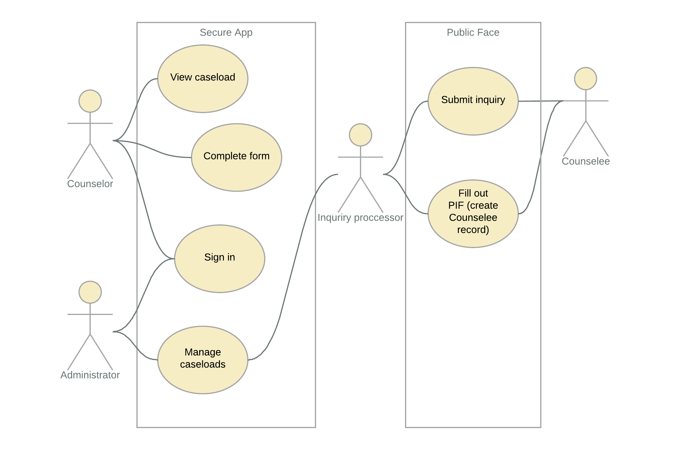

Counselees and counselors will be modeled. Counselor models will be tied to user accounts (a third model). Counselees will not have accounts but will have several models related to the PIF attached (HAS-A).

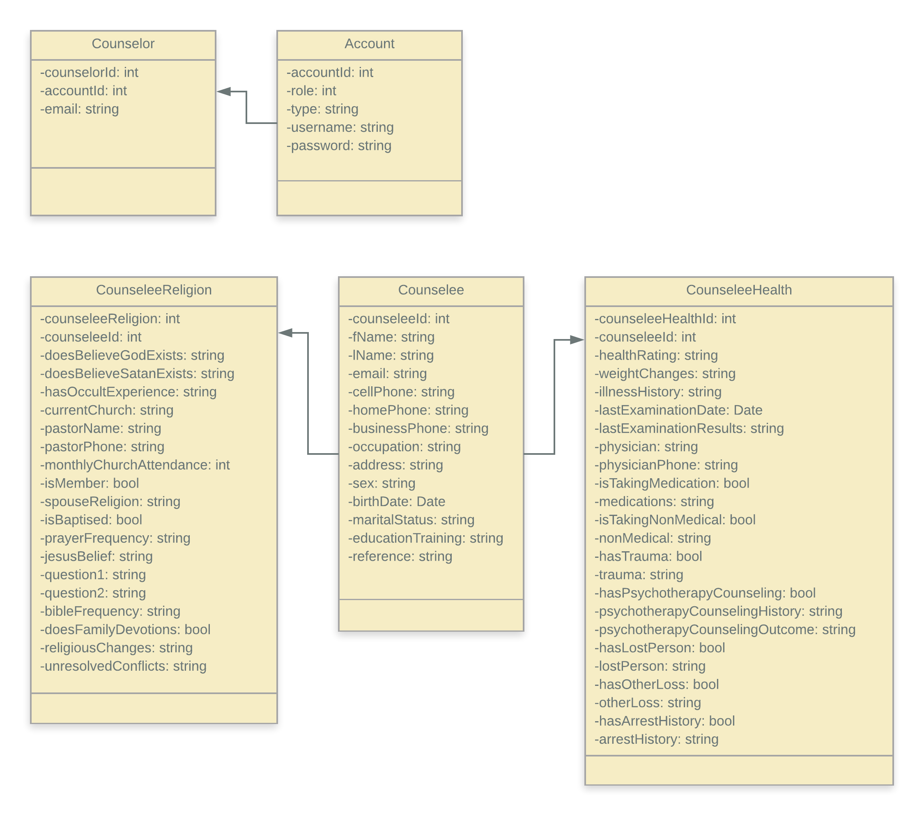

A high-level solution ER diagram:

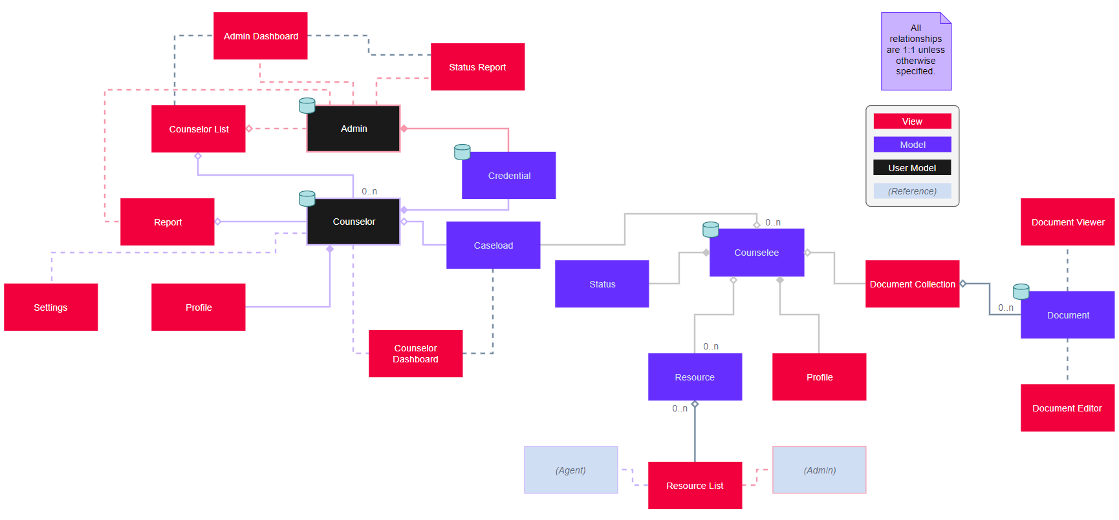

### Project Controls

#### Risks and Issues

|  |  |  |  |  |
| --- | --- | --- | --- | --- |
| Risk Management | | | | |
| Event | Probability | Impact | Mitigation | Contingency Plan |
| Inability to secure sensitive data | Medium | Minimization of the software’s effectiveness | Research best practices for saving and accessing data | Option to save data on local machine, external from the |
| Fail to understand Node.JS and React | Low | Must move to a more familiar Framework, such as .NET, requiring more planning. | Experiment with the frameworks outside of the project to understand better | Switch to .NET. |

|  |  |  |  |  |  |  |  |  |
| --- | --- | --- | --- | --- | --- | --- | --- | --- |
| Issues Log | | | | | | | | |
| ID | Description | Project Impact | Action Plan/Resolution | Owner | Importance | Date Entered | Date to Review | Date Resolved |
|  |  |  |  |  |  |  |  |  |

#### Change Control

|  |  |  |  |  |  |  |  |  |  |
| --- | --- | --- | --- | --- | --- | --- | --- | --- | --- |
| Change Control Log | | | | | | | | | |
| ID | Change Description | Priority | Originator | Date Entered | Date Assigned | Evaluator | Status | Date of Decision | Included in Rev. # |
| 1 |  |  |  |  |  |  |  |  |  |
| 2 |  |  |  |  |  |  |  |  |  |

#### Roles

|  |  |  |  |
| --- | --- | --- | --- |
| Roles and Responsibilities | | | |
| Name | Team | Project Role | Responsibility |
| Connor Low | Developer | Developer | Decides which functionality to include. Implementation. |
| Jim Low | CCFW | End User | Proposes functionality |

### Project Cost and Schedule

There are no expected expenses in developing this software.

#### Project Schedule

1. Initial Project Proposal (September 9th)
2. Project Requirements (September 23rd)
3. Architectural Plan, Development begins (November 11th)
4. Module Test Cases, Source Code Listing, Implementation Plan (December 16th)
5. Application Draft Client Meeting (February 3rd)
6. Application Testing (March 3rd)
7. Application Client Review (March 17th)
8. Application Release (April 14th)

#### Programming schedule

Schedule weeks beginning November 11th.

1. Database (week 1)
2. User account creation, authentication, counselors (week 2)
3. Counselee inquiry form (week 3)
4. Counselee PIF (week 4)
5. Administrator dashboard (week 6)
6. Counselor dashboard (week 8)
7. Counselor forms (week 10)
8. Counseling resources (week 11)
9. Counselor sign off counselee and evaluation form (week 12)

# Appendix A – References

List all references using APA style

# Appendix B – Copyright Compliance

For each external technical tool or code used, provide a reference to its copyright policy, clearly showing your right to use it. For each external technical tool or code used, detail how you used it, how you adapted it, how you modified it (if permitted), and why did you use it as opposed to write your own. Only a small portion of your project may rely on external code. When code libraries/packages are used, explain why this was necessary/required/recommended. Seek instructor approval for using external resources prior to beginning to work on the project.