ProverB

REQUIREMENTS COUNSELING MANAGEMENT SOFTWARE

Connor Low

CST-451 Capstone Project Requirements

Grand Canyon University

Instructor: Professor Mark Reha

Revision: 4

Date: April 10, 2019

# ABSTRACT

There are insufficiencies in existing counseling management systems for the specialized field of biblical counseling. A software that meets the specific needs of biblical counselors to store counselee information and track counselee progress is proposed. Although the current project is focused on a single client, due to the specialized nature of biblical counseling within churches, it has potential to appeal to a larger market. This application would allow administrative and counselor users to manage caseloads of counselees. An additional function of the application would be to provide access to biblical resources that may be given to counselees. Requirements for the application will be largely influenced by the client, Pastor Jim Low. To consider the product “complete,” the application will need to support administrator users, who will manage counselees and caseloads, and counselor users, who will manage their individual caseload. The main contributors to this project will be Connor Low, the developer, and Pastor Jim Low, the client. The general schedule for development is: the planning and design phase of the project will be completed by early November; the development phase will begin in November and will have a draft ready by February, and a complete product by March; the testing phase will begin in March; and the deployment phase will be completed by mid-April.

|  |
| --- |
| History and Signoff Sheet |

Change Record

|  |  |  |
| --- | --- | --- |
| Date | Author | Revision Notes |
| September 23, 2018 | Connor Low | Initial draft for review/discussion |
| November 11, 2018 | Connor Low | Applied Instructor Comments |
| April 10, 2019 | Connor Low | Added Definitions section above FR breakdown |
| April 14, 2019 | Connor Low | Added General FRs. Updated TRs to include software versions. Replaced NFRs with Architectural Design version. |

|  |
| --- |
| Overall Instructor Feedback/Comments |

|  |
| --- |
| Overall Instructor Feedback/Comments |

Integrated Instructor Feedback into Project Documentation

Yes  No

Table of Contents

ABSTRACT 2

Functional Requirements 4

Definitions 4

Key 4

1. Counselor 4

2~~. Counselee~~ 10

3. Administrator 10

4. General 12

Non-Functional Requirements 13

Technical Requirements 16

Logical System Design 17

User Interface Design 18

User Interface 20

Reports Design 26

Administrator Reports 26

Counselor Reports 26

# Functional Requirements

## Definitions

**Documents** – These are JSON formatted data objects that are rendered as HTML. Documents are created by filling out HTML forms; they are not uploaded documents like Word or PDF. Uploaded documents are currently out of scope and will be addressed independently if necessary.

**PIF** – Personal Information Form. This form is used in the second phase of the pre-counseling process.

**Primary content** - the data directly related to the current view selected from the navigation bar. Primary content will usually be in tabular or list form.

## Key

Black content – initial version requirement.

Green content – addition/update.

Underlined – outstanding feature.

~~Strike through~~ – out of scope.

## 1. Counselor

1. Initiate and close sessions
   1. Sign in to the application
      1. Single factor authentication
         1. Username
         2. Password
      2. Notify user when sign-in attempt fails
         1. The error message will be a Material-UI snackbar notification at the bottom of the screen.
      3. Manage the user’s “session” client side with a JWT cookie for authorization.
         1. The JWT should expire after eight hours (one work day).
   2. Sign out of the application
      1. Log out link sends user back to login page and ends “session”
         1. The JWT cookie will be overwritten with a blank value an expiration date in the past to clear the cookie.
2. A persisting navigational sidebar for the application (applies to all pages)
   1. User profile bar
      1. Username
      2. Profile picture
      3. Link to Settings View
   2. Links to application views:
      1. Manage Biblical Resources View
      2. Personal Report View
3. Counselee Caseload Dashboard View
   1. A list-view of counselees
      1. Each item in the list will contain basic information
         1. ID
         2. Name
         3. Start date
         4. Topic
         5. Status
      2. Each item in the list will also contFain action links:
         1. View documents
         2. Add document
         3. View information
         4. Update status
4. Counselee Document Management View
   1. A grid-view of current documents:
      1. Each item will provide basic document information
         1. Document name/type
         2. Create date
         3. Modify date
      2. Clicking on an item will load the document
   2. A control bar for adding/removing documents
      1. The Add button will load another view for adding documents
      2. The Remove button will change the grid into an “edit mode” where the user will be able to select and delete documents
         1. Removing requires confirmation.
         2. Certain documents, such as initial PIF, may not be removed.
         3. All deleted documents will persist in the database but will not be visible by the counselor.
         4. All deleted documents can be permanently deleted by an administrator.
         5. This button acts as a toggle: clicking once to enter edit mode, click a second time to revert to the normal mode.
5. Add Document View
   1. A counselor will be able to choose from a collection of pre-existing forms:
      1. PIF
      2. Counseling Summary Form
      3. Counselor’s Summary Form
      4. Comment/Note document
   2. The counselor will be able to choose one document from the list
   3. The selected document will be added to the counselee documents page
   4. The counselor will be able to cancel the operation and navigate back to the counselee document management view
6. Document View
   1. The view will display information of the individual document
      1. As HTML
   2. The view will have a control bar
      1. Edit Document link
      2. Back link
7. Edit Document View
   1. The document will display as an HTML form
      1. The form should pre-populate with existing information
      2. The counselor should be able to edit the fields
   2. The document will have a control bar
      1. A button to save the document
         1. Saving the document will cause a loader to pop up to indicate save action
         2. The successfulness of the save will display
         3. The user will remain on the page
      2. A button to save and close the document
         1. Performs the same save action
         2. If successful, the counselor will be navigated back to the Counselee Document Management view.
      3. A button to close the document
         1. Does not override previous saves.
         2. Will not save current state.
8. Manage Biblical Resources View
   1. A list display, like the Counselee Caseload Dashboard View
      1. Each item will contain basic information
         1. Resource name
         2. Source
         3. Topic tags
      2. Action links
         1. Open the source in a new tab
         2. Add to Counselee View
9. Personal Report View
   1. Display quick statistics
      1. Current caseload
      2. Total closed caseloads
      3. Average duration with a counselee in caseload
   2. A line-graph depicting the caseload volume over time
10. Settings View
    1. View Username
    2. Change password
       1. Enter current password
          1. Must match current password to update
          2. Failing to match will cause an error to display
       2. Enter new password
       3. Confirm new password
          1. Must match new password to update
          2. Failing to match will cause an error to display
    3. Update contact information
       1. Enter current password
          1. Must match current password to update information
          2. Failing to match will cause an error to display
       2. Add a phone number
          1. Listed as a button under current phone numbers
          2. Adds an input field for a phone number
          3. Can cancel operation
          4. Can confirm operation: if phone number invalid, report error
       3. Edit a phone number
          1. Select an existing phone number to change it to a pre-populated editable input with the phone number
          2. Can cancel operation
          3. Can confirm operation: if phone number invalid, report error
       4. Remove a phone number
          1. Listed as a button next to each phone number
          2. User is asked to confirm operation
       5. Edit address
          1. Select existing address to change it to a list of pre-populated editable inputs.
          2. Inputs separated into street, city, state, and zip.
          3. Can cancel operation
          4. Can confirm operation: if phone number invalid, report error
       6. Edit secondary address
          1. Select existing address to change it to a list of pre-populated editable inputs.
          2. Inputs separated into street, city, state, and zip.
          3. Can cancel operation
          4. Can confirm operation: if phone number invalid, report error
       7. Add an email address
          1. Listed as a button under current email addresses
          2. Adds an input field for an email address
          3. Can cancel operation
          4. Can confirm operation: if phone number invalid, report error
       8. Edit an email address
          1. Select an existing email address to change it to a pre-populated editable input with the current email address value
          2. Can cancel operation
          3. Can confirm operation: if email is invalid, report error
       9. Remove an email address
          1. Listed as a button next to each email
          2. User is asked to confirm operation
11. Add Source to Counselee View
    1. A description of the resource will be viewable at the top of the page
    2. Loads a list of Counselees in view
       1. Should contain the same information as in the dashboard
       2. Action link section replaced with a checkbox
          1. Selecting a row in the list will check the checkbox
    3. May select multiple counselees
    4. A control bar should be listed under the resource description
       1. Confirm button
          1. Will ask user to confirm action
          2. Will add resource to all selected counselees
       2. Cancel button
          1. Will ask user to confirm action
12. Counselee View
    1. Counselee information
       1. Fields:
          1. Name
          2. Counseling topic
          3. Start date
          4. Status
    2. Assigned Resources List
       1. List resources with basic information
          1. Resource title
          2. Assigned date
       2. Clicking on a resource will open it in a new tab
       3. List will include an action link to remove the resource from the counselee’s list
          1. Use will be asked for confirmation
    3. Simple document list
       1. Simple list of documents
          1. Title
          2. Create date
       2. Action link to Counselee Management View
    4. Action Controls
       1. Update status
          1. Displayed as a dropdown
          2. User may select a new value from the drop down
          3. Must click a confirm button to save the change
13. Update Status View
    1. A counselee can have one of five statuses
       1. Inquire – has inquired about counseling
       2. New – has completed the PIF form
       3. Active – is in the counseling process.
       4. Closed – is no longer in the counseling process.
       5. Archived
    2. A Counselor can change a counselee status to “Active”, “Closed”, or “Archived”.
       1. The view will display the counselee name, a status dropdown, a confirm button, and a cancel button.
       2. The status change will be logged in the database.
    3. A counselee will enter a Counselor’s caseload with the “Active” status.
    4. When a Counselor presses “confirm” after changing the status, or “cancel”, they will be directed to the Counselee Information view.

## 2~~. Counselee~~

1. ~~Public facing Counselling Inquiry Form~~
   1. ~~Submitting sends request to administrator at office~~
2. ~~Secured Personal Information Form (PIF)~~
   1. ~~A temporary URL will be generated when an inquiry form has been processed and counseling approved~~
   2. ~~Submitting the form will update the Administrator’s dashboard~~

## 3. Administrator

1. The application will recognize Administrator logins based on a “role” field in the database.
2. All Counselor views
   1. The Administrator will have access to all the same views and functionality as counselors
   2. The Administrator will have additional access in some areas
3. Counselee Caseload Dashboard additions
   1. An Administrator will be able to view the dashboard as any counselor in the system.
      1. A dropdown control will be added to the top of the view with a list of counselors.
      2. By default, the Administrator will see the dashboard from the global perspective.
   2. The default global perspective will list all counselees in order of start date.
      1. Counselees with “Initial” or “New” status will be on top, by default.
      2. Each row will contain the same information as the Counselor Dashboard with the addition of the counselor’s name.
         1. By clicking on the counselor’s name, an Administrator will be directed to the Assign Counselee view to assign or reassign a counselee.
      3. The counselee list will be sortable by any field.
   3. An Administrator can access and modify any counselee profile.
   4. An Administrator can filter out counselees by status.
      1. “Archived” counselees are filtered out by default.
4. Update Counselee Status additions
   1. An Administrator can select the “Initial” and “New” statuses in addition to the statuses available to the counselor.
5. Counselee Information View
   1. The counselee view will contain an additional link to the Assign Counselee view.
6. Assign Counselee View
   1. The view will contain basic counselee information
      1. Name
      2. Summary of PIF
   2. The view will contain a list of counselors and their current caseload count.
      1. Will render in a table format.
      2. Clicking a row will highlight the row indicating selection.
   3. An Administrator will be able to assign a counselor by clicking an “Assign” button above the counselor list.
      1. Assigning will direct the user back to the dashboard.
   4. An Administrator will be able to cancel the operation.
      1. Canceling will direct the user back to the dashboard.
7. Counselor List View
   1. The view will display a list of counselors.
      1. The view will render in a table format.
      2. Each row will contain basic information
         1. Name
         2. Phone number
      3. Each row will contain caseload count
      4. Each row will contain a set of action links
         1. Counselor View link
         2. Reporting View link that will generate a report for the selected counselor.
8. Counselor View
   1. The view will contain the same information and functionality present in settings view for the Counselor.
      1. Password will be hidden.
      2. Administrators can reset a password for a counselor.
         1. A button to reset the password.
         2. Resetting will generate a temporary link (expires after 48 hours) for the counselor to change their password.
   2. The Administrator will be able to suspend a counselor account.
      1. The view will have a button control “Suspend” at the bottom of the page.
         1. Will prompt for confirmation
         2. Will not delete account, but mark it as suspended in the database.
9. Reporting View
   1. General reporting
      1. This is the default view
      2. Administrator will be able to get a report of all counselors
         1. Monthly average count of counselees
         2. Average counselee count per counselor
      3. The data will be displayed as a graph and as an analog value.
   2. Counselor reporting
      1. The administrator will be able to view a report as any counselor in the system.
      2. To access this view, the administrator will select a counselor from a drop down at the top of the page.
         1. Selecting a counselor will update the view automatically.
10. Create user View
    1. Accessible from the User List View.
    2. Contains a form for populating a username and password.
       1. Form is validated.
       2. Submitting the form will create a new user with defaults.

## 4. General

1. Views will be built using the Material-UI grid component as a foundation.
   1. Each view will have two sections for managing primary and secondary content.
      1. Primary content will be in the left/top grid area.
      2. Secondary content will be in the right/bottom grid area.
2. Topic tags will be used to organize resources.
   1. Topic tags can be any alphanumeric value between 1-24 characters.
   2. Common topics will be suggested with an autofill feature
3. Typed data will match the following formats:
   1. Date
      1. UTC
      2. Date inputs will take the YYYY-MM-DD format
      3. Displayed dates will use the (MMMM DD, YYYY) format.
      4. Time stamps, when used, will be generated by the system, never input. They will take the following format: HH:mm A
   2. Phone number
      1. Acceptable formats must match the following regular expression: ^(\([0-9]{3}\)|[0-9]{3})[- ]?[0-9]{3}[ -]?[0-9]{4}$
   3. Email address
      1. Acceptable formats must match the following regular expression: ^[0-9a-zA-Z\-_.]+@[a-z]+\.[a-z]+(\.[a-z]+)?$
      2. Email addresses will be validated:
         1. In real time on the client end. The component managing the input value will check each input against the regex expression and will only apply the change to the DOM if there is a match.
         2. Within the manager layer of the Express App.
   4. Addresses
      1. Zip codes must match the following regular expression: ^[0-9]{5}([0-9]{4})?$
4. Data at rest
   1. Data at rest will be encrypted at an application level.
      1. Data flagged for encryption will be encrypted before entering the database and decrypted after retrieval.
   2. The SJCL (Stanford JavaScript Crypto Library) will be used
      1. AES encryption algorithm for PI data.
      2. SHA hashing for passwords.

# Non-Functional Requirements

## Availability

The application should be available for 105 hours each week during work hours (5 A.M. – 8 P.M.). The application should support usage for at least 20 employees.

* The office server should always be running at the office.
* The current counseling staff who would be using the application will be less than 20 employees. The current server usage is light.

## Backup:

The database should create daily backups.

* The MongoDB installation includes a mongodump command. A background process will run daily to create backups.

## Compliance/Privacy:

The software must comply with PI data laws and regulations defined in the HIPAA act.

N.B. It is possible that the PI form used in the counseling process does not need to be entered into the application; if this is the case, HIPPA will no longer be a concern for the initial product. This should be confirmed for the final version of this report.

* To comply with HIPPA, which requires reasonable threat anticipation, the application will be tested for confidentiality, integrity, and availability of all PHI. A cyber-security student or faculty should be consulted during the testing phase of the project.
* For security implementation, see **Security**.

## Documentation/Scalability:

The application is expected to grow in the future. The Client may require a scope change necessitating a rewrite of certain parts of the application; documentation will smoothen these changes. Additionally, the project has potential to become a COTS application.

* In addition to this design document, code will be commented throughout to clarify sections that are not self-explanatory.
* Each layer of the application will use full encapsulation to ensure low coupling.
  + The Express application will be designed as an API fully separable from the front-end React Application.
  + The separation and encapsulation of managers (business logic) and data access objects (persistence logic) will permit future expansion.

## Logging:

All data-modifications should be logged.

* A logging service will be implemented and utilized in the business layer.
* See **Operational Support Design** for implementation details.

## Security:

N.B. It is possible that the PI form used in the counseling process does not need to be entered into the application; however, the application should use the same security features regardless.

The application data should maximize the confidentiality, integrity, and availability of data within the application. Data will be encrypted. Data will not be altered without record. Data only will be available to counselors and administrators.

* OAuth will be implemented with JWTs.
  + Except for the login and logout API paths, all routes are protected and require a valid JWT.
  + The implementation of JWTs should follow some best practices, discussed in <https://auth0.com/blog/a-look-at-the-latest-draft-for-jwt-bcp/>:
    - The most recent version of 0Auth’s jsonwebtoken library will be used to implement the most up-to-date security and defend against vulnerabilities found in earlier versions and libraries.
    - To prevent “alg: none” attacks, explicitly define in the code which algorithm to use and consider all other JWTs to be invalid.
    - Since the API will be internal, no public keys and HS algorithms will be used to manage data accessibility.
    - Validate all claims match expected parameters (e.g. verify the JWT doesn’t contain claims that are not used in the application).
    - Keys will be at least 32 characters long and avoid dictionary words.
* Flush cookies and cache data when users log out, or a timeout occurs.
* For data integrity, see **logging**.
* All data at rest (MongoDB) will be kept confidential through using encryption built in to Mongo.
* Passwords will be hashed.

## Usability:

The target client has moderate computer experience. The application should logically flow from a business standpoint.

* Ship Shape’s Shepherd JavaScript library provides a powerful library for creating interactive tutorials on a site. A script using the Shephard library will be used to guide new users through the application.
* Like with counseling, the main data models in the application are counselees (resources and forms attach to counselees, counselee caseload appears as the default view with the dashboard).
* CSS design can be used to draw attention to controls by using sufficiently contrasting colors.

# Technical Requirements

1. **Babel (v7.4.3)**: A JavaScript compiler for browser friendly JavaScript.
2. **Express (v4.16.4)**: JavaScript library for handling HTTP requests.
3. **Git and GitHub (v2.20.1.windows.1)**: Version control.
4. **MongoDB (v4.0.2)**: NoSQL database.
5. **Node.js (v11.12.0)**: Server-side JavaScript.
6. **Npm (v6.9.0)**: JavaScript package manager.
7. **Nodemon (v1.18.0)**: Auto-redeployment for Node.js application development environment.
8. **React (v16.8.6)**: Front-end JavaScript Framework.
9. **Visual Studio Code (v1.33.0)**: A lightweight text editor perfect for JavaScript development.
10. **SJCL (v1.0.8)**: Encryption library.

# Logical System Design

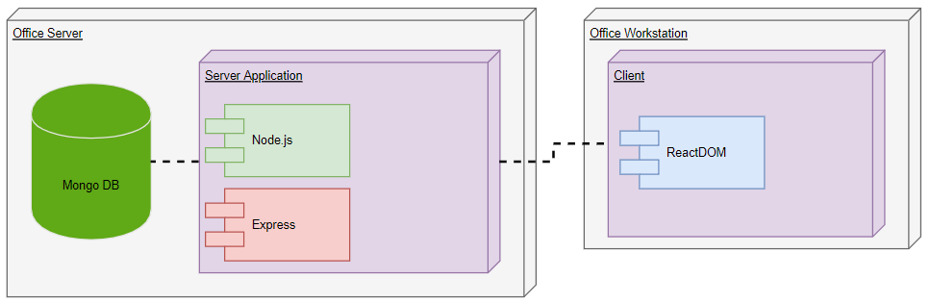

# User Interface Design

### Sitemap

Key

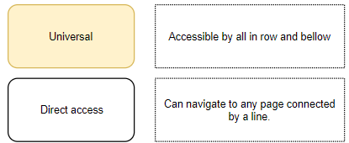

### Counselor

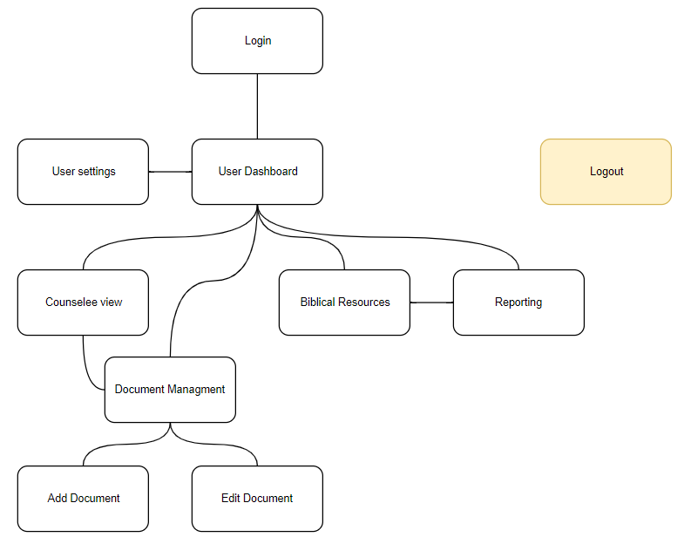

### Administrator

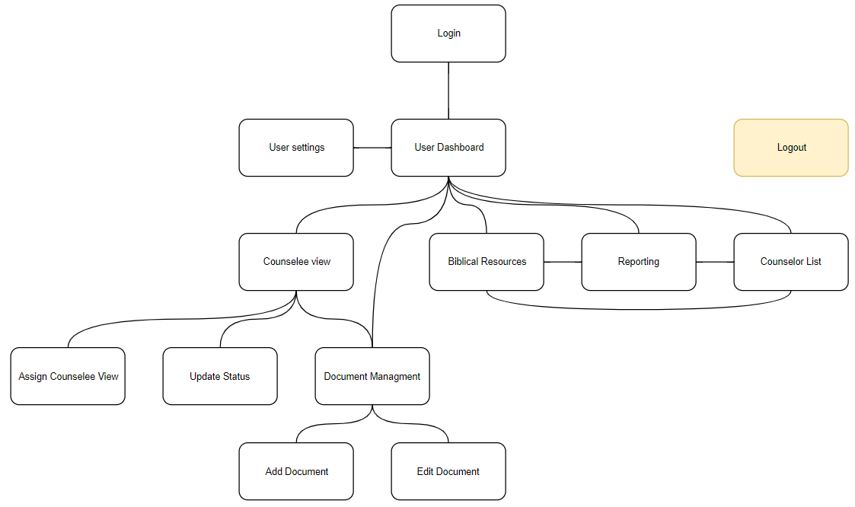

## User Interface

### Counselee/Administrator login

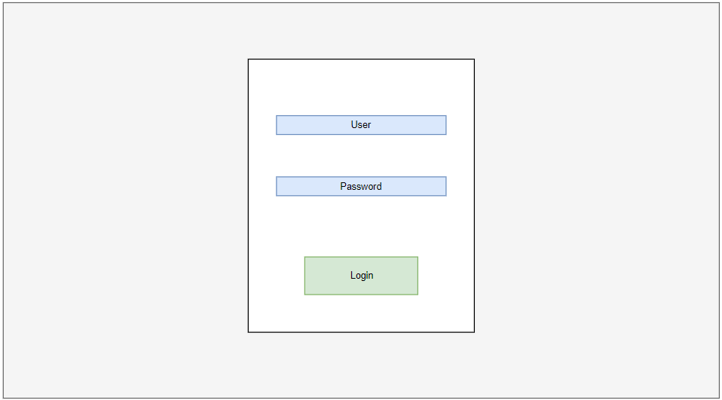

### Dashboard

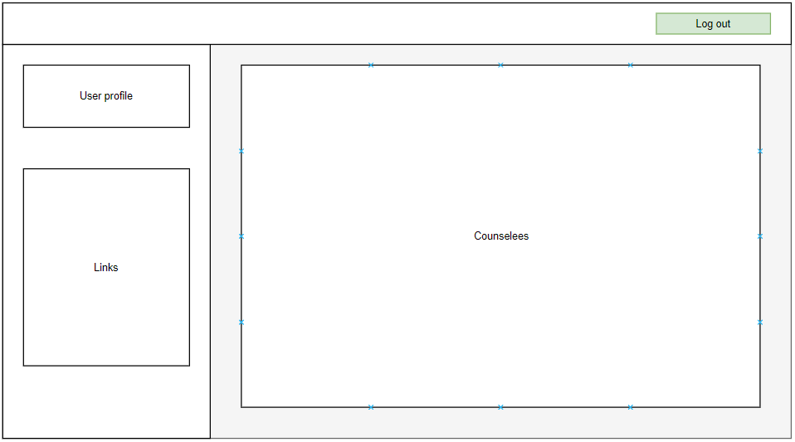

### User Settings

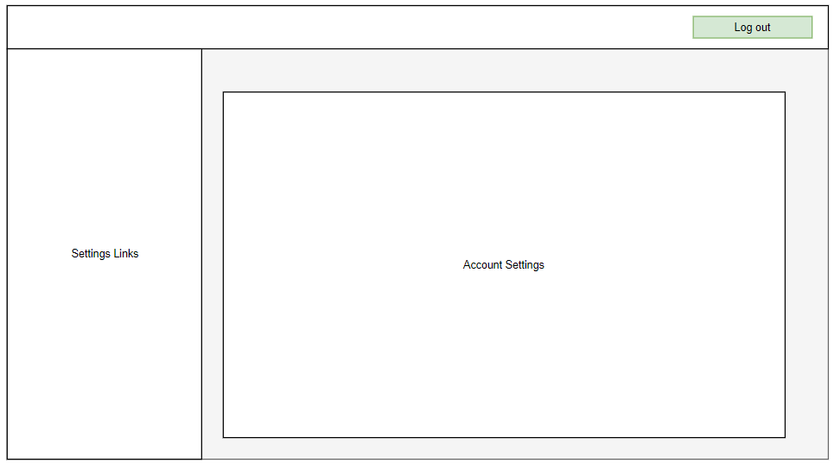

### Counselee

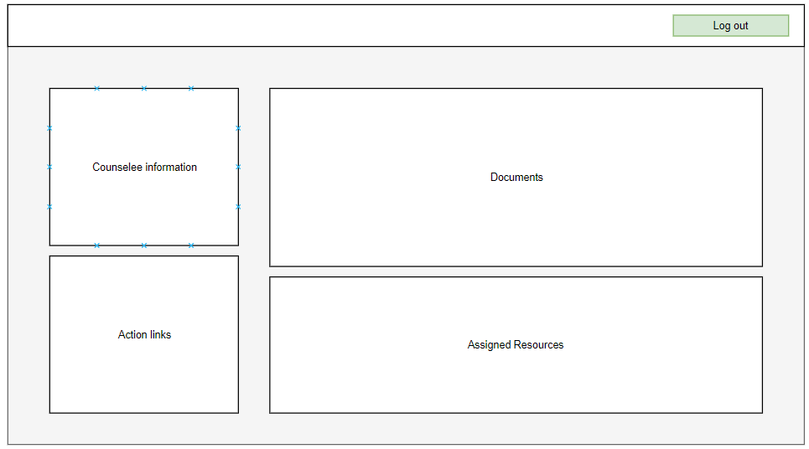

### Document Management

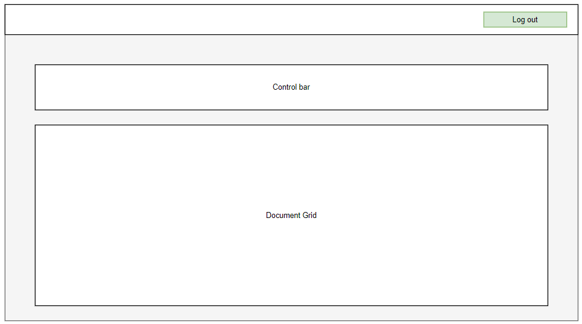

### Add Document

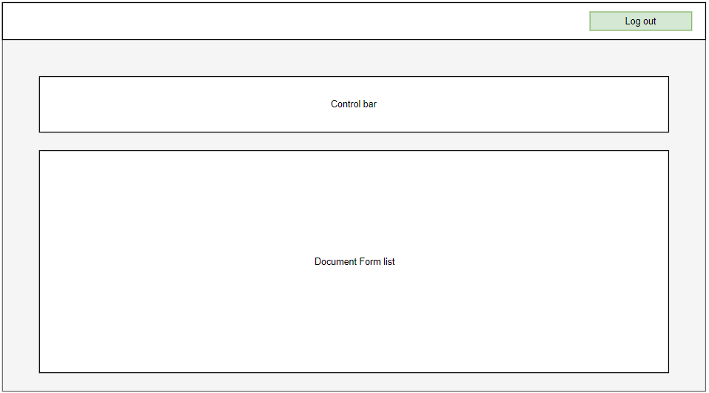

### Edit Document

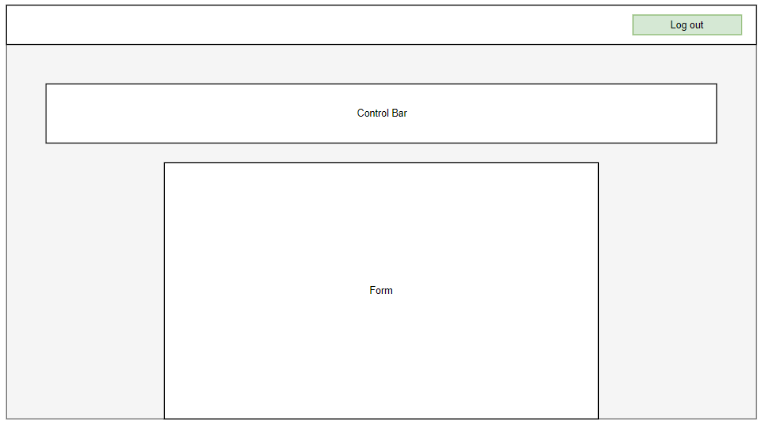

### Resources

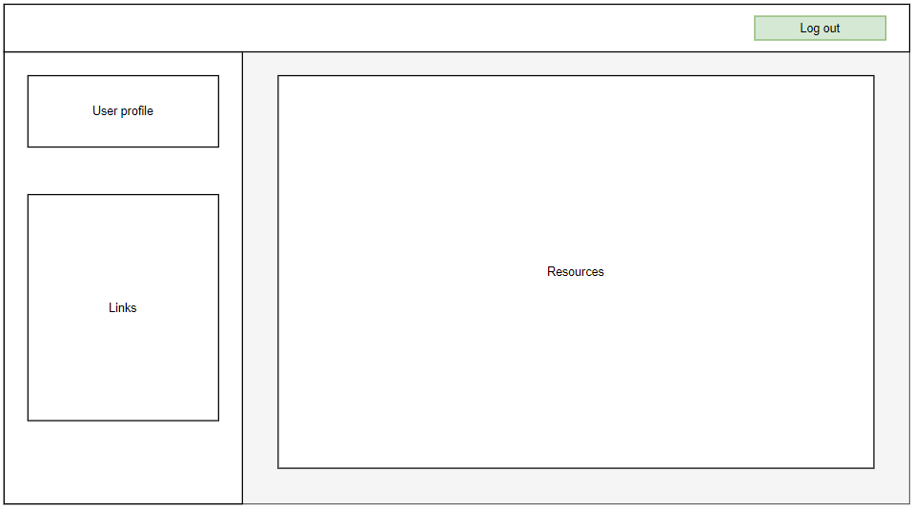

### Reporting

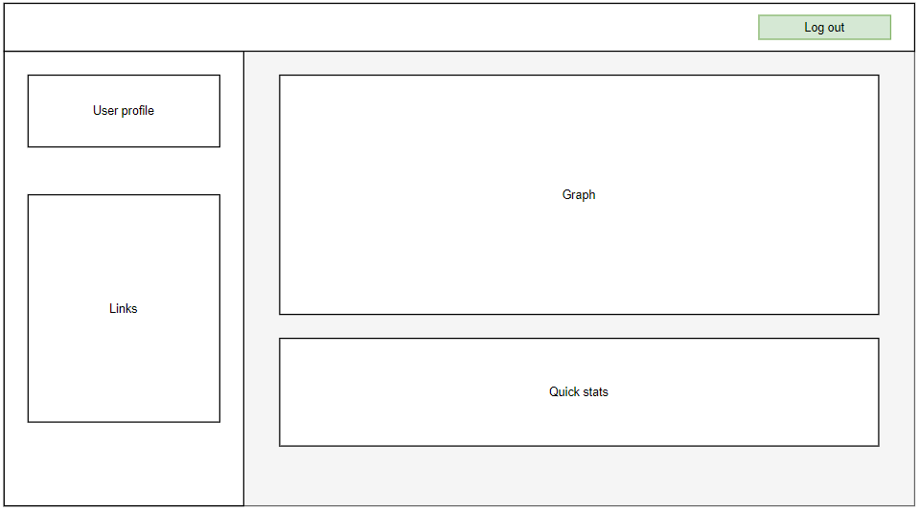

### Counselor List

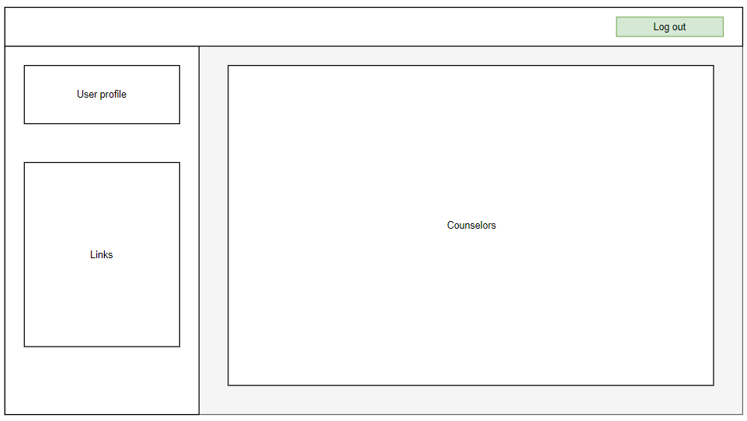

### Assign Counselee

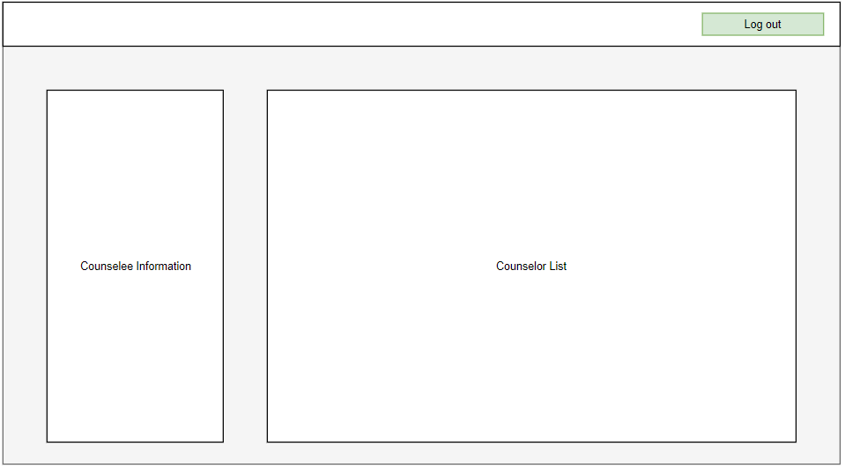

### Update Status

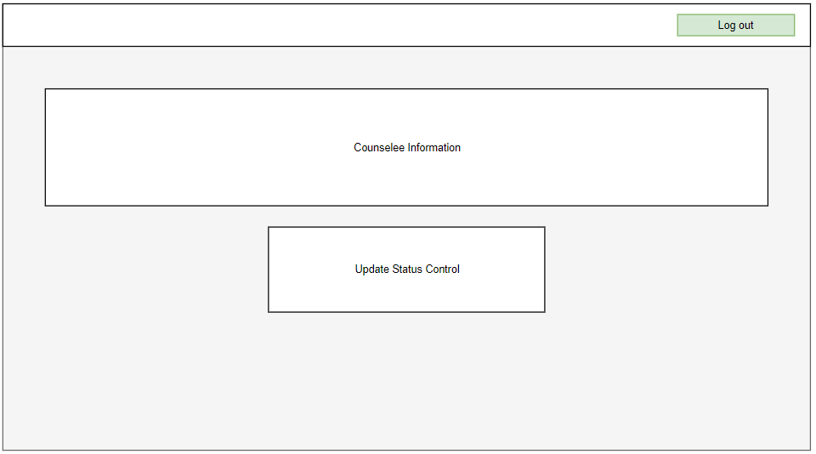

# Reports Design

The application will provide simple internal reporting. Most of the data managed by the system will be qualitative and therefore inapplicable. Counselors will be able to view a personal report. Administrators can view any Counselor’s personal report as well as a general report.

## Administrator Reports

**General Report**:

* Monthly totals for counselor caseload.
* Average caseload per counselor.
* Average duration for counselee.

**Counselee Reports** (see below)

## Counselor Reports

* Total counselees counseled.
* Average duration spent with counselees.
* Average caseload size.