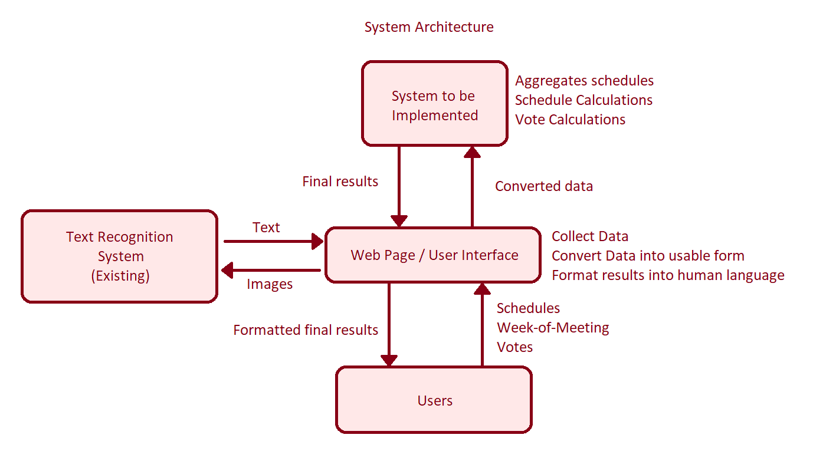

**Functional Requirements:**

1. Creation of user accounts (from user via web page)
2. Creation of a group of users. (from use via web page)
3. Creation of a new meeting including a list of attendees within a group. (from user in group, via web page)
4. Accept schedules of users (from user via web page)
5. Calculates meeting times from input schedules (at time of meeting creation)
6. Create a vote for an appointment time and date. (at time of meeting creation)
7. Meeting invitations accept attachments (at time of meeting creation)
8. Convert handwriting into text (on request, for meeting attachments)
9. Recalculate meeting times in real time if schedules change

**Non-Functional Requirements:**

1. User credentials must be stored securely
2. Each group must have a Manager
3. Schedules may need to be confidential

