Keion Peters

Connor McDonough

Samara Sarmiento

CIS-487 Game Design

Game Pitch

**Executive Summary**

The whole game story has finally been finished; however I would still only describe the game as Beta. Since game design and story design are extremely intertwined, especially with novice programmers such as our self’s. The full direction of the game is unknown. Ideas we previously had will have to be let go of truthfully because of a lack of Unity knowledge on our part. Ideally, we need to keep our ambition in check in order to progress any further with game design or story design. The current story of the game is very simple, to allow for room to grow and minimize. Flutter Cordova is fighting against capitalism and shitty health care. His mother has been diagnosed with cancer. In order to pay for the expensive chemo treatment, he has decided to dive into the ancient catacombs with hope of selling the bodies of the dead and undead. To put the whole game simply, you play as a character killing skeletons(Zombies and the other creepy crawlies have been removed), zombies and other creepy crawlies, murdering them and increasing your “Head count”. The head count is an in-game thing that you can see on your HUD, so you know how many bodies you have. The original idea for the game was that you keep going down endlessly killing for hours and there is no end to the game, however, not only could that be extremely boring if not done correctly. It could also be hard to do with Unity due to our lack in Unity knowledge. Effort towards the endless game play was made, however with the time constraints and other outside factors, The team decided to get rid of that idea.

**Game Play Look and Feel**

**Appearance**

The game’s appearance will resemble other well-known 2D platforming dungeon crawlers. Such as Dead Cells and the extremely popular Castlevania series, that actually started the genre.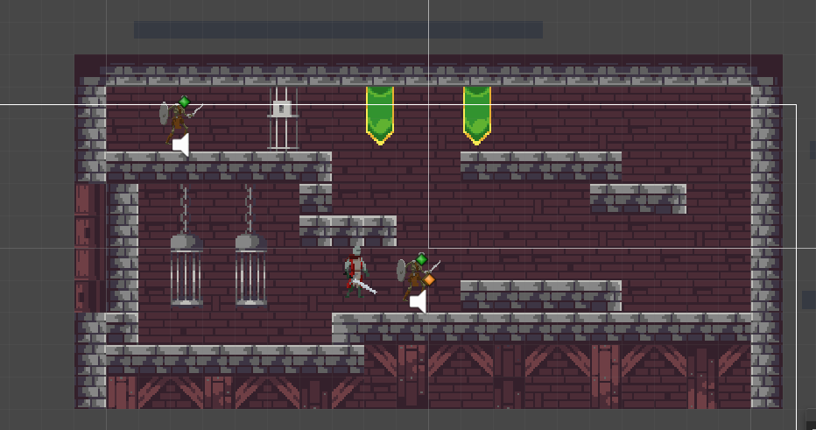

This is the current appearance of the game. Of course we are still in PRE PRE beta, so all of this is subject to change. The ambiance music will be to free lo-fi beats. The enemies are going to be various types of undead monsters, which is par for the course with a game like this. Skeletons, Zombies, and bat like enemies, are expected to be added at some point in the development cycle of the game (They have been patched out due to time and difficulty). Originally there were to be bosses, which were just going to be bigger version of the regular mobs, however that was dropped. Instead what we have are purple boss rooms, inside they have over 10 skeletons, which are a huge obstacle, and honestly harder than if we had a boss mob. They will need their own special AI’s as well as their own special health and damage scenarios. This screenshot does not fully show the whole atmosphere of the game. As the game progresses and as the player goes further and further into the catacomb, the world was supposed to turn more technical and futuristic, but the team decided that was too ambitious. The game does also include health potions now, which were not a plan in the original draft. In order to make the game completable.

**Player Roles and Actions**

The player plays the Hero role venturing into the catacombs kill undead and soon to be dead monsters in an attempt to collect money for his mother’s chemo treatment. The player can move with the regular movement keys, w a s d and the control arrows. The player has three attack options. He can attack forward, behind and above him. Using the j k l keys, respectively. The player does not have any form of ranged combat yet. Like the semi-aquatic hippo he has yet to master ranged combat. The main action of the player, will be to continually move further down into the cavern. Collectables were discussed for the character. Meaning new swords different armor, but that would mean recoloring his sprites and using different sprites once he collects the item, meaning that idea ventured into too ambitious and had to be dropped.

**Strategies and Motivations**

The build strategy of the game is an incremental strategy. We all code when we have the time adding our own elements, which has been discussed beforehand). Once we upload our portion to the main game file, we explain in detail the things that were added, and future things that still need to be implemented.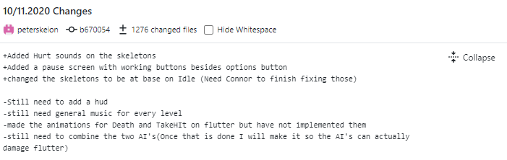

This is an example of a commit added very recently. Our game design is motivated by similar games such as CastleVania and the original Dead Cells. Simple game play and enjoyable atmosphere.

**Level Summary/ Story progression**

Now that the game is finally “complete” the level design can be explained. The game is using generic level design, I can explain the basics. There is one level that you can play through, however it is quite large. Assuming that you kill everything it could take a few tries, even an hour or so, to complete. You start at the top and navigate your way down hoping to get to the final floor where you can collect a potion that ends the game. This will then display your head count, so that you may know how well you did. Originally I wanted five levels, that was way to ambitious. Instead we decided upon two boss rooms, which don’t contain bosses, but instead contain a huge amount of mobs. The huge amount of mobs are much harder than if we just had two bosses in fact.

**Development Specification**

**Hardware**

According to the Unity documentation any, when referring to windows any GPU that is DX10, DX11, DX12 capable should have the ability to run low level unity games. When referring to macOS metal capable intel and AMD GPU’s are needed to run unity games. When referring to Linux, OpenGL 3.2+, Vulkan capable, is needed to run unity games. For the CPU when running windows x86, and x64 architecture with SSE2 instruction set support is mandatory. For mac and Linus x64 architecture with SSE2 instruction set support

**Software**

According to the Unity documentation. The only software you would need is an operating system such as, windows 7 to windows 10, Xbox operating system. Sierra 10.12 for mac, and for Linus Ubuntu 16.04 to Ubuntu 10.04.

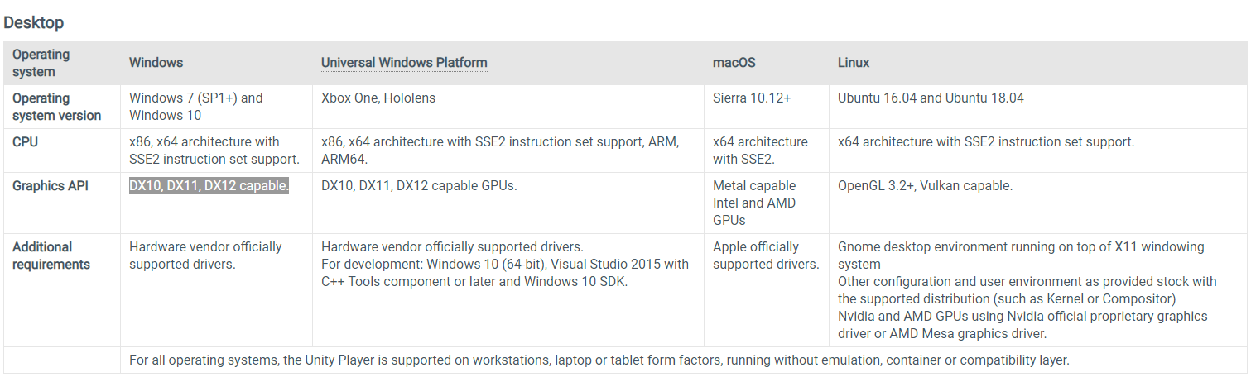

**Algorithm Style**

This game employs Unity’s 2D physics, and 2D graphics. For movement and attacking sprite animation will be used. The camera will follow the player as you traverse the map.