1. There are 5201 words of 5 letters long, courtesy of <http://www.litscape.com/words/length/5_letters/5_letter_words.html>

There are 11,881,376 possible permutations of 5 letter strings, so there is a .044% chance that a 5 letter string is a valid English word.

Calculations:

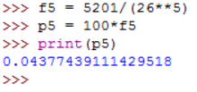

1. Using the litscape source, there are 9,155 words of 6 letters length. There are 308,915,776 possible permutations of 6 letter strings, only .00003 of the total number of possible permutations are valid words. Which is a .003 % chance of randomly creating a valid English word.

Calculations:

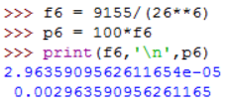

1. According to litscape, there are 11,557 words of 12 letter length. There are 95,428,956,661,682,176 possible permutations of 12 letter strings!!! Only .0000000000001 of the total possible permutations are valid words. Which is a .00000000001 % of possible strings of length 12.

Calculations: 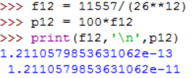

1. According to litscape, there are 188 words with a length of 20 letters. There are 19,928,148,895,209,409,152,340,197,376 possible permutations of 20 letters!!! I find this number troublingly large. Only .000000000000000000000000009 of the total possible permutations are valid words, the same amount of zeros as letters. Which is a .0000000000000000000000009% of possible strings of length 20.

Calculations: 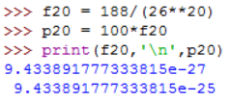

1. In the Oxford dictionary, the word: Pneumonoultramicroscopicsilicovolcanoconiosis, is the longest word in a major dictionary. <https://en.oxforddictionaries.com/definition/Pneumonoultramicroscopicsilicovolcanoconiosis>

It is 45 letters long. I couldn’t find any other words of that length. There are:

4,718,464,138,887,779,754,509,230,339,014,256,179,122,137,026,607,683,635,171,557,376

Possible permutations of 26 letters.

Which leave 1/4,718,464,138,887,779,754,509,230,339,014,256,179,122,137,026,607,683,635,171,557,376 acceptable words. This fractions is equivalently: 2.12e-64, and 2.12e-62 %.

Calculations: 