1. **Assume that the character set has 25 characters, that each line has 80 characters (*including*spaces), there are 40 lines per page, and that each book contains 410 pages. What is the number of different books in the Library? What happens if you try to calculate this number in the Idle shell**?
   1. Since there are 25 possible characters per slot in the line, and there are 80 slots in a line, there are 25**80 possible permutations of the characters in a line. There are 40 lines per page, thus there are 25**80**40 possible pages in a book. Since there are 410 pages, the total number of books is 25**80**40**410. This can be written as 25**(80*40*410) = 25**1312000
   2. My instance of the Idle crashes.
2. **How many books fit into each of the hexagonal galleries? Assume that the Library is vast enough to include all possible books, and assume that as many of the hexagonal galleries are completely filled as possible.  Are there any books left over, leaving a partially filled gallery? If so, how many are left over?  What happens if you try to calculate the number of filled galleries, using // ?**
   1. Given: *There are five shelves for each of the hexagon's walls; each shelf contains thirty-five books of uniform format.*
      1. There are six walls and 5 shelves for each wall, so there are 6*5 shelves, and there are 30 shelves per room, and there are 35 books thus there are 30*35 = 1050 books in a gallery 
      2. There are 1050 books per gallery, and 25**1312000 possible books in the library, so the number of galleries would be 25**1312000/1050, however this throws an overflow error in my idle client. 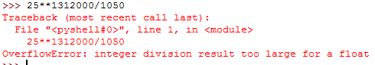
      3. However when I calculate 25**1312000 % 1050 which gives the remainder, I get 25 extra books, so there is 1 unfilled gallery.



* + 1. Using // causes my shell to crash again. Unfortunately.