How Psychology Affects

Difficulty Choice in Games

# Intro

# The wider topic

## Five Factor model

The “Five Factor Model” was proposed as a theory to measure personality traits through using five factors of behaviour, created by Tupes and Christal (1961/1922) (McCrae, R. R., & Costa, P. T., Jr. (2013)). The five factors of this theory were openness, conscientiousness, extraversion, agreeableness, and neuroticism.

This theory has been adapted to the video game industry to identify “Taste-maps” which can used to help determine what the individual would likely be interested in when looking for a game. (CITE GDC TALK) The data from the Taste-maps can also be used to see how these variants might effect the decisions players make when extrinsic motivation such as rewards is presented to them.

* + - Big 5 (O.C.E.A.N) (Five Factor Model) – **1st Engine of Play: Taste** (CITE GDC TALK)
    - A theory to measure personality traits in people through using 5 factors of behaviour, discovered by Tupes and Christal (1961/1922) (McCrae, R. R., & Costa, P. T., Jr. (2013)).
    - We can map the Big 5 model and correlate into the “Domains of Play” developed by (CITE GDC TALK)
      * Openness -> Novelty
      * Conscientiousness -> Challenge
      * Extraversion -> Stimulation
      * Agreeableness -> Harmony
      * Neuroticism does not map cleanly to an element of game design due to being driven by the want of negative emotions, the player would want to be put in stressful situations.
      * 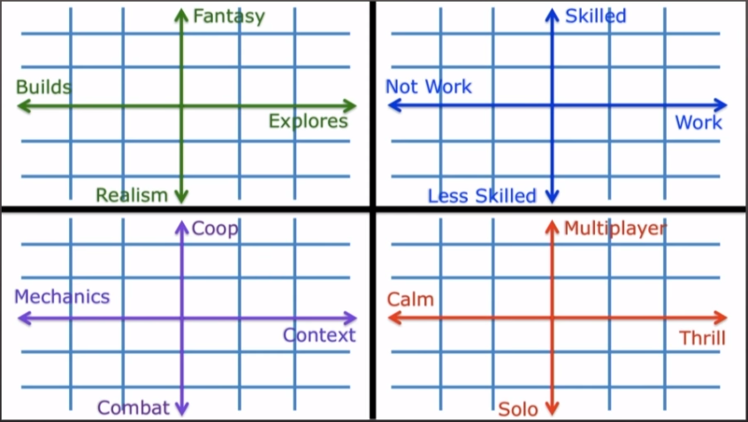
      * These can be mapped into the graphs seen above. This graph can be applied to the player to gauge what aspects they are most motivated initially by.
* The more invested in an aspect of a game a player is, seen as further out from the centre.

## Maslow's Hierarchy

## Self-Determination Theory

* + Self Determination Theory – **Player Experience of Need Satisfaction** theory, created by Scott Rigby (Check Document) **2nd Engine of Play: Satisfaction**
    - Competence
      * The universal want to seek to control outcomes and experience mastery (GDC) (official quote?)
      * Easy to learn, difficult to master **PENS**.
    - Autonomy
      * To have control over choices and see the impact of our choices.
      * Choice, customization, & agency **PENS**
    - Relatedness
      * The want to interact, be connected to, and experience caring for others.
      * Knowledge of our (relative rankings) compared to others.
      * Social grouping, status feedback systems **PENS**

## Multi User Dungeons (MUD)

## Engines of Play

* The “Engines of Play” work together over time to map player motivation, combining these two motivational theories we see the following chart.
* 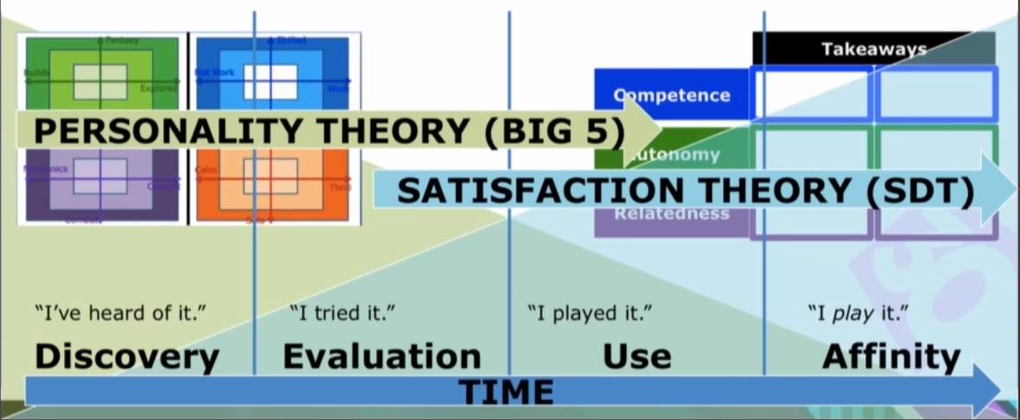
* We can see that overtime that the “Big 5” theory’s impact slowly decreases while “SDT” increases progressively the more time spent with a game as it fulfils these needs.
* GDC talk - is there a conference paper which goes along with it?
* Is there anything out there which is similar?
* Does them knowing the choice data is recorded affect the results?
* Ethics - do you need any personal information?

## Ethics of Reward Systems

### Guaranteed Rewards

### Random Chance Rewards

* Conclusions
  + What have you learnt? what next?
    - As can be seen with the Engines of Play, overtime the motivational impact of player taste (Big 5) decreases as a motivational factor, though (SDT) progressively increases the more time the player spends with the game, as it forms more of a lasting impact. (GDC)
    - Due to the nature of the constraints of this research it is best to use the Big 5 theory. This is as the deliverable is to test the choices a player makes when motivated by reward, opposed to testing the impact of reward as a motivator over time.
  + Here are the requirements
    - With the reward being the changing variable in this experiment other factors such as
  + Here’s who it’s for
  + Here’s what I’m trying to achieve
  + What are the risks (might not get good data, hard to measure, etc)

# Tools, Techniques, Technologies

## Development Methodology

### Agile

### Waterfall

### Method Used

## Player Analysis Method

### Method Used

### User Groups

### Limitations

Analysis of players (might move before this section)

* + Big 5 (O.C.E.A.N) variant used?
  + How to get accurate information?
  + How to avoid variables?
  + What do you even need?
  + Why are these the correct ways to analyse?
  + To get more testers is it ok to post online?

## Data Collection

### User Personality Questionnaire

### Mapping the Results

### Challenge Completion

### Quantity of Questions Needed

## Data Storage

### MySQL Server

### Firebase Server

### Google Forms

### Method Used

## Ethics

### User Data Stored

### Data Protection

## Difficulty Balance

### Challenge 1

### Challenge 2

### Challenge 3

### Challenge 4

### Challenge 5

# Project success - Analysis of data

* Visualisations
* Interpretations
* Is it statistically relevant

# Personal Analysis

Hack And Plan

* + You have all your estimates
  + You have all your actual time spent
  + How good is your time management?
  + If great, great, if shit, how can you improve on this? Any actionable things you can do? “SMART” plan.

# References

https://www.youtube.com/watch?v=Lg2GndSat1E&t=1136s

# Bibliography

McCrae, R. R., & Costa, P. T., Jr. (2013). Introduction to the empirical and theoretical status of the five-factor model of personality traits. In T. A. Widiger & P. T. Costa, Jr. (Eds.), Personality disorders and the five-factor model of personality (pp. 15-27). Washington, DC, US: American Psychological Association.

http://psycnet.apa.org/record/2012-10423-002

Pytlik Zillig, L. M., Hemenover, S. H., & Dienstbier, R. A. (2002). What Do We Assess when We Assess a Big 5 Trait? A Content Analysis of the Affective, Behavioral, and Cognitive Processes Represented in Big 5 Personality Inventories. Personality and Social Psychology Bulletin, 28(6), 847–858. <https://doi.org/10.1177/0146167202289013>

<https://www.sciencedirect.com/science/article/pii/019188699290236I> REF THIS

# Other shit

Recommended reading

Rasesh Ramanuj - FYP student from last year - look it up.

Ted Talk - The puzzle of motivation (SDT)

The Motivational Pull of Video Games: A Self-Determination Theory Approach (SDT)

Report advice

Referencing in the APA style

RefWorks

Search tool - Google Scholar - Cite button

Use graphics whenever possible, don’t say stuff you can show in a diagram

For the personal analysis section you can graph that shit. Burndown.

Keep references up to date as you go along

It should be like a story, make it flow

“Signposting” - cross referencing

Structure - make it match the way you worked - sprints, games

SOKOBAN for puzzle level