SHOOT THE MOON 3D

Jeffrey S. Parker and Martin W. Lo

Ever since 1990, with the launch of the Japanese Hiten Mission,^{1,2} the astro-dynamics community has been fascinated by ballistic lunar capture trajectories. An earlier work by Koon et al.³ provided an explanation of the dynamics and an algorithm for designing such trajectories using invariant manifolds of periodic orbits in the Planar Circular Restricted Three Body Problem (PCRTBP). However, this algorithm took specific advantage of the topology of the planar problem and could not be easily extended into the full spatial problem. The 2-dimensional invariant manifolds of orbits in the PCRTBP have well-defined interior and exterior regions within their 3-dimensional energy surface. Conversely, halo and Lissajous orbits in the spatial Circular Restricted Three Body Problem (CRTBP) have invariant manifolds of dimensions 2 and 3, respectively, in a 5-dimensional energy surface. Topologically, such manifolds do not have well-defined interior or exterior regions. The algorithms developed to construct planar ballistic lunar transfers could not therefore be easily extended to the spatial CRTBP. This paper addresses the Hiten Problem in the spatial CRTBP case by using three-dimensional libration orbits as staging orbits both at the Sun-Earth and the Earth-Moon Lagrange points to construct a ballistic transfer from a low-Earth orbit (LEO) to a temporary capture orbit around the Moon. The transfer requires no deterministic maneuvers other than the injection maneuver from LEO. It requires a total ΔV of approximately 3.26 km/s from a 200-km circular LEO parking orbit, compared with an approximate 3.7 – 4.0 km/s for a conventional Hohmann transfer.

Introduction
The conventional approach to transfer from the Earth to the Moon may be approximated by a Hohmann Transfer. A typical transfer from a 200-km low-Earth orbit (LEO) to a 100-km lunar orbit requires approximately 3.91 km/s. This includes 3.05 km/s for the first maneuver and 0.86 km/s for the second maneuver with a transfer time of approximately 5 days. If a mission merely requires the spacecraft to be captured by the Moon, e.g., in a very high orbit, then the cost is reduced to approximately 3.7 – 3.8 km/s⁴.
Many efforts have been made to reduce the cost of a lunar transfer. In 1968, Charles Conley was one of the first people to construct a low-energy lunar transfer based on the dynamics of the three-body problem⁵. However, since the transfer time required several months, it was unsuitable for human missions to the Moon and it was almost forgotten. Conley’s foundational work on the three-body problem is fundamental to the methods described in this paper. In 1990, the Japanese Hiten mission (see Uesugi et al.¹ and Belbruno & Miller²) implemented a low-energy transfer trajectory to the Moon using Weak Stability Boundary Theory which allowed the spacecraft to become temporarily captured by the Moon using less energy than that required by a standard Hohmann transfer. In honor of the Hiten mission, this paper refers to the ballistic transfer and lunar capture problem as the “Hiten Problem”. The community quickly realized that invariant manifolds play a key role in the Hiten Problem; however, there were no explicit numerical algorithms or computations showing how this can be done using invariant manifolds. In 2000, Koon et al.³ provided an algorithm that used numerical computations to show how invariant manifolds can be used to reproduce a Hiten-like mission. For clarity and simplicity, their study used invariant manifold theory in the planar bicircular model to prototype a trajectory that transferred from LEO to a ballistic lunar capture orbit. The resulting trajectory required only one small 34 m/s maneuver, which may be eliminated with optimization, to become captured by the Moon instead of the large conventional maneuver required by the Hohmann transfer. This paper refers to ballistic lunar transfer trajectories as “Shoot the Moon” trajectories in reference to the work of Koon et al.³
The present study extends Koon et al.’s work by constructing three-dimensional ballistic lunar transfers using dynamical systems theory. Three-dimensional trajectories have many advantages, including the following features: they may be designed to efficiently implement most inclined LEO parking orbits, they provide better geometry for communication purposes, and they provide access to any final lunar orbit, including polar orbits. Transfer trajectories may also be designed to rendezvous with other spacecraft or space stations in other three-body orbits, such as halo orbits about the lunar L₁ point. Many of these transfers may be designed to require much less energy than conventional transfers. Ultimately, this allows for larger payloads or smaller rockets.

This paper is organized in the following manner. Section 2 presents the most important aspects of the Circular Restricted Three Body Problem (CRTBP) for the Hiten Problem, including the three-dimensional families of halo orbits found about the first and second Lagrange points. Section 3 then introduces the Sun-Earth-Moon-Spacecraft four-body problem and discusses a means to decouple the four-body problem into two three-body problems. Section 4 summarizes the results of the work of Koon et al.³ to construct planar lunar transfers. Section 5 extends the lunar transfers into three-dimensions and verifies the transfers using the bicircular model. Finally, Section 6 discusses the conclusions and future directions of this work.

Three-Body Problem
The spatial CRTBP is used in this study to model the motion of a spacecraft in the Earth-Moon system and in the Sun-Earth system. This section introduces the important aspects of the CRTBP for the Hiten Problem, including some well-known three-dimensional orbit solutions. For more information about the CRTBP, see Szebehely⁶ for instance.

Definition of the CRTBP
The CRTBP places two primary bodies, e.g., the Sun and Earth-Moon barycenter or the Earth and Moon, in circular orbits about their barycenter and uses their gravitational attraction to approximate the motion of a massless third body. The primary bodies are assumed to be point-masses and no other forces or perturbations are included in the model. In this paper, the system that is referred to as the “Sun-Earth system” is shorthand for the three-body system where the larger primary mass is the Sun and the smaller primary mass is the Earth-Moon barycenter.
The coordinate system of the CRTBP is centered at the barycenter of the primaries and set to rotate with the motion of the primaries about the origin; that is, the synodic frame rotates in a counter-clockwise fashion compared to the inertial frame, assuming the conventional right-hand rule for the angular momentum in the system. The x-axis, also known as the syzygy axis⁶, extends from the origin through the smaller primary, the z-axis extends in the direction of the angular momentum of the system, and the y-axis completes the right-handed coordinate frame. It is convenient to normalize the units in the system such that the following metrics are equal to one: the distance between the two primaries, the sum of the mass of the two primaries, and the gravitational parameter. The orbital period of the two primaries is then equal to 2π. The three-body constant, μ, is defined as the ratio of the smaller primary’s mass (m₂) to the sum of the mass of the two primaries (m₁+m₂), approximately equal to 0.0121506 for the Earth-Moon system and 3.0404025 x 10⁻⁶ for the Sun-Earth system⁷. Since the system has been normalized, the coordinates of the primaries in the rotating axes are therefore equal to [-μ, 0] and [1 – μ, 0] for the larger and smaller primary, respectively. The mass of the larger and smaller primaries are equal to μ and 1 – μ normalized mass units, respectively. The mass of the third body is neglected in the model.

The equations of motion for the third body in the rotating frame are equal to:⁶
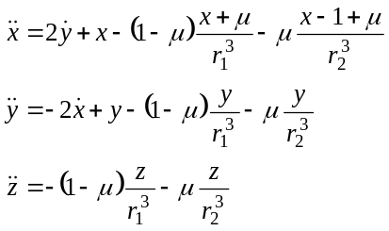 (7)
where r₁ and r₂ are equal to the distance from the third body to the larger and smaller primary, respectively:
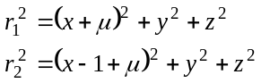 (8)
In this form it is clear that the dynamics of the system depend only on the mass fraction μ. Furthermore, when μ goes to zero, the dynamics approach the two-body dynamics in a rotating frame.

It is well known that five equilibrium points exist in the CRTBP⁶, referred to as the Lagrange points. In this study we will adopt the convention that L₁ lies between the two primaries, L₂ beyond the smaller primary, L₃ beyond the larger primary, L₄ above the x-axis, and L₅ below the x-axis. Figure 1 shows a plot of the locations of the Lagrange points in the Earth-Moon rotating coordinate system, where the Lagrange points have been labeled LL₁ – LL₅ for conventional reasons to avoid confusion with the Earth’s Lagrange points.
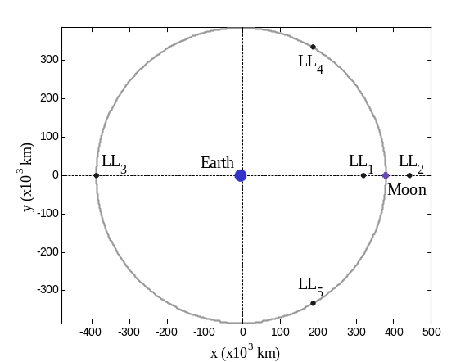
Figure 1. The Earth, Moon, and five Lagrange points in the rotating coordinate system of the CRTBP.

The five Lagrange points are the only fixed-point solutions to the CRTBP. Many periodic orbit solutions exist including planar and three-dimensional libration orbits. For discussions of periodic orbits, see Broucke⁸ or Hénon^{9 – 12} for instance. The three-dimensional libration orbits will be briefly discussed in the following section.

Libration Orbits
Libration orbits are two and three-dimensional periodic and quasiperiodic orbit solutions to the CRTBP that exist about the three collinear Lagrange points. These orbits are usually unstable. A particle on a three-dimensional libration orbit will oscillate about the corresponding Lagrange point with two independent frequencies: an in-plane frequency and an out-of-plane frequency. If the frequencies are equal then the particle is on a periodic orbit commonly known as a halo orbit¹³. Otherwise, the particle is on a quasiperiodic orbit, such as a Lissajous orbit.^{13, 14} The ISEE3 mission¹⁵ was the first mission to fly on a halo orbit and many have flown since. A portion of the family of halo orbits about the Earth-Moon L₁ point is shown in Figure 2.

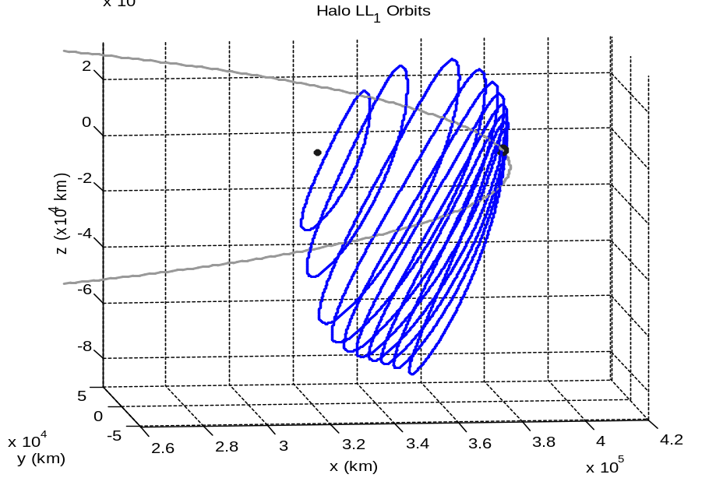
Moon
Moon’s Orbit
L₁
Figure 2. A portion of the family of halo orbits about L₁ in the Earth-Moon system.

Invariant Manifolds
The libration orbits shown in the previous section are typically unstable. If a particle is randomly perturbed while on the orbit, the particle will fall off of the orbit at an exponential rate. In Hamiltonian systems, not only are there asymptotic orbits departing from the unstable orbits, there are also asymptotic orbits approaching the unstable orbits. The set of all trajectories that asymptotically depart from the unstable orbit is known as the orbit’s unstable invariant manifold; the set of all trajectories that asymptotically arrive onto the unstable orbit is likewise known as the orbit’s stable invariant manifold. Figure 3 shows the stable and unstable invariant manifolds for a typical halo orbit about the Earth-Moon L₂ point. The manifolds are very similar for orbits about the L₁ point. One can see the underlying tubular structure in the manifolds. As the manifolds approach one of the primaries, this structure begins to break down due to the large divergent behavior near the primaries.

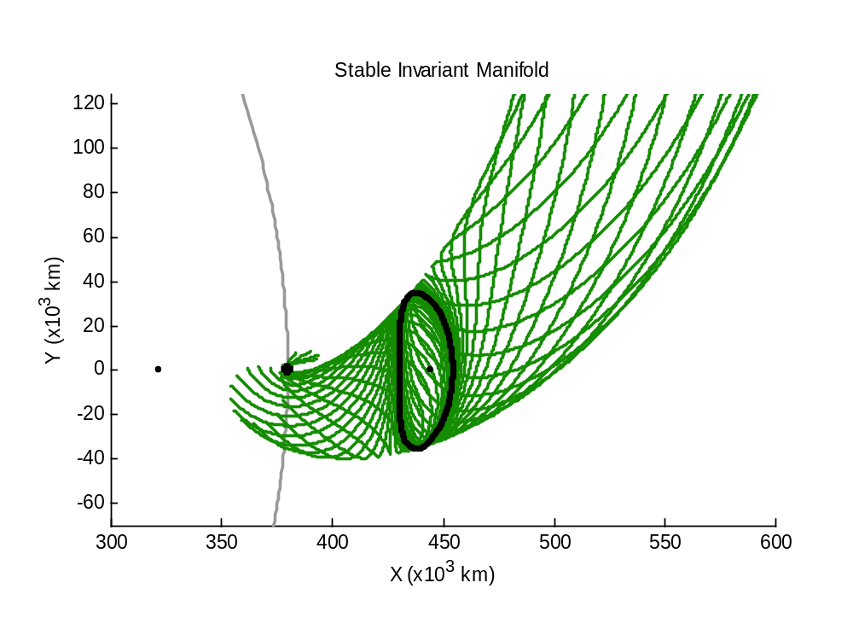  Moon’s Orbit  Periodic Orbit  Motion  Moon  Moon | 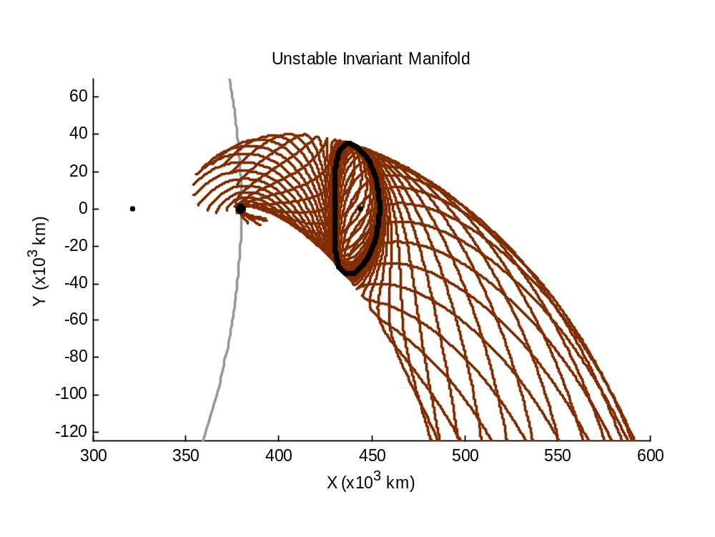  Moon’s Orbit  Periodic Orbit  Motion
Figure 3. The stable (left) and unstable (right) invariant manifolds for an orbit about L₂.

Mission designers may use these invariant manifolds to model the motion of spacecraft in their vicinity. If a mission’s objective is to transfer onto an unstable periodic orbit, then the spacecraft need only target that orbit’s stable manifold in order to insert into that orbit. Although missions such as ISEE3 and Hiten were not designed using invariant manifolds explicitly, the underlying dynamics may be understood using invariant manifold theory. The advantage of the dynamical systems approach is the ability to compute and visualize global families of low-energy transfer trajectories, giving mission designers a priori knowledge of the underlying dynamics in the libration orbit regime.

Four-Body Problem
Spacecraft in the near-Earth environment are influenced substantially by the Sun and the Moon, suggesting that a simple three-body analysis of the near-Earth environment is not sufficient to describe all of the dynamics observed in the Earth’s neighborhood. A very interesting aspect of the Sun-Earth-Moon system is that the invariant manifolds of orbits about the Earth’s L₁ and L₂ points (EL₁ and EL₂, respectively) intersect the invariant manifolds of orbits about the Moon’s L₁ and L₂ points (LL₁ and LL₂, respectively). Thus, objects may transfer between the Earth-Moon three-body system and the Sun-Earth three-body system and escape or become captured by either system. This characteristic of the Sun-Earth-Moon system will prove to be very useful when transferring from LEO to a lunar libration orbit.

Decoupling the Four-Body System
Since the four-body problem is more complex than the three-body problem, it helps to decouple the Sun-Earth-Moon-Spacecraft four-body problem into two three-body problems. Then one can use standard three-body analysis tools to determine the characteristics of solutions in different regimes of the four-body problem. In this paper, a method has been used to decouple the four-body system that is very similar to the method that mission designers use to approximate gravity-assisted trajectories, namely, the patched-conic method that uses the notion of a body’s sphere of influence (SOI). For instance, if a particle traveling in the Sun-Earth three-body system approaches the Moon, it may cross an invisible boundary after which the Moon’s influence becomes stronger than the Sun’s. At that boundary, the motion of the particle is better approximated by propagating it in the Earth-Moon three-body system rather than the Sun-Earth three-body system. Once the particle departs from the Moon’s vicinity, it may then re-cross that three-body boundary once again. In this paper, the three-body boundary is referred to as the Earth-Moon three-body sphere of influence (3BSOI). Using an analytical approximation that will be presented in a future paper, the 3BSOI may be approximated by a sphere centered at the Moon with a radius of about 160,000 km. This surface includes both the lunar L₁ and L₂, but not the other three libration points; see Figure 4 for a plot of the system.
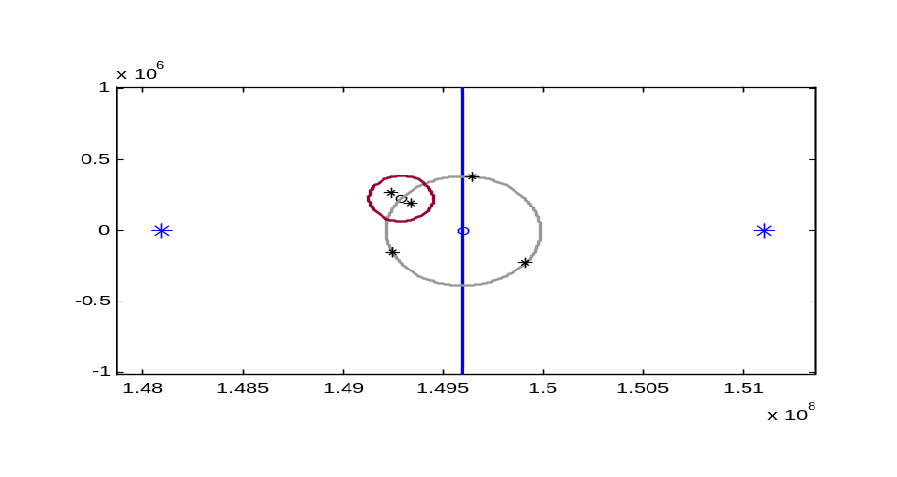
EL₁
EL₂
LL₃
LL₄
LL₅
Earth
Moon’s Orbit
Earth’s Orbit
3BSOI
To the Sun
Figure 4. A plot of the Earth-Moon 3BSOI in the Sun-Earth reference frame.

2D Shoot the Moon Transfer
In 2000, Koon et al.³ used dynamical systems theory to reproduce the Hiten trajectory in two-dimensions. Figure 5 shows two example trajectories of such transfers to the Moon in the Sun-Earth rotating frame.

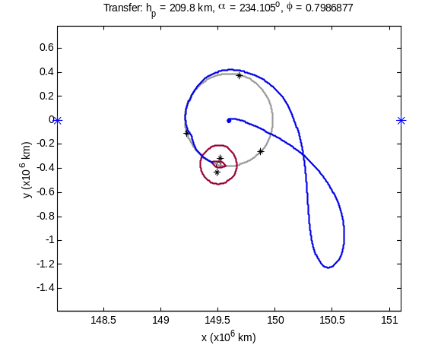  EL₁  EL₂  Earth  3BSOI  Moon’s Orbit  Moon | 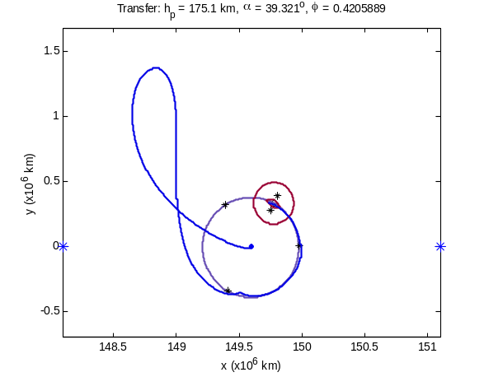  EL₂  EL₁  Earth  3BSOI  Moon’s Orbit  Moon
Figure 5. Two examples of dynamical systems transfers to the Moon. Left: a trajectory that skims EL₂ before targeting the Moon; right: a trajectory that implements an EL₁ encounter before targeting the Moon.

The total cost of the trajectory shown in Figure 5 is less than the cost of a typical Hohmann transfer, but the trade-off is transfer time. The transfer shown requires about 105 days to complete, compared with the required 5 days for a direct Hohmann transfer. However, the transfer requires only about 3.271 km/s compared with a Hohmann transfer’s approximate 3.9 km/s.

The planar “Shoot the Moon” trajectory by Koon et al.³ was designed by decoupling the Hiten Problem into two subproblems: the “Transfer Problem” and the “Capture Problem”. The Transfer Problem studies the transfer from LEO to the vicinity of the Moon by first traveling into a region roughly 1 – 1.5 million km away from the Earth; the Capture Problem studies how to ballistically transfer into an orbit temporarily captured by the Moon. Stable lunar orbits may also be accessed, but additional maneuvers are required for their insertion.
The motion observed in the Transfer Problem strongly suggests that the invariant manifolds of two-dimensional libration orbits, i.e., Lyapunov orbits, around EL₁ or EL₂ play a significant role in the ballistic lunar transfers. Koon et al.³ showed that the invariant manifolds of Lyapunov orbits around EL₁ or EL₂ may indeed be used to construct a ballistic transfer from LEO to a lunar capture orbit using the following method. Koon et al. recognized that the two-dimensional manifolds of a Lyapunov orbit topologically separate the three-dimensional energy surface of the PCRTBP into an interior region and an exterior region. This topological separation is significant because particles that travel in the interior region of the manifolds behave very differently from particles that travel in the exterior region of the manifolds. A particle that is temporarily captured by the Earth may escape if it is following a trajectory within the interior of the unstable manifolds of a Lyapunov orbit about either EL₁ or EL₂. Similarly, all trajectories that become temporarily captured by the Moon must pass through the interior of the stable manifold of a lunar Lyapunov orbit about either LL₁ or LL₂.
The goal of the Transfer Problem is to depart from a LEO parking orbit and ballistically transfer into a temporarily captured orbit about the Moon. Such a transfer may be constructed by exploiting the dynamics of the invariant manifolds of Lyapunov orbits. A spacecraft may shadow the stable manifold of the Lyapunov orbit to depart the Earth and then use the orbit’s unstable manifold to approach the Moon’s orbit. One may be assured that such a trajectory will not escape the Earth’s vicinity by ensuring that the spacecraft remains in the exterior region of the Lyapunov orbit’s manifolds. By properly phasing the trajectory with the Moon, mission designers may arrange for the trajectory to intersect the stable manifold of a desired LL₂ Lyapunov orbit. If the trajectory is constructed to intersect the interior of the lunar orbit’s manifold, then the spacecraft will freely transfer into a temporarily captured orbit around the Moon. If all of these intersections occur in full phase space, then the transfer is entirely free.
A three-dimensional Shoot the Moon transfer is achieved in the next section using a slightly different approach, but using the same dynamical systems theory.

3D Shoot the Moon Transfer
The two-dimensional Shoot the Moon transfer was very successful, although limited by its planar requirement. A three-dimensional transfer would offer the same benefits as the two-dimensional transfer along with additional advantages, including more options for the initial Earth parking orbit and the final lunar orbit, better geometry for communication purposes, access to other regions of space, etc. This section will introduce a three-dimensional version of the Shoot the Moon transfer.
The two-dimensional Shoot the Moon transfer was successful because the manifolds of periodic orbits in the PCRTBP separated the energy surface into interior and exterior regions. The spatial CRTBP has a six-dimensional phase space making its energy surface five-dimensional. Its periodic orbits, e.g. halo orbits, have two-dimensional manifolds and its quasiperiodic orbits, e.g., Lissajous orbits, have three-dimensional manifolds. Even three-dimensional surfaces cannot separate a five-dimensional energy surface into useful regions. Consequently, the three-dimensional Shoot the Moon transfer cannot be constructed in the same manner as its two-dimensional predecessor. Nevertheless, the invariant manifolds of three-dimensional orbits in the CRTBP still indicate the flow in the system; the orbits may still be used as staging orbits for a transfer. Theoretically, one may construct a three-dimensional Shoot the Moon transfer by phasing the Moon such that the stable manifold of a lunar libration orbit intersects the unstable manifold of a libration orbit about EL₁ or EL₂. If the stable manifold of the libration orbit about EL₁ or EL₂ intersects the Earth, then a Hiten-like trajectory may be constructed in the spatial system.
The selection of the type of libration orbits for the staging orbits must be given careful consideration due to the topology of the problem. An Earth staging orbit must be selected with the requirements that its stable manifold intersects the Earth and its unstable manifold intersects the Moon’s orbit. The lunar staging orbit must be selected with the requirement that its stable manifold intersects the unstable manifold of the Earth’s staging orbit in full phase space. Only then can the transfer be free of deterministic maneuvers. In a five-dimensional energy surface, it is much easier to intersect three-dimensional invariant manifolds than two-dimensional manifolds. This suggests that quasiperiodic orbits such as Lissajous orbits have a better chance of successfully intersecting their manifolds than periodic orbits such as halo orbits. In this paper, an end-to-end solution was constructed using a Lissajous orbit around EL₂ and a halo orbit around LL₂.

The solution presented in this paper consists of the following. First, the spacecraft departs its initial 200-km LEO parking orbit on a trajectory that shadows the stable manifold of a Lissajous orbit about EL₂. Because of the difficulty in viewing Lissajous orbits and their manifolds, a halo orbit with the same Jacobi constant has been used for visualization purposes in the figures below. Second, the spacecraft transfers from the stable manifold to the unstable manifold of the EL₂ Lissajous orbit and approaches the Moon. Finally, the trajectory is timed so that the stable manifold of a halo orbit about the Moon’s L₂ point intersects the spacecraft as the spacecraft departs the EL₂ Lissajous orbit. Thus, the spacecraft ballistically transfers from its LEO parking orbit onto a trajectory that either injects the spacecraft onto the LL₂ orbit or uses the manifolds of the LL₂ orbit to guide it to a more desirable final orbit near or about the Moon. A spacecraft on a halo orbit about the Moon’s L₂ point may remain there as a science, telecommunication, or support satellite; it may freely transfer to another unstable orbit near the Moon, such as a halo orbit about LL₁; it may freely transfer to a temporarily captured orbit about the Moon; or it may perform another maneuver to transfer onto any type of conic orbit about the Moon, including equatorial to polar orbits at any distance from the Moon.

Each step of this ballistic lunar transfer will now be discussed in more detail.

Earth Staging Orbits
The following requirements must be met to construct a proper Earth staging orbit for a three-dimensional Shoot the Moon trajectory:

- The orbit must be unstable;
- The orbit’s stable manifold must intersect LEO, or another intermediate staging orbit;
- The orbit’s unstable manifold must intersect the lunar staging orbit’s stable manifold.

There are several options that exist that meet these requirements, including halo orbits and Lissajous orbits. Halo orbits are limited to a very small class of orbits, but they are easy to construct, manipulate, and visualize; Lissajous orbits span a much broader region in the design space and thus provide better options for real missions, but are harder to construct and visualize. The Shoot the Moon transfer constructed in this paper implements a Lissajous staging orbit, but uses halo orbits to visualize the transfer connections. Figure 6 shows four perspectives of the family of Northern halo orbits centered about the Sun-Earth L₂ point. The family of Southern halo orbits is identical and has the same properties, except the orbits are reflected about the x-y axis. Many of these orbits could be used in a lunar transfer depending on the requirements of the mission. The specific orbit may only be chosen once one has identified the destination of the spacecraft and the lunar staging orbit used. Then one can identify which Earth staging orbit’s manifolds intersect the stable manifold of the lunar staging orbit.
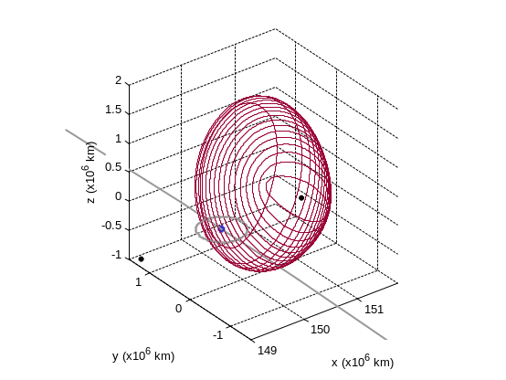 | 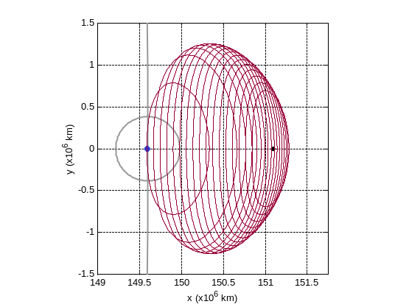  Moon’s Orbit  EL₂
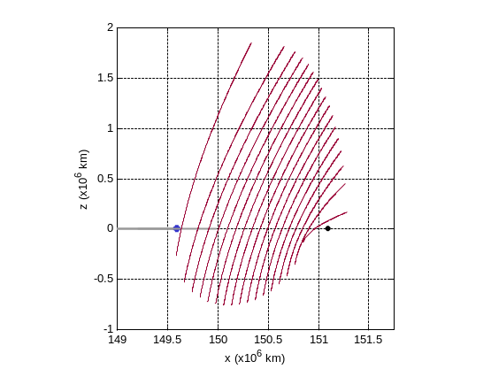  EL₂  Earth | 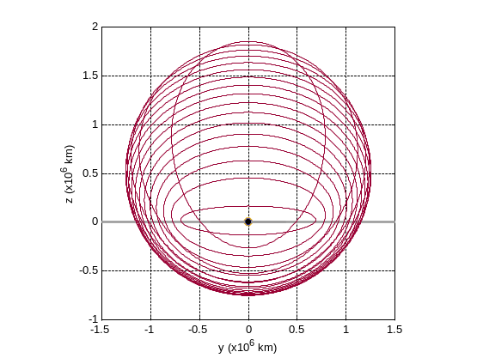
Figure 6. Four perspectives on the family of Northern EL₂ halo orbits.

Figure 7 shows four plots of an example halo orbit about the Sun-Earth L₂ point and its stable manifold. One can see that this stable manifold does intersect the Earth. Thus, a spacecraft could make a single maneuver to transfer from a LEO parking orbit to a trajectory on this halo orbit’s stable manifold. Similarly, Figure 8 shows four plots of the same halo orbit’s unstable manifold, showing that trajectories exist that intersect the Moon’s orbit about the Earth. Thus, a spacecraft on, or near, the halo orbit may use the orbit’s unstable manifold to guide it to intersect the Moon. The invariant manifolds of Lissajous orbits with similar Jacobi constants also demonstrate the same properties, making them viable candidates for Shoot the Moon staging orbits.

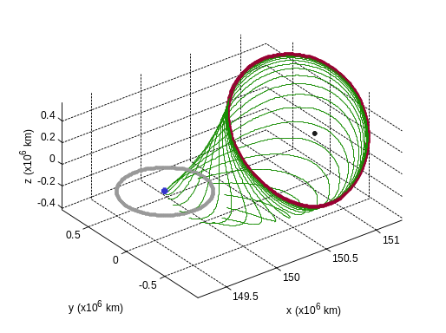 | 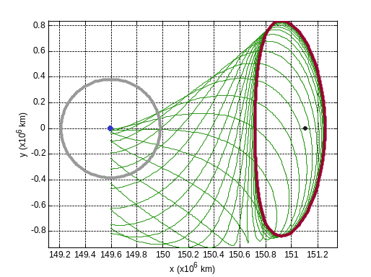  Earth  EL₂
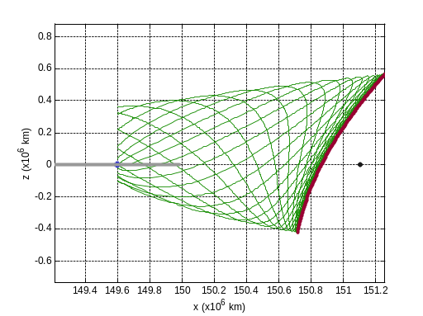  Earth  EL₂ | 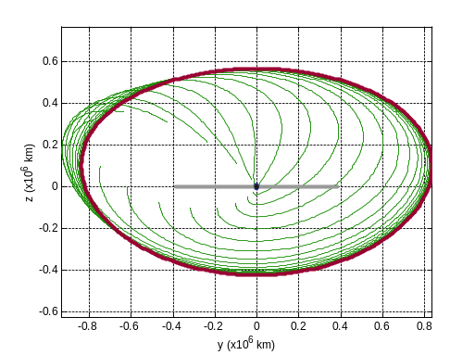  Earth
Figure 7. Four perspectives of an example Northern EL₂ halo orbit and its stable manifold. The stable manifold intersects the Earth.

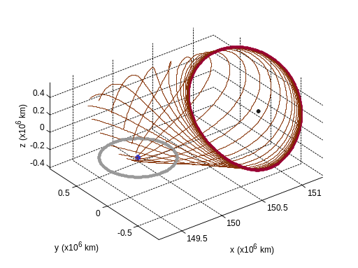 | 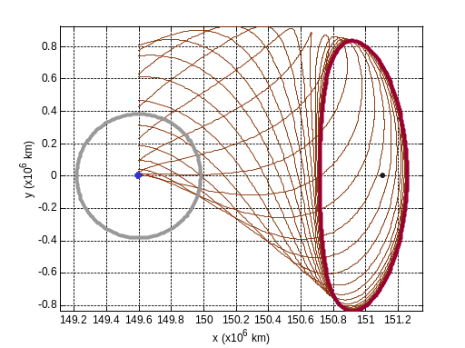  Earth  EL₂
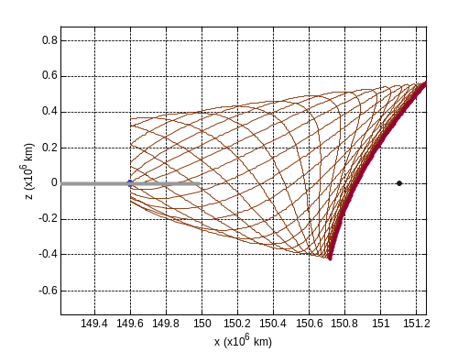  Earth  EL₂ | 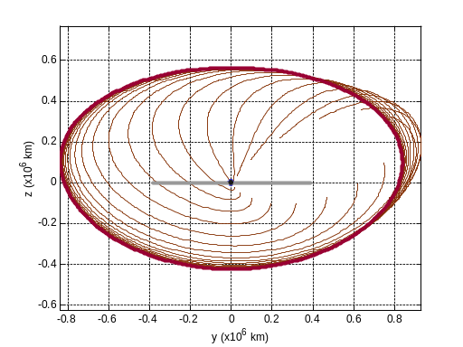  Earth
Figure 8. Four perspectives of an example Northern EL₂ halo orbit and its unstable manifold. The unstable manifold intersects the Moon’s orbit.

This section has demonstrated that a three-dimensional libration orbit about the Sun-Earth L₂ point can be used as a staging orbit to transfer a spacecraft from a LEO parking orbit to a trajectory that encounters the Moon. The next section explores lunar staging orbit options.

Lunar Halo Staging Orbits
This study has implemented halo orbits about LL₂ as staging orbits for the three-dimensional Shoot the Moon transfer, although numerous other orbits exist that would work as well. Halo orbits are easy to construct and visualize; in reality quasi-periodic Lissajous orbits are more practical since they add an additional degree of freedom to the design space. Figure 9 shows four perspectives on the family of Northern LL₂ halo orbits. Orbits in the Southern family are identical to Northern halo orbits except they are reflected about the x-y axis. These orbits demonstrate the great variety of available options that one may use as staging orbits about LL₂ even in the family of halo orbits alone. All of these orbits are unstable, thus a spacecraft may arrive onto one of these orbits for free by following that orbit’s stable manifold. The spacecraft may then depart this staging orbit for a free transfer to a trajectory that intersects another desired final lunar orbit.

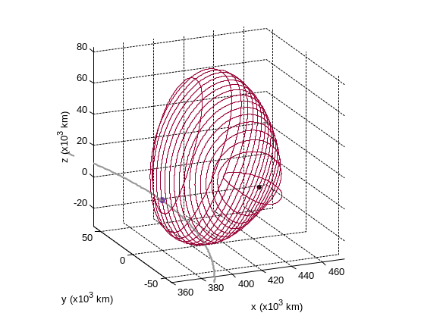 | 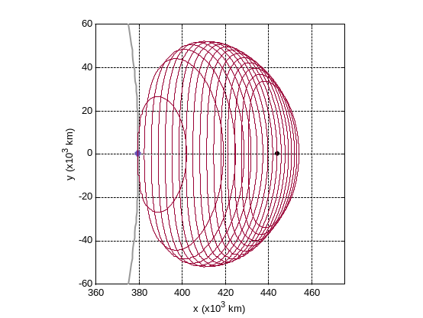  Moon  LL₂
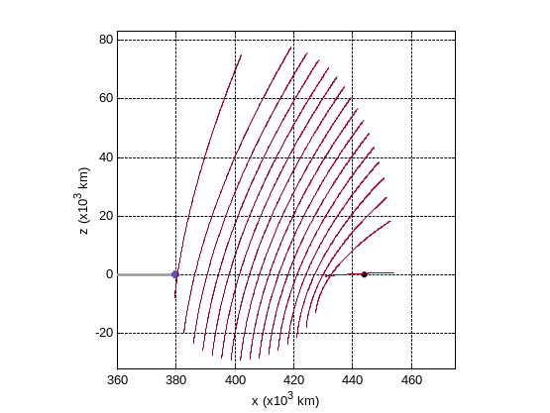  Moon  LL₂ | 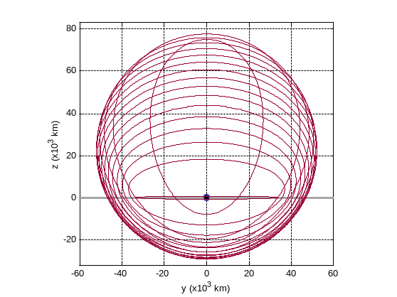  Moon
Figure 9. Four perspectives on the family of Northern LL₂ halo orbits.

Figure 10 shows four perspectives of an example LL₂ halo orbit, along with its stable manifold. If a spacecraft targeted a trajectory on this manifold, it would asymptotically approach the staging orbit. Thus, if a spacecraft were able to transfer from the EL₂ staging orbit’s unstable manifold, e.g. the manifold shown in Figure 8, onto this LL₂ halo orbit’s stable manifold, e.g., the manifold shown in Figure 10, then the spacecraft will have achieved a ballistic transfer to this lunar orbit from LEO. By phasing the Moon properly, one may align and intersect the two manifolds to accomplish this task.

If a mission’s goals were not to enter the staging orbit, but merely pass by it, then the spacecraft could target a trajectory that shadowed this stable manifold instead of a trajectory that was on this manifold. The stable manifold could then be used as an initial guess for a trajectory optimization tool to converge on a desired trajectory.
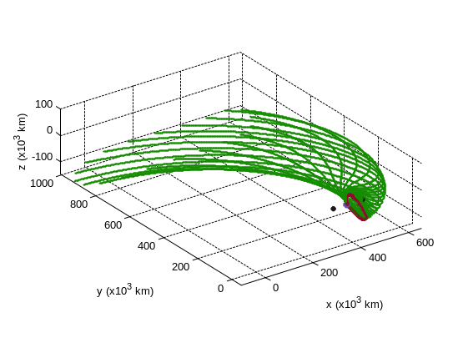
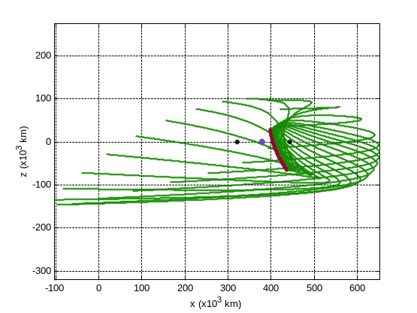 | 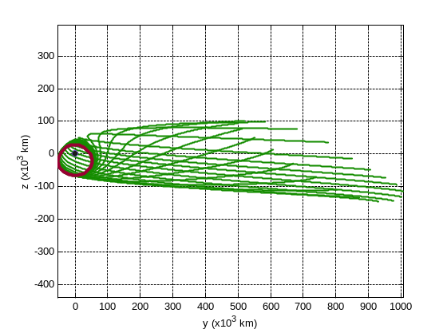
Figure 10. An example halo orbit about LL₂ and its stable manifold in four perspectives.

If one propagates the stable manifold backward in time, i.e., in the process of intersecting it with the EL₂ orbit’s manifold, one notices that it quickly departs the Moon’s vicinity. Because the Sun plays such a strong role in the motion of satellites near the Earth, trajectories on the lunar orbit’s stable manifold quickly begin to be affected by the Sun. This study therefore switches from the Earth-Moon three-body system to the Sun-Earth three-body system once the trajectories pass through the three-body sphere of influence. The trajectory is then propagated in such a way that it continues to switch coordinate systems anytime it crosses the 3BSOI boundary.

Lunar Capture Orbits from the LL₂ Staging Orbit
The orbits shown in Figure 9, above, indicate available options for staging orbits at the Moon. These orbits may provide good locations for communication satellites, relay satellites, or space stations. If a spacecraft needs to transfer to a lower lunar orbit, then the spacecraft may follow the halo orbit’s unstable manifold (for free) toward the Moon, intersect its final lunar orbit, and perform a capture maneuver. To demonstrate this, Figure 11 shows an example lunar halo staging orbit about LL₂ and its unstable manifold. A spacecraft on this halo orbit could depart along any one of these trajectories. These trajectories fly by the Moon at different radii and inclinations; thus, many different final lunar orbits are accessible from this staging orbit. Figure 12 shows one such trajectory that a spacecraft could take to depart the lunar halo staging orbit. If a maneuver were performed at perilune the spacecraft would be captured into a stable orbit about the Moon, thereby completing the end-to-end trajectory solving the Spatial Hiten Problem.
Moon
LL₁
LL₂
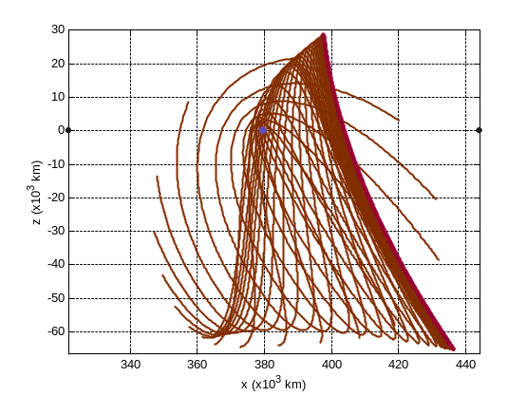  Moon  LL₁  LL₂ | 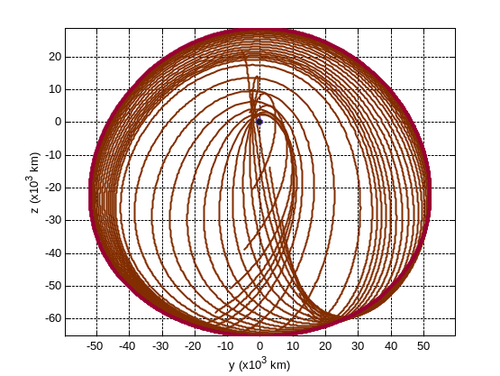  Moon
Figure 11. An example halo orbit about LL₂ and its unstable manifold in four perspectives.

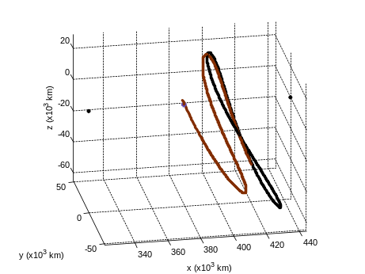  Moon | 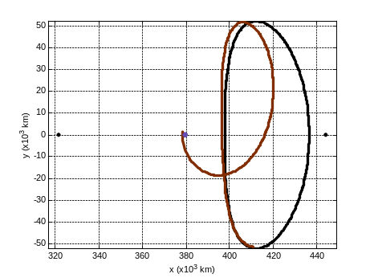  Moon  LL₁  LL₂
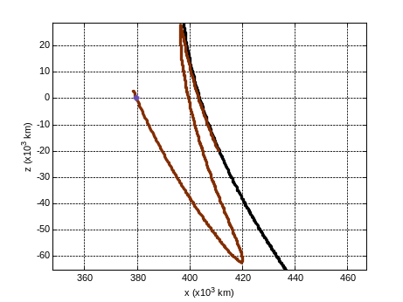  Moon | 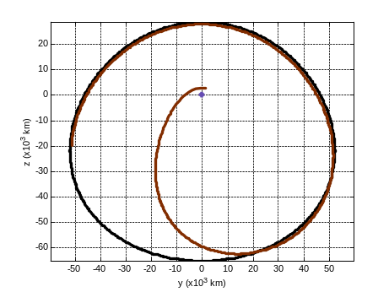  Moon
Figure 12. A trajectory from Figure 11, demonstrating an example destination for a spacecraft on a 3D Shoot the Moon trajectory. The trajectory is shown in four perspectives.
Additionally, since each halo orbit shown in Figure 9 has a different unstable manifold, the three-dimensional Shoot the Moon transfer can access nearly any lunar orbit. Figure 13, below, shows some available options for the radius and inclination of lunar orbits that may be accessed by Northern LL₂ halo orbits. The highlighted points are those that are accessible from the example halo staging orbit shown in Figure 11. Southern halo orbits can access the same set of lunar orbits except with a negative inclination.

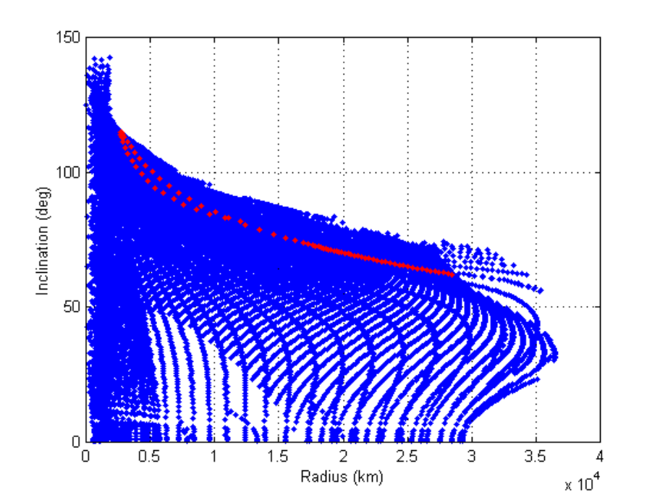
Figure 13. A plot showing the radius and inclination of lunar orbits that are accessible from the Northern LL₂ halo staging orbits. The highlighted points are accessible from the example halo orbit shown in Figure 11.

Full LEO to Lunar Halo Transfer
A full three-dimensional Shoot the Moon transfer involves two staging orbits: one in the Sun-Earth system and one in the Earth-Moon system. The orbits selected are members of full families of orbits, where the family includes orbits that share similar features and whose orbital parameters vary continuously from one end of the family to the other¹⁶. Thus, if a Shoot the Moon transfer is identified, then it will also be one member of a full family of such transfers. This study has constructed such a family of transfers. For brevity, only one example of such a transfer will be presented here. The full family of transfers will be discussed in a future paper.

Figure 14 shows the first portion of the three-dimensional Shoot the Moon transfer in four perspectives. The spacecraft is launched from a 200-km low-Earth orbit, travels outward toward EL₂ along a trajectory that shadows the stable manifold of an orbit about EL₂, skims the periodic orbit and then travels toward the Moon. The spacecraft’s motion shadows the manifolds of a Lissajous orbit, however, the Lissajous orbit’s manifold is very difficult to visualize. Therefore, the plots shown in Figure 14 include the stable manifold of the halo orbit with the same Jacobi constant to represent the nearby Lissajous manifolds. The spacecraft’s motion skims this manifold as well, although not quite as closely as the Lissajous orbit’s manifold.
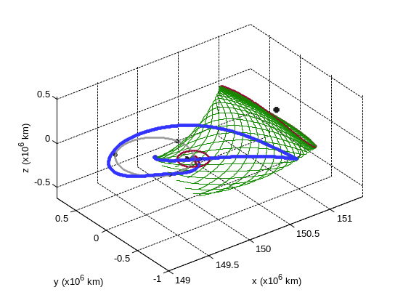 | 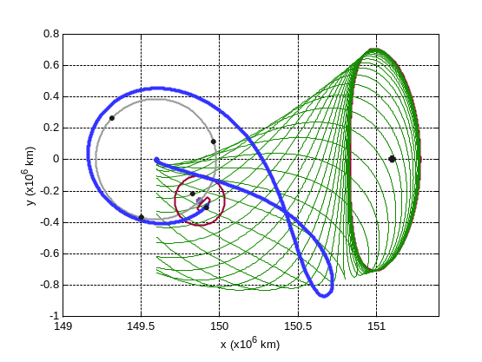  Earth
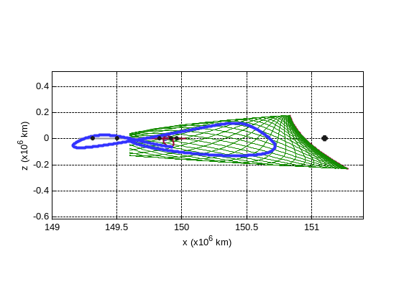 | 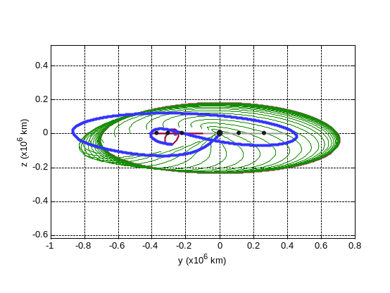
Figure 14. The 3D Shoot the Moon trajectory plotted alongside an EL₂ halo orbit’s stable manifold.

Figure 15 shows four perspectives of the same transfer trajectory, but this time with the EL₂ halo orbit’s unstable manifold plotted. One can see that the trajectory shadows the unstable manifold as it approaches the Moon.

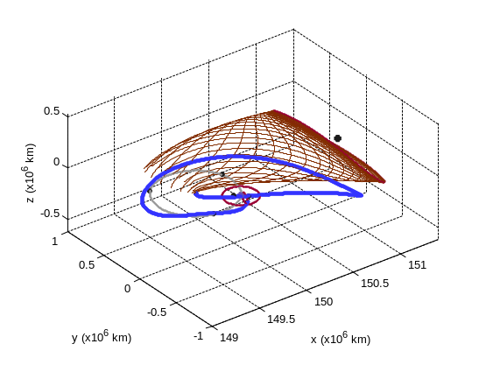 | 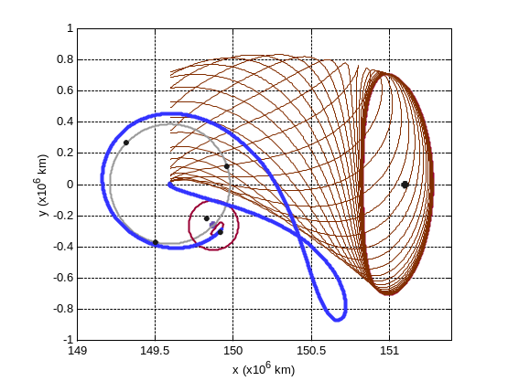  Earth
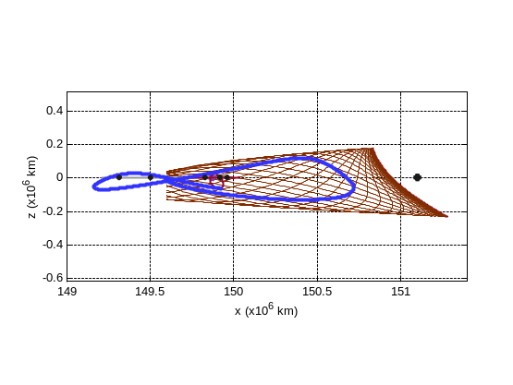 | 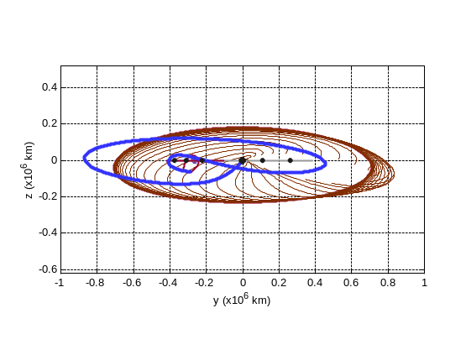
Figure 15. The 3D Shoot the Moon transfer plotted alongside an EL₂ halo orbit’s unstable manifold.

Figure 16 shows the same four perspectives of the three-dimensional Shoot the Moon transfer plotted alongside the LL₂ halo orbit’s stable manifold. One can see that the transfer lies on the manifold, indicating that the spacecraft has injected into the LL₂ halo orbit and has become temporarily captured by the Moon. If the mission objective were to achieve a final inclined low-lunar orbit and not a libration orbit, then the trajectory would not lie directly on the manifold, but would shadow the manifold. It would skim the LL₂ orbit’s stable manifold and transfer to the LL₂ orbit’s unstable manifold before intersecting the final lunar orbit.

Figure 17, below, shows the top-down perspective of the entire three-dimensional Shoot the Moon transfer with all three manifolds displayed.

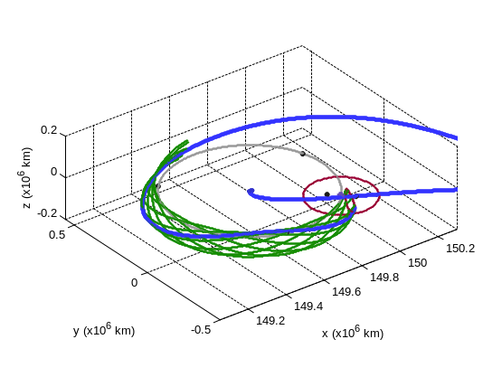 | 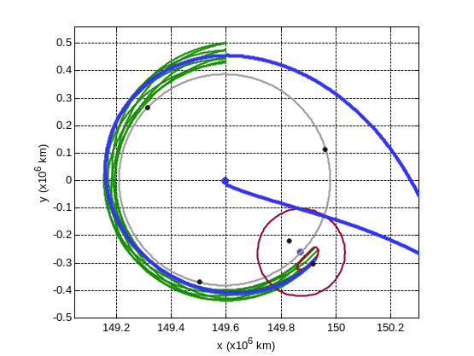  Earth  Moon
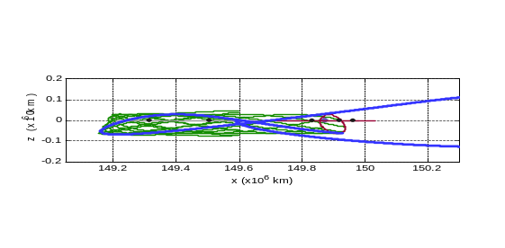 | 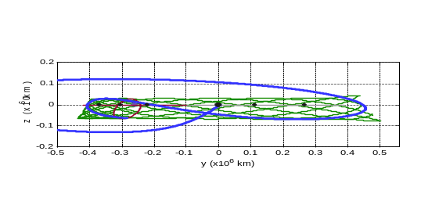
Figure 16. The 3D Shoot the Moon transfer plotted alongside the LL₂ halo orbit’s stable manifold.
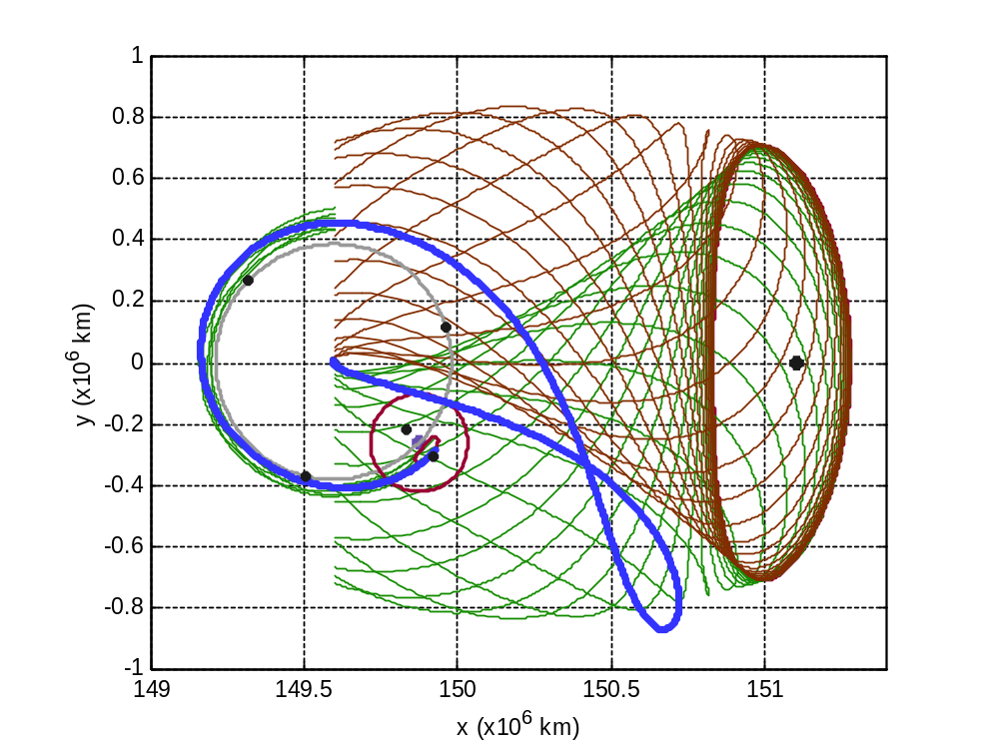
Earth
Moon
W^{S}_{LL2}
W^{U}_{EL2}
W^{S}_{EL2}
EL₂
Figure 17. The 3D Shoot the Moon transfer plotted alongside the stable and unstable manifolds of the EL₂ halo staging orbit and the stable manifold of the LL₂ halo staging orbit.

The total cost of the trajectory shown in the previous figures is only about 3.261 km/s, executed in a single maneuver at the LEO departure point. The inclination of the LEO parking orbit in this trajectory is approximately 25°. After that single maneuver, the only other maneuvers required are station-keeping maneuvers, which may be arbitrarily small based on other mission constraints. The cost is heuristically cheaper than Hohmann-type transfers to inclined lunar orbits, but the quantitative comparison has not been completed here since so many factors play in the construction of an inclined Hohmann transfer. It is interesting that most features in the three-dimensional transfer are very similar to the two-dimensional transfer computed by Koon et al. The duration and maneuver magnitude of the three-dimensional transfer are approximately the same as the duration and maneuver magnitude of a similar two-dimensional transfer. This is summarized in Table 1.

Table 1. A comparison of three lunar transfer types from a 200-km LEO
parking orbit to an orbit temporarily captured by the Moon.
Transfer Type | Hohmann* | 2D Shoot the Moon | 3D Shoot the Moon
ΔV | 3.73 – 3.95 km/s | 3.27 km/s | 3.26 km/s
Inclination range of LEO parking orbit | 0° | 0° | Any†
Inclination range of final lunar orbit | 0° | 0° | Any†
Transfer duration | 3.9 – 5.2 days | 105 days | 105 days
*The case of the Hohmann transfer includes final lunar orbits from 100-km out to L₁. †The inclination range includes the full family of orbit transfers, although this paper presented one that departed from a 25° LEO orbit.

Validation
The decoupled four-body system only approximates the motion of the full four-body system. More realistic models may be used to validate the results constructed in the decoupled four-body system. This section reproduces the Shoot the Moon transfer trajectory in the bicircular model.

Bicircular Model
The bicircular model of the Sun-Earth-Moon system is another model of the four-body system. In the bicircular model, the Earth and Moon orbit about their barycenter in circular orbits in exactly the same manner as in the circular restricted three-body system. However, the Earth-Moon barycenter and the Sun also orbit each other in circular orbits. Thus, the bicircular model may be described as the Earth-Moon circular restricted three-body system with the addition of the Sun orbiting the barycenter in circular motion. This paper restricts all three primary bodies to the same plane; however, the bicircular model may be adjusted to account for the inclination of the Moon’s orbit about the Earth with respect to the ecliptic. For more information about the bicircular model, see Gómez et al.¹⁷

The Shoot the Moon transfer constructed in the bicircular model appears nearly identical to the transfer shown above, and it is heuristically identical, but the two transfers are quantitatively slightly different. The transfer modeled in the bicircular model only requires a ΔV from the 200-km LEO parking orbit of approximately 3.175 km/s instead of the 3.261 km/s required by the decoupled four-body model. In the bicircular model the trajectory departs the Earth from a LEO parking orbit with an inclination of approximately 10.3°. A top-down perspective of this transfer is shown in Figure 18.

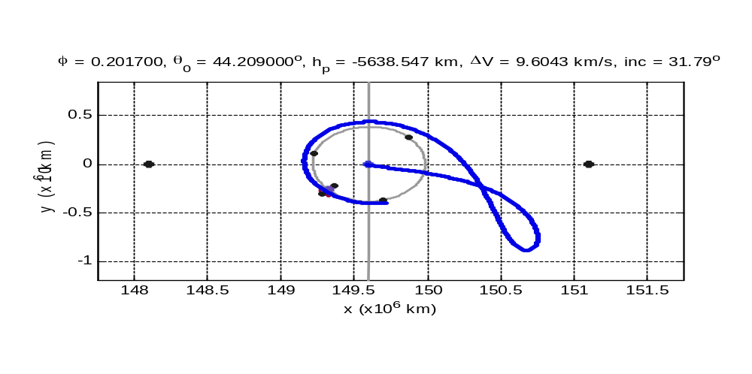
EL₂
EL₁
Earth’s Orbit
Moon’s Orbit
Figure 18. The 3D Shoot the Moon transfer constructed in the bicircular model.

Conclusions and Future Work
This paper has demonstrated how invariant manifold theory may be used to construct and understand three-dimensional ballistic lunar transfers. A specific transfer has been constructed that transfers from a 200-km LEO parking orbit into a halo orbit about LL₂ using only a single 3.26 km/s maneuver at the LEO injection point. A spacecraft on such a transfer could remain on the halo orbit, freely transfer to another libration orbit, freely transfer to a temporarily captured orbit about the Moon, or perform another maneuver to inject into any lunar orbit. The transfer implements three-dimensional libration orbits as staging orbits in the Sun-Earth and Earth-Moon three-body systems. Other orbits could be used to produce similar results. The advantages of the three-dimensional approach, compared with the two-dimensional work produced by Koon et al., include access to inclined lunar orbits, the option to use inclined LEO parking orbits, access to other regions of space in the Earth’s neighborhood, and better communication geometry. The Shoot the Moon transfer requires less energy than conventional Hohmann transfers, but requires a much longer transfer time. Such low-energy transfers are useful for cargo transport and robotic missions to lunar orbits or to the surface of the Moon. The lower ΔV cost permits larger payloads and/or smaller rockets to reach the Moon.

The approach used in this paper is robust enough to identify families of ballistic lunar transfers, including transfers that use other types of unstable orbits as staging orbits. These families will be explored and presented in future papers. Further analysis of the structure of the invariant manifolds of three-dimensional orbits in the spatial CRTBP may provide additional understanding of these lunar transfers, which may present alternative approaches for the construction and analysis of ballistic lunar transfers. The methods presented by Gómez et al.¹⁸, for example, may offer such an alternative. These alternative approaches will be explored in future papers. The goal of this research is to provide mission designers the tools needed to quickly construct and evaluate the performance of these lunar transfers for their own unique missions.

References
- Uesugi, K., et al., “Japanese first double Lunar swingby mission ‘HITEN’,” Acta Astronautica, Vol. 25, No. 7, pp. 347-355, 1991.
- Belbruno, E., Miller, J., “A Ballistic Lunar Capture Trajectory for the Japanese Spacecraft Hiten”, JPL IOM 312/90.4-1731-EAB, June 15, 1990.
- Koon, W.S., Lo, M.W., Marsden, J.E., & Ross, S.D., “Shoot the Moon,” Spaceflight Mechanics 2000, AAS, Vol. 105, Part II, pp. 1017-1030, 2000.
- Sweetser, T.H., “An Estimate of the Global Minimum DV Needed for Earth-Moon Transfer,” AAS Paper No. 91-101, Spaceflight Mechanics Meeting, Houston, 11-13 February, 1991.
- Conley, C., “Low Energy Transit Orbits in the Restricted Three-Body Problem,” SIAM Journal of Applied Mathematics, Vol. 16, pp. 732-746, 1968.
- Szebehely, V., Theory of Orbits: The Restricted Problem of Three Bodies, Academic Press, New York, 1967.
- Vallado, D.A., Fundamentals of Astrodynamics and Applications, McGraw-Hill Companies, Inc., 1997.
- Broucke, R.A., “Periodic Orbits in the Restricted Three-Body Problem with Earth-Moon Masses,” Technical Report 32-1168, Jet Propulsion Laboratory, Cal. Tech., 1968.
- Hénon, M., “Exploration Numérique du Problème des Trois Corps, (I), Masses Egales, Orbites Périodiques,” Ann. Astrophys., Vol. 28, No. 3, pp. 499-511, 1965.
- Hénon, M., “Exploration Numérique du Problème des Trois Corps, (II), Masses Egales, Orbites Périodiques,” Ann. Astrophys., Vol. 28, No. 6, pp. 992-1007, 1965.
- Hénon, M., “Exploration Numérique du Problème des Trois Corps, (III), Masses Egales, Orbites Non Périodiques,” Bull. Astron., Vol. 1, No. 1, pp. 57-80, 1966.
- Hénon, M., “Exploration Numérique du Problème des Trois Corps, (IV), Masses Egales, Orbites Non Périodiques,” Bull. Astron., Vol. 1, No. 2, pp. 49-66, 1966.
- Howell, K.C. and Pernicka, H.J., “Numerical Determination of Lissajous Trajectories in the Restricted Three-Body Problem,” Celes. Mech., Vol. 41, pp. 107-124, 1988.
- Gómez, G., Llibre, J., Martínez, R., & Simó, C., Dynamics and Mission Design near Libration Points, Volume I: Fundamentals: The Case of Collinear Libration Points, World Scientific Monograph Series in Mathematics, Vol. 2, 2001.
- Farquhar, R.W., Muhonen, D., & Richardson, D., “Mission Design for a Halo Orbiter of the Earth,” J. Spacecraft, Vol. 14., No. 3, pp. 170-177, March 1977.
- Hénon, M., “Numerical Exploration of the Restricted Problem. V., Hill’s Case: Periodic Orbits and Their Stability,” Astron. & Astrophys., 1, 223-238, 1969.
- Gómez, G., Simó, C., Llibre, J., & Martínez, R., Dynamics and Mission Design near Libration Points, Volume II: Fundamentals: The Case of Triangular Libration Points, World Scientific Monograph Series in Mathematics, pp 15 – 19, 2001.
- Gómez, G., W.S. Koon, M.W. Lo, J.E. Marsden, J. Masdemont, and S.D. Ross, “Invariant Manifolds, the Spatial Three-Body Problem and Space Mission Design”, AIAA/AAS Astrodynamics Specialist Meeting, Quebec City, Canada, August, 2001, AAS 01-301.

Acknowledgements
This work has been completed under funding by a National Defense Science and Engineering Graduate (NDSEG) Fellowship sponsored by the Deputy Under Secretary of Defense for Science and Technology and the Office of Naval Research.

Doctoral Student, Colorado Center for Astrodynamics Research, University of Colorado at Boulder, 431 UCB, Boulder, CO 80309-0431. E-mail: parkerjs@colorado.edu.
Visiting Associate, Computer Science, California Institute of Technology. E-mail: Martin.Lo@jpl.nasa.gov.
The bicircular model for the four body Sun-Earth-Moon-Spacecraft system models the orbits of the Earth and the Moon as coplanar circles around the Sun and Earth, respectively, and the spacecraft as an infinitesimal point mass. See Section 5, below.

