Abstract
Connor S. Maynes
Generating a Sinusoidal Output Voltage

The IEEE Design Challenge required the creation of circuit capable of outputting a sinusoidal voltage signal given a +1V rail and an input signal ranging from 0 to +1V. The circuit needed to be LTI (linear time-invariant) with a minimum of a 2Vpp swing maximized at input voltages of 1/8th, 3/8th, 5/8th, and 7/8th V. The design was based on the circuit called a folding amplifier, which is commonly used in Analog-to-Digital Converters [1]. Design and simulation of a circuit capable of meeting the 2Vpp output signal was successful; however, PCB implementation of the design was not successful and only achieved a 1.778Vpp output signal which was clipped at -1V.

Index Terms—MOSFET, Op-Amp, Differential Amplifier, Signal Folding, IEEE Design Challenge

INTRODUCTION
The sinusoidal I-V curve is common in electrical engineering; however, the sinusoidal Vout-Vin curve is rarely, if ever, seen. The IEEE Design Challenge requested the creation of such a Vout-Vin curve by a circuit operating on low current and a small voltage supply. The challenge was made increasing difficult by the limitation of only using a +1V rail to power components in the circuit in addition to the variable input voltage from 0 to 1V. Taking the problem piece-by-piece, a solution was arrived at using N-channel MOSFETs (Metal Oxide Semiconductor Field-Effect-Transistors) to generate the sinusoidal signal, by exploiting the partial sinusoidal shape generated by a differential amplifier (DA) made of two MOSFETs, and off-the-shelf components for generating the -1V rail to power the current sources in the DAs. Implementation on a PCB was somewhat successful as tolerance bands on all components contributed to more error than anticipated in simulation designs. The solution to the problem was broken into three parts, (a) generating a partial sinusoidal output voltage due to a variable input voltage, (b) chaining theses circuits generating partial sinusoids together to create a complete sinusoid, (c) maximizing output voltage about a 0V pivot point using a level shifter and operation amplifier, (d) creating a -1V rail to power the current sources in the DAs, and finally (e) PCB design and implementation.

METHODS

MOSFETs
By breaking a sinusoidal signal down into separate pieces in the middle of each period, the familiar shape of the crisscrossing output signal of a DA created from MOSFETs was observed. The desired output signal was broken down into sections, separated by local maxima and minima points at 1/8th, 3/8th, 5/8th, and 7/8th V, represented in Figure 1.
The MOSFET, represented in Figure 2, is a critical component in modern ADCs (Analog-to-Digital Converters) and crucial to a signal folding circuit’s operation. A MOSFET is simply a switch which turns on when the gate (G) to source (S) potential difference is at least ~+0.75V for a N-Channel MOSFET. Once the MOSFET has been “turned on,” current can flow freely from D to. The operation is not binary, which is to say that if the potential difference from G to S gradually ramps up to the required value, current will gradually increase. A DA, designed in LT-Spice and presented in Figure 3, represented this behavior well, Figure 4, as the input voltage, Vin, was swept from 0 to 1V [2].

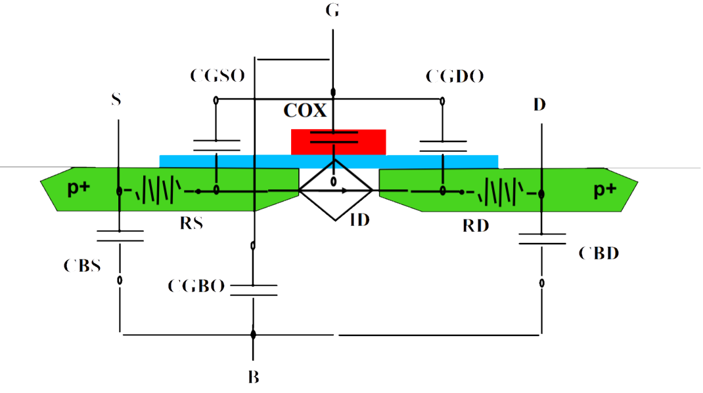
Figure 2: MOSFET Diagram of Ground (G), Source (S), Drain (D), and Substrate (B) [3]

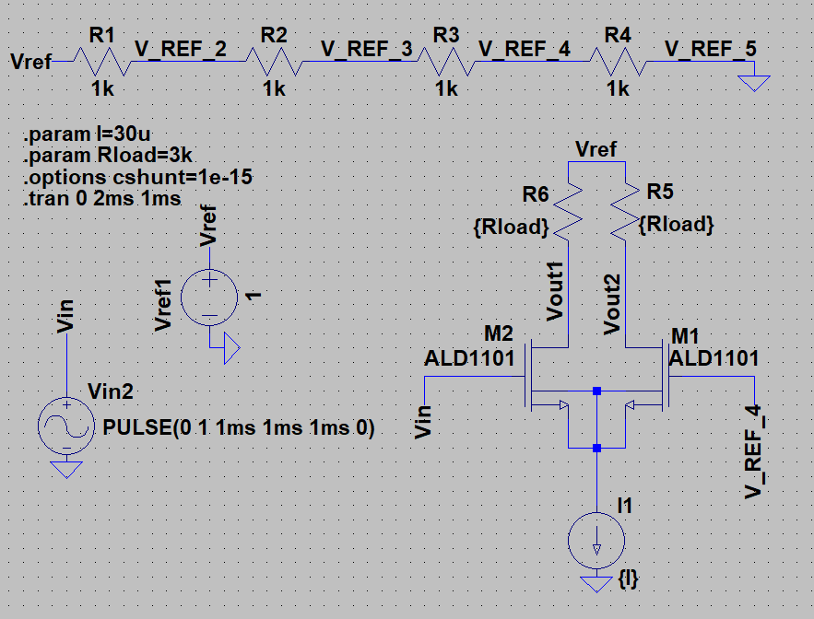
Figure 3: Schematic of Differential Amplifier (DA) with a 0.25V DC Gate Voltage on M1

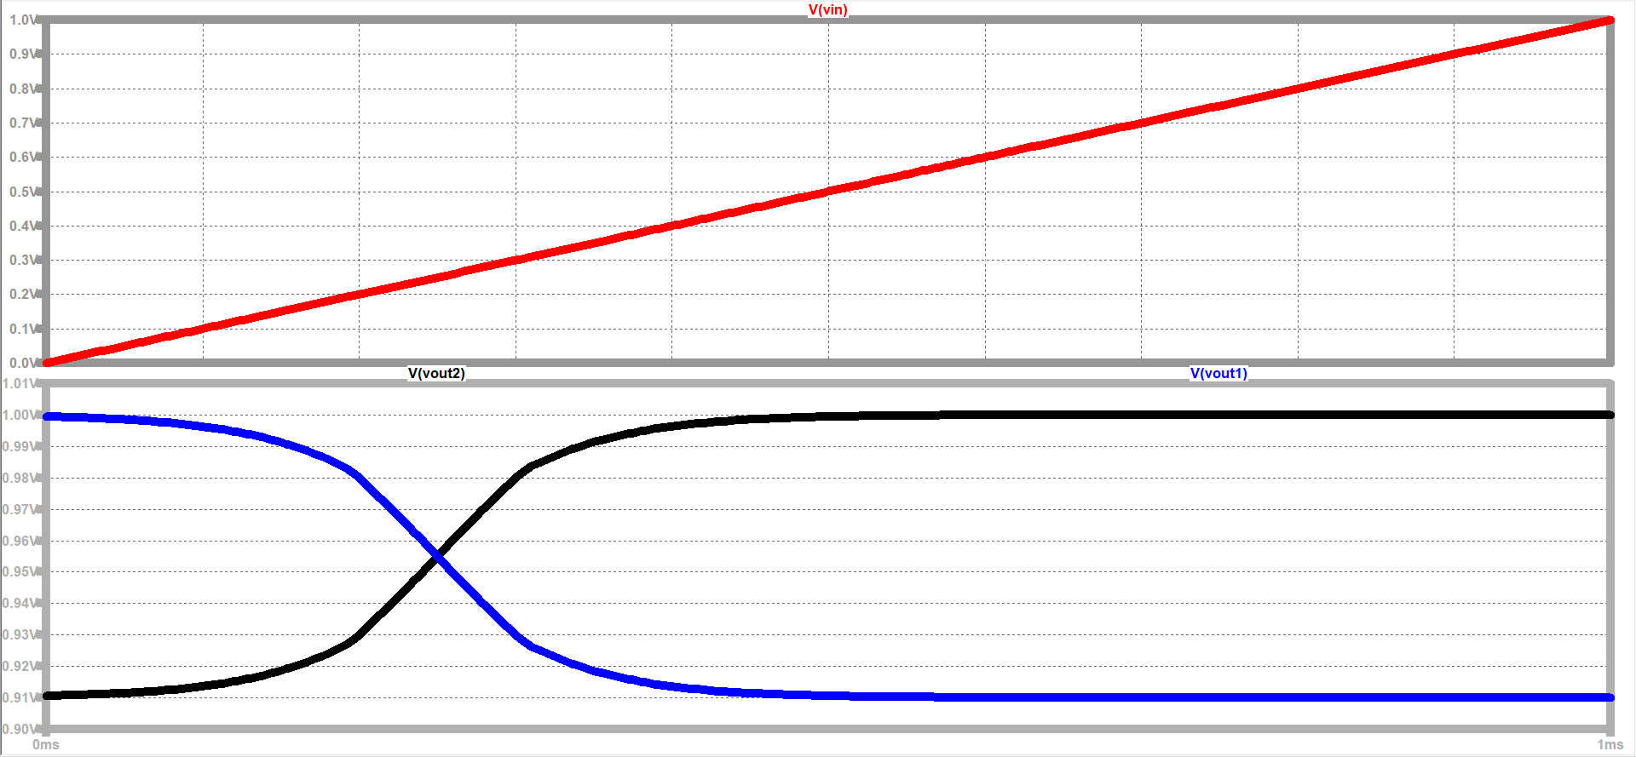
Figure 4: Differential Amplifier (DA) with Vin (top), Vout2 (bottom) and Vout1 (bottom) Waveforms as Vin Swept from 0 to 1V DC over 1ms

The nature of the operation of the DA, Figure 3, is relatively simple. The current source, I1, maintained constant current by ensuring the potential difference between the G and S of M1 remained at least ~+0.75V to keep the switch “turned on.” M2 didn’t turn on initially because for current to remain constant and flowing, the current source needed to create a ~-0.5V potential in the S to turn on M1, since M1’s G already had a potential of ~+0.25V. This ultimately meant that when Vin was at 0V, Vgs1 ( G to S potential of M1 ) was ~+0.75V and Vgs2 ( G to S potential of M2 ) was ~+0.50, turning M1 on while M2 remains off, Figure 5.

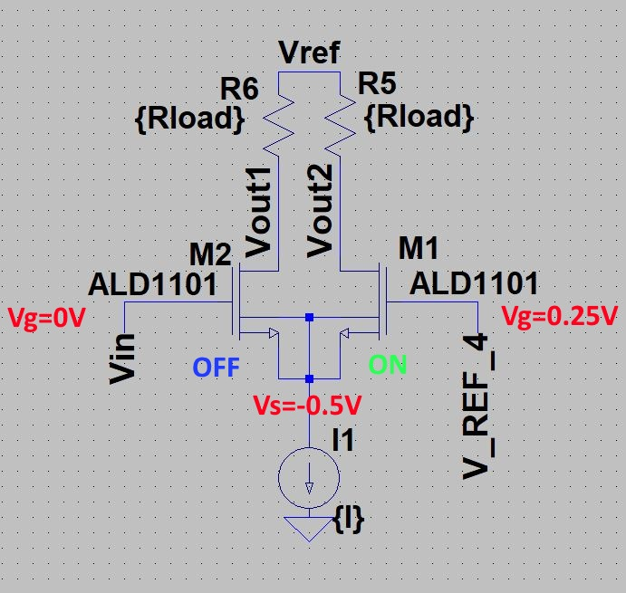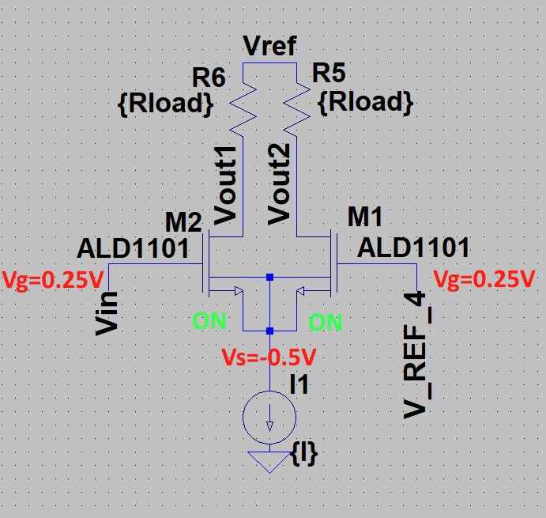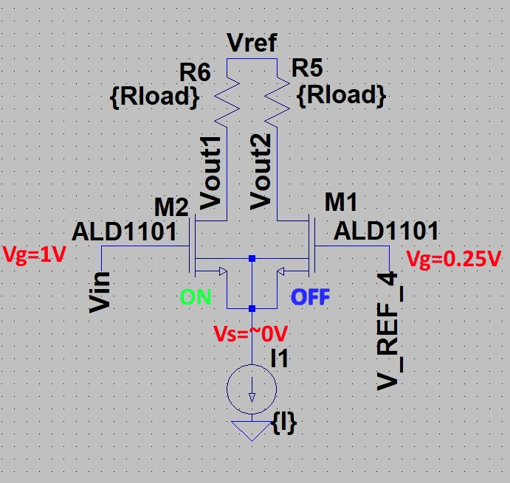
Figure 5: Diagram of Differential Amplifier (DA) with +0.25V DC Gate Voltage on M1 as Gate Voltage on M2 Varied from 0 to 1V

Vout1 was initially at 1V, because no current was flowing through M2 so there was no voltage drop across R6 and Vout1 = Vref. Vout2 was initially at ~0.91V, because current flowed through M1 and there was a potential drop of ~0.09V across the resistor R5. As Vin increased, current through M2 increased and the potential drop across the resistor R6 increased thereby lowering Vout1, while Vout2 increased as less current flowed through M1.
When Vin equaled 0.25V, Vgs1 and Vgs2 were equal and the current flowing through both M1 and M2 was equal, so the output voltages Vout1 and Vout2 were also equal as the potential drop across each of their respective resistors was equal. As Vin rose above +0.25V, the magnitude of the potential created by the current source decreased to only what was required to keep M2 turned on.
Eventually M1 turned off entirely and M2 turned on, leaving Vout1 at the potential where Vout2 started and Vout2 at the potential where Vout1 started. The DA created a crisscrossing LTI output signal, with the point at which the two output voltages were equal controlled by the gate voltage on one side of the DA.

Signal Folding with Chains of Differential Amplifiers
By combining these DAs together, Figure 6, and varying the reference voltage on one side, an LTI sinusoidal signal was generated, Figure 7, with an amplitude of about 33mV.

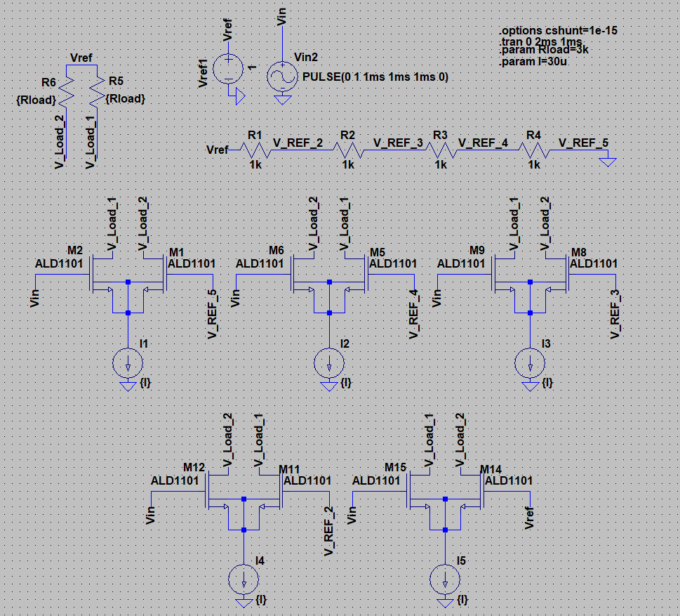
Figure 6: Schematic of Folding Amplifier with Five Differential Amplifiers (DAs) with Reference Voltages at 0, 0.25, 0.5, 0.75, and 1V

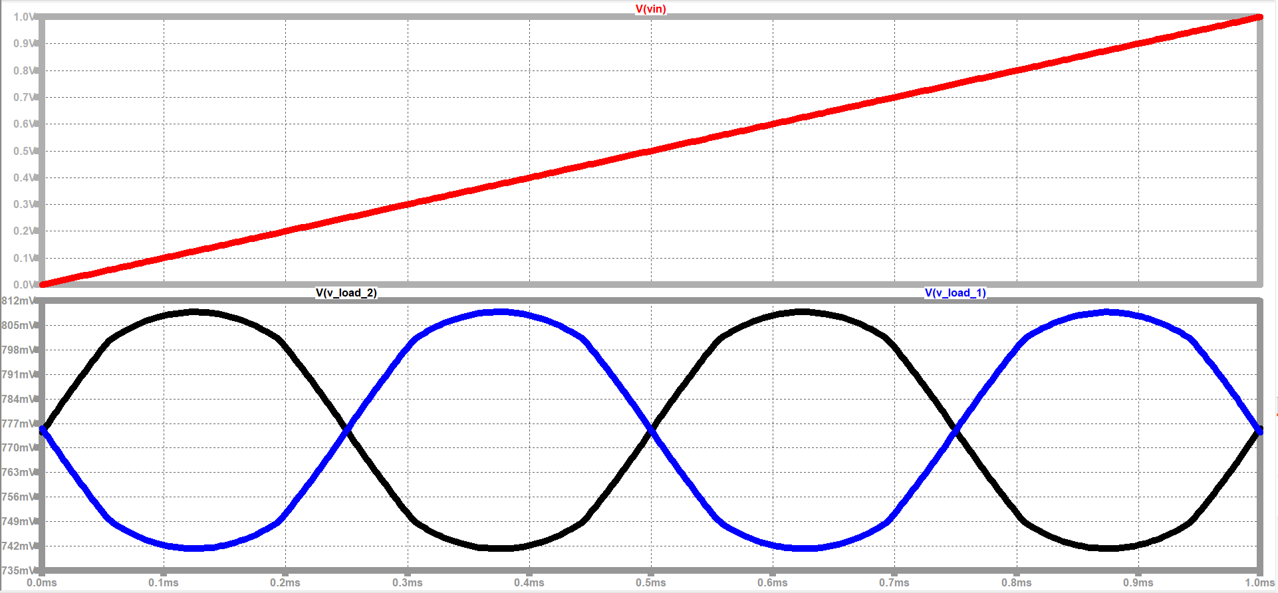
Figure 7: Vin (top), V_Load_1 (bottom), and V_Load_2 (bottom) Waveforms for Folding Amplifier in Figure 6 as Input Voltage, Vin, Swept from 0 to 1V DC

The circuit in Figure 6 with five DAs chained together operated on the same premise as previously described for the single DA in Figure 3. By changing the gate voltage on one side of each DA, the partial sinusoidal shape was shifted along the horizontal, Vin, axis. By selecting one output or the other of the DA, a output signal with either a positive or negative slope could be selected and added to the chain. In other words, the two outputs crisscrossed at 1, 0.75, 0.5, 0.25, and 0V, because of the reference voltages on the DAs (Vref, V_REF_2, V_REF_3, V_REF_4, and V_REF_5).

Maximizing Voltage Swing
The next requirement was that voltage swing be maximized, reaching a minimum of 2Vpp. To maximize voltage swing, an operational amplifier, TLV6001, was used in combination with a level shifter to bring the point of oscillation down from ~0.777V to 0V, Figure 8. The input voltage was swept from 0 to 1V and the output voltage V_Load_2, which was connected to the level shifter and operational amplifier, was plotted in Figure 9.

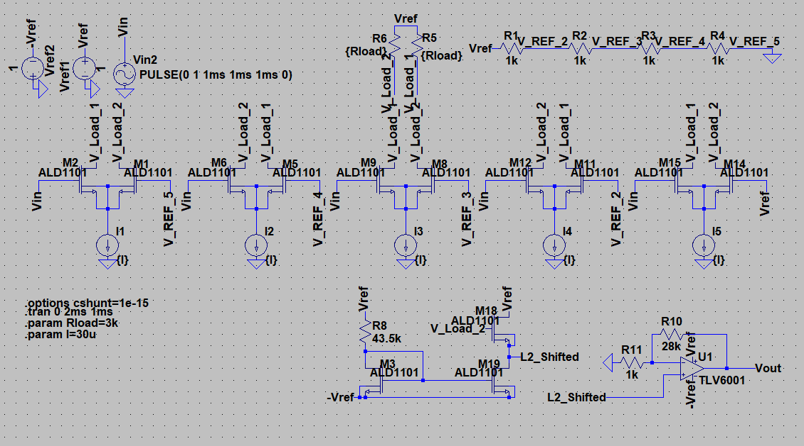
Figure 8: Schematic of Folding Amplifier with Five Differential Amplifiers (DAs), a Level Shifter, and an Operation Amplifier (OA) with Reference Voltages at 0, 0.25, 0.5, 0.75, and 1V

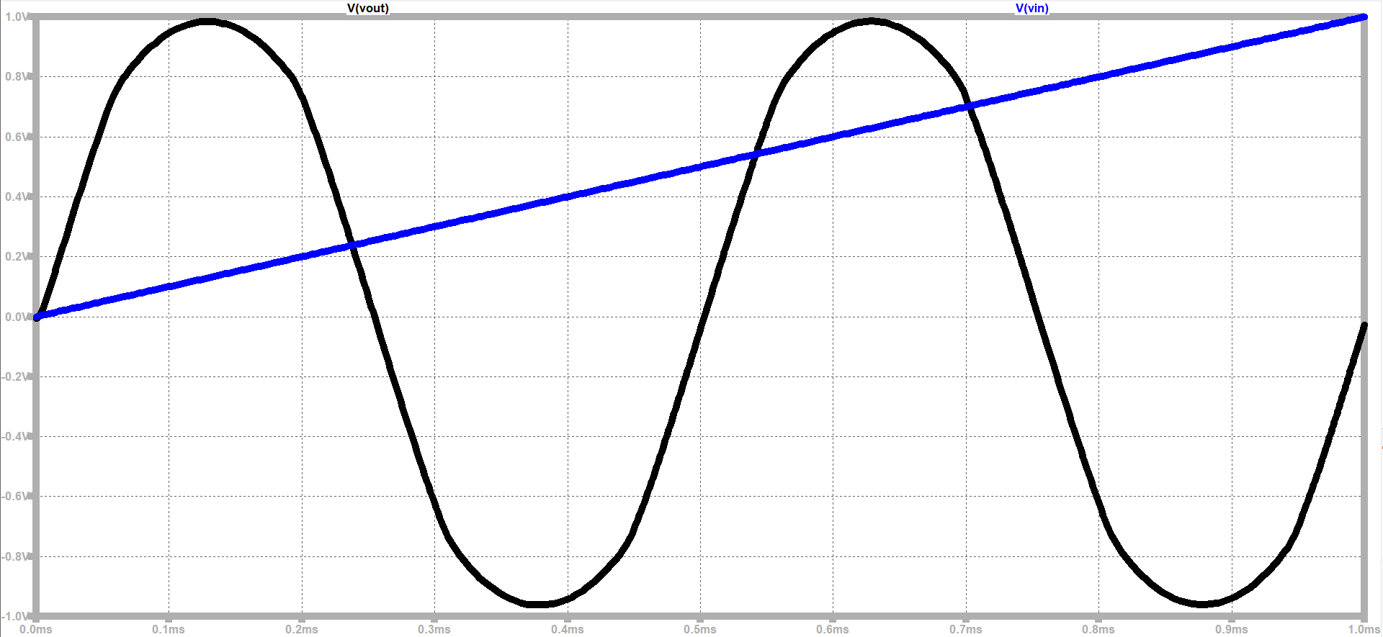
Figure 9: Vin Input Voltage and V_Load_2 Output Signal, 2Vpp, Level Shifted and Amplified for the Circuit in Figure 8

The desired sinusoidal output waveform, Figure 8, meeting the minimal requirement of a 2Vpp swing was simulated successfully. With the sinusoidal shape and maximized voltage swing requirements satisfied, the only remaining requirement was a -1V rail to power the current sources in the DAs.
The real-world implementation of the current sources in Figure 8 required a negative voltage rail to function, so a charge pump, LTC1502-3.3, was used to generate a +3.3 V signal to power an inverter, LT3483, to create a -1V rail. Significant time was spent in trial-and-error to minimize ripple in the negative rail circuit, which was amplified dramatically at the output of the operational amplifier. The final schematic, Figure 10, was simulated, Figure 11. The level shifter, previously a separate circuit, was built into one of the inputs of the operational amplifier in the final design to reduce parts and cost.

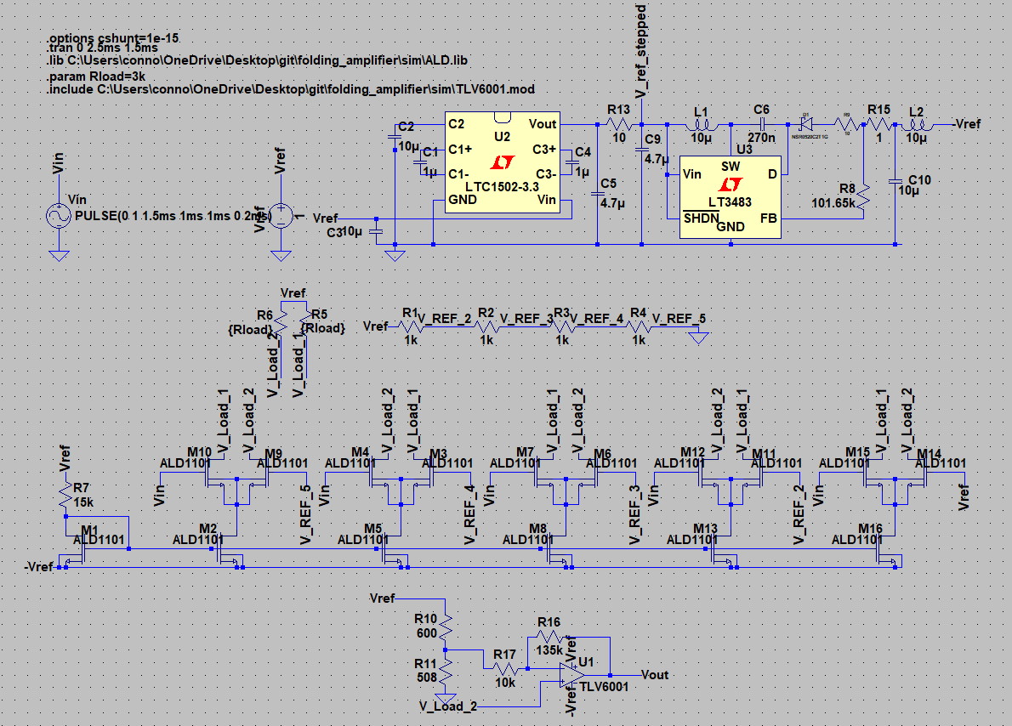
Figure 10: Schematic of Folding Amplifier Circuit with a +1V Rail, a -1V rail, and a Variable Input Voltage
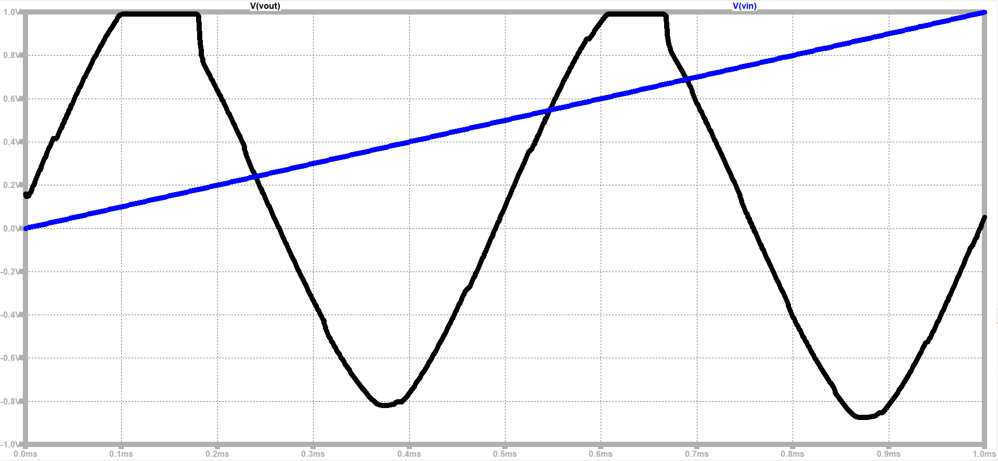
Figure 11: Vin Input Voltage and Vout Output Signal Waveform for Circuit in Figure 10

Due to ripple in the negative rail, the output signal, Figure 11, was cut off in some places and had ripple in others. The design still met the specifications, so the project proceeded to the PCB design phase.

PCB Design
KiCAD PCB design software was used to design the PCB for the circuit in Figure 10 [4]. Some resistor values were changed slightly to use standard values available from suppliers. The final schematic, Figure 12, and the PCB design, Figure 13, are below.

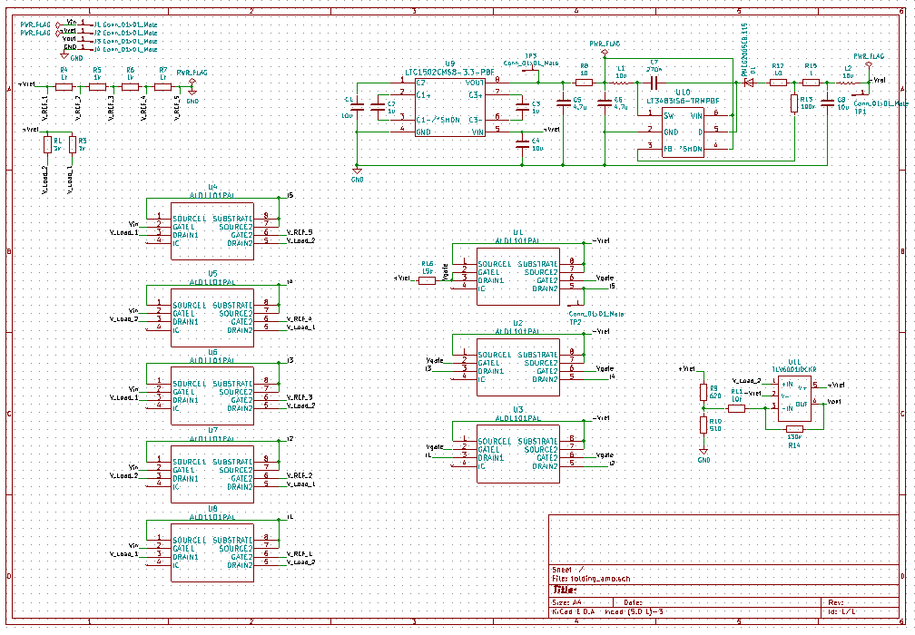
Figure 12: Final Folding Amplifier Schematic

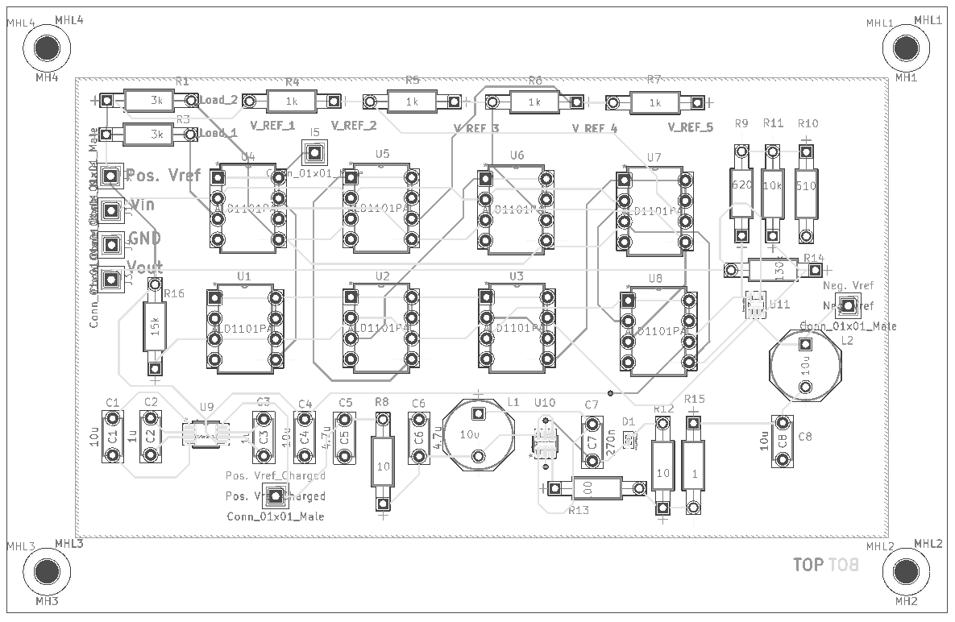
Figure 13: Final PCB Design for Folding Amplifier Circuit in Figure 12

results
The PCB design was sent to third-party company to create a board with the copper traces in Figure 13. The surface-mount components were soldered to the board using solder paste, which the larger through-hold components were soldered to the board by hand. The final version of the PCB is depicted in Figure 14.

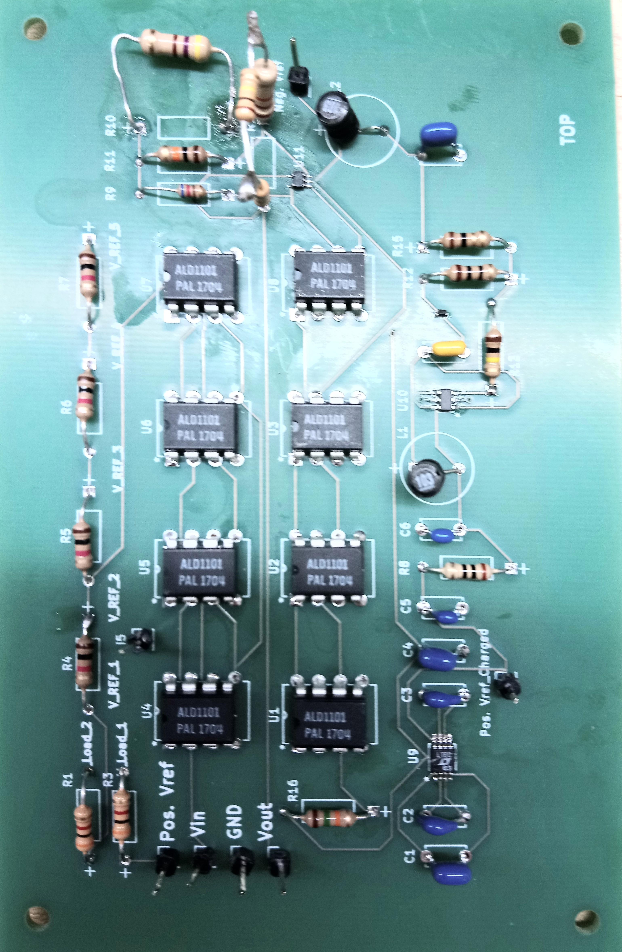
Figure 14: Picture of the Folding Amplifier PCB

Building of the PCB went through three iterations to create the desired output, but unfortunately due to a lack of Monte Carlo testing to account for the tolerances of the components, none of the attempts were successful. The result after all attempts were made used an R9 resistor value of 420 ohms and an R14 resistor value of 165k ohms. The output signal was centered on 0.3845 ohms and had a peak-to-peak voltage swing of 1.778Vpp, failing to meet the minimum spec of 2Vpp by about 0.222Vpp. The output signal is plotted in Figure 15.

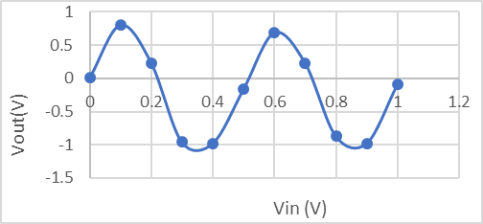
Figure 15: Plotted Output Signal of the PCB with a Variable Input Voltage from 0 to 1V for Attempt 1

The plot in Figure 15 suggests there was signal clipping, as the amplified signal outputted a signal greater than -1V; however, the simulations showed similar clipping – though in the positive – so some clipping was expected. The output swing was also like the expected output based on simulation. It is worth noting resistor R14 was replaced with a series combination of resistors totaling 165k ohms (measured by multimeter) and R10 was replaced by a resistance of 496 ohms (measured by multimeter), to achieve these results. The simulations called for 130k ohms resistor for R14 and 510 ohms for R10.

Conclusion
The five-stage LTI folding amplifier with a 2Vpp swing was successfully designed and simulated but the implementation only achieved a 1.778Vpp sinusoidal output. The tolerances of the components were not considered during the design and simulation phases of the project, which led to unexpected results when implemented. Components were soldered to the board and de-soldered multiple times to attempt different resistor configurations, finally resulting the one previously mentioned. The design relied far too heavily on precise resistances in the OA, because the voltage swing of the signal from the DAs was so small. Future research should focus on creating either a more robust design, which is less dependent on precise resistance values.

Acknowledgment
Connor S. Maynes thanks Professor Mark Indovina for his support and guidance during the design phase of the schematic and aid in improving PCB design. He also thanks Professor Carlos Barrios for his help in refining the PCB design.
References
- Oza, S. and Devashrayee, N. (2018). Low Voltage, Low Power Folding Amplifier for Folding & Interpolating ADC - IEEE Conference Publication. [online] Ieeexplore.ieee.org. Available at: https://ieeexplore.ieee.org/document/5329798/citations?tabFilter=papers#citations [Accessed 6 Dec. 2018].
- Devices, Analog. “LTspice.” LTspice, XVII, Analog Devices, 29 Mar. 2018, www.analog.com/en/design-center/design-tools-and-calculators/ltspice-simulator.html.
- Fuller, Lynn. “Introduction to Modeling MOSFETS in SPICE.” Rochester Institute of Technology, 2017.
- Charras, Jean-Pierre, et al. “KiCAD.” KiCAD, 5.0.1-3, KiCAD Developers Team, 14 Oct. 2018, kicad-pcb.org/.

This work was supported in part by the Electrical Engineering Department, Rochester Institute of Technology (RIT), through funding. Connor S. Maynes is with Electrical Engineering Department, Rochester Institute of Technology, Rochester, NY 14623 USA (e-mail: connormaynes@gmail.com).

