**Requirements Analysis Document**

Employee Scheduling System

CSCI 4711 Software Engineering

Fall 2016

Augusta University

Augusta, GA

Date: 10 October 2016

Version 2

Team Members

Chris Gonsalves

Matt Tennis

Connor Williams

Ryan Mahoney

**Abstract**

This document contains the requirements, analysis and design artifacts for the Employee Scheduling System (ESS) software system. ESS is a personnel scheduling system that facilitates the employee submission and subsequent supervisor approval or denial of time off requests.

The rest of this document is structured as follows: Chapter 1 contains the introduction. This chapter presents a brief description of the system. Chapter 2 outlines the functional requirements of the system.

**Table of Contents**

1. Introduction........................................................................................4

1.1 Scope of System....................................................................................4

1.2 Overview of Document.......................................................................4

2 Requirements of the System..............................................................5

2.1 Functional Requirements................................................................5

2.2 Use Case Diagram..............................................................................6

2.3 Use Case Descriptions.......................................................................7

3 User Interface Mockups..................................................................12

3.1 Login..................................................................................................12

3.2 InvalidLogin……..……………………………..………………….12

3.3 Logout……………….......................................................................13

3.4 RequestTimeOff................................................................................13

3.5 InvalidRequest.................................................................................14

3.6 SupervisorMenu................................................................................14

3.7 RequestResponse..............................................................................15

1. **Introduction**
   1. **Scope of System**

The Employee Scheduling System (ESS) is a system used to provide simple and efficient means for an employee to request time off and for appointed supervisors to administrate, approve, or deny those requests.

ESS has an internal database with authorized users and their password hashes. Employees can submit requests for time off, which are stored in the database. Supervisors are then able to see the contents of the time off requests, the employee that initiated it, and the reason for the request. Once the Supervisor responds to a request, it is removed from the Supervisor’s queue and the database.

The system includes secure login, logout functionality in addition to the primary scheduling applications.

* 1. **Overview of Document**

The rest of the document is structured as follows: Chapter 2 outlines the functional requirements of the system, then the use case diagram. Individual detailed use case descriptions are then listed. Chapter 3 depicts several individual user interface mockups.

1. **Requirements of System**
   1. **Functional Requirements**

* **Login –** All users, **Employees** and **Supervisors**, must supply valid login credentials (EmployeeID and password) to be authorized to access and use the system. Upon doing so, the user will have created a session with ESS, where a user can modify database contents through normal usage. Valid login will direct the user to his or her appropriate activity based on the user’s class.
  + **InvalidLogin** – Handle invalid credentials, out-of-scope characters, and exploitation attempts. Returns control to user after job.
* **Logoff –** All users must have clear and immediate access to a Logoff button in order to gracefully and securely close the connection with ESS. Resources allocated to a user session must be terminated in an orderly fashion as to eliminate potential software bugs. Every form or interface must have a clearly marked Logoff button.
* **RequestTimeOff – Employees** must be able to supply a time off request in the appropriate forms: either the calendar GUI or the text-based message box (which accepts only date information). Radio buttons enable the **Employee** to indicate the reason (and weight) of his or her request. The user can then submit or logout of that page, with the former checking if the request is valid, then sending it to the database, and the latter terminating the request and logging out.
* **RequestResponse – Supervisors** must be able to view the time off requests that have been submitted in a scroll box queue. The queue will have highlighted regions that correspond to the reason (or weight) supplied by the user’s time off request. The **Supervisor** can then approve, deny, or logout from this window. Approvals and denials modify database contents and update the queue, while logout will terminate the session gracefully.
  + **ApproveRequest** – Approves Employee request and updates relevant database data.
  + **DenyRequest** – Denies Employee request and updates relevant database data
  1. **Use Case Diagram**

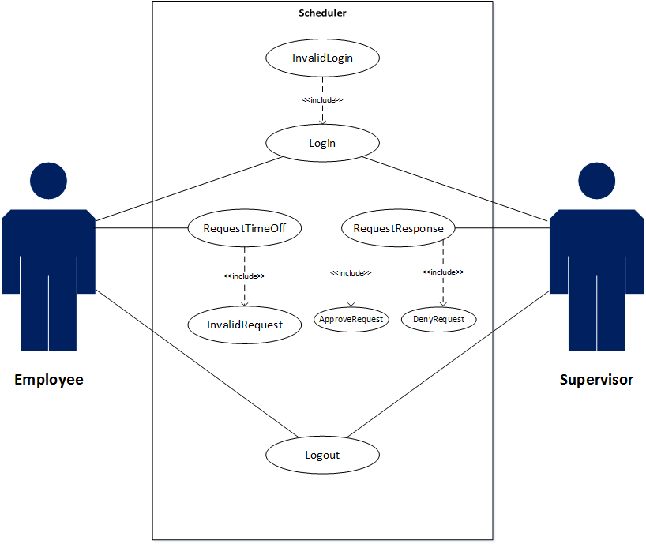

Figure 2.1 use case diagram for ESS

* 1. **Use Case Descriptions**

|  |  |
| --- | --- |
| *Use case name* | Login |
| *Participating actors* | Initiated by Employee or Supervisor |
| *Flow of events* | 1. Employee enters their LoginID in LoginID field and Password in Password field . 2. **ESS responds by authenticating the entered LoginID and Password**. 3. **The ESS will distinguish if User is Employee or Supervisor via SQL query.** 4. **The RequestTimeOff interface will open for Employee and the SupervisorDashboard interface will open for Supervisor.** |
| *Entry condition* |  |
| *Exit condition* | Login ID and Password are authenticated via SQL query. |
| *Security requirements* | The password must be hashed at all times. The dialogue boxes that handle username and password must be shielded against code execution and SQL injections. Password policy must be used to eliminate malicious input. Windows shortcut-key exploits must be disabled to avoid accessing a shell or forcing an exploit. Only <ENTER> will be recognized for acknowledgement of the message/dialogue box. |

Figure 2.2: Login: valid login

|  |  |
| --- | --- |
| *Use case name* | Login |
| *Participating actors* | Initiated by Employeeor Supervisor**.** |
| *Flow of events* | 1. User supplies invalid credentials to the login interface.  2. **System handles the input, returning a user-specific error in a pop-up message/dialog box. A dialogue box pops up to alert User of invalid login.**  3. The user must acknowledge the button in the dialog/box in order to proceed.  4. **System returns the user to the login page, where the user is then able to try to enter valid credentials once more.** |
| *Entry condition* |  |
| *Exit condition* | The user acknowledges the invalid entry. |
| *Security requirements* | The password must be hashed at all times. The dialogue boxes that handle username and password must be shielded against code execution and SQL injections. Password policy must be used to eliminate malicious input. Windows shortcut-key exploits must be disabled to avoid accessing a shell or forcing an exploit. Only <ENTER> will be recognized for acknowledgement of the message/dialogue box. |

Figure 2.3: Login: invalid login

|  |  |
| --- | --- |
| *Use case name* | Logout |
| *Participating actors* | Initiated by Employee or Supervisor |
| *Flow of events* | 1. Employee presses the logout button on the Time Off Request interface or Supervisor presses logout button on Supervisor Dashboard, Time Off Request interface, or Time Off Response interface.  **2. System closes any open form (Supervisor Dashboard, Time Off Request interface, or Time Off Response interface) and returns user to the login interface .** |
| *Entry condition* | Employee or Supervisor is logged in to the ESS system. |
| *Exit condition* | Employee or Supervisor is logged out and returned to the login interface. |
| *Security requirements* | Resources allocated to the session must be terminated properly to ensure there are no bugs in the software. |

Figure 2.4: Logout

|  |  |
| --- | --- |
| *Use case name* | TimeOffResponse |
| *Participating actors* | Initiated by Supervisor |
| *Flow of events* | 1. **ESS displays Employee Time Off Request in the Supervisor's Time Off Request queue**. 2. Supervisor selects the appropriate request from their ESS interface and clicks Approve. 3. **ESS updates Time Off Request status field in database with "Approved".** |
| *Entry condition* | The Supervisor selects Time Off Response from Supervisor Dashboard Form. |
| *Exit condition* | Time Off Request status field in database with "Approved". |
| *Security requirements* | All responses are tracked by EmployeeID ensuring that no unauthorized individuals are able to surreptitiously gain access to a request. |

Figure 2.5: TimeOffResponse: Approve

|  |  |
| --- | --- |
| *Use case name* | TimeOffResponse |
| *Participating actors* | Initiated by Supervisor |
| *Flow of events* | 1. **ESS displays Employee Time Off Request in the Supervisor's Time Off Request queue**. 2. Supervisor selects the appropriate request from Time Off Request queue on the Time Off Response interface 3. Supervisor clicks Deny. 4. **ESS updates Time Off Request status field in database with "Denied".** |
| *Entry condition* | The Supervisor selects Time Off Response button from Supervisor Dashboard Form. |
| *Exit condition* | Time Off Request status field in database with "Denied". |
| *Security requirements* | All responses are tracked by EmployeeID ensuring that no unauthorized individuals are able to surreptitiously gain access to a request. |

Figure 2.6: TimeOffResponse: Deny

1. **User Interface Mockups**
   1. **Login**



* 1. **Invalid Login**

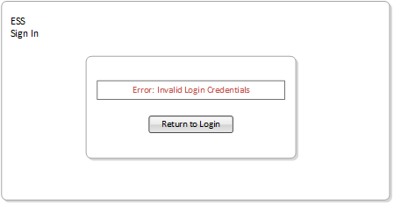

* 1. **Logout**

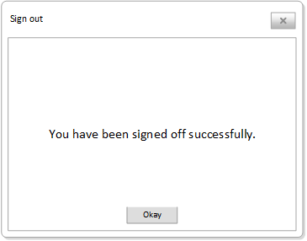

* 1. **RequestTimeOff**

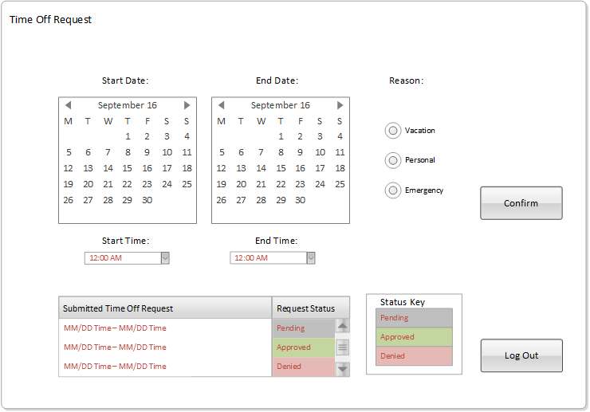

* 1. **InvalidRequest**



* 1. **SupervisorMenu**



* 1. **RequestResponse**

