RemoteDoc User Manual v1.1

Introduction

Welcome to RemoteDoc, an innovative telehealth solution designed to minimize the need for physical visits to healthcare centres. In rural Australia, vast distances and low population density create significant challenges for healthcare access. RemoteDoc addresses these challenges by serving as a virtual clinic, providing convenient medical consultations and follow-ups. This reduces the strain on healthcare resources, enhances efficiency, and ensures more effective healthcare delivery in remote areas.

Getting Started

**System Requirements**

* Operating System: Android 6.0 or later / iOS 12.0 or later
* Internet Connection: Stable internet connection (Wi-Fi or 4G/5G)
* Device**:** Smartphone with a camera and microphone

**Installation**

1. Download the App**:**
   * For Android: Visit the Google Play Store and search for "RemoteDoc."
   * For iOS: Visit the Apple App Store and search for "RemoteDoc."
2. Install the App**:** Follow the on-screen instructions to install the app on your device

**Creating an account**

1. Open the RemoteDoc app.
2. 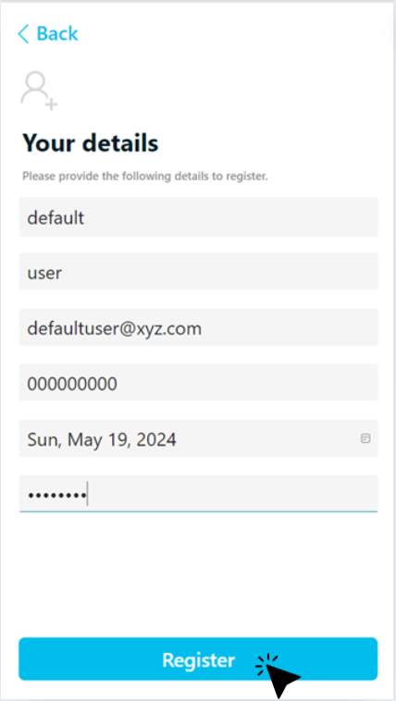Click on the "Register" button.

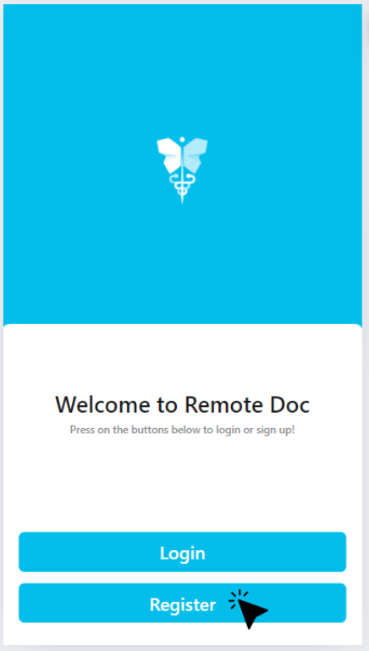

1. Enter your details: first name, last name, email address, phone number, and create a password, and click “Register”.
2. Verify your email and phone number by entering the verification codes sent to you.

**Logging in to your account**

1. Click on the “Login” button.
2. Enter either your email or your phone number and your password.

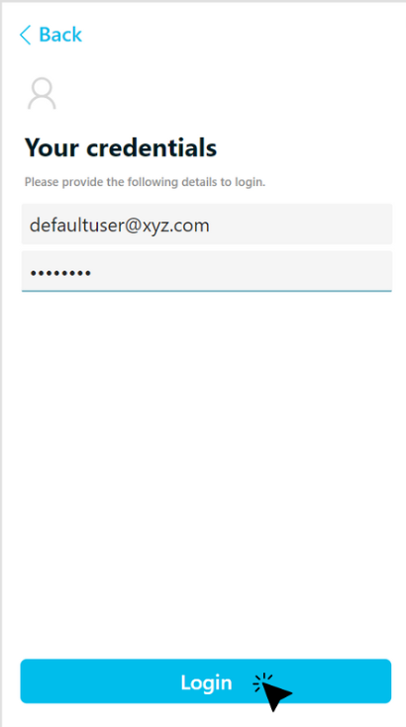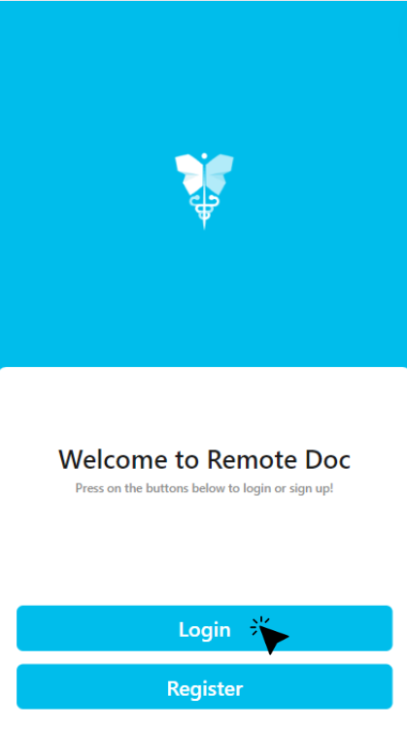

1. You will be successfully logged if you enter the correct details.

User Interface Overview

**Dashboard**

The Dashboard is your home screen. Here you can:

* Set Your Desired Clinics: Select and manage your preferred clinic locations.
* Book Appointments: Schedule new appointments with healthcare professionals.
* View Existing Appointments: Check the details and status of your upcoming and past appointments.
* 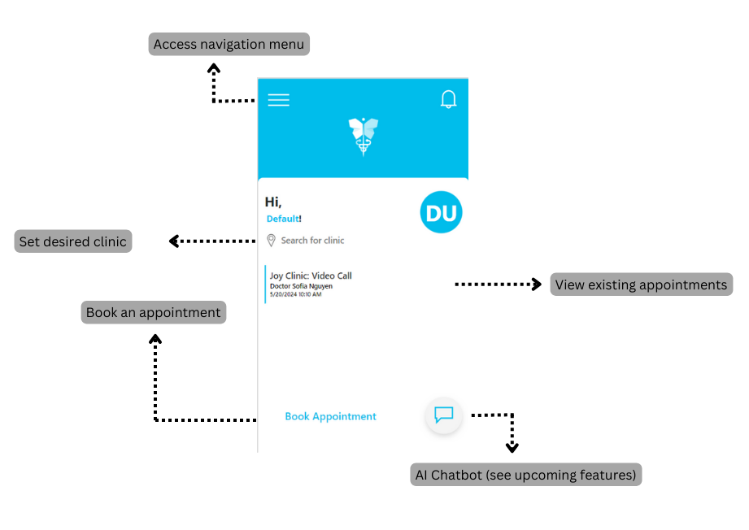Access the AI Chatbot: Get assistance and answers to common questions through our AI Chatbot.

**Navigation menu**

Access the navigation menu by tapping the menu icon (☰) in the top-left corner. Here you can:

* Book Appointments: Schedule new appointments with healthcare professionals.
* Chat with Clinic Admin: Communicate directly with the clinic's administrative staff.
* Chat with Your Doctor: Send messages to your doctor for consultations and follow-ups.
* Change Your Clinic: Update your preferred clinic location.
* Sign Out: Log out of the RemoteDoc app.

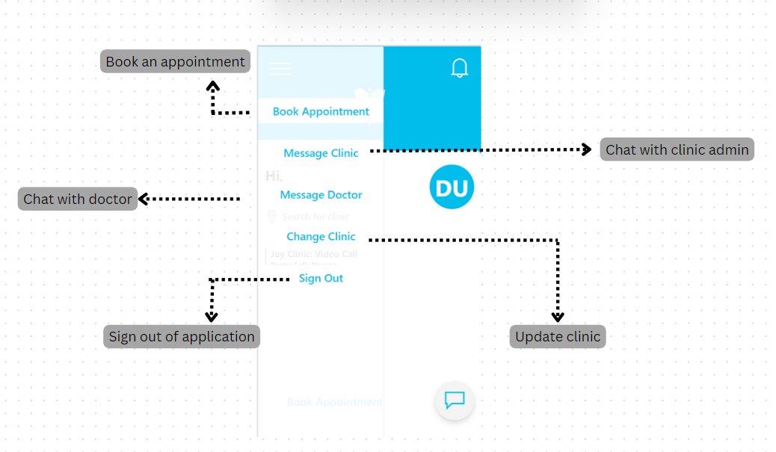

Features and Functions

**Selecting your clinic**

1. Tap “search for clinic” on the dashboard.
2. Scroll through the existing list to find your clinic. Alternatively, type the name of your clinic in the search bar, the list will filter as you type.
3. 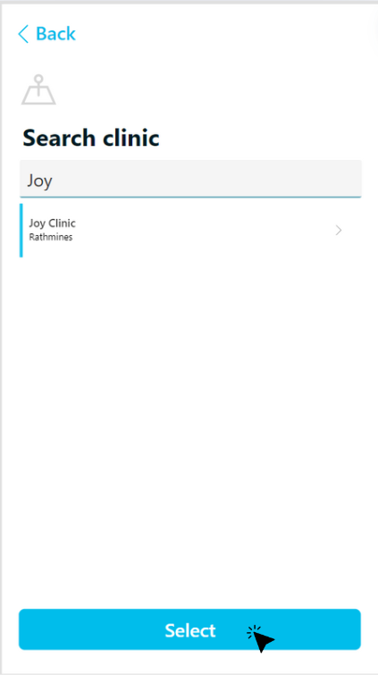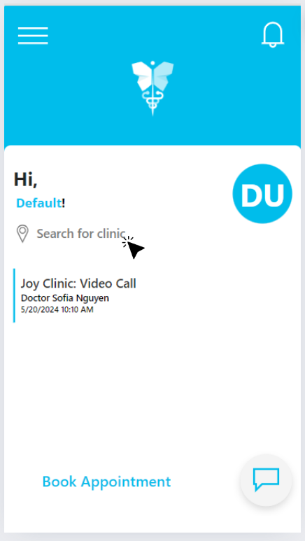Tap the name of your clinic. Click on the select button to select your clinic.
4. The name of the selected clinic will appear on the dashboard.

**Updating your clinic**

1. To update your clinic, tap the menu icon (☰) in the top-left corner, and click on “Change clinic”. Alternatively, tap the button that displays the name of your clinic.
2. Follow the same instructions as outlined in section “**Selecting your clinic”.**

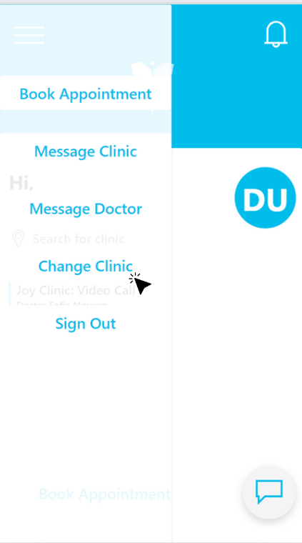****

**Booking an appointment**

1. If you have not selected a clinic, the app will prompt you to select your clinic.
2. 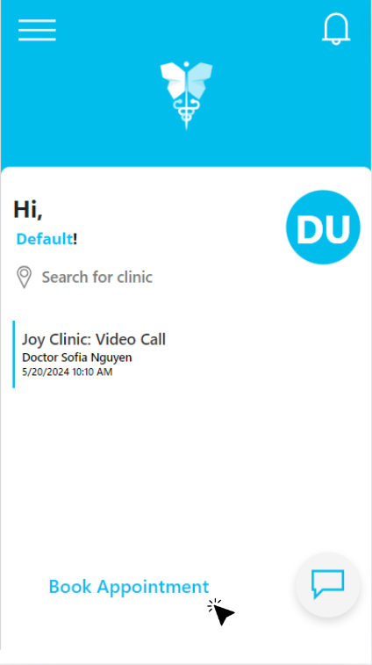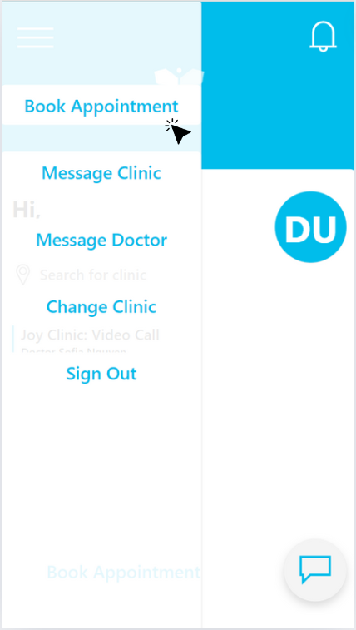Tap on “Book Appointment” on the dashboard. Alternatively, tap the menu icon (☰) in the top-left corner and select “Book Appointment”.
3. Search the name of the doctor you want to consult. Alternatively, find the doctor you want to consult in the list displayed.
4. Tap the name of the doctor. Click on the select button to make an appointment with them.

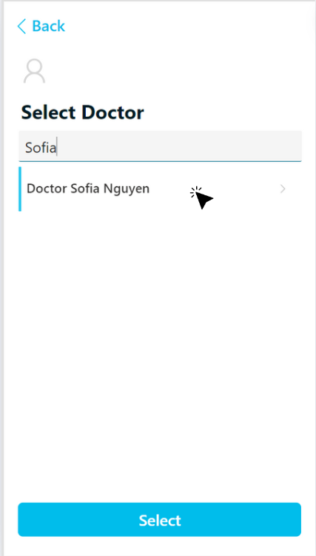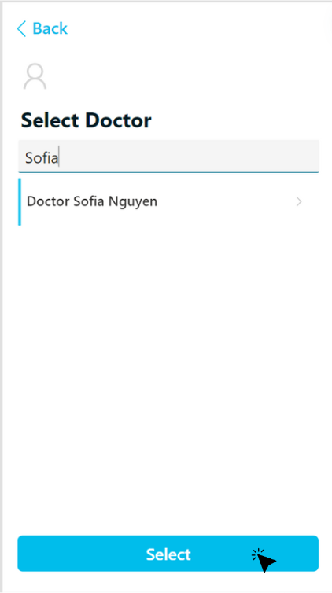

1. Select the appointment from the drop-down menu. You can choose a voice call, video call or an in-person appointment.
2. 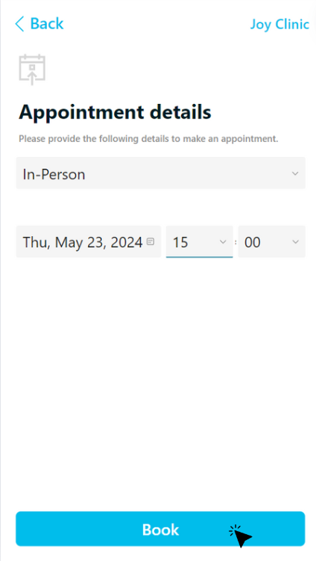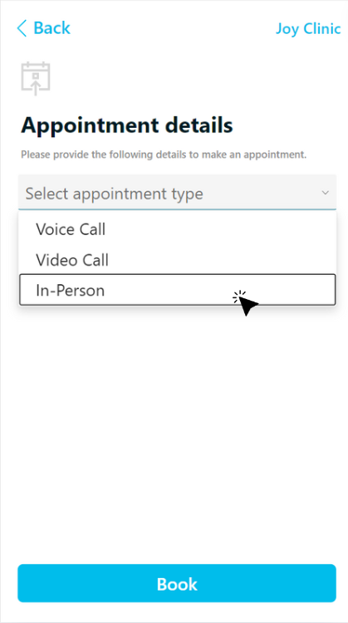Select the date and time for your appointment.
3. Tap on “Book” to confirm your appointment. It should be displayed on your dashboard.

**Chat with clinic**

1. If you have not selected a clinic, the app will prompt you to select your clinic.
2. Tap the menu icon (☰) in the top-left corner and select “Message clinic”.
3. 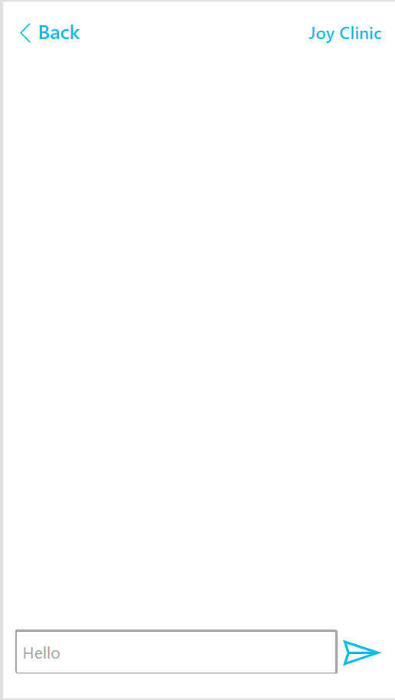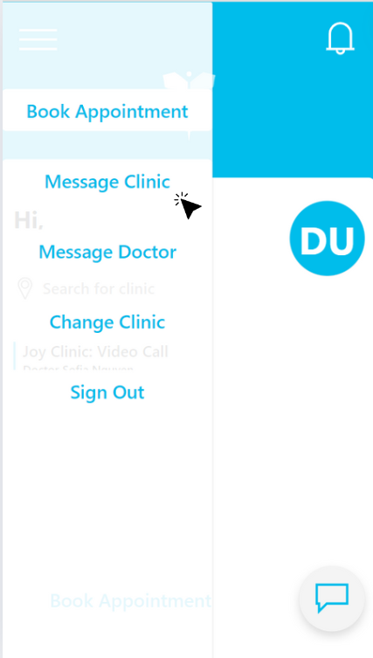You can now communicate via text with your selected clinic’s admin.

**Chat with Doctor**

1. If you have not selected a clinic, the app will prompt you to select your clinic.
2. Tap the menu icon (☰) in the top-left corner and select “Message Doctor.”
3. 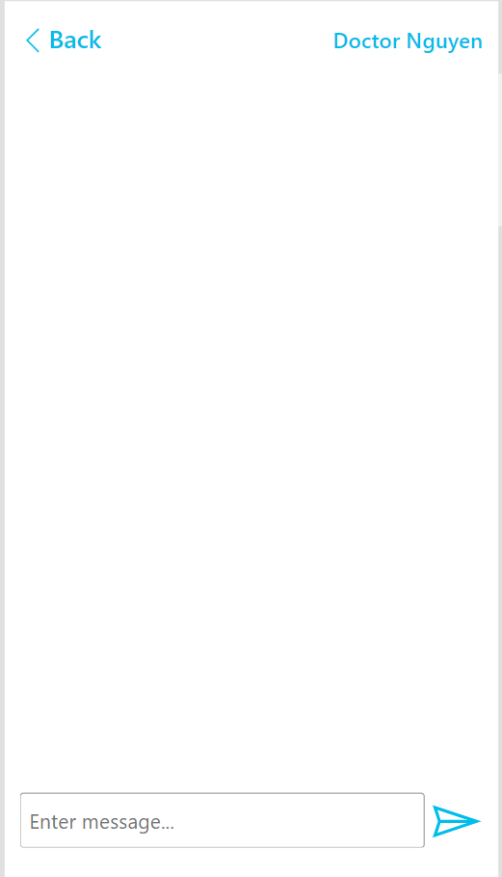You can now communicate via text with your doctor.

