**1050 Programming Logic**

Lab 4 (20 points total)

Name: ___Connor Singerline_______

*Paste your code and screenshots below.*

1. Compare and contrast the if single-selection statement and the while repetition statement. How are these two statements similar? How are they different? (2 Points).

ANSWER:

The if single selection statement and while repetition statements are similar due to both being control statements. They help to determine the actions to execute as well as the order in which these actions execute. The if single-selection statement selects or ignores a single action (or single group of actions).

The while repetition statement perform the action (or group of actions) in their bodies zero or more times.

1. Declare two int variables: 1) speedLimit and 2) speed. Assign values speedLimit=35 and speed=42. Write an if statement that displays “SLOW NOW” if speed is greater than speedLimit. (2 points)

namespace Lab04_ConnorSingerline

{

class Program

{

static void Main(string[] args)

{

int speedLimit=35;

int speed=42;

if (speed >speedLimit)

{

Console.WriteLine("SLOW NOW");

}

}

}

}

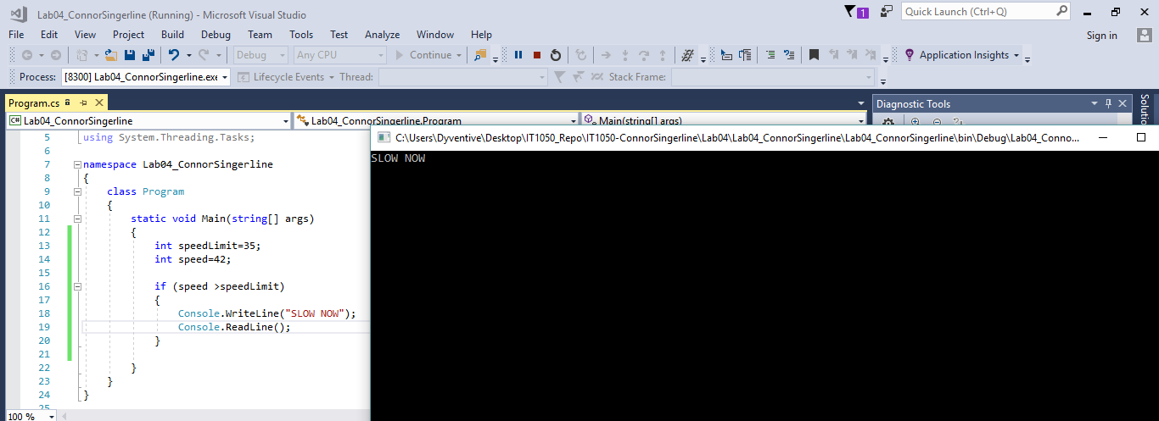

1. if-else statement - Write a program that declares and assigns a value to a Boolean variable called isTrue. Use a condition to output “It is True!” or “It is False!” based on the assigned value. Paste your code and screenshots of your program running with both true and false values (3 points).

Example: bool isTrue = true;

bool isTrue = false;

ANSWER:

{

class Program

{

static void Main(string[] args)

{

bool isTrue;

Console.WriteLine("Type true or false to assign isTrue a value");

string response = Console.ReadLine();

bool.TryParse(response, out isTrue);

if (isTrue == true)

{

Console.WriteLine("It is True!");

Console.ReadLine();

}

else if (isTrue == false)

{

Console.WriteLine("It is False!");

Console.ReadLine();

}

else

Console.WriteLine("Start over, isTrue must be true or false");

Console.ReadLine();

}

}

}

TRUE  
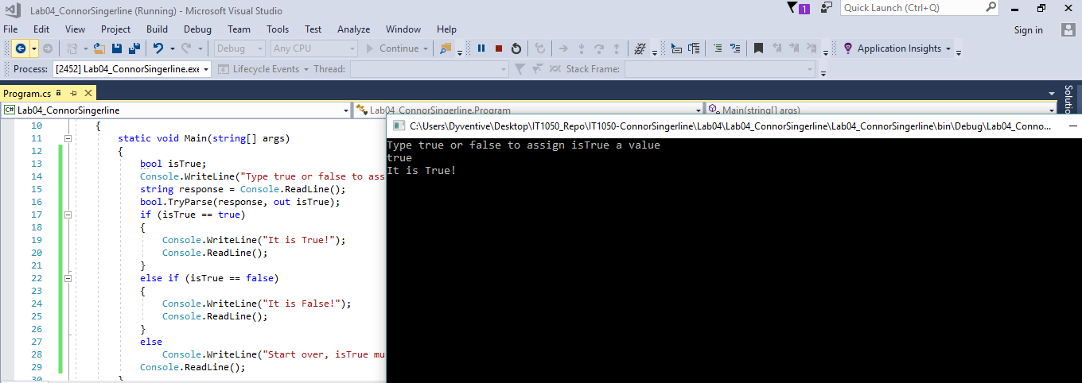  
FALSE  
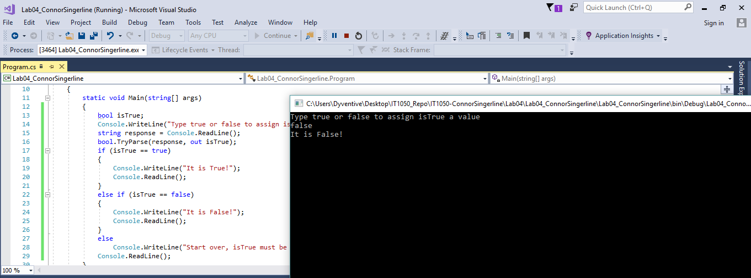

1. if statement - Write a program that converts a Fahrenheit temperature to Celsius. The user should be able to input the temperature at the Command prompt and it should output the temperature. In addition, you should output “It is cold” if the Fahrenheit value is less that 40 or it should output “It is hot” if the temperature is over 90 (4 points). ***Code to read a value: double fahrenheit = Convert.ToDouble(Console.ReadLine()); Code to convert: celsius = (fahrenheit - 32d) * 5d / 9d;***

ANSWER:

namespace Lab04_ConnorSingerline

{

class Program

{

static void Main(string[] args)

{

Console.WriteLine($"This program will convert Fahrenheit temperature to Celcisu. Please input a Fahrenheit temperature...");

double fahrenheit = Convert.ToDouble(Console.ReadLine());

var celsius = ((fahrenheit - 32d) * 5d / 9d);

if (fahrenheit < 40)

{

Console.WriteLine($"It is cold. The conversion from {fahrenheit} degrees Fahrenheit is equal to {celsius} degrees celcius.");

Console.ReadLine();

}

else if (fahrenheit > 90)

{

Console.WriteLine($"It is hot. The conversion from {fahrenheit} degrees Fahrenheit is equal to {celsius} degrees celcius.");

Console.ReadLine();

}

else

Console.WriteLine($"The conversion from {fahrenheit} degrees Fahrenheit is equal to {celsius} degrees celcius.");

Console.ReadLine();

}

}

}

COLD  
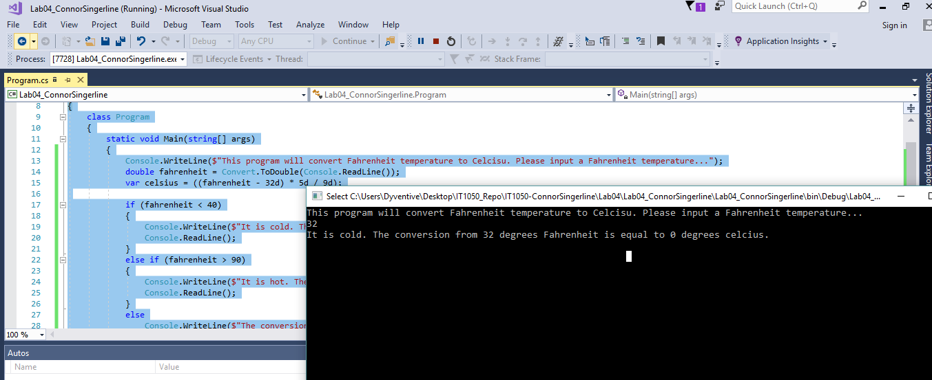

HOT  
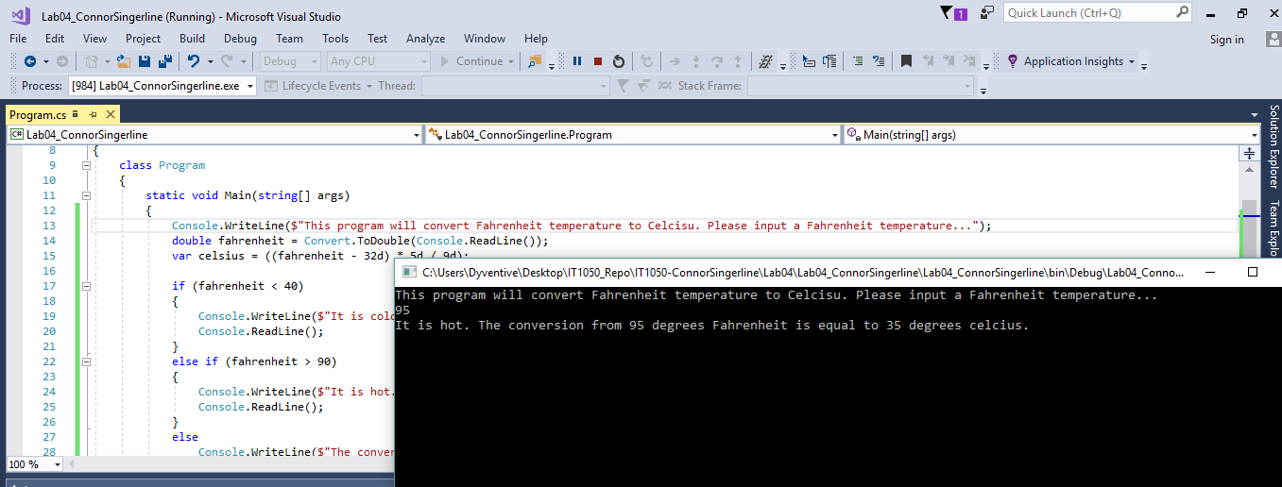

Neither HOT or COLD

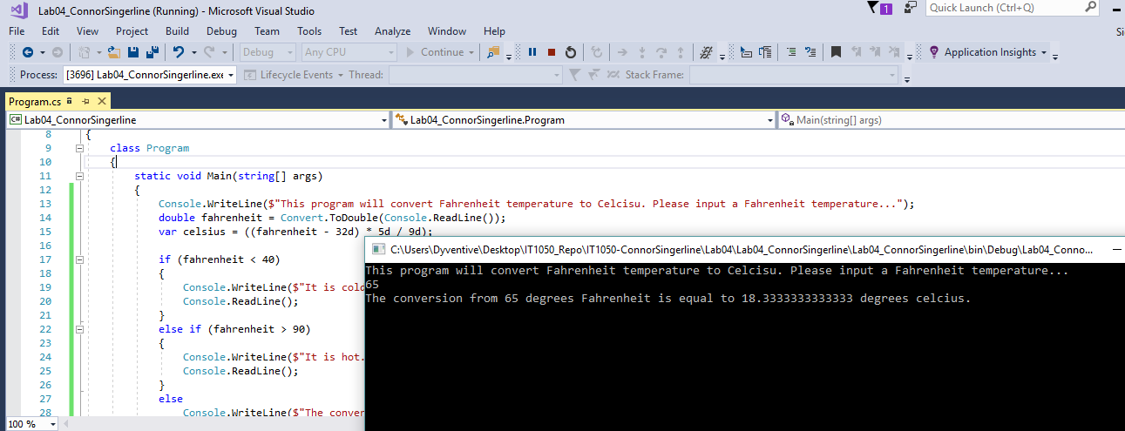

1. **Write a while loop** that outputs values 1-10. Increment by 1 (3 points).

namespace Lab04_ConnorSingerline

{

class Program

{

static void Main(string[] args)

{

int i = 0;

while(i < 10)

{

i = i + 1;

Console.WriteLine($"{i}");

}

Console.ReadLine();

}

}

}

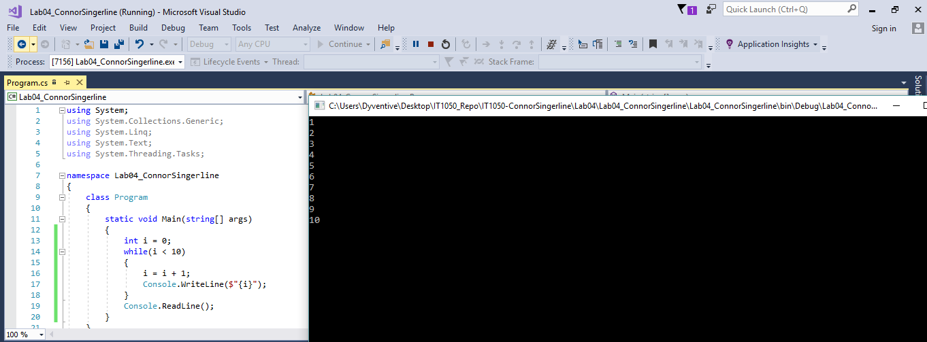

1. **Write a while loop** that outputs values 60 to 20. Decrement by 1 (3 points)

namespace Lab04_ConnorSingerline

{

class Program

{

static void Main(string[] args)

{

int i = 61;

while(i > 20)

{

i = i - 1;

Console.WriteLine($"{i}");

}

Console.ReadLine();

}

}

}

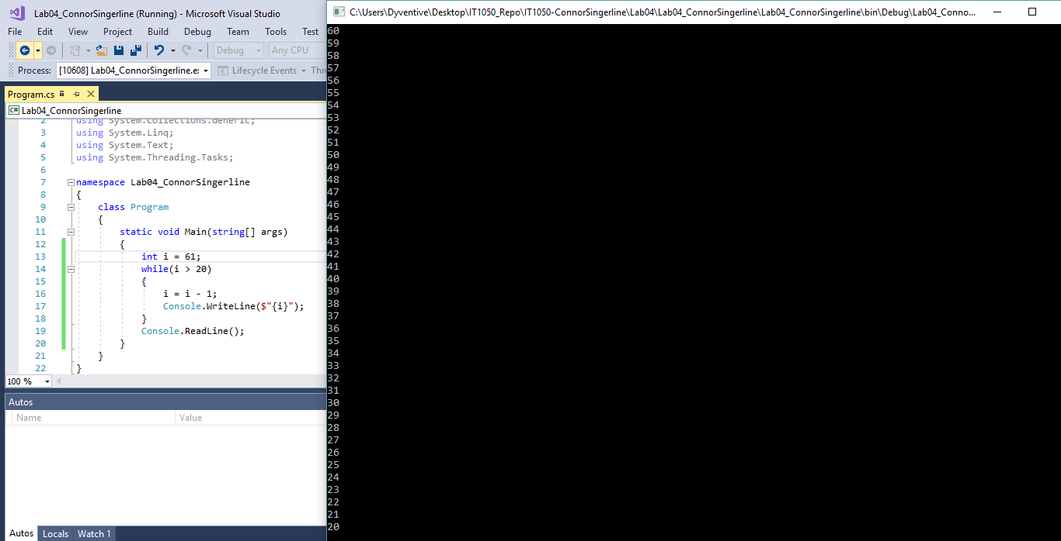

1. **Create a while** that outputs values 10-20 (3 points).

namespace Lab04_ConnorSingerline

{

class Program

{

static void Main(string[] args)

{

int i = 9;

while(i < 20)

{

i = i + 1;

Console.WriteLine($"{i}");

}

Console.ReadLine();

}

}

}

