# 1050 Programming Logic

Lab 5 (20 points total)

Name: ___Connor Singerline_____

*Paste your code and screenshots below.*

1. Describe the four basic elements of the counter-controlled repetition.
   1. A control variable (or loop counter)
   2. The control variable’s initial value
   3. The control variable’s increment that’s applied during each iteration of the loop
   4. The loop-continuation condition that determines if looping should continue
2. Compare and contrast the while and for repetition statements.

ANSWER:  
The while statement can be used to implement any counter-controlled loop. The for iteration statement specifies the elements of counter-controlled in a single line of code. Typically, for statements are used for counter-controlled iteration, and while statement s for sentinel-controlled iteration. While and For can be used for either iteration type.

1. Discuss a specific example when it would be more appropriate to use a do-while statement than a while statement. Explain why.

ANSWER:  
It would be more appropriate to use a do-while statement than a while statement when a set of instructions need to be executed at least once. An example would be needing to input integers to find the sum while prompting the users to enter the two numbers.

1. Create a for loop that goes from 1-100 using a variable named i as the counter. Each time through the loop, output whether or not the variable is even or odd

*Hint:* Use and if-else statement and the modulus % operator to determine whether the variable is even or odd. Example: if ((i % 2) == 0) // it’s even

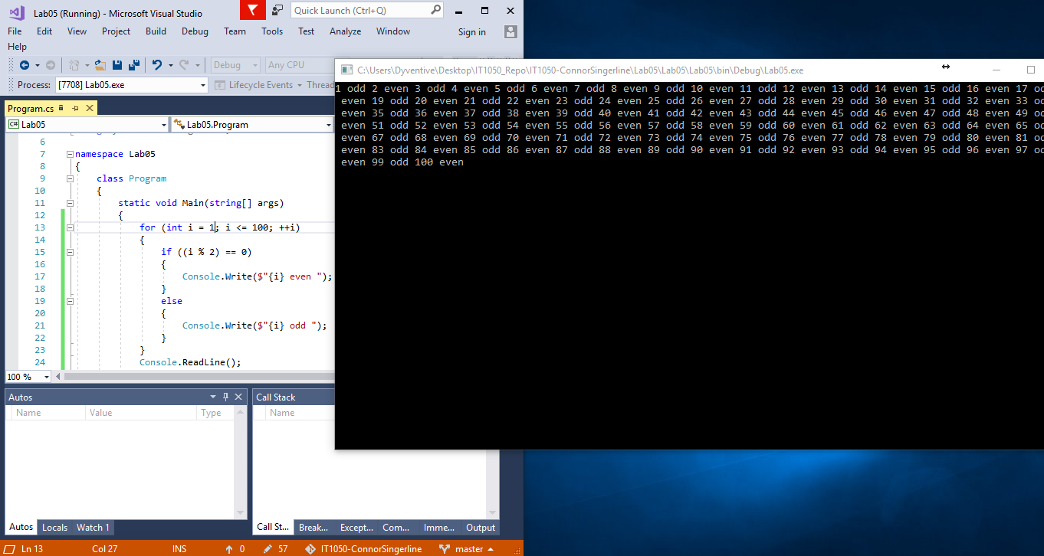

1. Use an if…else-if…else statement to output the following based on an int temp that is input by the user (3 Points) Prompt the user with “Please enter a temperature”.

**Input output**

< 10 Polar Bear

< 20 Penguin

< 40 Moose

< 50 Reindeer

< 60 Deer

< 70 Turtle

< 80 Lion

< 90 Fish

Default Bug

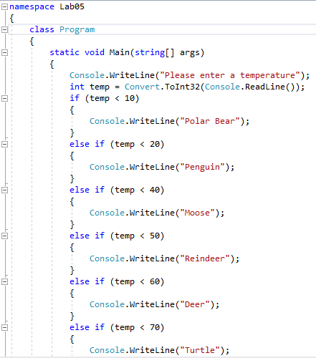  
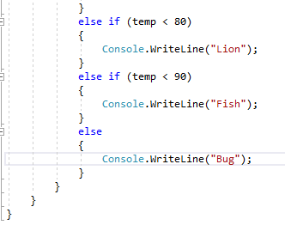

1. The following code is meant to loop and output 10-20, each number on a separate line. What’s wrong? Fix the problem.

int i = 10;

while (i < 21)

{

Console.WriteLine(i);

}

*Example output:*



ANSWER:

The problem is that there is not moving incrementally.

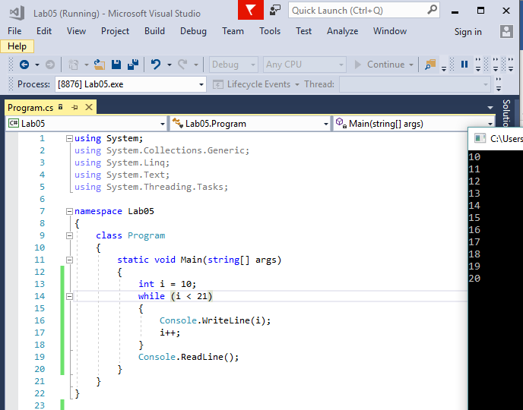

1. *The following statement is supposed to output every number from 0-100 separated by a line with asterisks on it. What is wrong with the code? Fix it.*

for (int i = 0; i < 101; i++)

Console.WriteLine(i);

Console.WriteLine("********");

*Example output:*

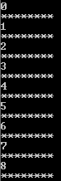

ANSWER:

The problem with the code is that there should be an opening “{“ after “itt)” and a closing “}” after The console.writeline line of code.

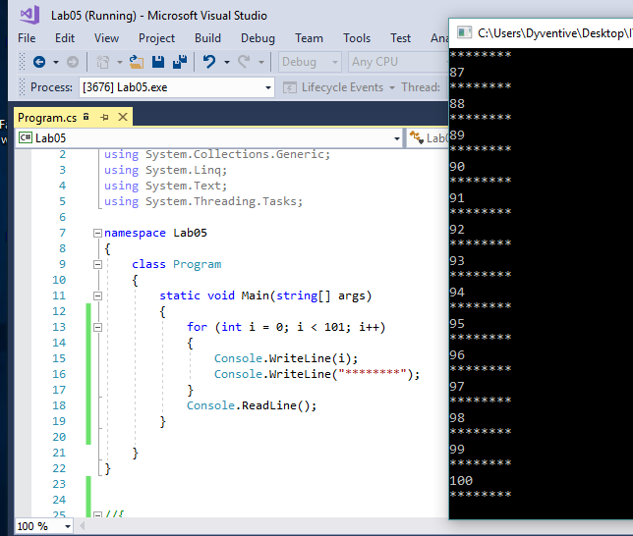

1. **Extra Credit:** Write an application that displays the following patterns separately, one below the other. Use for loops to generate the patterns. All asterisks (*) should be displayed by a single statement of the form Console.Write( '*' ); which causes the asterisks to display side by side. A statement of the form Console.WriteLine(); can be used to move to the next line. A statement of the form Console.Write( ' ' ); can be used to display a space for the last two patterns. There should be no other output statements in the application. [Hint: The last two patterns require that each line begin with an appropriate number of blank spaces.] (2 points possible - +0.5 per solution)

