**1050 Programming Logic**

Lab 6 (14 points total)

Name: ___Connor Singerline_____

***Paste your code and screenshots of the console as below.***

1. Use a while loop and if statement to write a program that prints the next 20 leap years (2 points).

using System;

using System.Collections.Generic;

using System.Linq;

using System.Text;

using System.Threading.Tasks;

namespace Lab06

{

class Program

{

static void Main(string[] args)

{

int i= 2020;

int counter = 1;

while (counter <=20)

{

if (counter > 20)

{

Console.WriteLine("Error");

Console.ReadLine();

}

else

{

Console.WriteLine($"{i}");

i = i+ 4;

++counter;

}

}

Console.ReadLine();

}

}

}

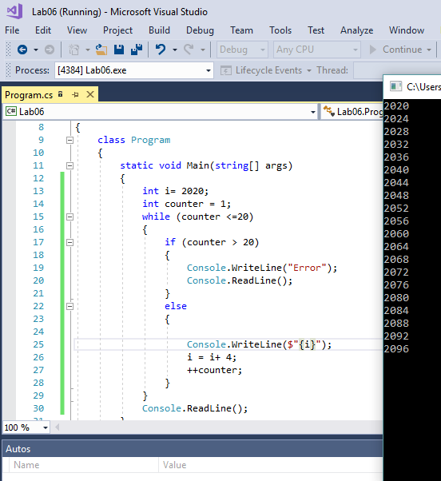

1. Write a guessing game where the user has to guess a secret number. After every guess the program tells the user whether their number was too large or too small. At the end the number of tries needed should be printed. To keep it simple, input the number at the beginning of the game. (6 points)  
   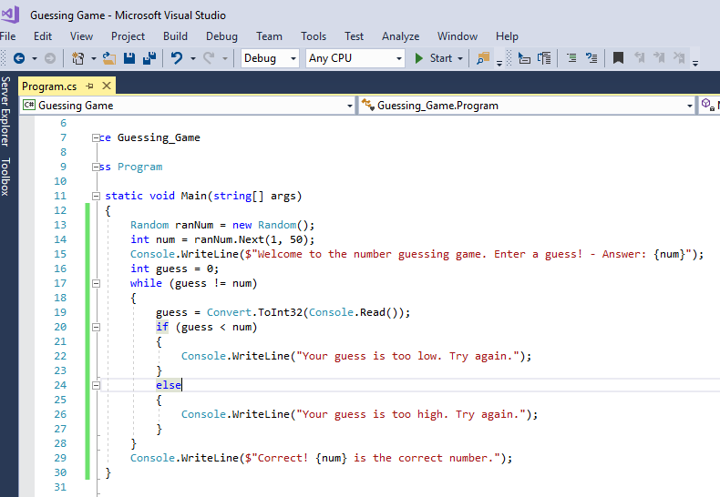
2. Create a while loop. The while loop will continue to run until the user inputs a value of “E”. During the loop, accept two other inputs: grocery item and cost. Keep a running total of the cost. Also, add the item to a string. When the loop is complete, display the items and the total cost. (6 points)

PARTIALLY COMPLETE:

using System;

using System.Collections.Generic;

using System.Linq;

using System.Text;

using System.Threading.Tasks;

namespace GroceryList

{

class Program

{

static void Main(string[] args)

{

string text = "";

int total = 0;

List<string> groceryList = new List<string>();

Console.WriteLine("Welcome to the grocery store.");

while (text != "E")

{

Console.WriteLine("Please enter an item: ");

string item = Console.ReadLine();

groceryList.Add(item);

Console.WriteLine("Please enter the item cost:");

int cost = Convert.ToInt32(Console.ReadLine());

total = total + cost;

Console.WriteLine("Type another item to continue or E to complete.");

}

foreach(var item in groceryList)

{

Console.WriteLine(item.groceryList);

}

// I completed until here due to needing to study for an interview

// Hopefully partial credit

}

}

}

Example:

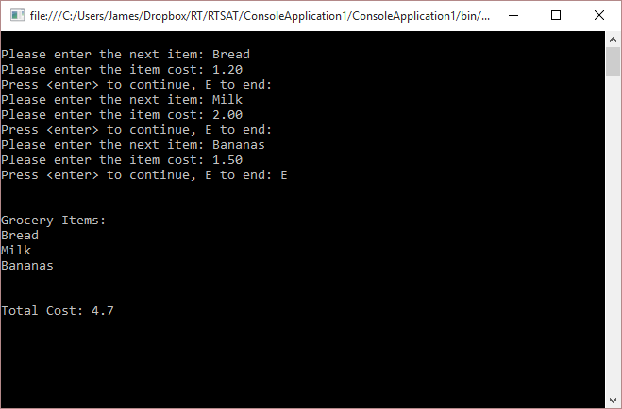

Example Code for keeping track of grocery items:

Console.Write("Please enter the next item: "); // this would go before the while loop

item = Console.ReadLine(); // this would go in the while loop

allItems += item + "\n";

**Deliverables:**

When Complete, please push to GitHub and submit the URL to your repository in Blackboard.