**IT 1050 – Programming Logic**  
Take Home Test 1

Create a project called IT1050-Midterm. Put all of your code into a single Program.cs class’ Main method. Once completed, push to your git repository and share the URL to your repository in

1. Create an infinite while loop. Use a Boolean variable called keepLooping that set to true in the loop’s termination condition. Hint: Use CTRL+C or Debug -> Terminate All to end the program.

using System;

using System.Collections.Generic;

using System.Linq;

using System.Text;

using System.Threading.Tasks;

namespace ConsoleApplication2

{

class Program

{

static void Main(string[] args)

{

bool keepLooping = true;

int counter = 1;

while (keepLooping)

{

Console.WriteLine("Loop iteration");

counter++;

}

}

}

} 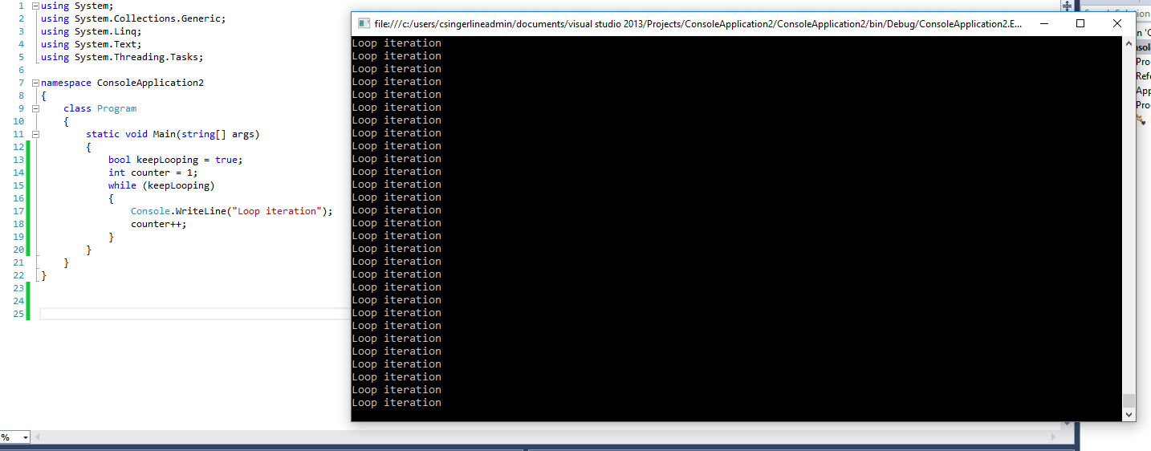

1. Write a while loop to prints 2 through 128 in brackets, each on a new line. You should initialize your loop control variable to 2. Output the value of the loop control variable each time through the loop.

[2]

[4]

[8]

[16]

[32]

[64]

[128]

using System;

using System.Collections.Generic;

using System.Linq;

using System.Text;

using System.Threading.Tasks;

namespace ConsoleApplication2

{

class Program

{

static void Main(string[] args)

{

int i = 2;

Console.Write("[");

Console.Write((i));

Console.Write("]");

Console.WriteLine(" ");

while (i < 128)

{

i = i * 2;

Console.Write("[");

Console.Write((i));

Console.Write("]");

Console.WriteLine(" ");

}

Console.ReadLine();

}

}

}

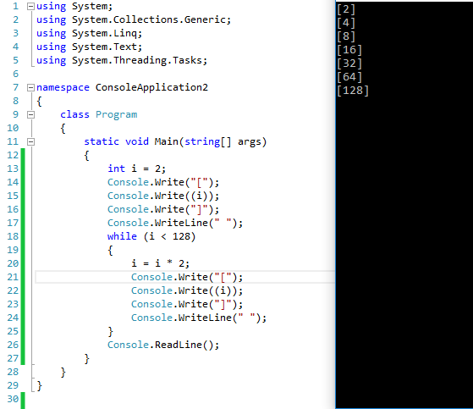

1. Write a for loop that prints 49 through 1 separated by a comma. Note, you will need to use a condition inside of the loops so it does not print the comma the last time through (no newlines – although there should be a newline after 1. You need to be a little tricky with the newlines).

49, 48, 47, …, 3, 2, 1

using System;

using System.Collections.Generic;

using System.Linq;

using System.Text;

using System.Threading.Tasks;

namespace ConsoleApplication2

{

class Program

{

static void Main(string[] args)

{

for (int num =49; num > 0;)

{

if (num == 1)

{

Console.Write(num);

num--;

Console.WriteLine(" ");

}

else

{

Console.Write(num);

num--;

Console.Write(", ");

}

}

Console.ReadLine();

}

}

}  
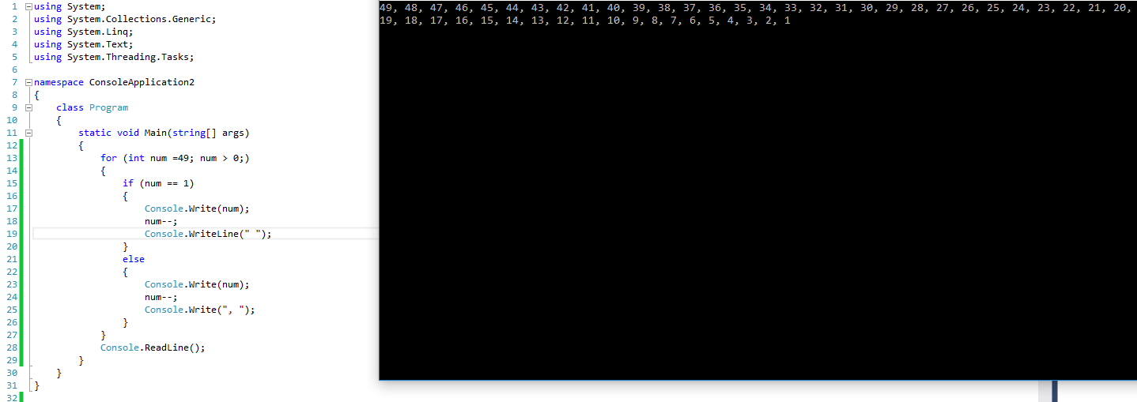

1. Write a while loop that prints all odd numbers 1 through 21, each separated by three spaces (no newlines except after the last number).

1 3 5 7 9 11 13 15 17 19 21

using System;

using System.Collections.Generic;

using System.Linq;

using System.Text;

using System.Threading.Tasks;

namespace ConsoleApplication2

{

class Program

{

static void Main(string[] args)

{

int num = 1;

while(num < 22)

{

Console.Write(num);

Console.Write(" ");

num++;

num++;

}

Console.WriteLine(" ");

Console.ReadLine();

}

}

}  
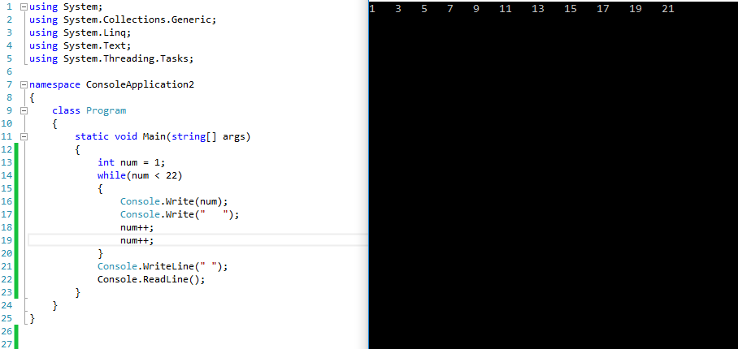

1. Implement the following code using a while loop. In a comment in your code, explain the difference in output between the do-while and while.

int n = 8;

int i = 10; // initialize

do {

Console.Write("*");

i++; // update!

} while (i < n); // test condition

ANSWER:

using System;

using System.Collections.Generic;

using System.Linq;

using System.Text;

using System.Threading.Tasks;

namespace Test1_Connor_Singerline

{

class Program

{

static void Main(string[] args)

{

int n = 8;

int i = 10;

while (i < n)

{

Console.Write("*");

i++;

}

// in a while loop the condition is checked before the inner code is run. On the do while example the code is ran then the condition is checked

Console.ReadLine();

}

}

}

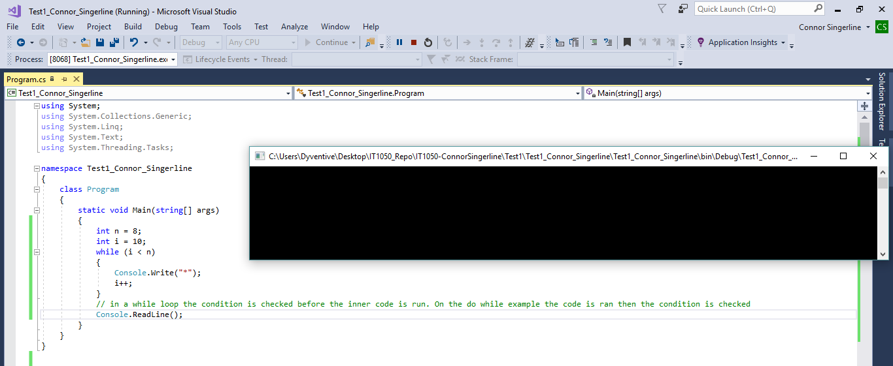

1. Use AND and OR (&& and ||) to write an if statement that outputs “Let’s go outside!” when both Boolean values are false.

boolean icyRain;  
boolean tornadoWarning;

using System;

using System.Collections.Generic;

using System.Linq;

using System.Text;

using System.Threading.Tasks;

namespace Test1_Connor_Singerline

{

class Program

{

static void Main(string[] args)

{

bool icyRain = false;

bool tornadoWarning = false;

if ((icyRain == false) && (tornadoWarning == false))

{

Console.WriteLine("Let’s go outside!");

Console.ReadLine();

}

Console.ReadLine();

}

}

}  
  
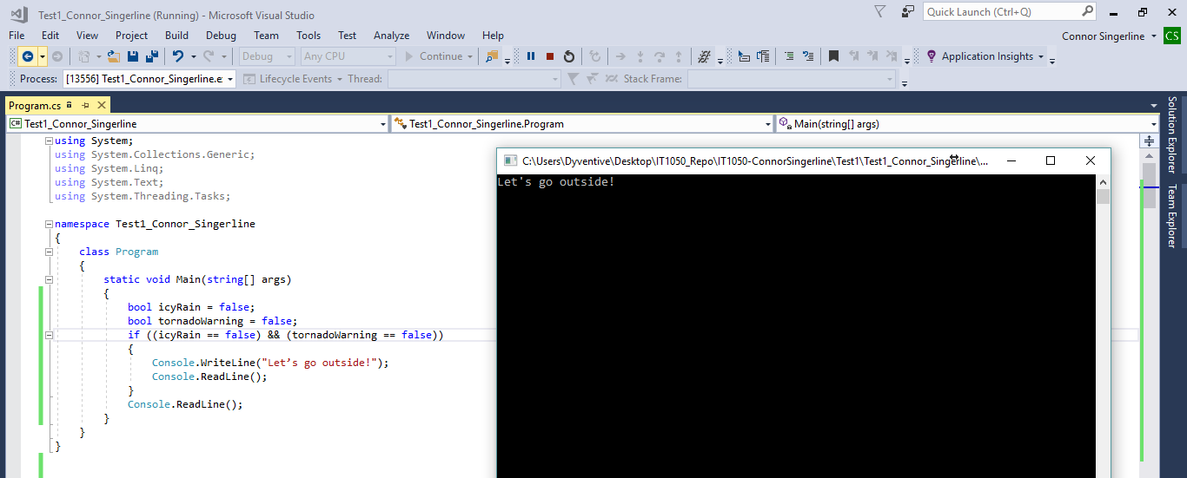

1. Extra Credit: Use nested loops to print the following to the console:

123454321

1234321

12321

121

1