Home Screen

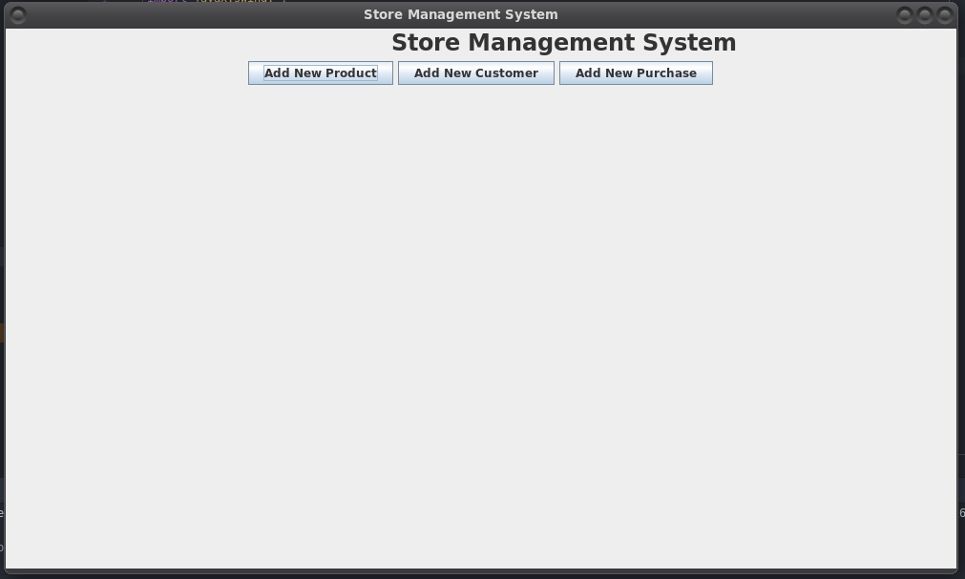

Add New Product Screen

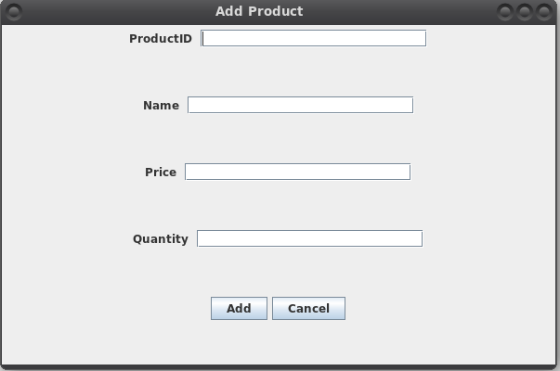

Product Added Successfully Screen

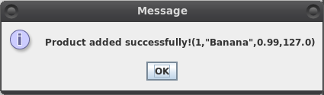

Add Product Error Screen

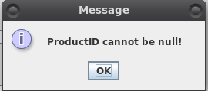

Add New Customer Screen

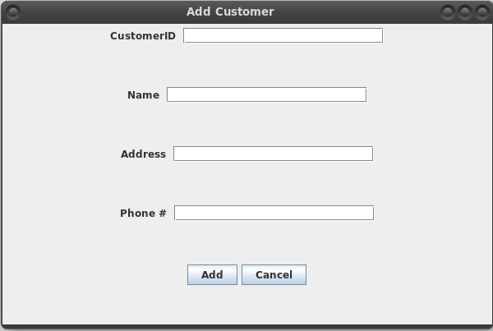

Customer Added Successfully Screen

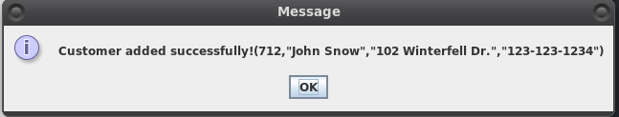

Add Customer Error Screen

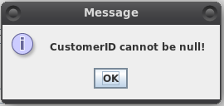

Add New Purchase Screen

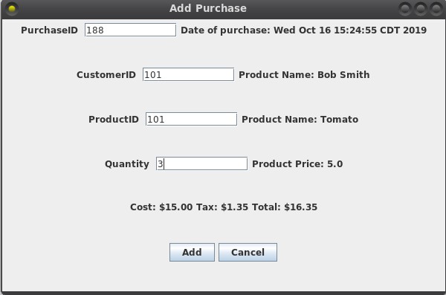

Purchase Added Successfully Screen

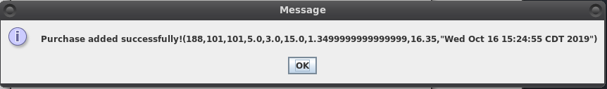

Add Purchase Error Screen

