Misael Perez

Connor Twohey (1001177282)

CSE 4340

Lab 3 Write-up

LIMITATIONS:

* None

INSTRUCTIONS:

1. Download the repo of Iotivity from correct sources (depends on running OS)
2. Install necessary libraries and tools as listed in the Iotivity documentation for appropriate OS.
3. Use $scons in the root directory of Iotivity project to build project.
4. If everything is installed correctly and the build was completed successfully, then the executable files of the given example files should be in the <iotivity root>/out/<os>/<arch>/release/resource/examples directory.
5. Run ./simpleclient and ./simpleserver either on different machines or on the same machine with two terminal windows.

ASSUMPTIONS:

* Using appropriate OS

Connecting (ran on one machine):

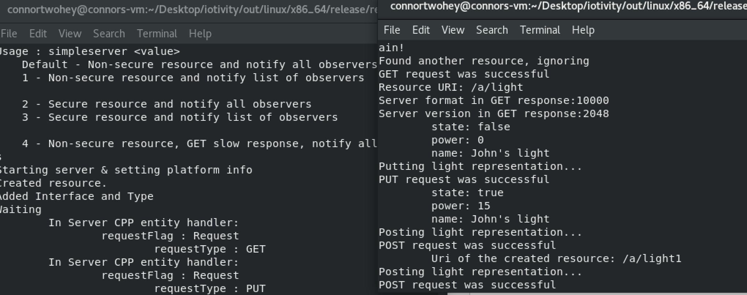

Services syncing together:

