Adam Sami, Connor Williams, Nicolas Montes Aracena, Panagiotis Papakostas
CS3070- Lab Milestone 1
5 Feb 2026

D1 - For userThreadTrivialWorkload.py and kernelThreadTrivialWorkload.py [4 pts]
a) Based on an examination of the code, what do you expect for relative runtime performance & output?

We’d expect the userThread script to run faster due to its use of threading vs the kernelThread creating entirely new processes for each “program”. Both will show a debugging message for free-threading, the output of each “program”, PIDs and Thread IDs (if applicable), as well as the total time to run through the 3 processes.

b) Run them, summarize their differences in output.

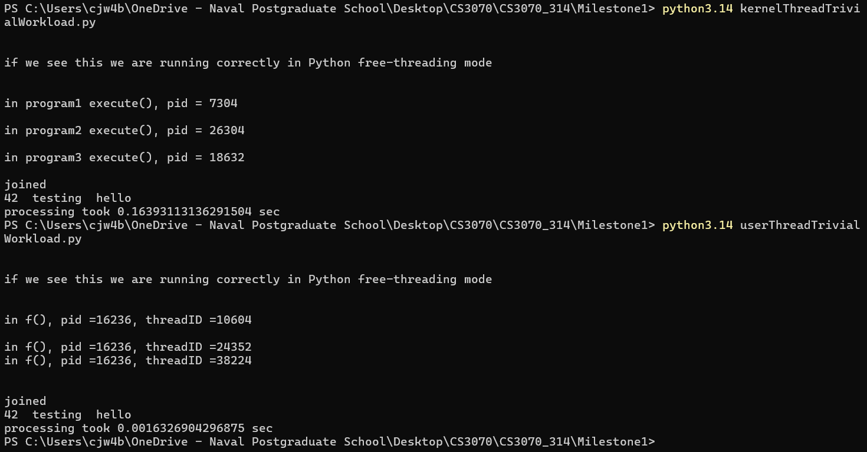

The kernelThread script ran approximately 100x slower than the userThread script. The userThread script all ran under one PID (16236) with 3 different thread IDs, whereas the kernelThread created 3 processes (one for each “program”).

c) Compare your expectations to the actual behaviors, explain any differences.

Our expectation of the userThread script running faster was met, however we weren’t expecting it to be 2 orders of magnitude better than the kernelThread. After researching it a bit more, this was primarily due to the amount of overhead, inter-process communication, and context switching going on in the kernelThread script at a low level (due to creating the 3 separate processes). The userThread script avoided nearly all that complication by multithreading.

d) Is the timing methodology adequate? Why or why not?

The timing methodology is useful and proves a point, but there are a lot of other variables (stdout buffer, process creation, etc.) baked into the timing that muddy the water a bit and make it less of an “apples to apples” comparison. In this instance, the test isn’t an entirely comprehensive nor exhaustive test, however it serves as a useful and adequate initial benchmark for testing the performance of threading vs multiprocessing on simple tasks. This is especially so considering the 100x difference between the two. Even adjusted for the smaller factors, multithreading will be better in this instance every time.

D2 - For userThreadHeavyWorkload.py and kernelThreadHeavyWorkload.py [4 pts]
a) Based on an examination of the code, what do you expect for relative runtime performance & output?

We’d expect the userThread script to again run faster due to the overhead costs associated with setting up three processes to determine prime-ness. We think that it may be closer than the previous question due to the heavier workload associated with checking for prime-ness. Both threads will output a debugging message, program number with PID and ThreadID (if applicable), as well as a summary output of execution time and the answer (True or False for isPrime). The kernelThread will also output time taken per process.

b) Run them, summarize their differences in output.

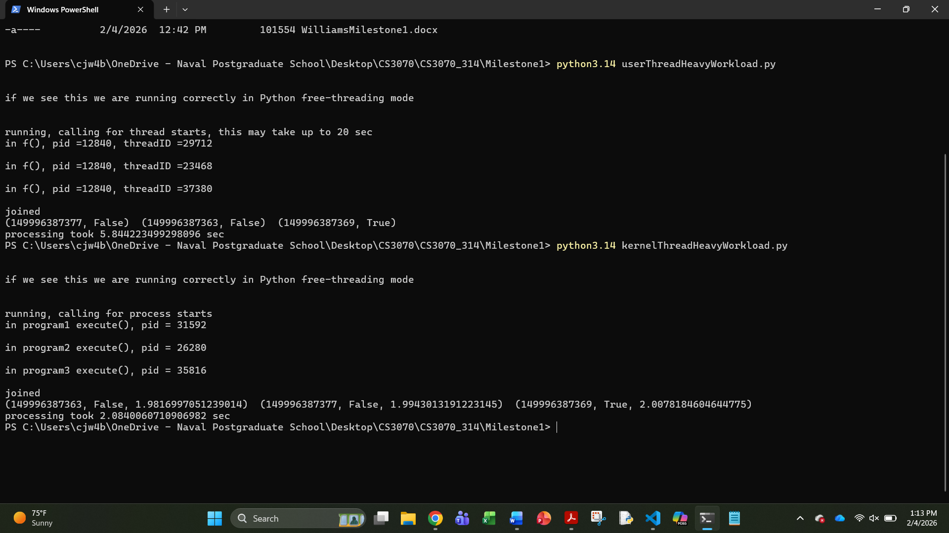

The actual screen output was as expected from the code. userThread showed the PID (same for all three “programs”) and the associated threadID for each one. The script checked all three numbers for prime-ness and displayed the results and the time it took. kernelThread showed the same, just the various PIDs for the three programs as well as the time to run each. Interestingly, the longest forked process took ~2.01 seconds but the parent took another ~0.07 seconds to join them all and display the results. Also interestingly, the userThread script took 2-3x as long as the kernelThread script to execute.

c) Compare your expectations to the actual behaviors, explain any differences.

We were expecting the userThread to run faster, so obviously we were mistaken there. It’s likely due to the computation heavy task in this specific example. Multiprocessing allows each process its own memory and interpreter (versus multithreading which has some shared structures), which is optimal for a job like this with likely hundreds of thousands of temporarily stored integers/floats and millions of computations.

d) Is the timing methodology adequate? Why or why not?

Like question D1d, the timing methodology proves a point, but it isn’t a clean cut, perfect demonstration of one method being “better” or faster than another. It shows that for one instance with some arbitrary length integers, multiprocessing is faster for checking prime-ness. That said, multiple iterations should be run on integers of other length as well to determine if/when there is a break point. The relative closeness of the two methods leads us to believe that the two methods are more competitive than a clear better/worse scenario (like with D1).

D3 - With respect to D1 & D2 parts d) [8 pts]
a) If there is a difference in answer d) between D1 and D2? Why

Yes. In D1, multithreading beat multiprocessing by two orders of magnitude. It wasn’t remotely close on a relative scale. The timing proved that clearly, and even adjusting for some of the variables, the result likely wouldn’t have changed considerably. Certainly not enough to question multithreading’s superiority for a task like this.
In D2, however, the results were a lot closer (relatively). Variables like the amount of print statements, type of queue, type of computation, size of integer to be checked, prime checking function, and many others factor into the equation for how long each script will take. While the multiprocessing script was clearly faster (and likely generally will be for computationally heavy jobs), more testing with different controlled parameters should be done to find the approximate threshold between the two methods.

b) If the answer is yes: What could be done to fix this? If the answer is no: Why is it not necessary to adjust?

Assuming the same core test (checking prime-ness of large integers), a tester could control for other variables (number of numbers to be checked in one go, digits in the number itself, etc.), as well as fiddle around with other things like different built in libraries/functions optimized towards multithreading or processing. Really just exploring other adjacent tests to get a better picture on both methods’ performance in slightly different circumstances.

D4 - In a paragraph and/or a handful of bullet points, compare and contrast user and kernel threads providing an example problem for each where it is favored over the other. [4 pts]

Multiprocessing forks entirely new child processes when called, complete with their own memory space and interpreter state. This takes maximum advantage of multiple cores, but it does have somewhat significant overhead when setting up/tearing down. Multithreading creates multiple threads all within the same process that execute in parallel but still share certain structures. In a sense, threads are “light” version of processes- They facilitate parallel execution but without the costs & benefits of creating entirely separate processes. Multithreading is great for minimally intensive processes that need to run in parallel, potentially like displaying some family of static objects to the screen. Anything with minimal computation and CPU load. Multiprocessing is better for more complex, computation heavy tasks. An example is a brute force password breaker. It could initiate a separate process controlling for some character in the password (e.g. first character is 1, 2, 3, etc.), then check all the associated permutations. This task requires a lot of computation and iteration, making it better suited for execution via multiprocessing than multithreading.

