Security Incident Response Report

1. Contact Information for this Incident
Name(s): | Connor Smith
Date of Report: | 03/05/2020
2. Detection
Provide a brief description of what was detected and the security threat, vulnerability, or breach identified:
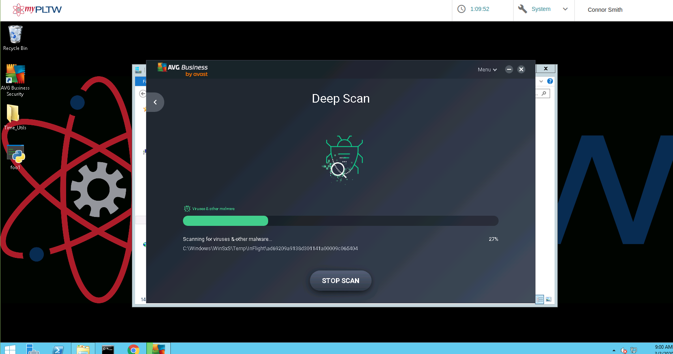
Avg scan would stop at 27% and would not continue. Not sure if it was an error or something wrong with scanning the C: Windows

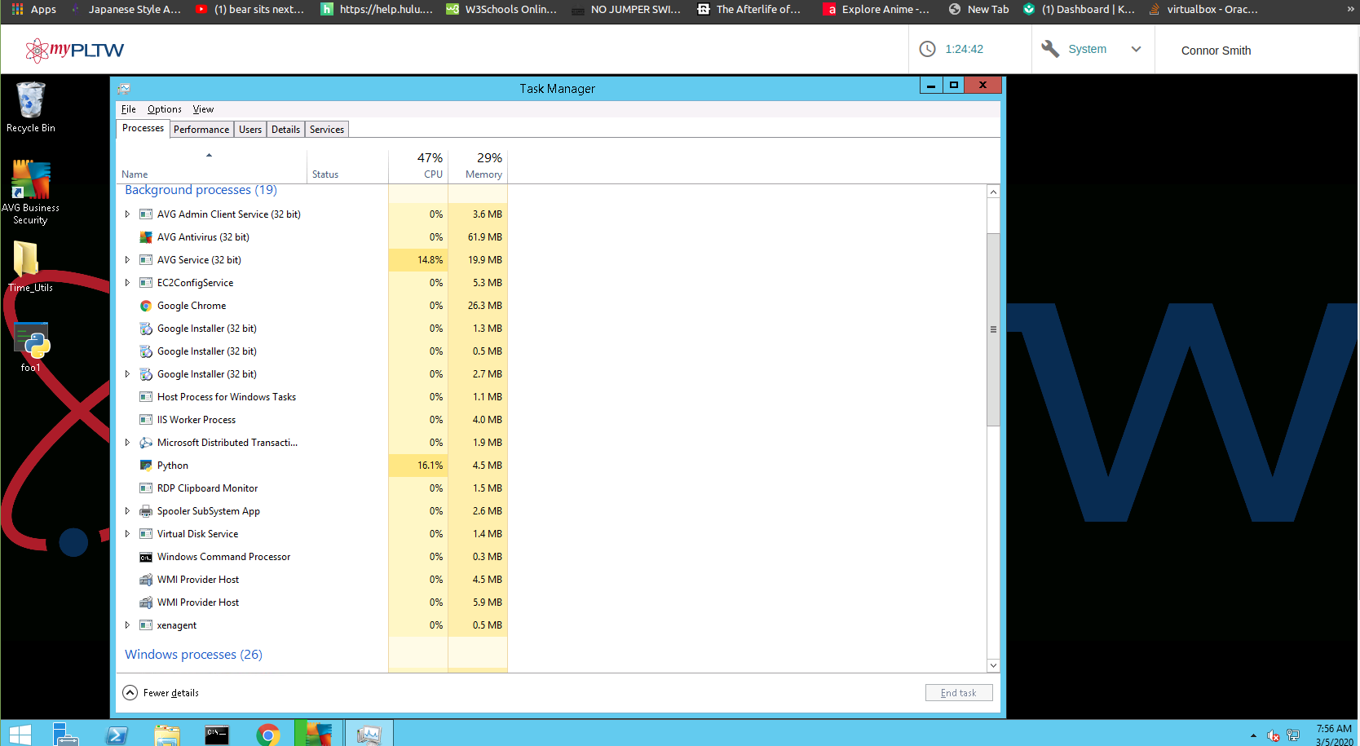

Python background process took up a lot of the CPU. I ended the task and had avg scan it.

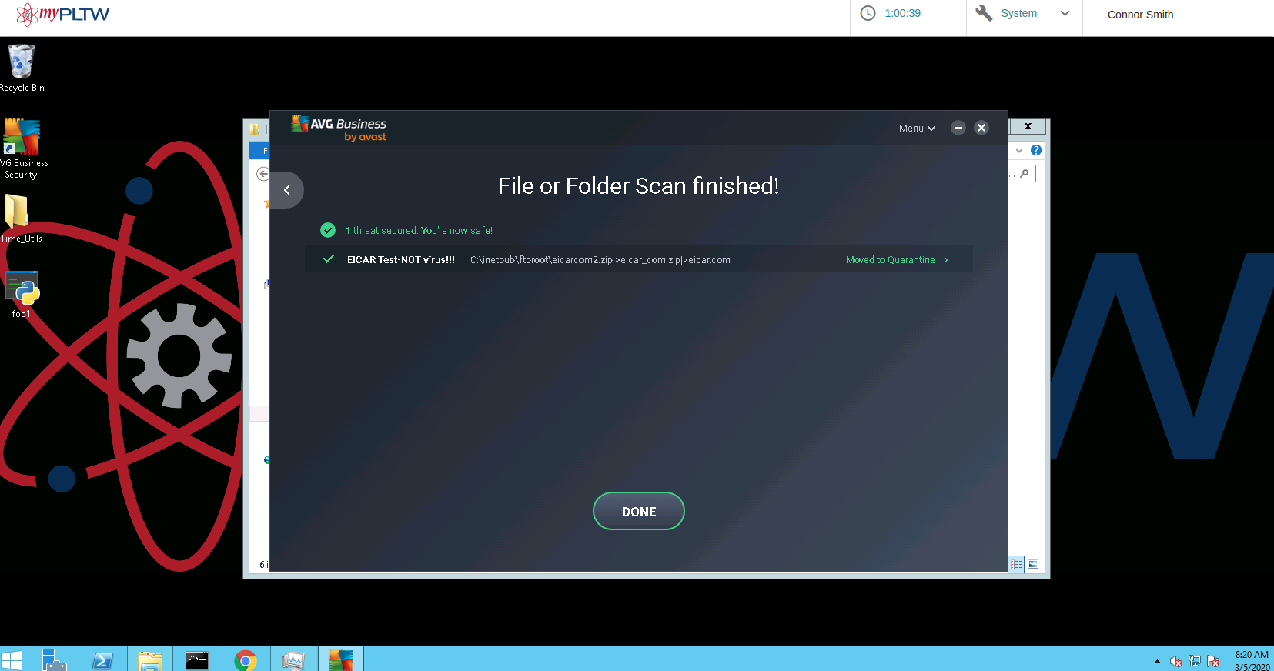

Threat detected while scanning /c:/inetpub.
Threat moved to quarantine by AVG.

3. Response
Provide a brief description of the actions you took to contain and eradicate the security threat, vulnerability, or breach:

Scanned C: drive with avg and found 2 threats that were eradicated.

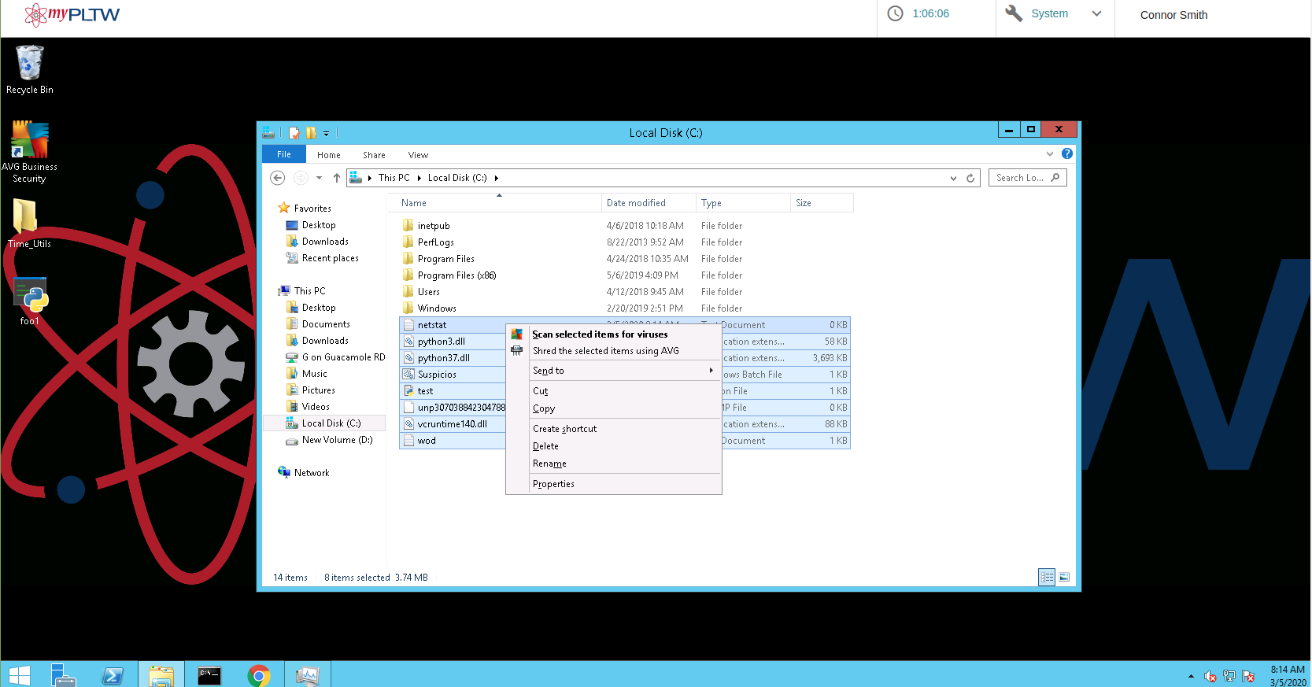

Using Avg scanned weird files on the c: drive with suspicious names.

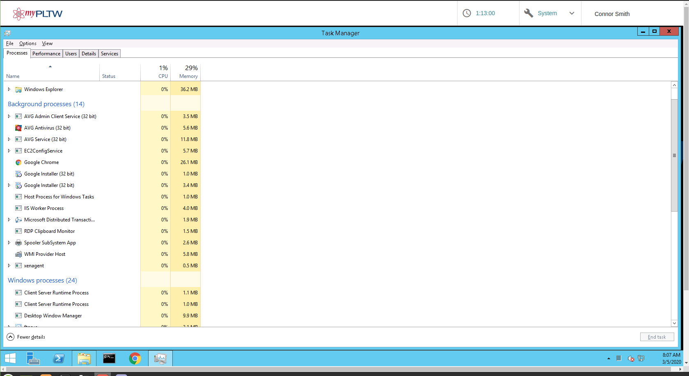

Ended all background tasks that seemed suspicous
to speed up cpu and find more potential threats

4. Recovery
Provide a brief description of the actions you took to recover any affected data:
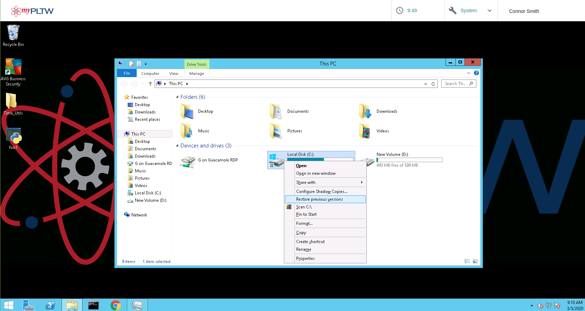
Couldn't find any missing data

scanned whole c: drive using avg
5. Identify
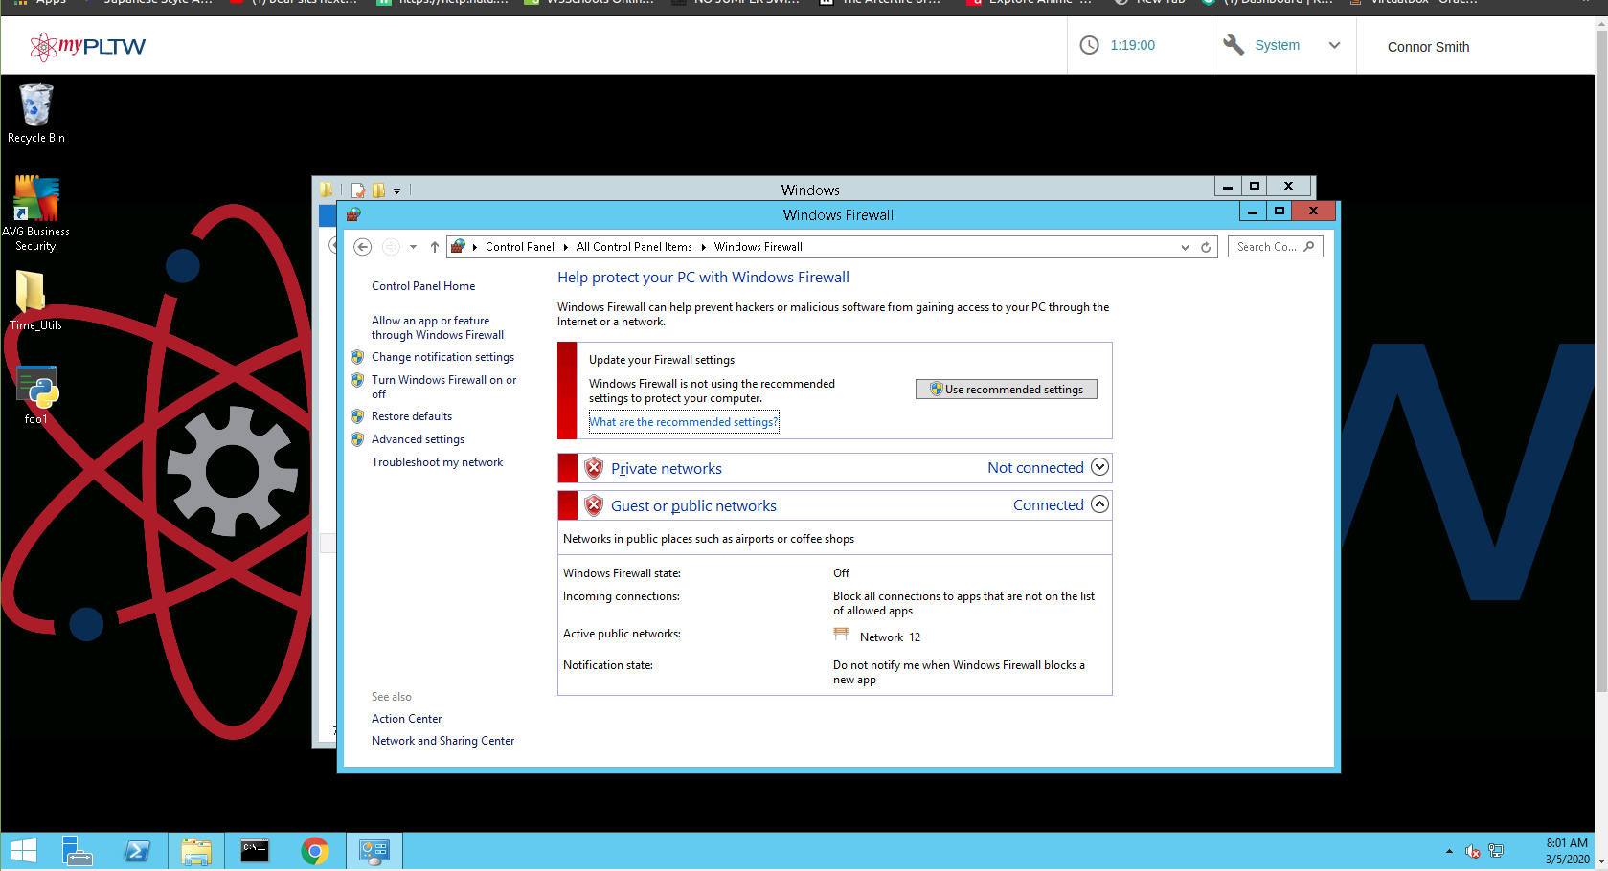
Provide a brief description of any assets you identified that need to be protected:

Firewall and system security settings were not set.

Avg protection for the computer and web were not set.
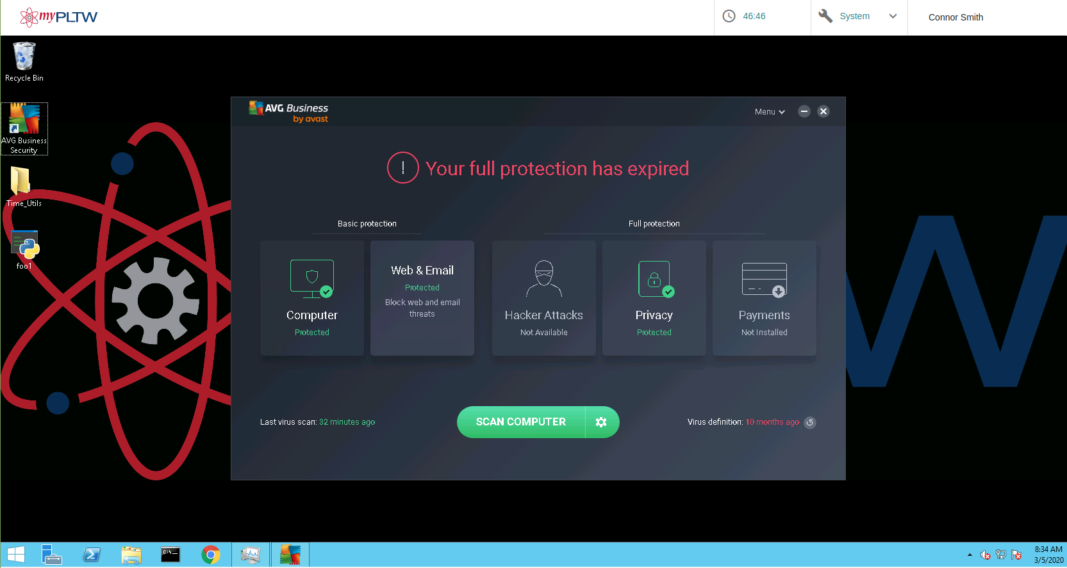

Google security setting also were not set.

6. Protect
Provide a brief description of the actions you took to protect your assets from future threats:
Changed avg settings so the computer and web are being scanned.

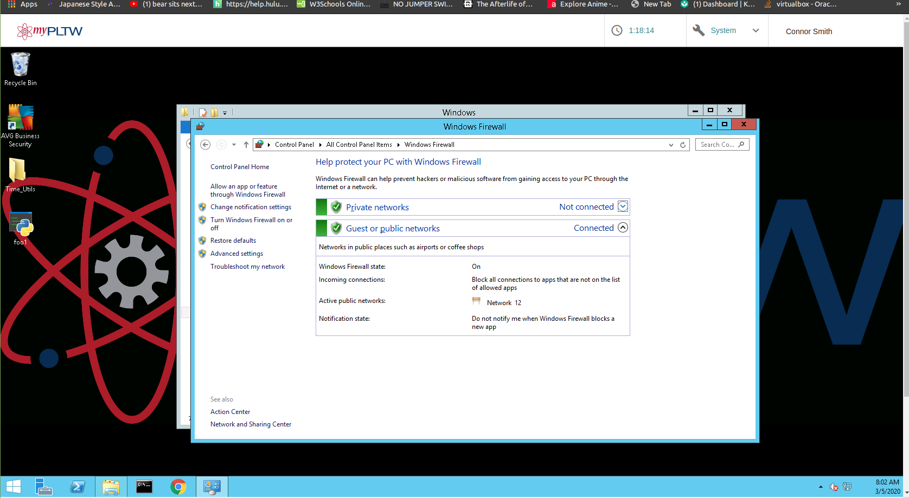

Changed system security and firewall settings

changed google security settings.

7. Lessons Learned
Please describe two lessons your team learned while solving this problem.

Having a software program like Avg that protects your computer from viruses and threats is essential when you have private data on your computer that you need to keep private.

Cyber security involves a lot of documentation
8. Other Information
Please provide any additional information you feel important.

Please submit this completed form to your teacher.

