Analysis of Algorithms

*Defend all answers based on specific references to the code. Do not count return statements or initialization of method arguments. You are* ***strongly*** *encouraged to walk through algorithms in the debugger and to add statement-counting code to given methods to test and refine your analysis.*

# Algorithm: find()

# Minimum Statements:

# How many statements would be executed in a call to find() when the array size is zero (n == 0)?

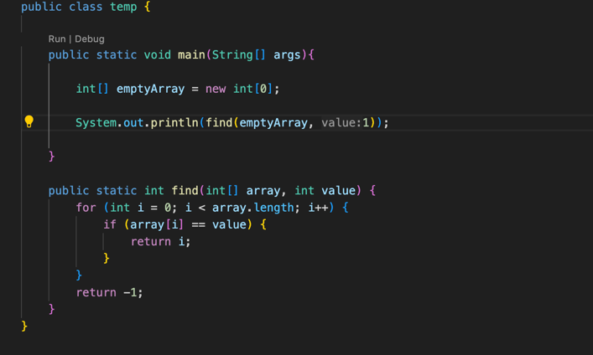

If the array size was 0 then only 2 statements would be executed. First the for loop which will determine the size, and second the return statement returning -1.

# Best Case Scenario:

# Under what conditions would the minimum number of statements be executed for an array where n is large?

The minimum number of statements executed would be 3 statements. One, for the for loop, another for the if statements, and the last one for the return statement.

# Where would the target element be located in the array?

In the best case scenario the target element would be located in the first index of the array (array[0]).

# What is the growth function under these conditions?

The growth function for the find(); method in the best case scenario would be o(n) or logarithmic.

# Worst Case Scenario:

# Under what conditions would the maximum number of statements be executed for an array where n is large?

The maximum number of statements that would be executed for an array that is n large is: 2n + 1. Which means the loop will run n times(+n), and also the if statement will run n times (+n) and then finally when it cycles through the whole array it will run the return statement once (+1).

* Where would the target element be located?

In the worst case scenario the target element would be located in the very last index of the array, Or not in the array at all.

# What is the growth function under these conditions?

The growth function for the find(); method in the worst case scenario would still be o(n) or logarithmic.

# Expected Average Case Scenario:

# Assuming a random array of unique elements and the target element is in the array, where would a target element be located on average?

In an average case scenario the target element would be located in the middle of the array.

# What is the expected average number of statements (the expected growth function) for a call to find()?

The average expected number of statements for a call to find would be (2n + 1) / 2. I wrote this because instead of running through all the statements in the loop it would only run through half, which would be half the number of statements for the worst case scenario.

# What is the runtime order (big-O) of find() based on the above growth functions?

The big-O notation for find base on the above growth functions is O(n) or logarithmic.

# Algorithm: replaceAll()

# Minimum Statements:

# How many statements would be executed in a call to replaceAll() when the array size is zero (n == 0)?

The amount of statements that would run if the size of the array was zero would be 3 statements. The first statement would be declaring the integer variable (.int index = find(array, oldValue);). The second statement would be the for loop inside the find(); function, and the last statement would be the return -1 from the find(); function.

# Best Case Scenario:

# Under what conditions would the minimum number of statements be executed for an array where n is large?

The minimum number of states that would be executed, assuming array[0] had the value of -1, would be 8 statements.

I came to this conclusion assuming one statement would be used for declaring the integer,

3 statements would be the minimum for statements for the find(); function,

And 1 statement to get out of the while loop.

# How many occurrences of the oldValue element would be in the array?

There would be 0 occurrence of old values in the array because the while loop was never started because the index was < -1.

# Where would it/they be located in the array?

There wouldn’t be any in the array.

# What is the growth function under these conditions?

Growth function under these conditions are: 1(declare int) + 2n + 1(find function) +1 (while loop) which would be 2n + 3.

# Worst Case Scenario:

# Assuming newValue and oldValue are not equal, under what conditions would the maximum number of statements be executed for an array where n is large?

This one was tough.

# How many occurrences of oldValue are in the array?

It would fill the whole array.

# Where would it/they be located?

It would be located at either the end of the array or not in the array at all.

# What is the growth function under these conditions?

The growth function under the worst-case scenario would be 4n^3 +14n^2+14n+4.

# Expected Average Case Scenario:

# Assuming a random array of unique elements and oldValue is a value in the array, what is the average number of statements (the expected growth function) for a call to replaceAll()?

4n^3 +14n^2+14n+4.<-- The average of this cubic function.

# What is the runtime order (big-O) of replaceAll() based on the above growth functions?

The growth function of replaceAll() would be O(n^3). Because the highest coefficient in the growth function is 4n^3;

# Algorithm: sortIt()

# Minimum Statements:

# How many statements would be executed in a call to sortIt() when the array size is zero (n == 0) or one (n == 1)?

It would only execute one statement if array size was n ==0. which would be the initialization of for loop where next > array length and exit the for loop .

If the array size was n == 1 then the statements that would be executed would be only one statement also because next wouldn’t be less than the array length.

# Best Case Scenario:

# Under what conditions would the minimum number of statements be executed for an array where n is large?

The minimum number of statements to be executed would be n^2+5n+6. I got this by giving the for loop an “n” and every statement that wasn’t a loop a “1” which equaled (n+3). Then I multiplied that by the for loop + its single statements (n+2). To get n^2+5n+6

So the minimum statements would be 12 in best case scenario. n^2+5n+6 (n=1)

# Would the algorithm execute a different number of statements if the elements in the array were already in sorted order? Reverse order? Random order? All the same value?

The algorithm would execute the same in the best case scenario if the int in the array was found in first in the array.

# What is the growth function under the best case conditions?

n^2+5n+6 Is the growth function.

# Worst Case Scenario:

# Under what conditions would the maximum number of statements be executed for an array where n is large? (Already in some kind of sorted order? Duplicates?)

n^2+5n+6 in the worst case.

# What is the growth function under the worst case conditions?

n^2+5n+6 Is the growth function. ??

# Expected Average Case Scenario:

# Assuming a random array of unique elements, what is the expected average number of statements (the expected growth function) for a call to sortIt()?

Average number would be something that gets the average of a quadriatic function.

# What is the runtime order (big-O) of sortIt() based on the above growth functions?

The big-o for the above function would be O(n^2).