Task II

小组成员：沈正圆 2111812118 专硕1802

孙剑

张雄波

沈雷钊

**EMG signal test report**

Electromyography (EMG), the use of electronic instruments to record electrical activity when muscles are still or contracted, and the use of electrical stimulation to examine nerve, muscle excitation and conduction functions. English referred to as EMG. Through this examination, the functional status of peripheral nerves, neurons, neuromuscular junctions, and muscles themselves can be determined. The purpose of this experiment is to classify the acquired EMG signals, including collecting data, forming data sets and test sets, and model training.

First of all, for the data acquisition part, the signal generated by the precise action is more convenient to classify. We specify the action mode of the acquisition. Before the official acquisition starts, set the save time according to the selected number of acquisition actions. If 10 sets of actions need to be collected, set to 100000. (100s), if 8 sets of actions are collected, set 80000 (80s). Each set of actions takes up 10 s. Here we have 5 sets of actions:

0-5s: rest, keep hands relaxed

6-10s: Action 1

11-15s: rest, keep hands relaxed

16-20s: Action 2

21-25s: rest, keep hands relaxed

26-30s: Action 3

31-35s: Rest, keep hands relaxed

36-40s: Action 4

41-45s: rest, keep hands relaxed

46-50s: Action 5

51-55s: Rest, keep hands relaxed

Second, read the acquired signal and form a training set and test set in a ratio of 7:3. The code is shown in Figure 1.

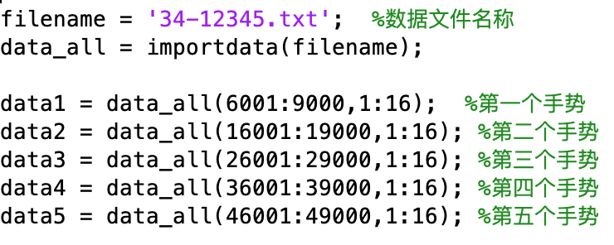

Figure 1-a Data read

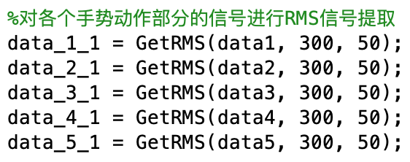

Figure 1-b Extracting the RMS signal

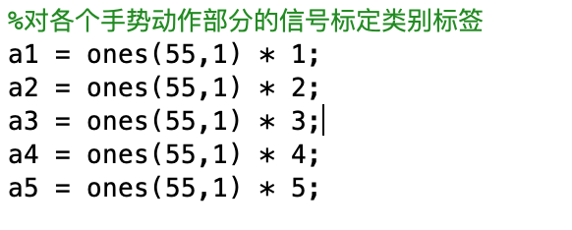

Figure 1-c Calibration Label

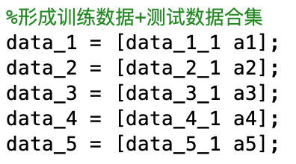

Figure 1-d Forming training data + test training collection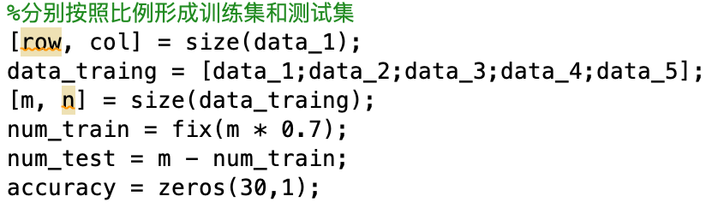

Figure 1-e Forming a training set and test set

The RMS signal extraction part of the code is shown in Figure 2.

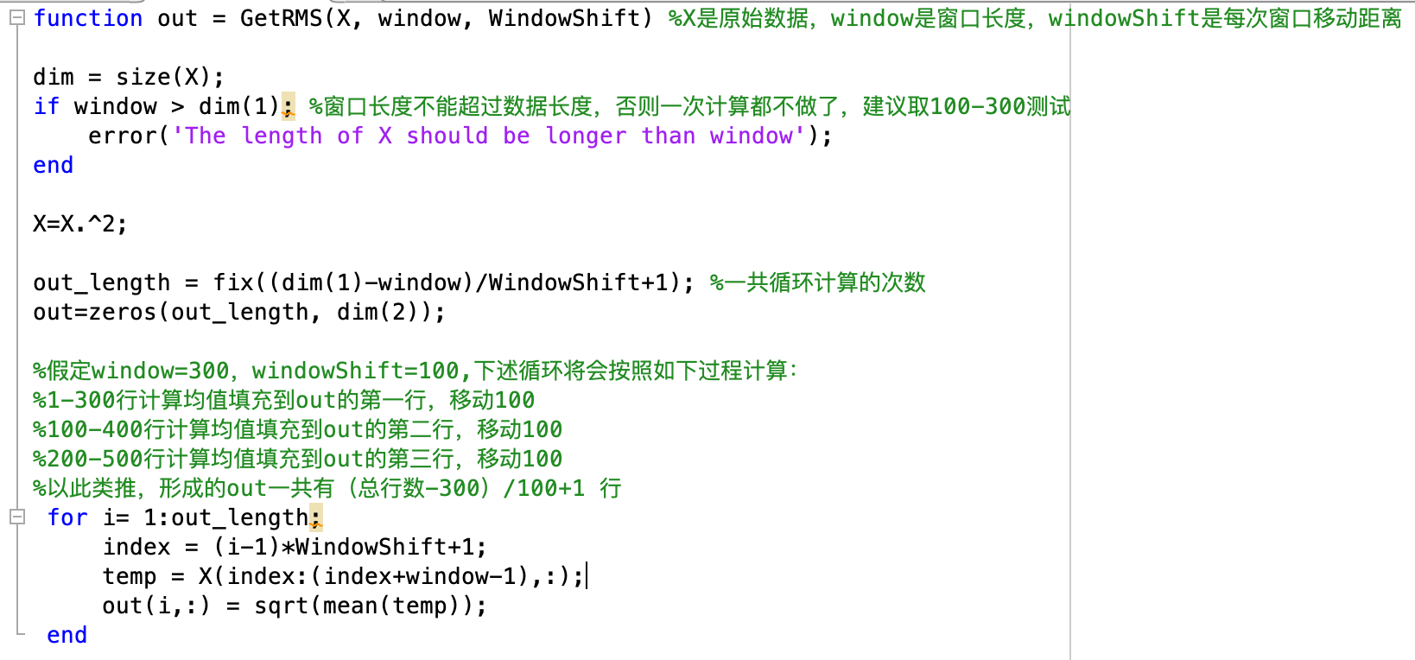

Figure 2 RMS signal extraction

We use a total of four classification methods to classify, the code of the key algorithm is shown in Figure 3.

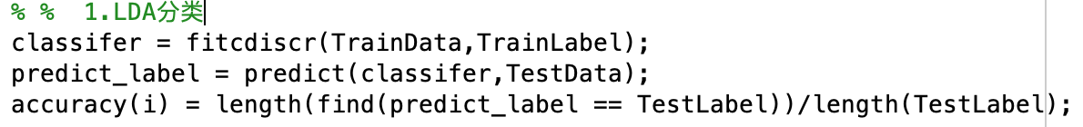

Figure 3-a LDA classification algorithm

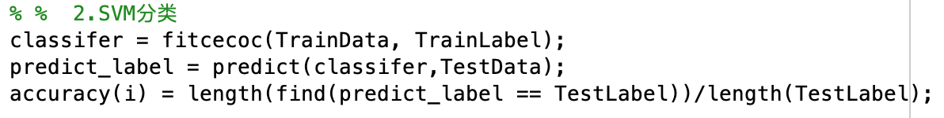

Figure 3-b SVM classification algorithm

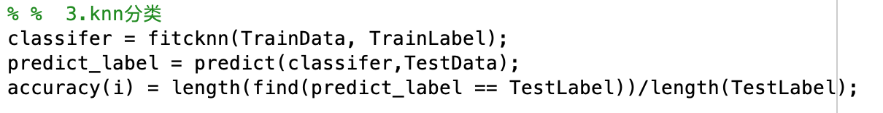

Figure 3-c KNN classification algorithm

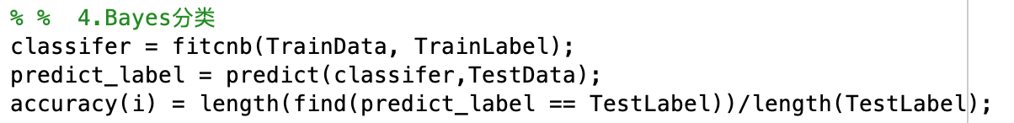

Figure 3-d Bayes classification algorithm