**Water Quality Modeling and Prediction Method Based on Sparse Recurrent Neural Network**

**Abstract:** It is an important prerequisite for scientific management and maintenance of water resources to accurately predict all kinds of indicators that affect water quality. *This paper proposed a method of forecasting water quality index and rank based on sparse recurrent neural network (SRNN). Based on the principle of minimum mean square recursive error, the training algorithm of the network was designed. The neural network was used to construct a water quality prediction model.* The experimental results showed that the model can be used to predict the trend of water quality in ZheJiang province.

**Keywords:** water quality modeling; water quality prediction; sparse recurrent neural network; learning algorithm

**Introduction**

With the rapid economic development and population growth, sewage and wastewater generated by the production and living of human are posing a serious threat to the water quality of lakes and rivers.[1]。There are various problems such as water shortage, water pollution and deterioration of water ecological environment in all parts of China [1], which has become the main bottleneck restricting the sustainable development of economy and society. In order to effectively solve this problem, the rational planning of water resources is particularly important. In order to effectively solve this problem, the rational planning of water resources is particularly important[2, 3]. Accurate detection of water quality parameters of rivers and lakes, as well as reasonable prediction of future changes in water quality parameters [4], is a necessary prerequisite for scientific planning of water resources. Water quality prediction is the process of constructing a water quality model using existing data and then estimating the future water quality parameters of the predicted point via the model. Common predictive models can be divided into two categories: Principle Driven Model (PDM) and Data Driven Model (DDM).

PDM is generally based on the principle of mass and energy conservation, and considers the interaction between water quality components and its own biochemical effects, and then through the construction of hydrodynamic motion and energy equations of water [5, 6]. Typical principle driven water quality models include the Streeter Phelps(SP) model for quantifying oxygen balance[7], which is often applied to simple water body self-purification; a QUAL model capable of simulating up to 15 water quality components [5], which is often used to study the impact of influent wastewater load on the water quality of the receiving river; the Water Quality Analysis Simulation Program(WASP) model of pollutant interaction[6] and the BASINS model combined with geographic information system[5, 8]. The above prediction model has been widely used in water pollution control and early warning, water quality planning and other fields because it can accurately describe the relationship between various components of water. For PMD, however, once the factors affecting water quality change, it is often necessary for domain experts to redesign the model, resulting in the lack of flexibility in the application of such water quality models.

The construction of DDM which is different from PDM does not necessarily require the participation of domain experts. It only needs to input a large amount of water quality data into a learning model, and then adjust the parameters of the learning model according to the algorithm to obtain the mapping between the input data and the data to be predicted. The learning model with adjusted parameters can be used for water quality prediction. Common learning models include various regression analysis based on statistical principles[9-12] and artificial neural network model[13-18] Artificial Neural Network(ANN). Because of the learning process of these models, they can be applied to various water quality prediction under the changeable environment scenarios.

In order to obtain higher prediction accuracy, the ANN model commonly used in DDM often needs a large number of historical water quality data, and then automatically learns the water quality prediction model to meet the demand according to the historical data. However, the Back Propagation(BP) network which is commonly used in ANN often has the disadvantage of slow convergence speed. In addition, BP network is a typical feedforward structure neural network, but water quality data is often a time series[19]. BP network is difficult to simulate the time correlation between water quality data. To this end, this study based on the latest theoretical research results of the prefrontal cortex in neuroscience[20, 21], through the construction of a sparsely connected large-scale recurrent neural network and the recursive least mean square error algorithm to quickly learn the water quality data mode. The accuracy of the model was verified by predicting the water quality indicators such as ammonia nitrogen, dissolved oxygen, permanganate index, total phosphorus and total nitrogen in a reservoir.

**1 Water quality model**

This study used a sparsely connected recurrent neural network (SRNN) to simulate the temporal correlation between water quality data. SRNN which is unlike common recurrent neural networks contains a large number of neurons. The positive and negative connection weights between neurons are roughly the same. In particular, when the intensity coefficient of weighted connections between neurons in SRNN exceeds a certain threshold, the spontaneous activity of the recursive network will exhibit chaotic characteristics [17]. This feature makes the network have strong state coding capabilities. SRNN has been widely used in cognitive modeling of neuroscience. Some theoretical neuroscientists even speculate that SRNN is similar to the function of the prefrontal cortex of the brain [18].

**1.1 SRNN network structure**

As shown in Figure 1, the SRNN contains three parts, an input layer y, a recursive layer x, and an output layer z. Vector **y** = [*y*1, *y2,…, y*m]Trepresents the input layer neuron activity, where *yi* is the input water quality indicator and the superscript T is the transpose.

Figure 1 Structure of SRNN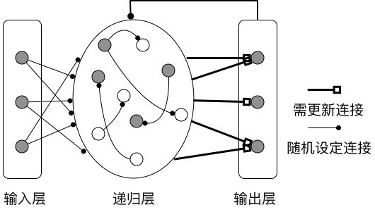

Neuronal activity level is represented by recursion x, whose activity was calculated by the formula:

$τ\frac{dx}{dt}= -x+ w^{RNL}r+ w^{in}y+ w^{fb}z$ (1)

Among them, **r** = tanh(**x**) represents the rate of release of recurrent layer neurons and tanh is a hyperbolic tangent function as well as the activation function of recursive layer neurons. $τ=0.01$ is the neuron activity decay constant.

$w^{RNL}$ represents the recursive connection matrix between neurons in the recursive layer. Since the recursive layer has *N*=1000 neurons, $w^{RNL}$ is a matrix of size 1000×1000. The element $w_{ij}^{RNL}$ in the matrix represents the connection weight between the i-th neuron and the j-th neuron in the recursive layer. The recursive layer is a sparse connection, and $w_{ij}^{RNL}$ sets the probability of $p=0.1$ to a non-zero value and the probability of $1-p=0.9$ to zero.

This means that only a few of the reciprocal layer neurons have a mutual connection. The value of the non-zero element of $w_{ij}^{RNL}$ is randomly selected from the Gaussian distribution Norm(0, g^2/pN), where $g$ is the intensity coefficient of weight. When $g≥1.5$, the recursive layer neurons will have the spontaneous activity of chaotic characteristics [17].

$w^{in}$ represents the connection matrix between the input layer and the recursive layer.

The weights are randomly selected according to the Gaussian distribution *Norm*(0, 0.5). $w^{fb}$ is the connection weight of the output neuron feedback back to the layered neuron, it is still a sparse connection. 90% of the weights are set to 0, and other non-zero elements are still randomly selected according to the Gaussian distribution $Norm(0, 0.5)$.

**z** is the output layer neuron activity, corresponding to the predicted output, and its calculation is determined by:

$z= wr$ (2)

$w$ represents the connection matrix between the recursive layer and the output layer. The recursive layer and the output layer are fully connected, and the weights are randomly assigned according to a uniform distribution between [-1, 1]. $w$ is different from $w^{RNL}$, $w^{in}$, and $w^{fb}$. Its element values need to be updated during the learning phase, while the values of $w^{RNL}$, 、 $w^{in}$, and $w^{fb}$ remain unchanged during the learning period.

As can be seen from the structure of SRNN, it is similar to the Echo State Network (ESN) [22].

They all have a recursive layer and the learning process only adjusts the weight between the recursive layer and the output layer. However, SRNN and ESN also have the following differences. First of all, the SRNN's recursive layer connection weight does not need to be specially set, but the ESN needs to have a weight matrix with a spectral radius greater than or equal to 1 in order to achieve reverberation. Secondly, the training of ESN is a kind of offline learning. It needs to wait for the network to pre-calculate for a period of time before starting to adjust the weight, but SRNN can update the weight immediately according to the current input.

**1.2 SRNN learning algorithm**

According to the description of SRNN in the previous section, the recursive layer connection weights only need to be randomly selected according to a given probability distribution and use the online learning mode. These features require a learning algorithm that quickly determines how the output weight should be updated so that the network output is equal to the value of the real output.

The target output expected at time *t* is *f(t)*. The real output of the network is $w^{T}\left(t-∆t\right)r$，r. The error between them is $e_\left(t\right)$.

$e_{-}(t)= w^{T}\left(t -∆t\right)r-f\left(t\right).$ (3)

The learning algorithm is to adjust the output weight from $w^{T}\left(t -∆t\right)$ to $w^{T}\left(t\right)$ so that the error $e_\left(t\right)$ is gradually reduced. After the output weight is updated, the output error of the network becomes:

$e_{+}\left(t\right)= w^{T}\left(t\right)r-f(t)$***.*** (4)

After the algorithm converges, the value of $e_\left(t\right)/e_{+}(t)$ should go to 1 and $e_\left(t\right)>e_{+}(t)$. This means that the adjustment of the output weights will not further reduce the output error. In order to achieve fast learning, the weight adjustment of the output requires a quick reduction in the error value during the previous learning. To this end, according to the recursive least mean square error algorithm [23], the output weights are adjusted as follows:

$w\left(t\right)= w\left(t -∆t\right) - e_\left(t\right)P\left(t\right)r(t)$ (5)

Equation 5 shows that the decision to update the output weight is the error $e_\left(t\right)$, the distribution rate ***r*** of recurrence of the recursive network neurons, and the matrix ***P***(*t*).

The function of matrix ***P***(*t*) is equivalent to the learning rate, which is used to determine the size and scale of weight adjustment. However, it is unlike the general learning rate, this learning rate is a matrix. It means that each output weight has its own learning rate, which is one of the main reasons that the algorithm can converge quickly.

The computation of the learning rate matrix $P\left(t\right)$ is carried out in the following way:

$P\left(t\right) = P\left(t-∆t\right)- \frac{P\left(t-∆t\right)r^{T}(t)P\left(t-∆t\right)}{1+r^{T}(t)P\left(t-∆t\right)r^{T}}$ (6)

$P\left(t\right)$ needs to have an initial value in the first step of the algorithm, and then update it every step according to Equation 6. The initial value of $P\left(t\right)$ is set to **I**/α where **I** is a unit matrix of 1000 x 1000, and α is a constant.

**2 Experimental result**

**2.1 Water quality data preparation**

This paper selects the water body data of a reservoir in Zhejiang from May 2012 to May 2015. The data source is the actual value of the water detection by the automatic monitoring station every 4 hours. Dissolved oxygen, permanganate index, ammonia nitrogen, total phosphorus and total nitrogen, were selected to evaluate the water quality grade. In addition, in order to reduce the influence of daytime illumination and human activity factors, only the water data at 4 o'clock in the morning when the water body is most stable is selected. Considering the possible abnormalities of the water quality parameters in the measurement, the data is preprocessed to remove some obvious abnormal data. It uses the Grubbs criterion for outlier detection. First of all, the data is sorted in ascending order. The outliers are sequentially removed from both ends until the data set meets the requirements. In order to determine the anomaly data, it need to calculate:

$G_{i}=\left|X_{i}- \overline{x}\right|/S$ (7)

Where $G_{i}$ is the characteristic data of the Grubbs criterion test. $X_{i}$ is the data to be tested. $\overline{x}$ is the arithmetic mean of the data set. S is the standard deviation of the data set If $G_{s}$ is bigger than $G_{p}(n)$, it is judged that the data is an abnormal value. The critical value $G_{p}(n)$ is determined by the Grubbs table. It is related to the detected level σ = 0.05 and the number n of data of the test data set.

Since the data units and the detection range of the water body index are not uniform, the input data needs to be normalized. The value of the input data x is mapped between 0.2 and 0.8. The normalization formula is as follows:

$y=[0.6*\left(x-min\left(x\right)\right)/(max(x)-min(x))]+0.2$ (8)

The minimum time unit of the data set is day T. T was taken form 7 days, 14 days, and 30 days. They respectively generate 3 sets of training and testing data sets. The water quality data of the data set from May 1, 2012 to April 30, 2014 are selected as training data. The water quality data of the data set from May 1, 2014 to April 30, 2015 are selected as testing data. Ammonia nitrogen, dissolved oxygen, permanganate index, total phosphorus and total nitrogen were selected as the measured parameters to verify the effectiveness of SRNN.

**2.2 Water quality parameter prediction**

Water quality data for several days are used as input to predict water quality afterwards parameters. Network performance is quantified by calculating the root mean square error RMS:

$RMS= \frac{1}{t_{e}-t_{s}}\sum_{i=t_{s}}^{t_{e}}{\sqrt{{\left(\hat{y}\left(i\right)- y\left(i\right)\right)}^{2}}}$ (9)

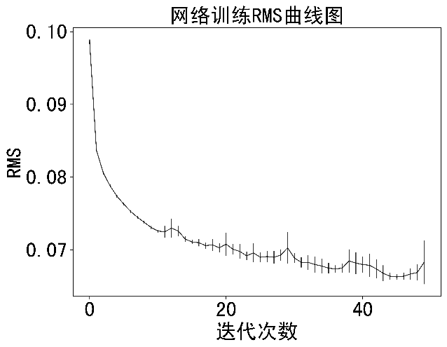

Figure 2 Learning curve for SRNN

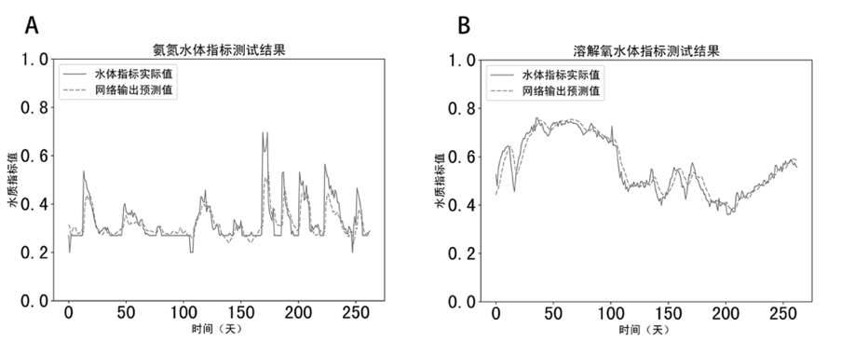

Figure 3 Prediction results for ammonia and dissolved oxygen using SRNN

$\hat{y}\left(i\right)$ and $y\left(i\right)$ are network estimates and real values. *te* and *ts* are the start time and end time. The training results of the ammonia nitrogen index are selected to examine the convergence of SRNN. The number of recursive layer neurons is set to 1000. The weight intensity coefficient g is set to 1.5. The step size of Equation 1 is set to 0.05. The constant α of the learning rate matrix ***P*** is set to 1.5. Figure 2 shows the learning curve of SRNN, that is the change of RMS with the number of iterations. The data in the figure is the result of repeating 10 training sessions. It can be seen from the figure that the value of RMS gradually decreases with the number of iterations. It converges after about 15 iterations, which indicates that the training speed of SRNN is faster.

Although the SRNN training converges faster, it is necessary to calculate the prediction result of SRNN under the test data in order to characterize the prediction ability of SRNN. To this end, we test the prediction results of SRNN on ammonia nitrogen and dissolved oxygen in water quality. The predicted result is shown in Figure 3. The solid line is the measured data of ammonia nitrogen and dissolved oxygen, while the dotted line is the predicted result given by SRNN. Ammonia nitrogen refers to nitrogen in the form of free ammonia (NH3) and ammonium ions (NH4+) in water. The ammonia nitrogen wastewater is mainly derived from chemical fertilizer, coking, petrochemical, pharmaceutical, food, landfill and so on. The discharge of a large amount of ammonia nitrogen wastewater into the water not only causes eutrophication of the water body, but also causes black odor in the water. The trend of the change of ammonia nitrogen in time in Figure 3 indicates (solid line) that the change of ammonia nitrogen in water is extremely unstable and there are often mutations. The dissolved oxygen content in the water is closely related to the partial pressure of oxygen in the air and the temperature of the water. Compared with the ammonia nitrogen index in water, the change of dissolved oxygen index is relatively flat. It is not difficult to find from the prediction results in Figure 3 (dashed line) that SRNN can Accurately predict these two water quality indicators whether it is for the ammonia nitrogen index with mutation (Figure 3(A)) or for the relatively stable dissolved oxygen (Figure 3(B)). The prediction errors (RMS) for the two water quality indicators in Figure 3 against the test data set were 0.065 and 0.057.

Determining the model prediction results are often free parameters in the model, such as the number of BP network hidden layer neurons as well as the initial value of the weight and the strength coefficient *g* of the SRNN recursive layer weight. The generalization ability of the SRNN network is verified by calculating the RMS under repeated tests. Let the intensity coefficient *g* be equal to 0.5, 1.0 as well as 1.5 and run 10 replicates for each parameter. Each repeated experiment includes two phases of training and testing. The weight of each repeated experiment SRNN is randomly selected according to a given distribution. As shown in Figure 4(A), the mean values of the test RMS under the three intensity coefficients are less than 0.08. Their respective variances are 0.0042, 0.0001 and 0.0006. This shows that SRNN can obtain better prediction results under different weight intensity coefficients. In particular, when the intensity coefficient *g* is equal to 1.5, the spontaneous activity of the SRNN recursive network has chaotic characteristics [17]. But SRNN can still obtain better prediction results.

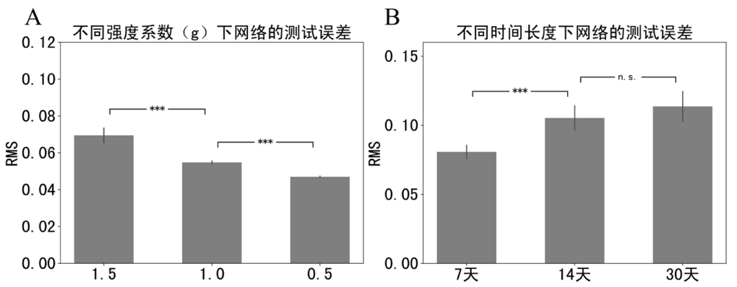

Figure 4 Generalization for SRNN

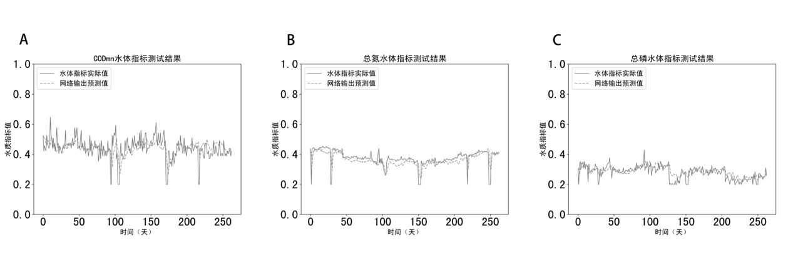

Figure 5 Prediction results for other water quality indicators

The length of the SRNN input sequence has a different impact on the prediction results. As shown in Figure 4(B), the prediction results based on the time series of the previous 7 days are significantly better than the prediction results based on the time series of the first 14 days or the first 30 days.

In addition, SRNN was used to test the three water quality indicators of permanganate index, total nitrogen and total phosphorus in water. The test results are shown in Figure 5. It is not difficult to see that SRNN's predictions for these three water quality indicators are equally accurate.

**2.3 Water quality level prediction**

After successfully predicting water quality indicators, SRNN will be further used to predict water quality levels. According to the National Surface Water Environmental Quality Standard: GB3838-2002, the surface water quality grade (L) is divided into five grades from I to V. Class I-III water meets urban drinking water standards. In order to correspond to the five levels of water quality, the output of SRNN is modified to 5 neurons. Each neuron corresponds to a level. The five neurons with the highest rate of release are set to the output of SRNN:

$L=\underset{i}{argmax}\left[z_{1}, z_{2}, z_{3},z_{4},z_{5}\right], i=1/2/3 /4 /5.$ (10)

When the output result **z** = [0.001, 0.089, 0.2, 1.23, 0.5]T and the index *i* of the largest element in **z** is 4, then the water quality level *L* predicted by SRNN is IV. In order to more accurately describe the relationship between the predicted level and the true level, the relative distance *D* between the two levels is also calculated to represent $e_\left(t\right)$. The setting of $e_\left(t\right)$ is shown in Table 1.

Table1 Training error setting

|  |  |  |  |  |  |
| --- | --- | --- | --- | --- | --- |
| *D* | 0 | 1 | 2 | 3 | 4 |
| $$e_\left(t\right)$$ | 0 | 0.15 | 0.25 | 0.35 | 0.45 |

Training use a total of 368 data sets with a 7-day monitoring interval from May 1, 2012 to April 30, 2014. Testing use a total of 200 data sets with a 7-day monitoring interval from May 1, 2014 to April 30, 2015. Through 20 repeated experiments, the best correct rate of water level prediction was 89%, as well as the average correct rate was 85.6%. At the same time, this paper also tests the SRNN forecast to reach the water quality level in the next 2 to 6 days. The correct rate of prediction results is above 80%. It is shown in Figure 6

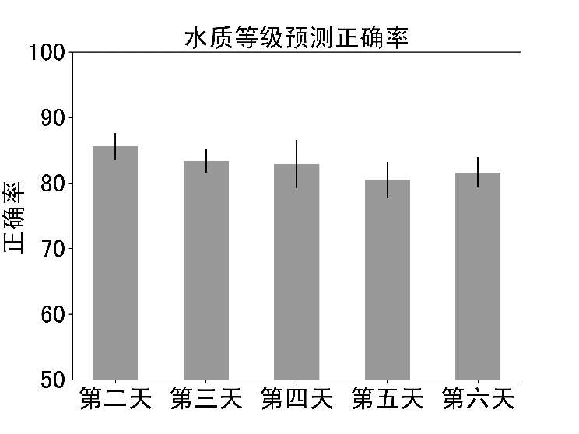

Figure 6 Predict water quality level using SRNN

**2.4 Model comparison[1]**

The effectiveness of SRNN has been demonstrated by predicting different water quality indicators and water quality levels in water. In the following, we will further explain that SRNN is more suitable for the prediction of water quality indicators and grades with time correlation by comparing with the prediction results of BP neural network. BP neural network model structure is a three-layer structure BP. The number of neurons in the input layer corresponds to the input length of the data. The time scale of the input data is converted together into the input of the BP network. The number of hidden layer neurons is taken as 13, and the number of neurons in the output layer is set to 1 or 5 according to the prediction task. The experiment was repeated 10 times. The comparison between the BP network and the SRNN prediction results is shown in Table 2.

**3 Discussion**

In this paper, a recurrent neural network with sparse connection features was designed to model the water quality data. The mean square recursive error algorithm was used to train the network to predict various indicators of water quality and water quality levels. The simulation results show that SRNN has better prediction ability. In particular, SRNN has few free parameters. The three weights of $w^{RNL}$, $w^{in}$, and $w^{fb}$ only need to be randomly set according to the distribution to obtain better prediction results. This makes SRNN easier to apply to environmentally variable water quality predictions.

SRNN which is similar to Echo State Network (ESN) training only needs to adjust the weight between recursive layer and output layer. This greatly improves the operational efficiency of the recursive network. Since there is no need to adjust the connection weights between the neurons in the recursive layer during learning, the recursive layer of SRNN and ESN can be considered as a general-purpose computing unit similar to the function of the prefrontal cortex of the brain[20, 21]. Although SRNN and ESN are similar in structure, there are also essential differences between them. Firstly, SRNN's recursive layer connection weight does not require special settings. In order to achieve reverberation, ESN requires a weight matrix with a spectral radius greater than or equal to 1. Secondly, ESN training is a kind of offline learning, that is, it needs to wait for the network to pre-calculate for a period of time before adjusting the output weight. But SRNN can update the output weights on the fly based on the current input.而SRNN. This feature is especially important in situations where the amount of training data is insufficient.

The good predictive performance of SRNN is not only related to its structure, but also closely related to the learning algorithm it uses. It is not difficult to see from Equation 5 and 6 that the learning algorithm of SRNN is the same as the BP network error back propagation algorithm. However, compared to the error backpropagation algorithm, the learning process of SRNN can quickly make the network output close to the target output which mainly in the calculation of the matrix ***P***. The matrix ***P*** is equivalent to the inverse of the correlation matrix in estimating the recurrence rate of the recursive layer [23]. Intuitively, SRNN's algorithm can accurately adjust the weights between the neurons and the output neurons based on the activity of the recursive layer neurons, so that the output of the output neurons quickly approaches the actual output value. In addition, SRNN has better predictive performance than BP networks commonly used for water quality prediction. Because the BP network is just a feedforward neural network, which cannot model the correlations that may exist in the input data over time. SRNN which is unlike BP networks is a recurrent neural network. The existence of the recursive layer makes it possible to establish the temporal correlation of the input data.

The prediction model proposed in this study belongs to the data-driven water quality prediction model DDM. Compared with PDM, DDM can adapt to water quality prediction under changing conditions. However, the model constructed in DDM mode is difficult to interpret from the perspective of true biochemical reaction between water quality indicators. This makes it possible to overfit the data when applying DDM. Therefore, when applied to the prediction of water quality indicators, considering the integration of PDM into DDM is a problem that needs to be studied in the future. In addition, there are many factors affecting water quality parameters and grades, such as seasons and climate. However, this study did not add these factors to the model. Therefore, how to integrate more variables into SRNN to improve the accuracy of model prediction is a problem worthy of further study.

Table 2 Comparison on prediction results between BP network and SRNN network

|  |  |  |  |  |  |  |
| --- | --- | --- | --- | --- | --- | --- |
| model | RMS error value | | | | | The next day water quality grade prediction accuracy rate |
| Ammonia nitrogen | Dissolved oxygen | Permanganate | Total phosphorus | Total nitrogen |
| SRNN | 0.0342 | 0.0234 | 0.0468 | 0.0241 | 0.0244 | 85.6% |
| BP | 0.066 | 0.1082 | 0.0943 | 0.0441 | 0.0662 | 51.75% |

**4 Conclusion**

This study designed a recurrent neural network with sparse connection features for modeling water quality data. This study uses the mean square recursive error algorithm to train the network to predict various indicators of water quality and water quality levels. The simulation results show that the method has the characteristics of wide adaptability to the model parameters and fast convergence. This method can be used to predict the future trends of water quality parameters and water quality levels of rivers and lakes. The method can play an active role in intelligent modeling of river water quality, watershed planning and pollution control.

**参考文献**

[1] 吴舜泽, 夏青, 刘鸿亮. 中国流域水污染分析[J]. 环境科学与技术, 2000(2):1-6.

Wu Shunze, Xia Qing, Liu Hongliang, Analysis of Water Pollution in Chinese Watershed. Environmental Science & Technology, 2000(2):1-6.

[2] 王惠勇, 闫鹏. 中国污水资源化问题及对策[J]. 环境保护, 2000(4):35-36.

Wang Huiyong, Yan Peng, Problems and Countermeasures of Wastewater Reuse in China. Environmental Protection, 2000(4):35-36.

[3] 陈红书. 浅析我国水资源与水污染治理现状[J]. 环境科学导刊, 2003, 22(b03):66-69.

Chen Hongshu, Analysis and Discussion for the Current Situation of Water Resources on Administer and Water Pollutions on Prevention in Our Country. Environmental Science Survey,2003, 22(b03):66-69.

[4] 姜北, 邱林, 郑志宏. 水质预测方法研究综述[J]. 农业与技术, 2016, 36(23):68-69.

Jiang Bei, Qiu Lin, Zhen Zhihong, Review of Water Quality Prediction Method. Agriculture and Technology, 2016, 36(23):68-69.

[5] 汪家权, 陈众, 武君. 河流水质模型及其发展趋势[J]. 安徽师范大学学报(自科版), 2004, 27(3):242-247.

Wang Jiaquan, Chen Zhong, Wu Jun, Stream Water Quality Models and Its Development Trend. Journal of Anhui Normal University(Natural Science), 2004, 27(3):242-247.

[6] 叶常明. 水环境数学模型的研究进展[J]. 环境工程学报, 1993(1):74-81.

Ye Changming, Progress of Studies on Water Environmental Mathematic Models. Chinese Journal of Environmental Engineering, 1993(1):74-81.

[7] Bayram A, Uzlu E, Kankal M, et al. Modeling stream dissolved oxygen concentration using teaching–learning based optimization algorithm[J]. Environmental Earth Sciences, 2015, 73(10):6565-6576.

[8] 杨具瑞, 方铎. GIS支持下水质模型模拟的实现研究[J]. 甘肃农大学报, 1999(3):307-309.

Yang Jurui, Fang Duo. The Realization of Water Quality Simulation Model Based on GIS. Journal of Gansu Agricultural University, 1999(3):307-309.

[9] 王国丽, 陈晓飞, 刘刊,等. 回归分析在水科学中的应用综述[J]. 中国农村水利水电, 2004(11):40-44.

Wang Guoli, Chen Xiaofei, Liu Kan,et al., Summary on Application of Regression Analysis in Water Science. China Rural Water and Hydropower, 2004(11):40-44.

[10] 扈震, 杨之江, 齐培培. 基于贝叶斯方法的饮用水水质预测及可视化研究[J]. 中国给水排水, 2012, 28(5):53-56.

Hu Zhen, Yang Zhijiang, Qi Peipei, Drinking Water Quality Prediction and Visualization Based on Bayesian Method. China Water & Wastewater, 2012, 28(5):53-56.

[11] 孙兆兵, 王保良, 冀海峰,等. 基于概率组合的水质预测方法[J]. 中国环境科学, 2011, 31(10):1657-1662.

Sun Zhaobing, Wang Baoliang, Ji Haifeng,et al., Water Quality Prediction Based on Probability-Combination. China Environmental Science, 2011, 31(10):1657-1662.

[12] 张颖, 高倩倩. 基于灰色模型和模糊神经网络的综合水质预测模型研究[J]. 环境工程学报, 2015, 9(2):537-545.

Zhang Ying, Gao Qianqian, Comprehensive prediction model of water quality based on Grey Model and Fuzzy Neural Network. Chinese Journal of Environmental Engineering, 2015, 9(2):537-545.

[13] Najah A, El-Shafie A, Karim O A, et al. Application of artificial neural networks for water quality prediction[J]. Neural Computing & Applications, 2013, 22(1):187-201.

[14] Hamid Z A. Evaluation of multivariate linear regression and artificial neural networks in prediction of water quality parameters[J]. Journal of Environmental Health Science & Engineering, 2014, 12(1):40.

[15] 胡铁松, 袁鹏, 丁晶. 人工神经网络在水文水资源中的应用[J]. 水科学进展, 1995, 6(1):76-82.

Hu Tiesong, Yuan Peng, Ding Jin, Applications of Artificial Neural Network to Hydrology and Water Resources. Advances in Water Science, 1995, 6(1):76-82.

[16] 冯红利, 刘秀红, 杨庆,等. 低溶解氧下氨氧化过程神经网络预测控制模型[J]. 中国环境科学, 2017, 37(1):139-145.

Feng Hongli, Liu Xiuhong, Yang Qin,et al., Neural Network Prediction and Control Model for Ammonia Oxidizing Process under Low DO Concentration. China Environmental Science, 2017, 37(1):139-145.

[17] 张青, 王学雷, 张婷,等. 基于BP神经网络的洪湖水质指标预测研究[J]. 湿地科学, 2016, 14(2):212-218. Zhang Qing, Wang Xuelei, Zhang Ting, et al., Prediction of Water Quality Index of Honghu Lake based on Back Propagation Neural Network Model. Wetland Science, 2016, 14(2):212-218.

[18] 李莹, 张新政, 邹经湘,等. 河流水质的预测模型研究[J]. 系统仿真学报, 2001, 13(2):139-142.

Li Ying, Zhang Xinzheng, Zou Jingxiang,et al., The Study on Prediction Modeling for River Water Quality. Journal of System Simulation, 2001, 13(2):139-142.

[19] 王勇. 时序数据挖掘技术及其在水质预测中的应用研究[D]. 广东工业大学, 2005.

Wang Yong, Timing Data Mining and Its Application in Water Quality Prediction. Guangdong University of Technology, 2005.

[20] Sussillo, D. and L.F. Abbott, Generating coherent patterns of activity from chaotic neural networks. Neuron(S0896-6273), 2009. **63**(4): p. 544-557.

[21] Cheng, Z., et al., Efficient reinforcement learning of a reservoir network model of parametric working memory achieved with a cluster population winner-take-all readout mechanism. Journal of neurophysiology (S0022-3077), 2015. **114**(6): p. 3296-3305.

[22] Jaeger, H. and H. Haas, Harnessing nonlinearity: Predicting chaotic systems and saving energy in wireless communication. science((S1095-9203)), 2004. **304**(5667): p. 78-80.

[23] Haykin, S.S., Adaptive filter theory Fifth Edition. 电子工业出版社, 2017. ISBN: 9787121322518

1. 本文SRNN代码公开在https://github.com/weather319/SRNN.