Project 1A
Listed below is liquid-vapor equilibrium data from a binary system of methanol (1)/water (2) at 40$℃$.Liquid and vapor mole fraction vs. total pressure are reported in the table below.
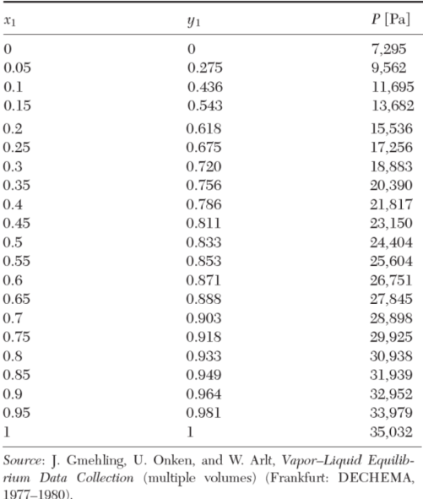

The activity coefficients for methanol and water will be calculated and plotted vs x1. Additionally ln($γ_{1}$/$γ_{2}$) will be plotted vs x1. This will be used to verify the accuracy of the VLE data above by using the thermodynamic consistency area test. It will also be used in Wisniak’s test criterion for the thermodynamic consistency test.

The activity coefficients of methanol $γ_{1}$ and water $γ_{2}$ are listed below with the corresponding mole fraction of liquid methanol. In order to obtain these values the two-suffix Margules model was used where gE = A$x_{1}x_{2}$ , RTln$γ_{1}$ = A$x_{2}^{2}$ ,and RTln$γ_{2}$ = A$x_{1}^{2}$. A was calculated my minimizing the sum of the squared difference between P_exp listed in the VLE data and P_calc which equals: x1 $γ_{1}$ P1_sat + x2$γ_{2}$ P2_sat. The built in MATLAB function “fminsearch” was used to minimize the sum or squared differences for each x1. This allowed for the parameter A within the two-suffix Margules model to be determined. Then, the table below was populated using the calculated value of A, 1286.46130, within the two-suffix Margules model.
x1 | γ1 | γ2
0 | 1.639059 | 1
0.05 | 1.561966 | 1.001236
0.1 | 1.492181 | 1.004953
0.15 | 1.42904 | 1.01118
0.2 | 1.371957 | 1.019962
0.25 | 1.320412 | 1.031364
0.3 | 1.273947 | 1.045475
0.35 | 1.232157 | 1.062399
0.4 | 1.194687 | 1.082269
0.45 | 1.161221 | 1.105237
0.5 | 1.131485 | 1.131485
0.55 | 1.105237 | 1.161221
0.6 | 1.082269 | 1.194687
0.65 | 1.062399 | 1.232157
0.7 | 1.045475 | 1.273947
0.75 | 1.031364 | 1.320412
0.8 | 1.019962 | 1.371957
0.85 | 1.01118 | 1.42904
0.9 | 1.004953 | 1.492181
0.95 | 1.001236 | 1.561966
1 | 1 | 1.639059

Reference state: $γ_{1} → 1$ as x1 $→1$ and $γ_{2} → 1$ as x2 $→1$
Therefore, the reference states for both methanol and water are the Lewis-Randall reference state.
Below is a plot of $γ_{1}$ vs x1, $γ_{2}$ vs x1, and ln($γ_{1}$/$γ_{2}$) vs x1.

Using the plot to estimate the activity coefficients at infinite dilution:
$ln γ_{1}^{∞}$ = 1.639 and $ln γ_{2}^{∞}$ = 1.639

In order to verify the accuracy of the VLE data the thermodynamic consistency area test using:
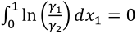
must be used.

Using the built in “trapz” function in MATLAB to evaluate the integral above, a value of zero is returned for the area. Therefore, the VLE data agrees with the thermodynamic consistency area test.
Additionally, to determine if the VLE data satisfies Wisniak’s test criterion for the thermodynamic consistency test the value of D in the equation below must be less than 5; where D is:
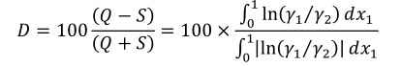

Again, using trapz in MATLAB to evaluate the integrals, a value of 0 is returned for D. Therefore, the VLE data meets the test criterion proposed by Wisniak.
The VLE data recorded is accurate within the thermodynamic area consistency test, as definite the integral evaluated to 0. Additionally, according to Wisniak, the test criterion is met for isothermal data sets with 𝐷 < 5. The D value for the VLE data is 0, which makes sense as the numerator is zero. Due to these tests, since D is less than 5 and the thermodynamic area consistency test equals zero it can be concluded that the VLE data is accurate within the bounds of the accuracy of the trapz function in MATLAB.

Project 1B
The excess Gibbs energy (gE_exp) will be calculated using the VLE data, additionally the optimal values for $λ_{12}$ and $λ_{21}$ within the Wilson equation will determined using the built in MATLAB function nlinfit to fit the VLE data to the Wilson equation. Once the optimal values are determined the excess Gibbs energy (gE_calc) will be calculated using the Wilson equation.
Using the two-suffix Margules model for gE_exp, where gE_exp = A$x_{1}x_{2}$, where A was calculated in part 1A, values for gE_exp vs x1 are listed in the table below.
x1 | gE_exp (J/mol)
0 | 0
0.05 | 61.10691175
0.1 | 115.781517
0.15 | 164.0238158
0.2 | 205.833808
0.25 | 241.2114938
0.3 | 270.156873
0.35 | 292.6699458
0.4 | 308.750712
0.45 | 318.3991718
0.5 | 321.615325
0.55 | 318.3991718
0.6 | 308.750712
0.65 | 292.6699458
0.7 | 270.156873
0.75 | 241.2114938
0.8 | 205.833808
0.85 | 164.0238158
0.9 | 115.781517
0.95 | 61.10691175
1 | 0

Using the built in MATLAB function nlinfit fitting the gE_exp vs. x1 data to the Wilson equation:
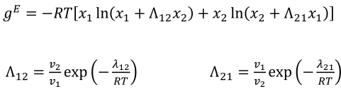

where,

𝑣1 = 41.489 liter/mol and 𝑣2 =18.156 liter/mol.
After using nlinfit, values for $λ_{12}$ and $λ_{21}$ are:
$$λ_{12} = -1.4636E+03$$
$$λ_{21} = -2.8397E+03$$

Next, it is possible to plot gE_calc vs x1, using the Wilson equation with $λ$ parameters above, as well as plot gE_exp vs x1, using the value A from part 1A, and the gE value using the two-suffix Margules model. This is shown below in the gE vs x1 plot.

Finally, we can determine the error (gE_exp – gE_calc) vs x1. This data is shown in the table below.
gE error calculated as: (gE_exp – gE_calc):
x1 | gE (error)
0 | 0
0.05 | -0.22916
0.1 | -0.32287
0.15 | -0.31869
0.2 | -0.24951
0.25 | -0.1436
0.3 | -0.02478
0.35 | 0.087614
0.4 | 0.178567
0.45 | 0.237402
0.5 | 0.257724
0.55 | 0.237403
0.6 | 0.178568
0.65 | 0.087614
0.7 | -0.02478
0.75 | -0.1436
0.8 | -0.2495
0.85 | -0.31869
0.9 | -0.32287
0.95 | -0.22916
1 | 0

The largest error is a value of -0.32287 at x1 = {0.1,0.9}. gE_exp at x1 = {0.1,0.9} is 115.781517 J/mol. This is a percent error of 2.789E-1 %. As the error is very small, and visually the gE_exp points and the gE_calc equation appear to follow the same trend very closely, it can be concluded that the Wilson equation describes the experimental data very well.

