NOTE: Use of internet is not permitted, calculators are permitted and your answers must include worked solutions. If you require extra sheet(s) please write your name and student number at the top of each additional sheet.
Part A
Objective
Complete exam questions a, b, c, d, and e (max 65 marks)
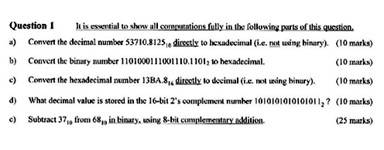
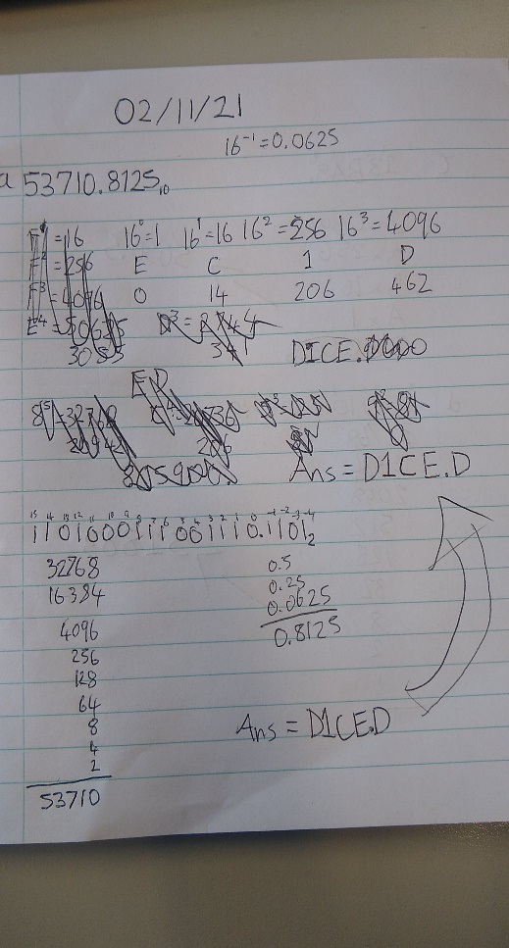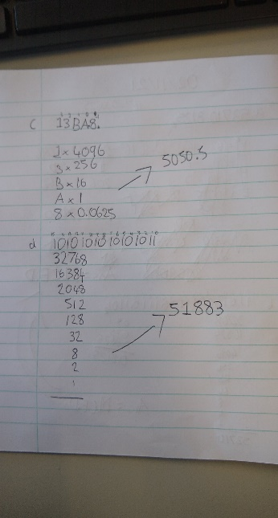

Part B
Objective
Complete exam questions a, b, c, d, e and f (max 75 marks)

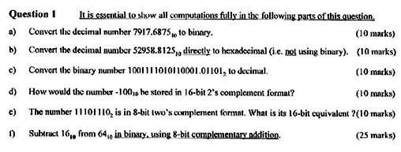
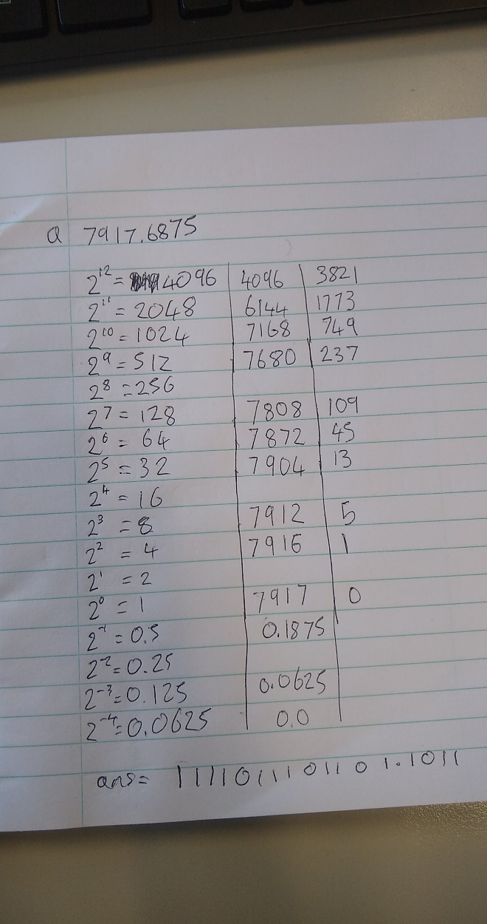

Part C
Objective
Complete exam questions a, b, c, d, and e
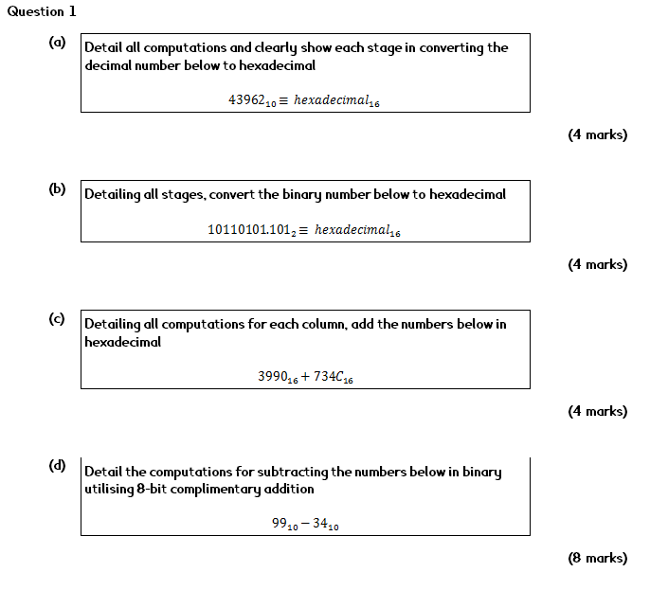

Hand up this practical report at the end of session and ensure it has been checked
Student Name |  | Student Number
Date |  | Checked
Group | A / B

