Godot Game Engine Ontology
By Conor McDonagh Rollo (20118714)
Human Centred Systems

Table of Contents
Godot Game Engine Ontology 1
Reasoning 3
Inferred Relationships 3
SPARQL 5
Query 1: All individuals and their types 5
Query 2: All nodes with attached scripts 5
Query 3: All subclasses of type Node 6
Query 4: All things that are built in components 6
Query 5: All scenes with root nodes 7
Linked Data 7
Reusability 7
Table of Figures
Figure 1: Reasoner is running 3
Figure 2: Instances are inferred in class hierarchy 4
Figure 3: Types are inferred 4
Figure 4: Types are inferred 4
Figure 5: SPARQL Query for all individuals and types 5
Figure 6: Results for Figure 5 5
Figure 7: SPARQL Query all nodes with attached scripts 5
Figure 8: Results for Figure 7 6
Figure 9: SPARQL Query all subclasses of type Node 6
Figure 10: Results for Figure 9 6
Figure 11: SPARQL Query all things that are both built-in and have names 6
Figure 12: Results for Figure 11 6
Figure 13: SPARQL Query all scenes that have a root node 7
Figure 14: Results for Figure 13 7

Reasoning
I chose to use the HermiT 1.4.3.456 reasoner and run it against the ontology for the Godot Engine in order to verify its consistency. The reasoner did not produce any errors which confirmed that the ontology had no inconsistency in class definitions, constraints, or any individual assertions.

Figure 1 shows the Reasoner menu with HermiT, along with the metrics panel displaying 162 axioms, 10 classes, 7 object properties, 5 data properties, and 24 individuals.
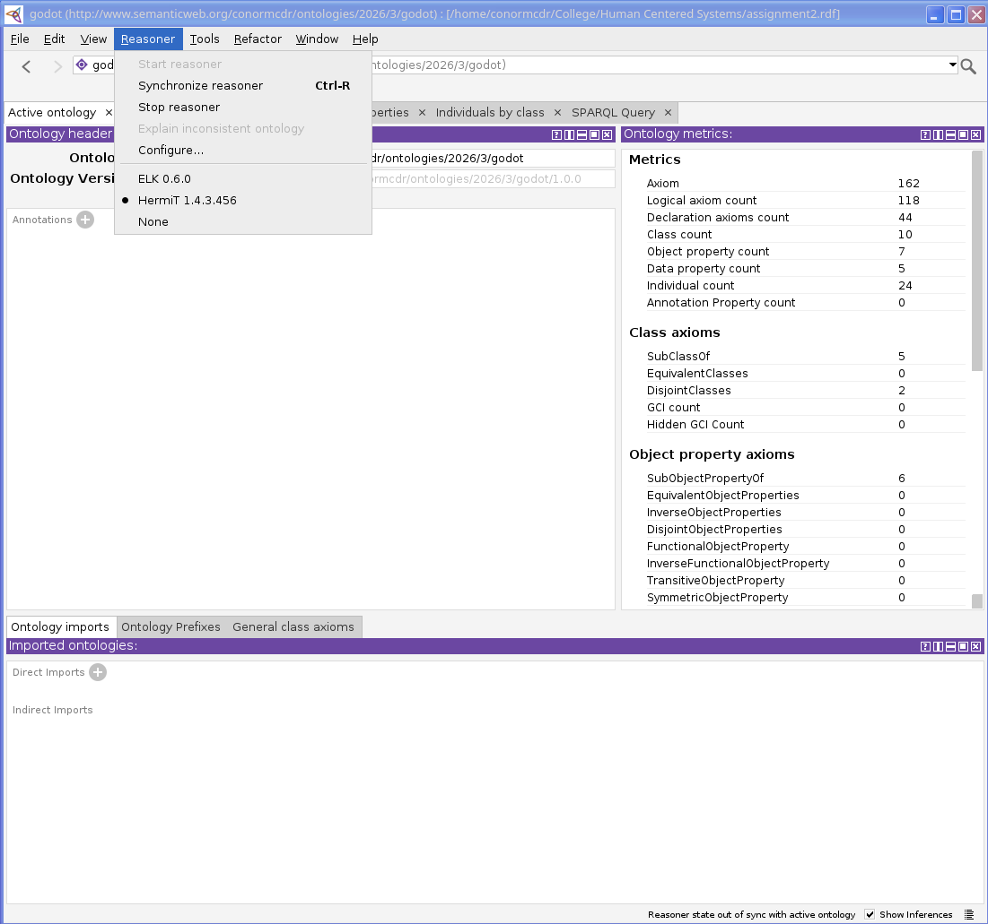Figure 1: Reasoner is running

Inferred Relationships
The reasoner was able to infer a few relationships that I had not stated explicitly within the ontology. The individuals MainScene and PlayerScene were both inferred to be Node types in addition to their original Scene type. This inference was able to happen because both of the individuals held the hasChild property, which has a domain of Node. MainScene uses hasChild to link the HealthBar and PlayerScene, the reasoner was able to conclude that MainScene was also a Node, PlayerScene also appears as the range of hasChild since it is a child of MainScene, so the reasoner was able to infer that it was also of type Node.

Figure 2 below shows the Node class description with MainScene and PlayerScene appearing as inferred and are highlighted in yellow. The disjointness axiom with resource is also visible here.
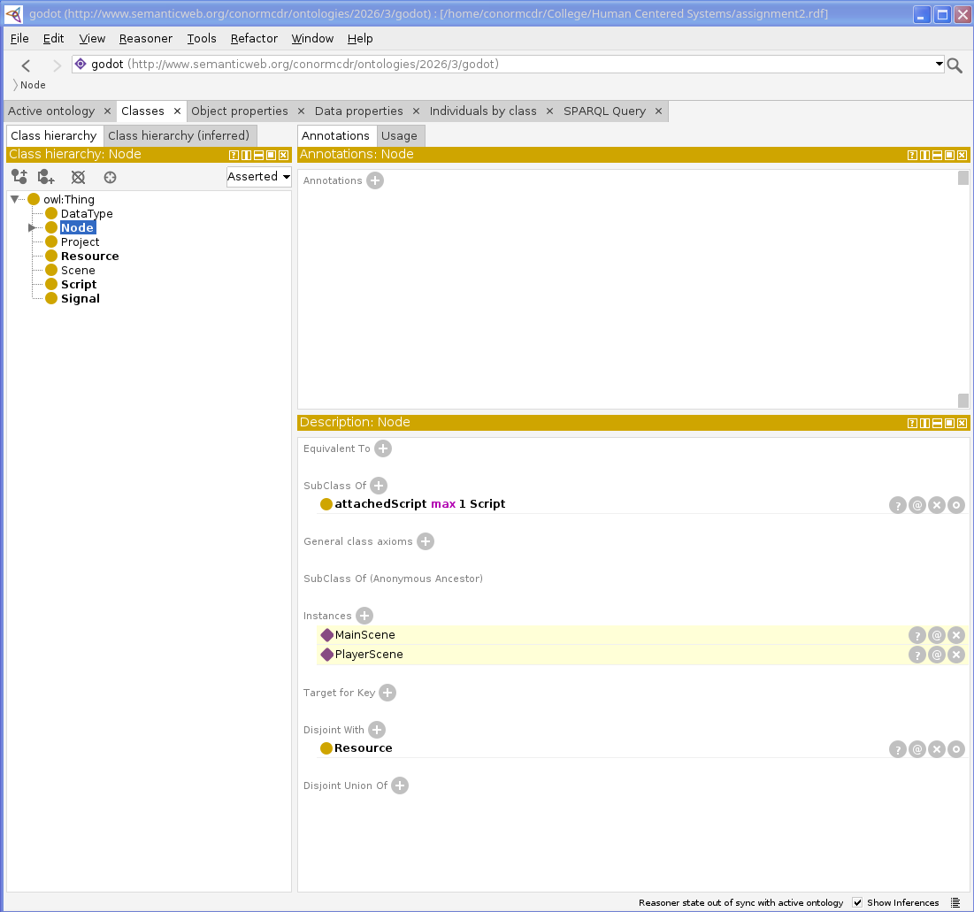Figure 2: Instances are inferred in class hierarchy
Figure 3 and 4 show the individual detail views for both MainScene and PlayerScene, and in both of these, the Types panel shows Scene as the asserted type and Node as the inferred type highlighted in yellow. This is a confirmation that the reasoner was able to apply both domain and range inference.
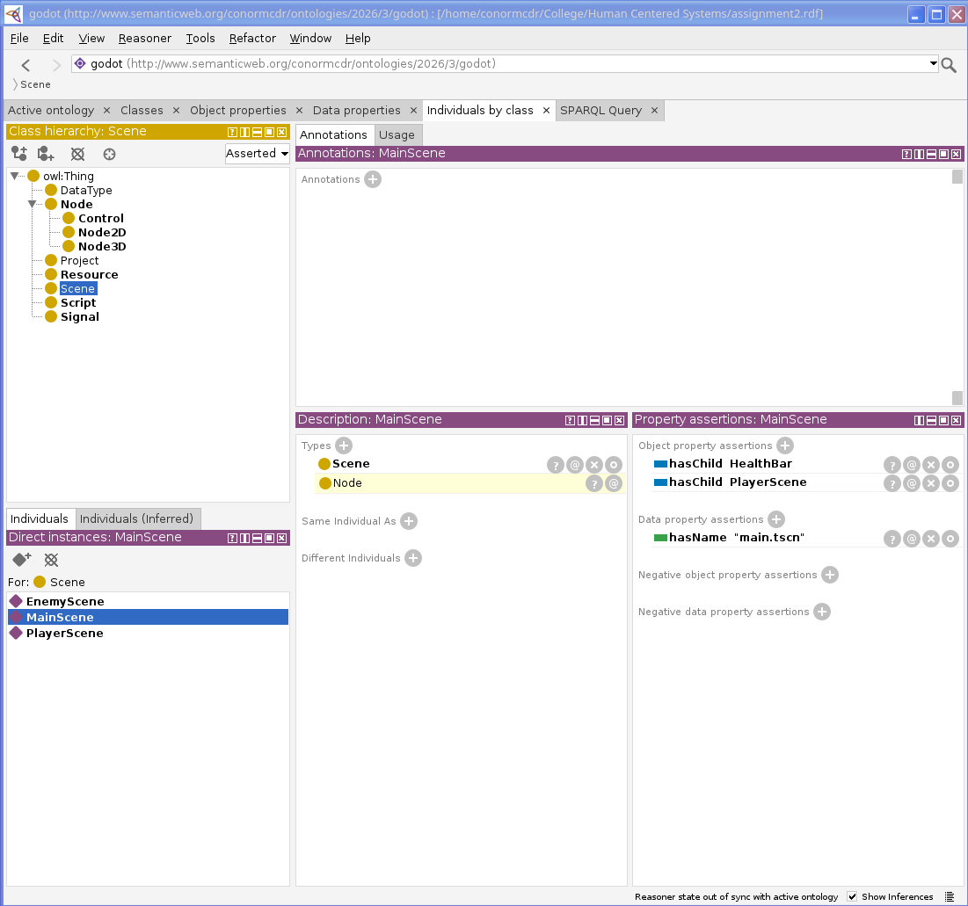Figure 3: Types are inferred
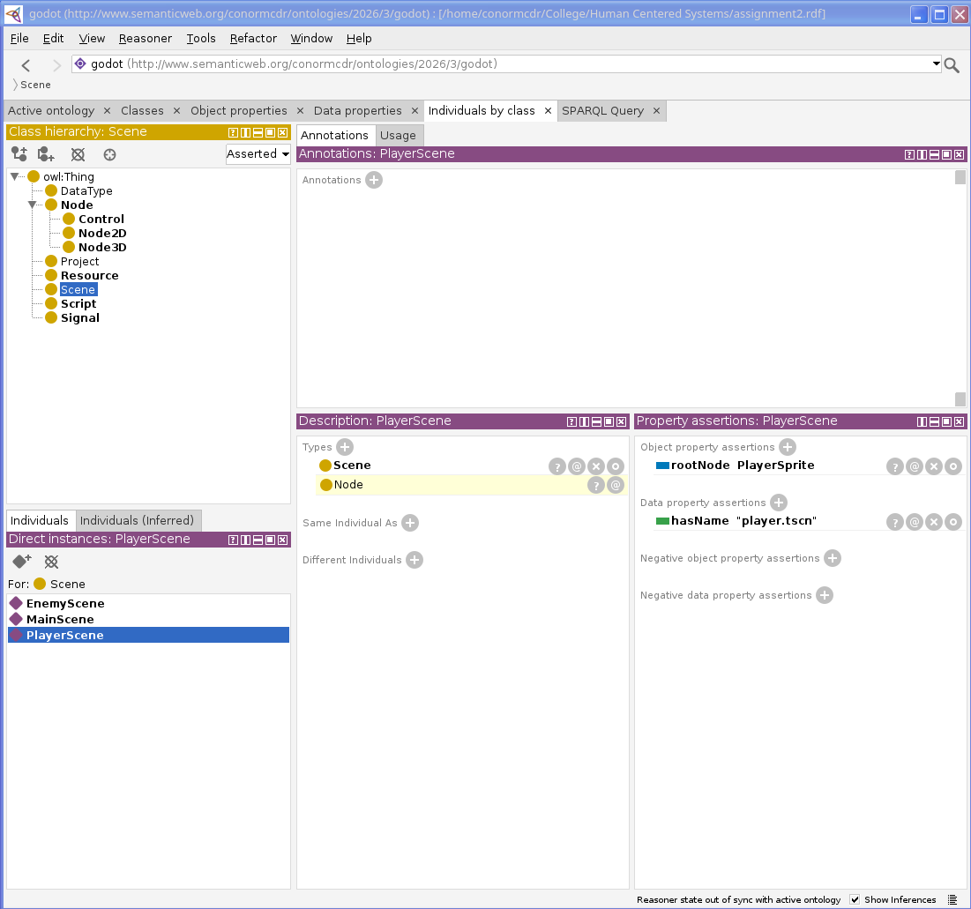Figure 4: Types are inferred
An interesting thing to note here is that EnemyScene was not inferred as a Node, seeing as it only uses the rootNode property (domain being Scene and range being Node) it is not referenced by hasChild from any other individual. This can demonstrate that the reasoner will only make an inference based on logic justified in the axioms of the ontology.

SPARQL
I have executed five SPARQL queries within the ontology using the Protege query tab to test the ontology myself. Each query uses the godot prefix to use things specific to this ontology.

Query 1: All individuals and their types
The first query will retrieve every named individual in the ontology along with its class type, and filters out any generic “owl:NamedIndividual” type so that we only show our own meaningful class assignments.
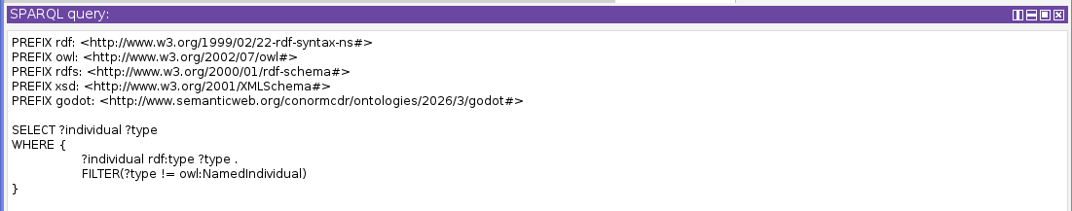Figure 5: SPARQL Query for all individuals and types
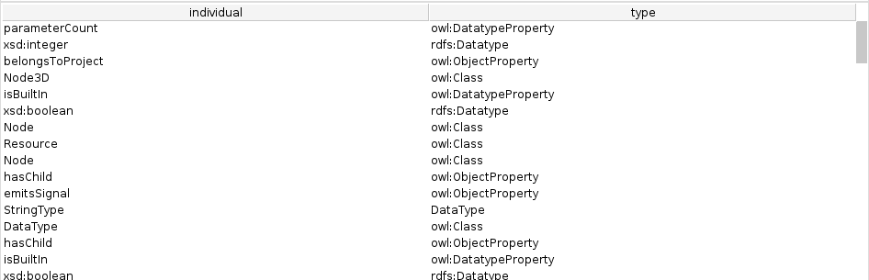Figure 6: Results for Figure 5

Query 2: All nodes with attached scripts
The second query finds all individuals that have a script attached with the attachedScript object property. This shows nodes that have an associated GDScript file.
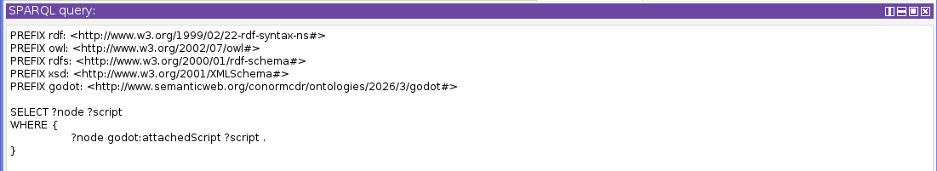Figure 7: SPARQL Query all nodes with attached scripts
Figure 8: Results for Figure 7

Query 3: All subclasses of type Node
The third query uses rdfs:subClassOf to get all classes that are defined as subclasses of Node. This tests the class hierarchy and allows us to test subclass relationships.
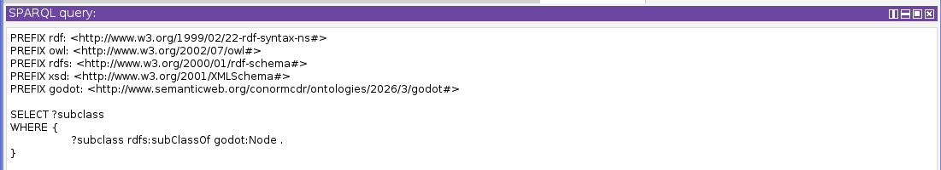Figure 9: SPARQL Query all subclasses of type Node
Figure 10: Results for Figure 9
This confirms for us that Node2D, Node3D, and Control are all correctly defined as subclasses of Node. This directly mirrors the Godot game engine’s actual class hierarchy which is what we were attempting to achieve with this ontology.

Query 4: All things that are built in components
The fourth query uses the isBuiltIn data property in order to filter for individuals that are part of Godot’s built in functionality, and then returns their names.
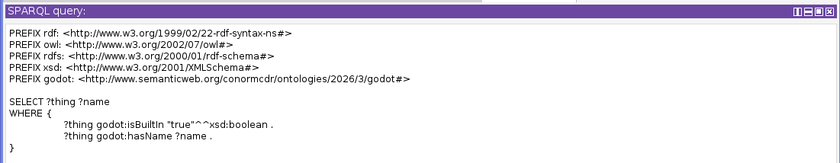Figure 11: SPARQL Query all things that are both built-in and have names
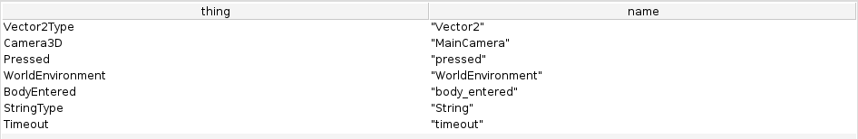Figure 12: Results for Figure 11

Query 5: All scenes with root nodes
The last query gets all Scene individuals as well as their associated root node with the rootNode object property.
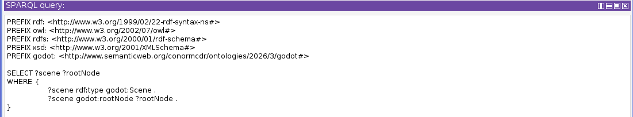Figure 13: SPARQL Query all scenes that have a root node
Figure 14: Results for Figure 13
Interestingly you may note that MainScene doesn’t appear here, this is because it does not have a rootNode assertion, since Godot wants to treat the MainScene of the application a little differently since it is at the top-most level.

Linked Data
I have uploaded my ontology to a public Github repository and published it with Github pages, it can now be accessed as linked data on the web. You may import it with this URL: “http://conormcdr.com/godot-ontology/assignment2.rdf”.

Reusability
Since the ontology is able to be accessed with the link above, other developers and researchers are able to import it into their own projects. Protege allows this using the Import Ontology feature. If put on a web server, it could be queried programmatically with a SPARQL endpoint.
Game development researchers that are building a broader game engine comparison ontology could import this ontology (if it was completed) along with a Unity or Unreal ontology to compare node based or component based architecture.

