L00173495 - Conor Callaghan – Applied Computing
https://github.com/Conor153/HaskMapsAssignment

Question 1 Hashing Fundamentals

  - Hash Function

A hash function creates a mapping between a key and an index within a hash table. The input key is converted to a hash value of a fixed size. This hash value determines where the key and value are stored within the table. Hash functions are deterministic as the same hash value will be produced for the same key (GeeksforGeeks, 2021).

  - Hash Table

A hash table is a data structure which is used to store key-value pairings. It uses the hash function to determine the index of the stored pair in the table (GeeksforGeeks, 2023). It is an efficient data structure for searching, adding and removing data with an average O notation of O(1). This efficiency makes hash tables useful in situations where data is frequently searched for (W3Schools, 2025c).

  - Collision in Hash Table
A collision within a hash table occurs when two keys produce an identical hash value. The probability of a collision occurring increases as more keys are hashed and added to the hash table. If collisions are unresolved, it can lead to a reduction in the efficiency of the hash table (JumpCloud, 2025).

  - Load Factor
The load factor is a measurement used to determine when the hash table is resized. The default load factor is 75% of the hash table’s capacity. When the load factor measurement exceeds that of the default load factor, the capacity is doubled (baeldung, 2021b).
The formula to calculate the load factor current load factor is.

$$load factor= \frac{N}{M}$$

Where N represents the number of elements within the hash table. M represents the capacity of the table.

  - Open Addressing

Open Addressing is a method used to resolve collisions within hashing tables. When a collision occurs, the table is probed using different techniques to find the next available bucket to store the key-value pair (GeeksforGeeks, 2015b). Open addressing offers a great caching performance as all key-vale pairs are stored into the one table. This is useful as all data can be stored with little wastage.

Question 2
2.1. Discuss how hash-based data structures (like hash tables) differ from tree-based data
structures (like red-black trees or AVL trees).

Hash based structures are used to store key-value pairs in an unsorted order whereas tree-based structures store a series linked of nodes in sorted order (baeldung, 2021a). In tree structures nodes have a parent and child relationship. In comparison, in hash structures the key-value pairings stored have no connection between each other.

When deciding where to store the key-value pairing the key is hashed and the hashed value is used as the table index to store the pairing (GeeksforGeeks, 2023). In trees the value of the node is compared against the nodes already stored in the tree to identify its positioning. In red-black trees if the value is greater, then it is positioned to the right of the parent node. If less the value of the node is less than the value of the parent node then it will be placed as the left child. AVL trees follow a similar suit however, if one side of the tree is heavier than the other, then the tree is rotated to rebalance the tree (W3Schools, 2025a). Trees feature a root node to base as the first comparison. Hash structures do not contain a root key-value pairing.

Hash tables have an average case of O(1) however for its worst case it has an O notation of O(n). Tree structures have a guaranteed O(logN) which is faster than the worst case of hash tables but when compared to the average case of hash tables the tree is a slower algorithm (GeeksforGeeks, 2015a).

2.2. What are the advantages and disadvantages of each in terms of time complexity for
operations such as insert, delete, and search?
Hash Structures
The advantage hash structures have over tree structures is its average case O notation. If has an O(1), for insertion, deletion and searching. This speed is achieved when the correct hashing function is applied. This speed is achieved by the hash function where the value returned decides the position of the data. By hashing the given key, it is possible to find and delete the value instantaneously (GeeksforGeeks, 2015a).

The disadvantage however is that the average case scenario is not a guarantee. If a poor hash function is applied, then it is possible that the performance of the hash structure to run at O(n). This speed is significantly slower than the average case. This occurs when collisions are frequent and the table must be iterated through to find an empty position. It also occurs when the table increases in size causing all key value pairs to be rehashed. The unpredictability of the hash function plays a major role in the efficiency of hash tables.
(baeldung, 2021a).

Tree Structures
Unlike hash structures the efficiency of tree structures is guaranteed to be O(logN) for insertions, deletions and searches. This speed significantly faster than the worst-case scenario of the hash structures O(n). With the unpredictability of the hash function, it may prove more beneficial to use tree structures in situations where a consistent speed is required (GeeksforGeeks, 2015a). The disadvantage however is that trees structures are slower at searching, adding and deleting data than the average case of hash structures (GeeksforGeeks, 2015a).

Question 3
https://github.com/Conor153/HaskMapsAssignment

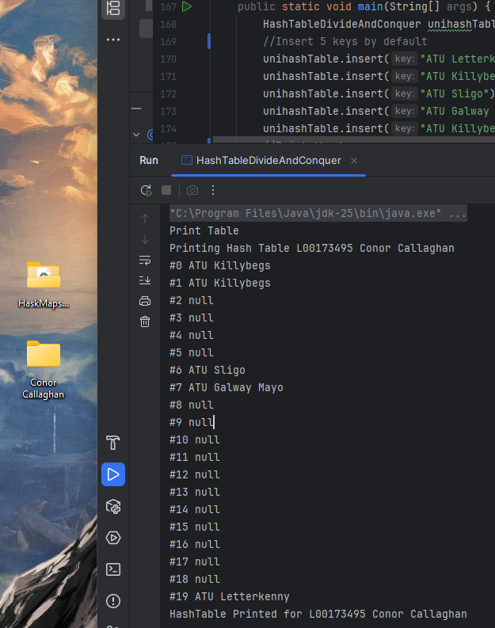

Original Table after inserting 5 keys. Demonstrates insertion and printing the hash table. Note that ATU Killybegs produces the same hash value however, using open addressing it probes for the next available index to store the key.

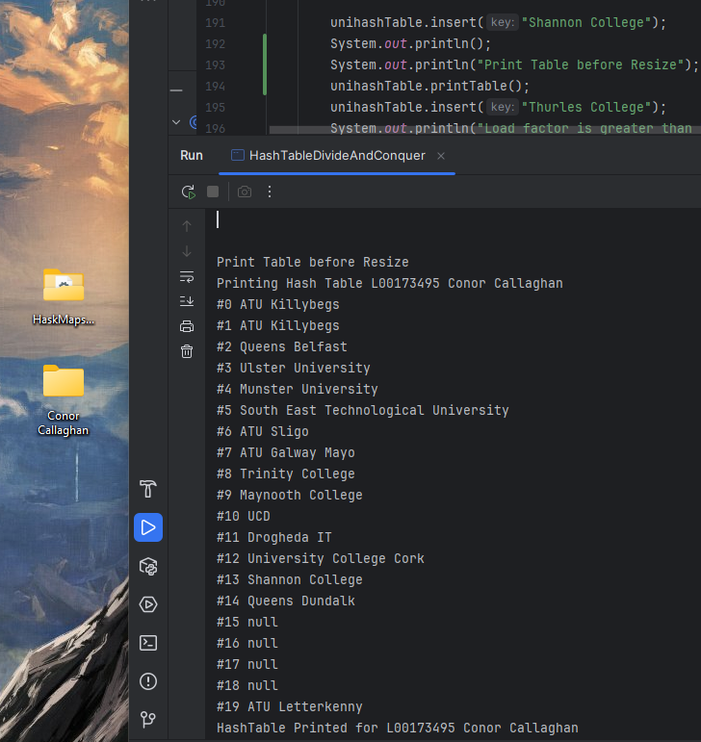

Table printed before it exceeds the load factor causing it to resize. The load factor is 75% of the table’s capacity. 16 items have been added to the table by adding a 17th the table will exceed this load factor and invoke the resize function

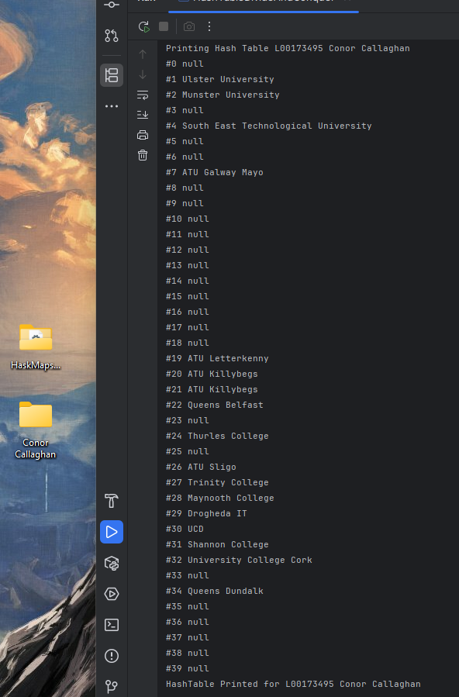

A 17th value has been added to the table causing the table to resize. Now the maximum capacity is 40 keys. The keys have also been rehashed in order to map correctly to the new table size. ATU Killybegs was at positions 0 and 1. They are now at positions 19 and 20.

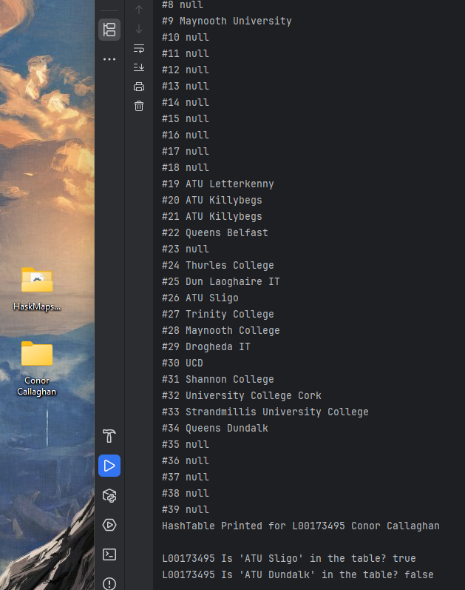

ATU Sligo is searched for in the table. It is in position 26 so, it returns true as the key is part of the table.
ATU Dundalk however does not exist in the table and when searched for it returns false.

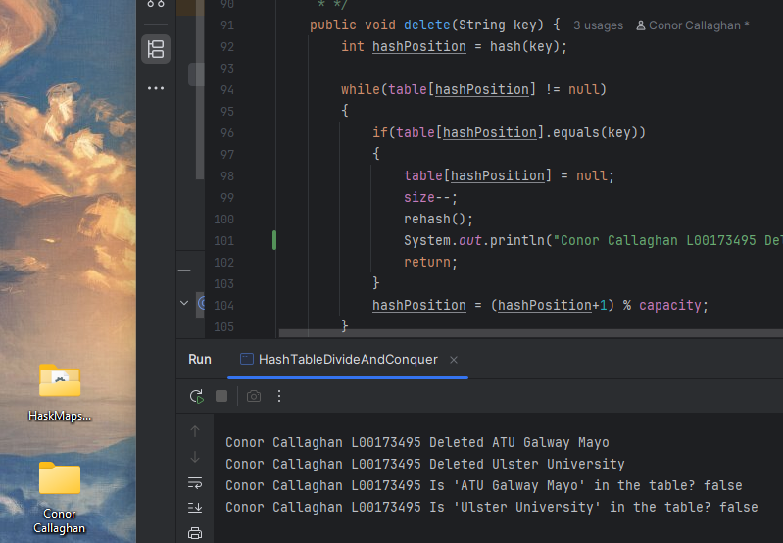

Both ATU Galway Mayo and Ulster University are removed from the table. When searched for they both return false as they are no longer in the hash table
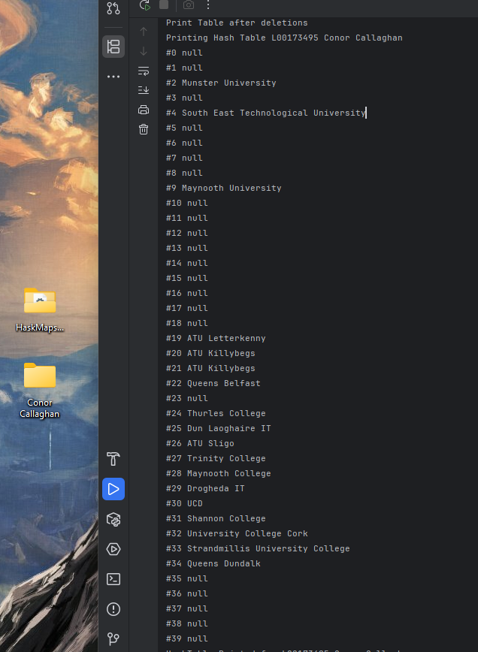

The final table printed. Ulster University has been removed from position 2 and ATU Galway Mayo has been removed from position 7.

Question 4
https://github.com/Conor153/HaskMapsAssignment
Photos start on the next page

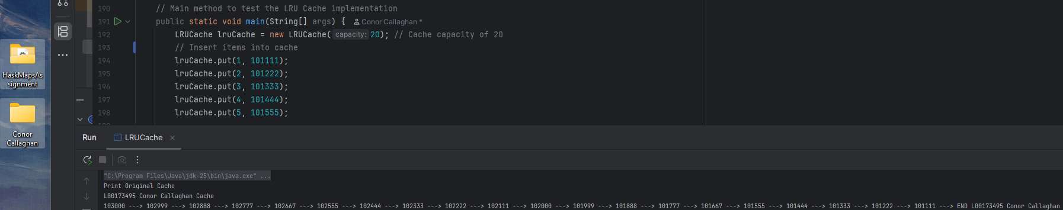

Print of the Initial Cache with 20 items added. Note node with key 1 is at the very end whereas, Node 20 is at the front of the cache. The values of the nodes are printed.

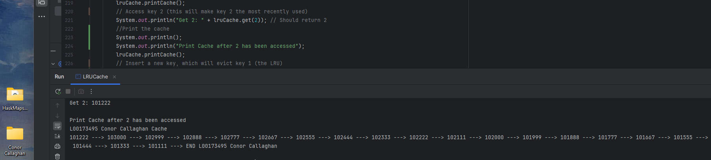

Access the Node with key 2. As seen in the previous image it was the 2nd to last value stored in the cache. When accessed it is moved to the front of the cache at it is more recently used.

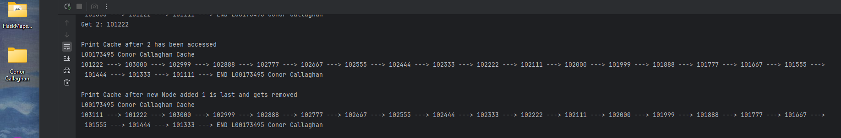

Node 21 is added to the cache. It is placed at the head of the cache. As the capacity was at its maximum, Node with key 1 was removed from the cache. The difference between the cache can be visualised between the prints of the table Node 3 is now the tail.

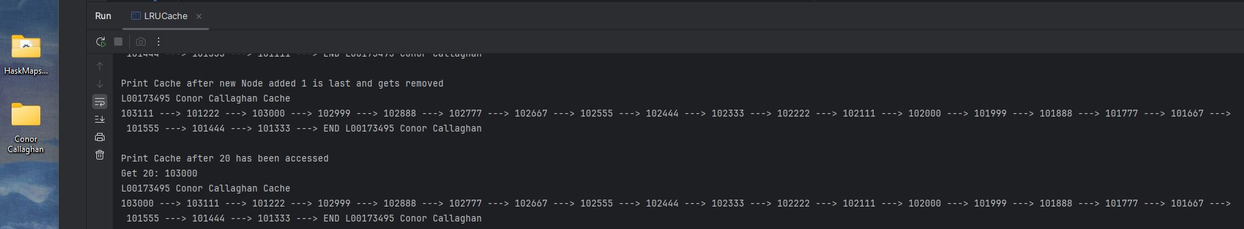

Node 20 is accessed and as a result it is moved to the front of the cache and becomes the head. Node 21 is now the second most recently used Node.

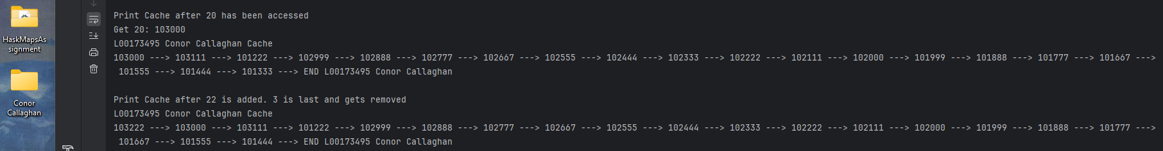

Node 22 is now added to the cache. And becomes the head. As 3 was the least recently used item it was removed from the cache when 22 was added. Node 4 is now the tail.

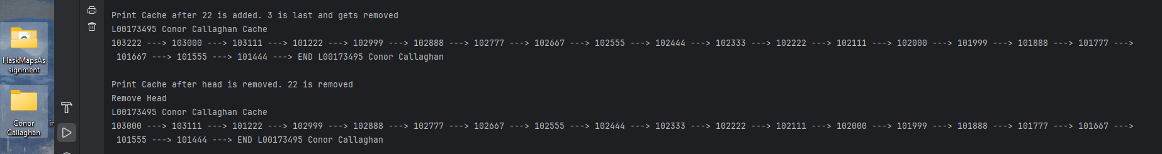

To showcase the remove function works with a Node that is not the tail. I called remove on the head. This leads to Node 22 being removed from the cache. Node 20 becomes the head once more and 4 remains as the tail.

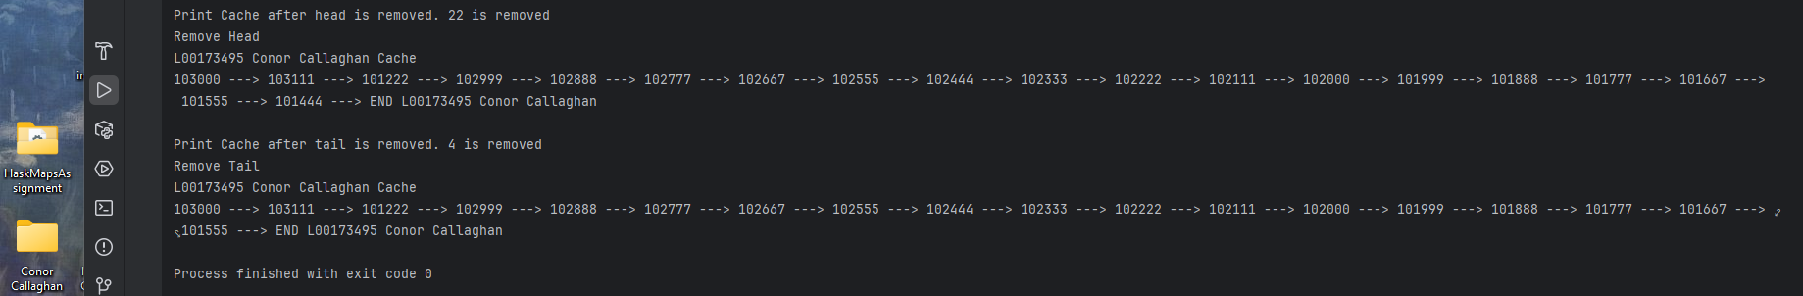
I called remove on the tail Node. Node 4 is removed from the table and Node 5 becomes the tail.

Question 5
The LRU cache currently has issues with its thread safety as race conditions can occur. One thread may attempt to access the tail element within the cache whereas a second thread may have simultaneously added a new item to the cache causing the tail to be removed. To improve the thread safety, a locking mechanism would be implemented to avoid data corruption.

A coarse grained locking mechanism would be simple to implement however, it would cause the entire data structure to be locked when a single thread is accessing the data. This would reduce the level of parallelism of the LRU cache and lead to a reduction in its concurrency.

A fine grained locking mechanism would achieve a better level of concurrency than that of coarse grained. Instead of locking the entire data structure, every node within the cache would contain a lock. This would allow multiple threads to access data structure while maintaining the correctness of the data (Filip Pizlo, Frampton and Hosking, 2011).

One thread may want access to the head of the list whereas another might want to access the tail. Both threads can access the data structure simultaneously instead of one locking access to the structure and having the other thread wait for it to finish. Only in situations where two threads attempt to access the same node would one of the threads be locked out from accessing the node. This could potentially lead to deadlocks within the LRU cache however, as one may have to wait forever to gain access to the data. To resolve deadlocking, global lock ordering should be used. This means that threads would follow a strict ordering of the locks such as from head to tail. This will allow every thread to eventually gain access to the data (thealgorists.com, 2025).

The HashMap object used in the program would also be replaced to an object of type ConcurrentHashMap. This class is designed to support concurrency while also avoiding locking the entire table when accessing the data (Oracle, 2025).

Overall to improve the concurrency of the LRU cache I would incorporate a fine grained locking mechanism with global lock ordering and switch the HashMap object to a ConcurrentHashMap object. These changes will improve the concurrency of the current LRU cache whilst maintaining the correctness of its data.

References
baeldung (2021a). Hash Table vs. Balanced Binary Tree | Baeldung on Computer Science. [online] www.baeldung.com. Available at: https://www.baeldung.com/cs/hash-table-vs-balanced-binary-tree.
baeldung (2021b). Java HashMap Load Factor | Baeldung. [online] www.baeldung.com. Available at: https://www.baeldung.com/java-hashmap-load-factor.
Filip Pizlo, Frampton, D. and Hosking, A.L. (2011). Fine-grained adaptive biased locking. doi:https://doi.org/10.1145/2093157.2093184.
GeeksforGeeks (2015a). Advantages of BST over Hash Table. [online] GeeksforGeeks. Available at: https://www.geeksforgeeks.org/dsa/advantages-of-bst-over-hash-table/.
GeeksforGeeks (2015b). Open Addressing Collision Handling technique in Hashing. [online] GeeksforGeeks. Available at: https://www.geeksforgeeks.org/dsa/open-addressing-collision-handling-technique-in-hashing/.
GeeksforGeeks (2021). Hash Functions and Types of Hash functions. [online] GeeksforGeeks. Available at: https://www.geeksforgeeks.org/dsa/hash-functions-and-list-types-of-hash-functions/.
GeeksforGeeks (2023). Hash Table Data Structure. [online] GeeksforGeeks. Available at: https://www.geeksforgeeks.org/dsa/hash-table-data-structure/.
JumpCloud (2025). What Is a Hash Collision? [online] JumpCloud. Available at: https://jumpcloud.com/it-index/what-is-a-hash-collision.
Oracle (2025). ConcurrentHashMap (Java Platform SE 8 ). [online] docs.oracle.com. Available at: https://docs.oracle.com/javase/8/docs/api/java/util/concurrent/ConcurrentHashMap.html.
thealgorists.com (2025). Deadlock Prevention. [online] Thealgorists.com. Available at: https://www.thealgorists.com/Concurrency/DeadlockPrevention.
W3Schools (2025a). DSA AVL Trees. [online] www.w3schools.com. Available at: https://www.w3schools.com/dsa/dsa_data_avltrees.php.
W3Schools (2025b). DSA Binary Search Trees. [online] www.w3schools.com. Available at: https://www.w3schools.com/dsa/dsa_data_binarysearchtrees.php.
W3Schools (2025c). DSA Graphs. [online] www.w3schools.com. Available at: https://www.w3schools.com/dsa/dsa_theory_hashtables.php.

