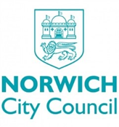[GoldenRule]

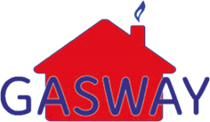

[Name]

[Address1]

[Address2]

[Address3]

[Postcode]

**[Letter]**

Dear [Name]

**Re: Planned electrical testing**

Gasway Services Ltd are working with Norwich City Council and NPS Norwich to carry out electrical testing in council-owned properties to ensure your home is safe.

You have missed the first appointment we made for you. We will visit you again on **[Date] [Time].** If this appointment is inconvenient please contact our Project Administrator on 01603 309510 or email Electrical@gasway.co.uk **Monday – Sunday (24 Hours)**

Norwich City Council carry out electrical tests to all properties on a rolling programme so that they can ensure homes are safe and electrically sound. The tests are essential as they can identify issues that you may not know are present. This gives the council an opportunity to remedy any potential hazards prior to problems arising. Should the electric readings be poor this could result in a loss of power or have serious implications for your health and safety.

Please remember it is your responsibility to allow Norwich City Council access to carry out maintenance and safety checks. Failure to provide access to carry out the electrical inspection is a breach of your tenancy agreement.

Norwich City Council may consider tenancy enforcement action if we are unable to carry out the electrical test.

Everyone who enters your home will have been through a full induction and all our operatives work within our Code of Conduct. Our work will be carried out in a professional and courteous manner with as little inconvenience and disruption to you as is practical. We apologise in advance for any noise or inconvenience this may cause.

Please note, that all our staff and operatives will carry full face identification cards. Should you have any doubts about the authenticity of the person(s) who is calling to your home please ask them to wait and contact me, and I will confirm their identity.

We would like to take this opportunity to thank you in advance for your patience and co-operation and look forward to working with you.

Yours sincerely

[User]