[GoldenRule]

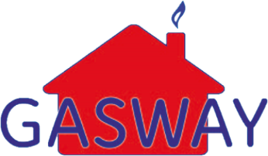18 Burnet Road

Sweet Briar Industrial Estate

Norwich, NR3 2BS

Tel: **01603 855464**

Email: [**enquiries@gasway.co.uk**](mailto:enquiries@gasway.co.uk)

[Tenant]

[Address1]

[Address2]

[Address3]

[Postcode]

[Date]

**ANNUAL GAS SAFETY CHECK**

Dear [Tenant],

As part of your **Star Maintenance** cover plan you receive an annual service to your appliance(s).

Our records show that on [NextServiceDate] the following appliance(s) are due for an annual service.

Gas Safe and all manufacturers recommend that all gas appliances should be serviced on an annual basis to ensure that they are running safely and to their optimum efficiency.

For greater overall savings and peace of mind why not look at our fantastic value **Silver, Gold and Platinum Maintenance Cover Plans**, which include:

* Annual service and safety check, as recommended by Gas Safe and all manufacturers
* Priority breakdown visit
* No callout charges (average saving of £67 per call)
* Guaranteed same day service *
* All parts and labour necessary *

* Terms and conditions apply, see enclosed leaflet for full details

[ContractCover]

**Please note all Star Maintenance services must be carried out by the end of September.**

Yours sincerely



Gasway Service Department

|  |
| --- |
| footer.jpg  Head Office: Gasway Services Ltd – 18 Burnet Road – Sweet Briar Industrial Estate – Norwich – NR3 2BS  Telephone; 0800 0743030 Email: enquiries@gasway.co.uk  Company No: 4158628  VAT No: 688 4634 78 |