[GoldenRule]

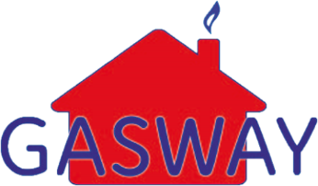18 Burnet Road

Sweet Briar Industrial Estate

Norwich, NR3 2BS

Tel: **01603 855464**

Email: [**enquires@gasway.co.uk**](mailto:enquires@gasway.co.uk)

[CustomerName]

[Address1]

[Address2]

[Address3]

[Postcode]

[Date]

**GAS SERVICE AND SAFETY CHECK**

Dear [CustomerName],

**Re: Landlord’s Annual Service and Gas Safety Certificates due for Renewal**

Our database is showing the following properties are due for renewal.

Gas Safe and all manufacturers recommend that all gas appliances should be serviced on an annual basis to ensure that they are running safely and to their optimum efficiency.

If you would like us to carry out your annual service, please call us on 01603 855464

**If you have already arranged an appointment, please disregard this letter.**

Yours sincerely



Gasway Service Department

|  |
| --- |
| footer.jpg  Head Office: Gasway Services Ltd – 18 Burnet Road – Sweet Briar Industrial Estate – Norwich – NR3 2BS  Telephone; 0800 0743030 Email: enquiries@gasway.co.uk  Company No: 4158628  VAT No: 688 4634 78 |