**Webdriver Methods**

**.get(url)**

Example:

* driver.get(“https://www.google.com”);

Example code

Return : Load new web page

**.getCurrentUrl();**

Example:

* driver.getCurrentUrl();

Return : Gets a string of the current URL

**.getTitle();**

Example:

* driver.getTitle();

Return : Gets the title of the current page

.findElement()

Example

* driver.findElement(By.cssSelector(“#primaryButton”));

Returns: first matching element on the current page

.

.findElements()

Example

* Driver.findElement(By.xpath (“//div”));

Returns: finds matching element on the current page and list of all all web elements

.close()

Example:

driver.close();

Purpose : This will close the current window

.quit()

Example

driver.quit();

Result

Quits the Driver instance and closing every window which is open

**Exercises**

Create a Java class and using ChromeDriver methods open the URL <http://www.automationtesting.co.uk> and maximise the window.

Test Result – Pass

Create a Java class and using GeckoDriver methods open the URL <http://www.automationtesting.co.uk> and maximise the window with Firefox.

Test Result –Pass

Create a Java class and using EdgeDriver methods open the URL <http://www.automationtesting.co.uk> and maximise the window with Edge.

Test Result – Pass

Finding an element on a webpage by Element ID and clicking it

Test - Pass

On the Contact form web page, interact with the input box which user enters their first name into. We will use findElement with the Name value of first_name.

Test Data:

first_name: “This is my first Name, I have sent”.

Message: This is the Message, I have sent.

Test Result – Pass

Test – find an element using the Xpath selector

Test - Pass

Test - Check to see if the Checkbox is selected. Note: By Default, the RED checkbox is Selected and the Green is not selected.

Test Data : Website has the Red check as checked by Default and Green is unchecked

Test Result: Pass (Console runs boolean value of True for first selector and False for the second selector)

Test – Test whether Button four and button two is enabled or not.

Test Data – Button Four is disabled by Default.

Test - Pass

--------------------------

Test – using the Link Text Selector direct the program to the actions page.

Test Passed

Test – Direct the program to the buttons page and Locate by CSS and find the button one and click.

Test – Pass

Test – Locate the dropdown menu on the website and check that the value “jeep”(Case Sensitive) is selected

Test - Pass

Test –

Locate the Trigger alert button and click it which will display an alert. We then want to accept the alert to close it.

Test – Pass and then it was accepted and closed the alert

Alert is accepted

Test – Locate the Radio Button (number 2) with CSS Selector and click

Test – Pass

Test – Assertions JUnit, test to see if Title = homepage and test an incorrect value

Correct Value Test - the test has passed , Run successfully with no Junit Exception within the console.

Incorrect Value Test – The test has passed Junit Exception within the console.

Assertions JUnit, Checking Total price within cart is correct or incorrect

Correct Value Test - the test has passed, Run successfully with no Junit Exception within the console.

Incorrect Value Test – The test has passed Junit Exception within the console.

Test – Test will click a button which display a PopUp , this test will allow the program to switch windows between the Main window and the PopUp generated by clicking the button and then return the focus back to the MainWindow.

Test – Pass

PopUp appears.

Using Thread sleep, 3 seconds later the popup is closed and the focus is changed to main window

Test – Find the accordion elements and try click the

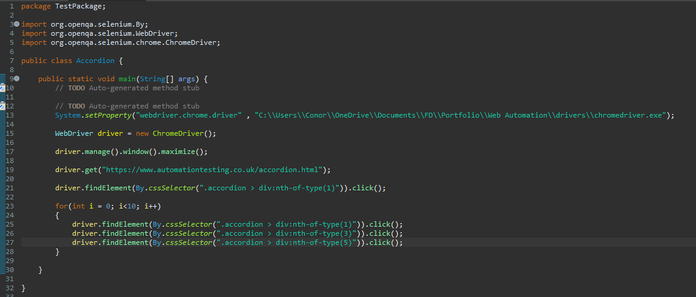

Test – Pass, The Accordion sections were clicked.

Close cookie warning

driver.findElement(By.cssSelector(".close-cookie-warning > span")).click();