I have designed my application to function exactly as requested in the demonstration video and project documentation, but the following alterations were made.

1. Added a grey colour to the <ion-content> of the page, leaving heading as it was. Just thought it was a bit nicer to view than the standard all white background. When APIs for news or 7DayWeather are called, they display in a standard white box.
2. Added a new provider for the 7 Day Weather button, which calls on another API from openweathermap.org. I didn’t need a new apikey to access this new API (One Call API). This new provider uses coordinates taken from original API (Current Weather API), then sets them as input variables to the new API call to One Call API. It also uses the units variable to display temperatures which are consistent with the main weather data call. To display the date and time for the 7 Day Weather, I had to use a small function to convert from the unix timestamp which was read from the API call into a readable format. This content is displayed after the news content if both buttons are pressed.
3. I didn’t use storage to store the country variable (like in the demonstration video) as I found it ran fine without it. There was compatibility issues with some country codes. For example, a city in Spain returns “es” as the countryID, but the newsapi doesn’t accept this as a parameter. See list below taken from newsapi.org documentation.

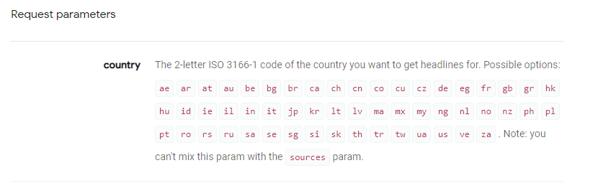

Regards,

Conor.