CDM ETL for Optum Oncology EHR

Chris Knoll, Ajit Londhe, Anthony Sena, Erica Voss

# Changelog

|  |  |
| --- | --- |
| Date | Comments |
| 6/10/2016 | Phase 1 ETL with the following tables: LOCATION, CARE_SITE, PROVIDER, PERSON, OBSERVATION_PERIOD, DEATH, VISIT_OCCURRENCE, CONDITION_OCCURRENCE, DRUG_EXPOSURE |
| 7/13/2016 | Person table changes - no patients with unknown gender or unknown birth year  New death table rule to prevent death status for patients with data 32+ days after date_of_death |
| 7/20/2016 | Changed drug_exposure_start_date mapping in medication_administration → drug_exposure to use admin_date/admin_time. Added mappings for drug_exposure, device_exposure, procedure_occurence, measurement and observation |
| 8/11/2016 | Adjusted all STCM file names. Added CDM_Domain_Meta and CDM_Source. |
| 8/24/2016 | Adjusted logic of prescriptions_written → drug_exposure (quantities, unit source value). |
| 9/15/2016 | Cleanup of logic and comments fields. More details on concept_id mappings, referring to appendices as appropriate |

# Source Data Mapping Approach to CDMV5

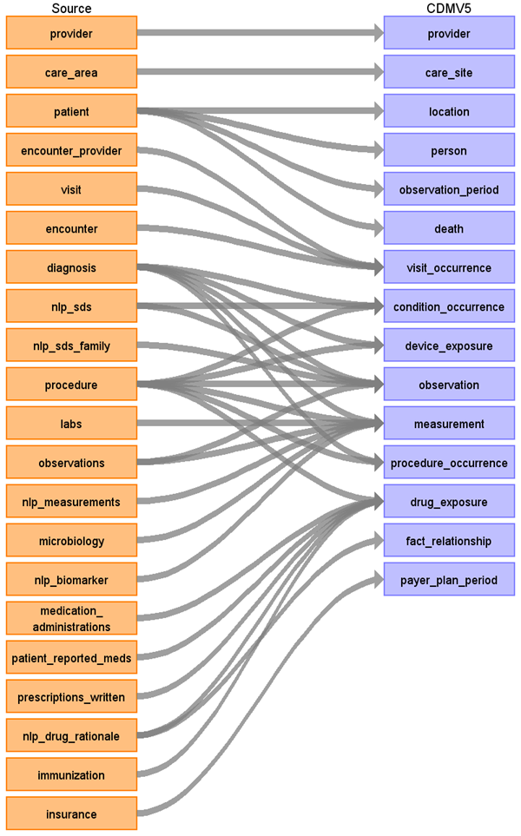

## Default Domains

The following table lists the default domain for a given source table/source column where a CDM row should be inserted with an unmapped concept ID (0) if no other domains were found for this source row.

|  |  |
| --- | --- |
| **Table.Column** | **Default Domain** |
| diagnosis.diagnosis_cd | Condition |
| medication_administratons.ndc | Drug |
| prescriptions_written.ndc | Drug |
| immunization.ndc | Drug |
| procedure.proc_code | Procedure |
| patient_reported_meds.ndc | Drug |
| labs.test_name | Measurement |
| observations.obs_type | Observation |
| nlp_measurements | Measurement |

## Table name: provider

### Reading from provider

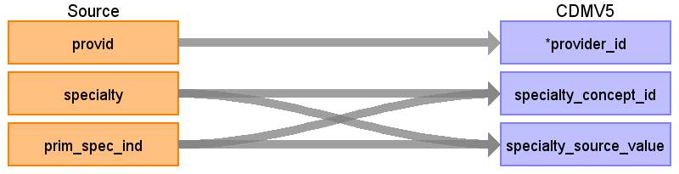

|  |  |  |  |
| --- | --- | --- | --- |
| Destination Field | Source Field | Logic | Comment |
| provider_id | provid |  |  |
| provider_name |  |  |  |
| npi |  |  |  |
| dea |  |  |  |
| specialty_concept_id | specialty |  | Use mapping JNJ_OPTUM_EHR_SPCLTY.csv. |
| care_site_id |  |  |  |
| year_of_birth |  |  |  |
| gender_concept_id |  |  |  |
| provider_source_value |  |  |  |
| specialty_source_value | specialty |  |  |
| specialty_source_concept_id | specialty |  | Use mapping JNJ_OPTUM_EHR_SPCLTY.csv. |
| gender_source_value |  |  |  |
| gender_source_concept_id |  |  |  |

Use the following query to select the provid, specialty to use for creating the provider table:

SELECT provid, specialty

FROM (

 select provid, specialty, prim_spec_ind, row_number() over (      partition by provid, specialty order by prim_spec_ind desc) ordinal

from native.provider

) P

WHERE P.ordinal = 1

## Table name: care_site

The Optum Oncology EHR does not contain site specific information. The care_area information relates to divisions of organizations and not physical locations, so we are not producing a care_site mapping for this ETL.

## Table name: location

### Reading from patient

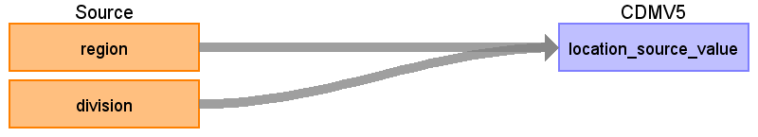

|  |  |  |  |
| --- | --- | --- | --- |
| Destination Field | Source Field | Logic | Comment |
| location_id |  |  | Autogen |
| address_1 |  |  |  |
| address_2 |  |  |  |
| city |  |  |  |
| state |  |  |  |
| zip |  |  |  |
| county |  |  |  |
| location_source_value | division  region | {region}_{division} | Concatenate region_division region to create unique location_id |

## Table name: person

### Reading from patient

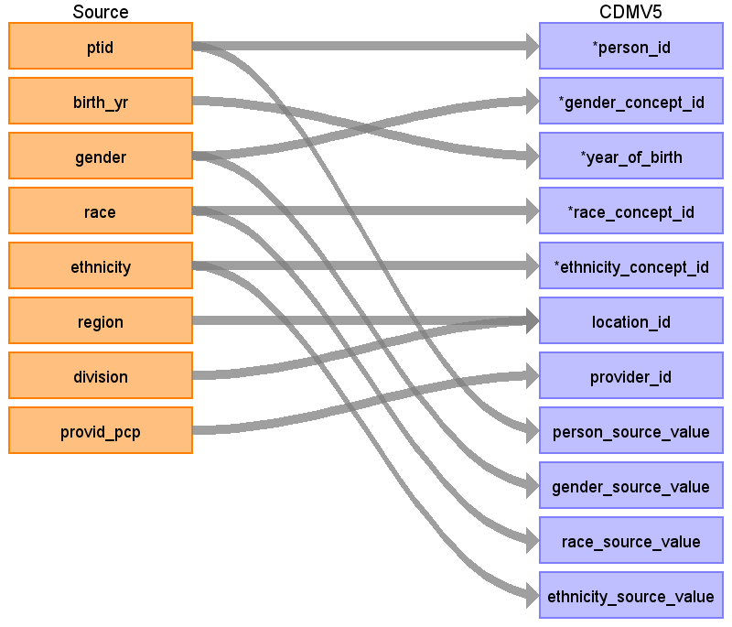

|  |  |  |  |
| --- | --- | --- | --- |
| Destination Field | Source Field | Logic | Comment |
| person_id | ptid |  | Remove ‘PT’ prefix: cast(replace(ptid, 'PT','') as bigint) |
| gender_concept_id | gender | If gender = ‘Unknown’ then remove  Else if gender = 'Male' then 8507  else if gender = 'Female' then 8532 |  |
| year_of_birth | birth_yr | if birth_yr == 'Unknown' then remove  Else if birth_yr <> 'Unknown' then  if birth_yr = '1927 and earlier' then 1927  else birth_yr |  |
| month_of_birth |  |  |  |
| day_of_birth |  |  |  |
| time_of_birth |  |  |  |
| race_concept_id | race | if 'Caucasian' then 8527  else if 'African American' then 8516  else if 'Asian' then 8515  else 0 |  |
| ethnicity_concept_id | ethnicity | if 'Hispanic' then 38003563  else 0 |  |
| location_id | region  division | Look up from Location table |  |
| provider_id | provid_pcp | Look up from Provider table |  |
| care_site_id |  |  |  |
| person_source_value | ptid |  |  |
| gender_source_value | gender |  |  |
| gender_source_concept_id |  |  |  |
| race_source_value | race |  |  |
| race_source_concept_id |  |  |  |
| ethnicity_source_value | ethnicity |  |  |
| ethnicity_source_concept_id |  |  |  |

## Table name: observation_period

### Reading from patient

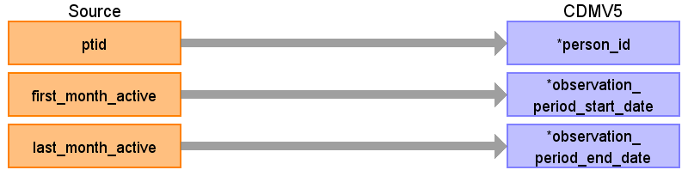

|  |  |  |  |
| --- | --- | --- | --- |
| Destination Field | Source Field | Logic | Comment |
| observation_period_id |  |  |  |
| person_id | ptid |  |  |
| observation_period_start_date | first_month_active | First day of first_month_active |  |
| observation_period_end_date | last_month_active | Last day of last_month_active  Add 1 month to last month active |  |
| period_type_concept_id | 38000280 |  | Observation recorded from EHR |

## Table name: death

Reading from patient

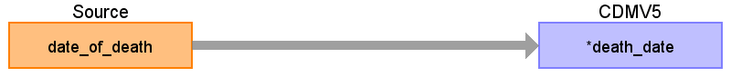

**A person’s death should be removed if any data available > 30 days after date_of_death**

|  |  |  |  |
| --- | --- | --- | --- |
| Destination Field | Source Field | Logic | Comment |
| person_id |  |  |  |
| death_date | date_of_death | if patient.date_of_death is not null, then use the last day of the month of death: Same logic as observation_period_end_date:  Add 1 to month of death and subtract 1 day. Example: month of death of 200402 becomes Feb + 1 month = March 1st - 1 day = Feb 29th, 2004. |  |
| death_type_concept_id |  |  |  |
| cause_concept_id |  |  |  |
| cause_source_value |  |  |  |
| cause_source_concept_id |  |  |  |

## Table name: visit_occurrence

When creating visits, create a temporary mapping table named **TEMP_VISIT** to associate encids from the native to VISIT_OCCURRENCE in cdm. This lookup will be needed when ETLing the CONDITION_OCCURRENCE, DRUG_EXPOSRE, PROCEDURE_OCCURRENCE, and any native table which references an encounter_id that maps into a CDM table with a visit_id.

**TEMP_VISIT table query**

select Q.visitid source_visit_id, Q.encid cdm_visit_id, e.encid as source_encounterid

from

(

select v.visitid, e.encid, row_number() over (partition by v.visitid order by e.interaction_date) as ordinal

from native.visit v

join native.encounter e on v.visitid = e.visitid

) Q

JOIN native.encounter e on e.visitid = Q.visitid

where Q.ordinal = 1

### Reading from encounter

**Note: when pulling in encounters, only pull in encounters not associated with a visit:**

LEFT JOIN visit v on e.visitid = v.visitid where v.visitid is null

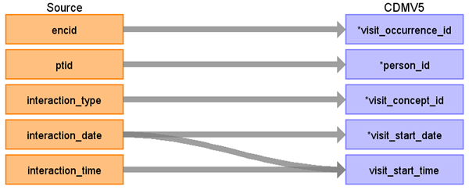

|  |  |  |  |
| --- | --- | --- | --- |
| Destination Field | Source Field | Logic | Comment |
| visit_occurrence_id | encid |  |  |
| person_id | ptid |  |  |
| visit_concept_id | interaction_type | STCM Lookup JNJ_OPTUM_EHR_VISIT.csv |  |
| visit_start_date | interaction_date |  |  |
| visit_start_time | interaction_time |  |  |
| visit_end_date | interaction_date |  |  |
| visit_end_time |  |  |  |
| visit_type_concept_id |  | 44818518 | Visit derived from EHR record |
| provider_id | encid | Look up in Provider table using encounter_provider.provid |  |
| care_site_id |  |  |  |
| visit_source_value | encid |  |  |
| visit_source_concept_id | interaction_type | STCM Lookup JNJ_OPTUM_EHR_VISIT.csv |  |

### Reading from visit

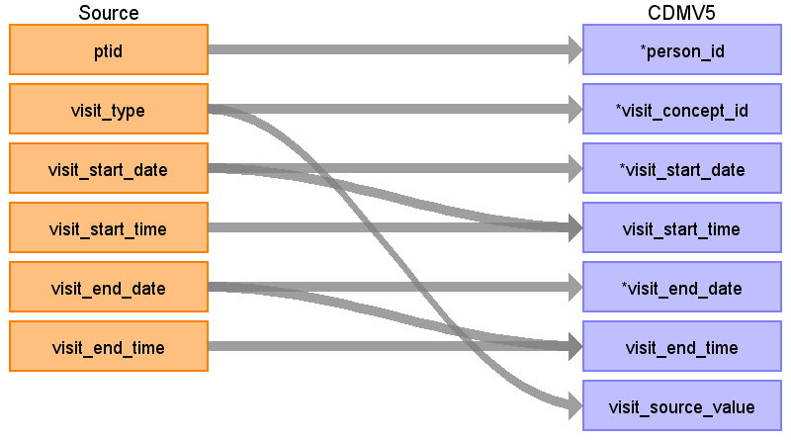

|  |  |  |  |
| --- | --- | --- | --- |
| Destination Field | Source Field | Logic | Comment |
| visit_occurrence_id | visitid | Lookup visitid in TEMP_VISIT and use cdm_visit_id |  |
| person_id | ptid |  |  |
| visit_concept_id | visit_type | Case ‘Inpatient’ : 9201 Case ‘Emergency Patient’: 9203 Case ‘Observation Patient’: 9201  ELSE: 0 |  |
| visit_start_date | visit_start_date |  |  |
| visit_start_time | visit_start_time | Use the date portion from visit_start_date |  |
| visit_end_date | visit_end_date |  |  |
| visit_end_time | visit_end_time | Use the date portion from visit_end_date |  |
| visit_type_concept_id |  | 44818518 | Visit derived from EHR record |
| provider_id | visitid | Use visitid to first encounter.encid associated, then to encounter_provider.provid |  |
| care_site_id |  |  |  |
| visit_source_value | visit_type |  |  |
| visit_source_concept_id |  | Use first encid associated to visit. |  |

## Table name: condition_occurrence

Any row mapped to a target concept must be in the Condition domain when inserting into CONDITION_OCCURRENCE.

**This is the only table where duplicate records should be collapsed.**

### Reading from diagnosis

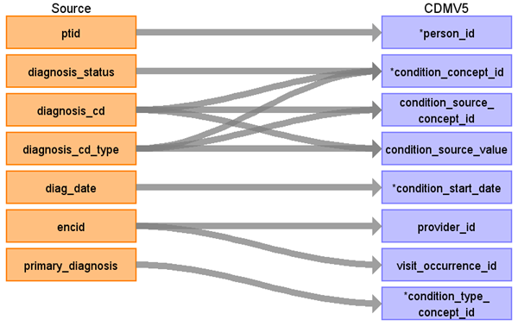

**Only use diagnosis records with DIAGNOSIS_STATUS = 'Diagnosis of'**

|  |  |  |  |
| --- | --- | --- | --- |
| Destination Field | Source Field | Logic | Comment |
| condition_occurrence_id |  | autogen |  |
| person_id | ptid |  |  |
| condition_concept_id | diagnosis_cd_type  Diagnosis_cd  diagnosis_status | Use Appendix 1.1.2.  If diagnosis_status = ‘Diagnosis of’  Then  { Case diagnosis_cd_type = ‘ICD9’:  Use lookup for ICD9CM Case diagnosis_cd_type = ‘ICD10’:  Use lookup for ICD10CM Case diagnosis_cd_type = ‘SNOMED’:  Use lookup for SNOMED CASE ‘’:   Lookup code in ICD9CM, ICD10CM, SNOMED CASE ELSE: 0 }  Else exclude record | For diagnosis_cd_type = ICD9, strip dot from lookup  For diagnosis_cd_type = ICD10, leave dots in lookup. |
| condition_start_date | diag_date |  |  |
| condition_end_date |  |  |  |
| condition_type_concept_id | primary_diagnosis | If primary_diagnosis = ‘1’ then 44786627 Else 44786629 |  |
| stop_reason |  |  |  |
| provider_id | encid | join to encounter_provider to attempt to lookup the provid |  |
| visit_occurrence_id | encid | If encid is found in TEMP_VISIT, use cdm_visit_id, else use encid |  |
| condition_source_value | diagnosis_cd  diagnosis_cd_type | Use diagnosis_cd if available. Otherwise use diagnosis_cd_type |  |
| condition_source_concept_id | diagnosis_cd  diagnosis_cd_type | Use Appendix 1.1.1, and obtain the source_vocabulary_id and target_vocabulary_id for the where clause using this:  If diagnosis_status = ‘Diagnosis of’  Then  {  Case diagnosis_cd_type = ‘ICD9’:  Use lookup for ICD9CM  Case diagnosis_cd_type = ‘ICD10’:  Use lookup for ICD10CM  Case diagnosis_cd_type = ‘SNOMED’:  Use lookup for SNOMED  CASE ‘’:  Lookup code in ICD9CM, ICD10CM, SNOMED  CASE ELSE: 0  }  else exclude record | For diagnosis_cd_type = ICD9, strip dot from lookup  For diagnosis_cd_type = ICD10, leave dots in lookup. |

### Reading from nlp_sds (DO NOT LOAD)

Phase 1 note: do not perform this map into Condition_occurrence for phase 1.

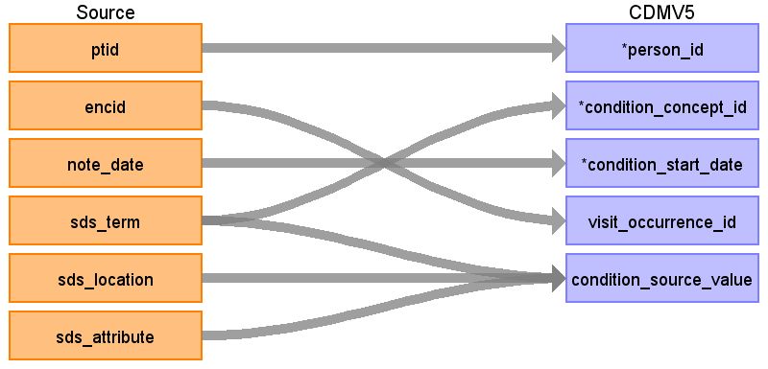

|  |  |  |  |
| --- | --- | --- | --- |
| Destination Field | Source Field | Logic | Comment |
| condition_occurrence_id |  |  |  |
| person_id | ptid |  |  |
| condition_concept_id | sds_term |  |  |
| condition_start_date | note_date |  |  |
| condition_end_date |  |  |  |
| condition_type_concept_id |  |  |  |
| stop_reason |  |  |  |
| provider_id |  |  |  |
| visit_occurrence_id | encid |  |  |
| condition_source_value | sds_term  sds_location  sds_attribute |  |  |
| condition_source_concept_id |  |  |  |

### Reading from procedure

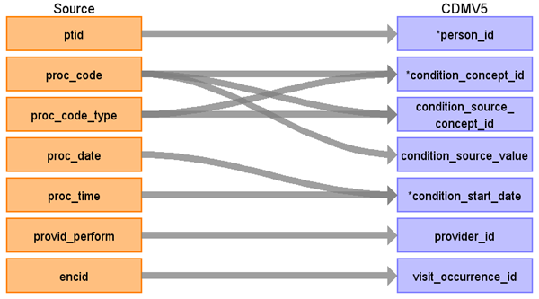

|  |  |  |  |
| --- | --- | --- | --- |
| Destination Field | Source Field | Logic | Comment |
| condition_occurrence_id |  | Autogen |  |
| person_id | ptid |  |  |
| condition_concept_id | proc_code  proc_code_type | Use Appendix 1.1.2  Case proc_code_type: “CPT4” : use CPT4 Vocab “HCPCS”: use HCPCS Vocab “ICD10”: user ICD10PCS “ICD9”: use ICD9Proc Vocab Else: 0 |  |
| condition_start_date | proc_date |  |  |
| condition_source_value | proc_code |  |  |
| condition_source_concept_id | proc_code  proc_code_type | Use Appendix 1.1.1.  Case proc_code_type: “CPT4” : use CPT4 Vocab “HCPCS”: use HCPCS Vocab “ICD9”: use ICD9Proc Vocab Else: 0 |  |
| provider_id | provid_perform | Use Provider Lookup |  |
| visit_occurrence_id | encid |  |  |
| condition_end_date |  |  |  |
| condition_type_concept_id |  | 0 |  |
| stop_reason |  |  |  |

## Table name: drug_exposure

### Reading from medication_administrations

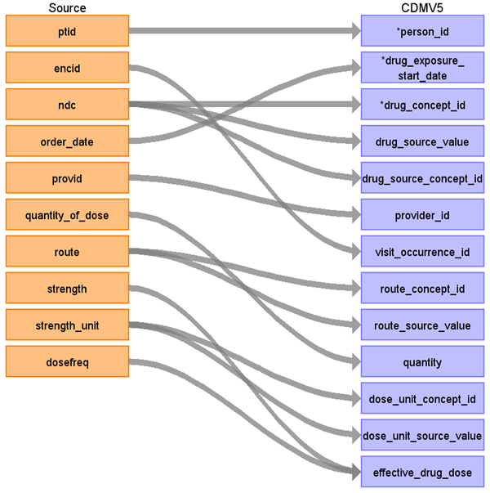

|  |  |  |  |
| --- | --- | --- | --- |
| Destination Field | Source Field | Logic | Comment |
| drug_exposure_id |  | autogen |  |
| person_id | ptid |  |  |
| drug_concept_id | ndc | Use Appendix 1.1.2  WHERE Vocabulary_ID = ‘NDC’ |  |
| drug_exposure_start_date | order_date |  |  |
| drug_exposure_end_date |  |  |  |
| drug_type_concept_id |  | 38000180 | Inpatient Administration |
| stop_reason |  |  |  |
| refills |  |  |  |
| quantity | quantity_of_dose |  |  |
| days_supply |  |  |  |
| sig |  |  |  |
| route_concept_id | route | STCM Lookup JNJ_OPTUM_EHR_ROUTE.csv |  |
| effective_drug_dose | quantity_of_dose  dosefreq  strength |  | Leave empty for Phase 1, to revisit in phase 2 |
| dose_unit_concept_id | strength_unit |  | Leave empty for Phase 1, to revisit in phase 2 |
| lot_number |  |  |  |
| provider_id | Provid  encid | If the provid is not specified, look at the encounter associated with this record. If there is a provider specified, used that value here. |  |
| visit_occurrence_id | encid |  |  |
| drug_source_value | ndc |  |  |
| drug_source_concept_id | ndc |  |  |
| route_source_value | route |  |  |
| dose_unit_source_value | strength_unit |  |  |

### Reading from prescriptions_written

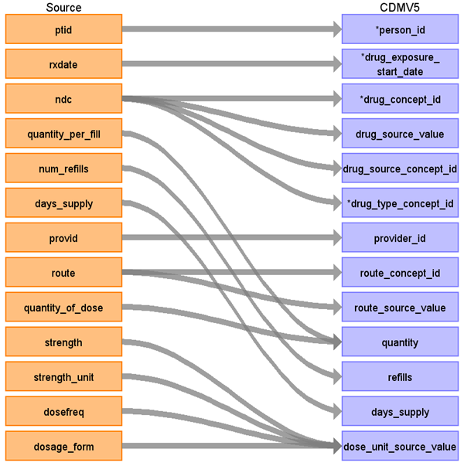

|  |  |  |  |
| --- | --- | --- | --- |
| Destination Field | Source Field | Logic | Comment |
| drug_exposure_id |  |  |  |
| person_id | ptid |  |  |
| drug_exposure_start_date | rxdate |  |  |
| drug_concept_id | ndc |  |  |
| drug_source_value | ndc |  |  |
| drug_source_concept_id | ndc |  |  |
| drug_type_concept_id | ndc | 38000177 |  |
| provider_id | provid |  |  |
| visit_occurrence_id |  |  |  |
| route_concept_id | route | Lookup route value in the STCM Lookup JNJ_OPTUM_EHR_ROUTE |  |
| route_source_value | route |  |  |
| quantity | quantity_per_fill  quantity_of_dose | IF quantity_per_fill != null THEN  cdm.quantity = split(quantity_per_fill).first()  ELSE IF quantity_of_dose != null THEN  cdm.quantity = quantity_per_dose  ELSE 0; |  |
| refills | num_refills |  |  |
| days_supply | days_supply |  |  |
| dose_unit_concept_id |  |  |  |
| dose_unit_source_value | strength  strength_unit  dosage_form  dosefreq | Concatenate: strength + strength_unit + dosage_form + dosefreq with a semi-colon for delimiter |  |
| effective_drug_dose |  |  |  |
| stop_reason |  |  |  |
| sig |  |  |  |
| lot_number |  |  |  |
| drug_exposure_end_date |  |  |  |

### Reading from patient_reported_meds

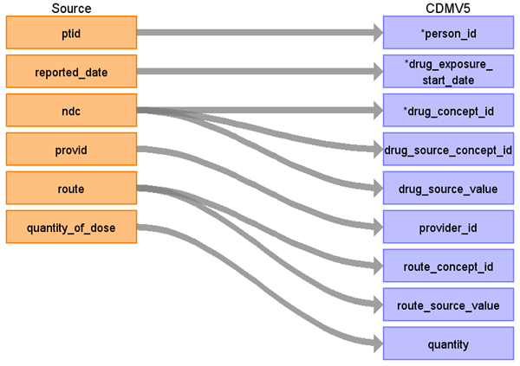

|  |  |  |  |
| --- | --- | --- | --- |
| Destination Field | Source Field | Logic | Comment |
| drug_exposure_id |  |  |  |
| person_id | ptid |  |  |
| drug_exposure_start_date | reported_date |  |  |
| drug_concept_id | ndc |  |  |
| drug_source_concept_id | ndc |  |  |
| drug_source_value | ndc |  |  |
| drug_type_concept_id |  | 44787730 | Patient Self-Reported Medication |
| provider_id | provid |  |  |
| route_concept_id | route | Lookup route value in the STCM Lookup JNJ_OPTUM_EHR_ROUTE |  |
| route_source_value | route |  |  |
| quantity | quantity_of_dose |  |  |
| refills |  |  |  |
| days_supply |  |  |  |
| dose_unit_concept_id |  |  |  |
| dose_unit_source_value |  |  |  |
| effective_drug_dose |  |  |  |
| visit_occurrence_id |  |  |  |
| stop_reason |  |  |  |
| sig |  |  |  |
| lot_number |  |  |  |
| drug_exposure_end_date |  |  |  |

### Reading from immunization

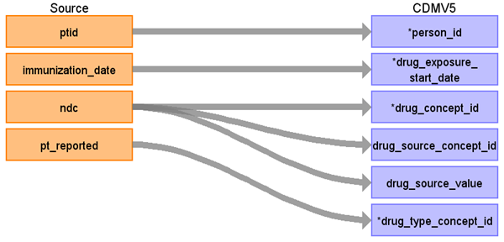

|  |  |  |  |
| --- | --- | --- | --- |
| Destination Field | Source Field | Logic | Comment |
| drug_exposure_id |  |  |  |
| person_id | ptid |  |  |
| drug_concept_id | ndc  pt_reported | where pt_reported = 'N' |  |
| drug_exposure_start_date | immunization_date |  |  |
| drug_exposure_end_date |  |  |  |
| drug_type_concept_id |  | 43542358 | Physician administered drug (identified from EHR observation) |
| stop_reason |  |  |  |
| refills |  |  |  |
| quantity |  |  |  |
| days_supply |  |  |  |
| sig |  |  |  |
| route_concept_id |  |  |  |
| effective_drug_dose |  |  |  |
| dose_unit_concept_id |  |  |  |
| lot_number |  |  |  |
| provider_id |  |  |  |
| visit_occurrence_id |  |  |  |
| drug_source_value | ndc |  |  |
| drug_source_concept_id | ndc |  |  |
| route_source_value |  |  |  |
| dose_unit_source_value |  |  |  |

### Reading from procedure

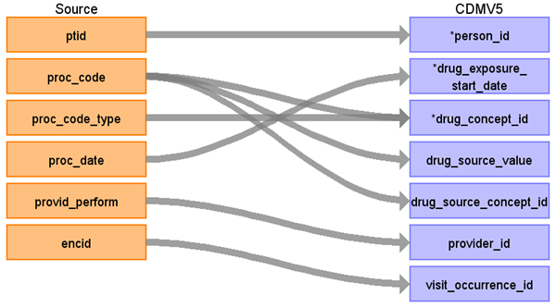

|  |  |  |  |
| --- | --- | --- | --- |
| Destination Field | Source Field | Logic | Comment |
| drug_exposure_id |  |  |  |
| person_id | ptid |  |  |
| drug_exposure_start_date | proc_date |  |  |
| drug_concept_id | proc_code  proc_code_type |  | Only map rows where the proc_code and proc_code_type map to a concept in the vocabulary that has domain_id = ‘drug’ |
| drug_source_value | proc_code |  |  |
| drug_source_concept_id | proc_code |  |  |
| drug_type_concept_id |  | 38000275 | EHR order list entry |
| provider_id | provid_perform |  |  |
| visit_occurrence_id | encid |  |  |
| route_concept_id |  |  |  |
| route_source_value |  |  |  |
| quantity |  |  |  |
| refills |  |  |  |
| days_supply |  |  |  |
| dose_unit_concept_id |  |  |  |
| dose_unit_source_value |  |  |  |
| effective_drug_dose |  |  |  |
| stop_reason |  |  |  |
| sig |  |  |  |
| lot_number |  |  |  |
| drug_exposure_end_date |  |  |  |

### Reading from nlp_drug_rationale

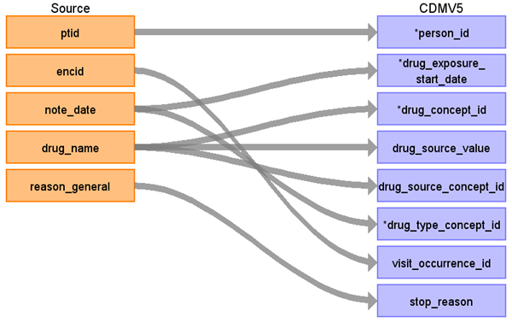

Only map the rows that match the following query:

select *

from nlp_drug_rationale

where (drug_action is null or drug_action not in ('STOP', 'TAKE.NOT', 'ON.NOT', 'SWITCH FROM', 'AVOID', 'REMOVE', 'REMAIN OFF', 'START.NOT', 'GET.NOT', 'TRY.NOT'))

AND (sentiment is null or sentiment not in ('REJECT', 'NEED.NOT', 'WANT.NOT'))

|  |  |  |  |
| --- | --- | --- | --- |
| Destination Field | Source Field | Logic | Comment |
| drug_exposure_id |  |  |  |
| person_id | ptid |  |  |
| drug_exposure_start_date | note_date |  |  |
| drug_concept_id | drug_name | STCM Lookup JNJ_OPTUM_NLP_DRUG.csv |  |
| drug_source_value | drug_name |  |  |
| drug_source_concept_id | drug_name |  |  |
| drug_type_concept_id | note_date | 38000281 = Observation recorded from EHR with text result |  |
| provider_id |  |  |  |
| visit_occurrence_id | encid |  |  |
| route_concept_id |  |  |  |
| route_source_value |  |  |  |
| quantity |  |  |  |
| refills |  |  |  |
| days_supply |  |  |  |
| dose_unit_concept_id |  |  |  |
| dose_unit_source_value |  |  |  |
| effective_drug_dose |  |  |  |
| stop_reason | reason_general |  |  |
| sig |  |  |  |
| lot_number |  |  |  |
| drug_exposure_end_date |  |  |  |

## Table name: device_exposure

### Reading from procedure

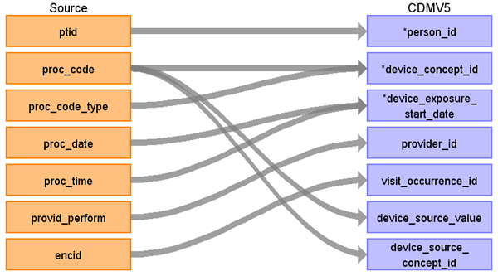



|  |  |  |  |
| --- | --- | --- | --- |
| Destination Field | Source Field | Logic | Comment |
| device_exposure_id |  |  | Auto-incremented |
| person_id | ptid |  |  |
| device_concept_id | proc_code |  | Domain_id = Device for those procedures that have device concepts in the proc_code (mainly HCPCS) |
| device_exposure_start_date | Proc_date |  |  |
| device_exposure_end_date |  |  |  |
| device_type_concept_id |  |  |  |
| unique_device_id |  |  |  |
| quantity |  |  |  |
| provider_id | provid |  |  |
| visit_occurrence_id | encid |  | Lookup using visit_occurrence mapping logic |
| device_source_value | proc_code |  |  |
| device_source_concept_id | Proc_code mapped to concept_id |  | Source code mapped to vocabulary |

### Reading from diagnosis

|  |  |  |  |
| --- | --- | --- | --- |
| Destination Field | Source Field | Logic | Comment |
| device_exposure_id |  |  |  |
| person_id | ptid |  |  |
| device_concept_id | diagnosis_cd  diagnosis_status  diagnosis_cd_type |  | Domain_id = Device for those procedures that have device concepts in the proc_code (mainly HCPCS) |
| device_exposure_start_date | diag_date |  |  |
| device_exposure_end_date |  |  |  |
| device_type_concept_id | primary_diagnosis |  | If primary_diagnosis = ‘1’ then 44786627  Else 44786629 |
| unique_device_id |  |  |  |
| quantity |  |  |  |
| provider_id | Encid -> provider_id |  | Use this field to map up to the encounter_provider |
| visit_occurrence_id | encid |  | Use the visit_occurrence mapping logic |
| device_source_value | diagnosis_cd |  |  |
| device_source_concept_id | diagnosis_cd |  |  |

## Table name: procedure_occurrence

### Reading from procedure

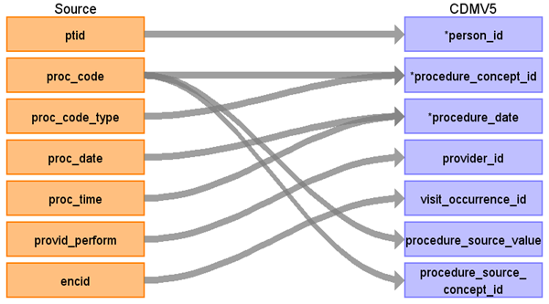

|  |  |  |  |
| --- | --- | --- | --- |
| Destination Field | Source Field | Logic | Comment |
| procedure_occurrence_id |  |  |  |
| person_id | ptid |  |  |
| procedure_concept_id | proc_code  proc_code_type |  | Lookup to the vocabulary using the proc_code_type to find the proper vocabulary_id |
| procedure_date | proc_date |  |  |
| procedure_type_concept_id | 38000275 |  | EHR order list entry |
| modifier_concept_id |  |  |  |
| quantity |  |  |  |
| provider_id | provid_perform |  |  |
| visit_occurrence_id | encid |  |  |
| procedure_source_value | proc_code |  |  |
| procedure_source_concept_id | proc_code |  |  |
| qualifier_source_value |  |  |  |

### Reading from diagnosis

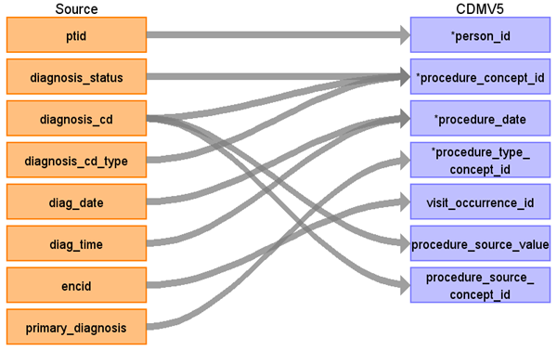

|  |  |  |  |
| --- | --- | --- | --- |
| Destination Field | Source Field | Logic | Comment |
| procedure_occurrence_id |  |  |  |
| person_id | ptid |  |  |
| procedure_concept_id | diagnosis_status  diagnosis_cd  diagnosis_cd_type |  | Diagnosis_status = ‘Diagnosis Of’ and diagnosis_cd must map to domain = procedure  Where the target vocabulary_id = diagnaosis_cd_type. |
| procedure_date | diag_date  diag_time |  |  |
| procedure_type_concept_id | 42865906 |  | ‘Condition Procedure’ |
| modifier_concept_id |  |  |  |
| quantity |  |  |  |
| provider_id |  |  |  |
| visit_occurrence_id | encid |  |  |
| procedure_source_value | diagnosis_cd |  |  |
| procedure_source_concept_id | diagnosis_cd |  |  |
| qualifier_source_value |  |  |  |

## Table name: measurement

### Reading from diagnosis

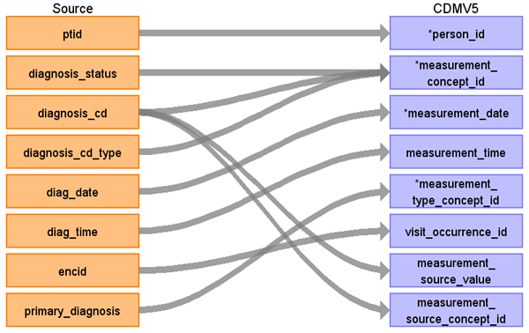

|  |  |  |  |
| --- | --- | --- | --- |
| Destination Field | Source Field | Logic | Comment |
| measurement_id |  |  |  |
| person_id | ptid |  |  |
| measurement_concept_id | diagnosis_status  diagnosis_cd  diagnosis_cd_type | Use Appendix 1.1.2 to obtain the source_vocabulary_id for the where clause  If diagnosis_status = ‘Diagnosis of’  Then  {  Case diagnosis_cd_type = ‘ICD9’:  Use lookup for ICD9CM  Case diagnosis_cd_type = ‘ICD10’:  Use lookup for ICD10CM  Case diagnosis_cd_type = ‘SNOMED’:  Use lookup for SNOMED  CASE ‘’:  Lookup code in ICD9CM, ICD10CM, SNOMED  CASE ELSE: 0  } | For diagnosis_cd_type = ICD9, strip dot from lookup  For diagnosis_cd_type = ICD10, leave dots in lookup. |
| measurement_date | diag_date |  |  |
| measurement_time | diag_time |  |  |
| measurement_type_concept_id | primary_diagnosis | if primary_diagnosis = ‘1’ then 44786627  else 44786629 |  |
| operator_concept_id |  |  |  |
| value_as_number |  |  |  |
| value_as_concept_id |  |  |  |
| unit_concept_id |  |  |  |
| range_low |  |  |  |
| range_high |  |  |  |
| provider_id |  |  |  |
| visit_occurrence_id | encid |  |  |
| measurement_source_value | diagnosis_cd |  |  |
| measurement_source_concept_id | diagnosis_cd | Use Appendix 1.1.1 to obtain the source_vocabulary_id for the where clause  If diagnosis_status = ‘Diagnosis of’  Then  {  Case diagnosis_cd_type = ‘ICD9’:  Use lookup for ICD9CM  Case diagnosis_cd_type = ‘ICD10’:  Use lookup for ICD10CM  Case diagnosis_cd_type = ‘SNOMED’:  Use lookup for SNOMED  CASE ‘’:  Lookup code in ICD9CM, ICD10CM, SNOMED  CASE ELSE: 0  } | For diagnosis_cd_type = ICD9, strip dot from lookup  For diagnosis_cd_type = ICD10, leave dots in lookup. |
| unit_source_value |  |  |  |
| value_source_value |  |  |  |

### Reading from labs

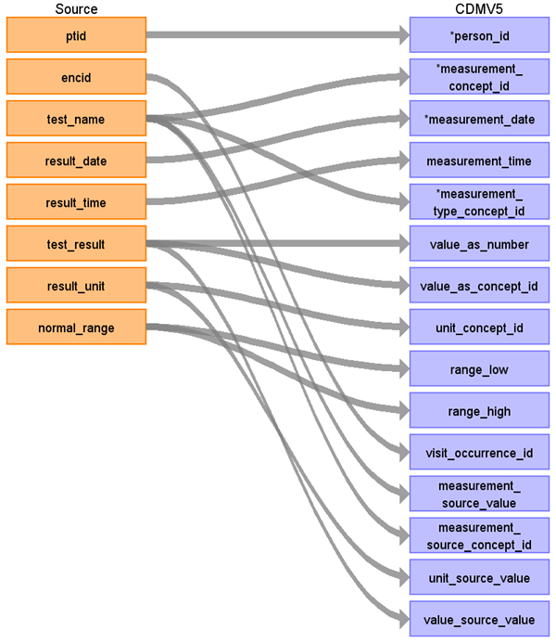

|  |  |  |  |
| --- | --- | --- | --- |
| Destination Field | Source Field | Logic | Comment |
| measurement_id |  |  |  |
| person_id | ptid |  |  |
| measurement_concept_id | test_name |  | STCM Lookup JNJ_OPTUM_EHR_LABNAME.csv |
| measurement_date | result_date |  |  |
| measurement_time | result_time |  |  |
| measurement_type_concept_id | 44818702 |  | Lab result |
| operator_concept_id | relative_indicator |  | When relative_indicator is NULL/empty, leave the value as NULL. These will map to domain_id = 'Meas Value Operator' in the vocabulary.  CASE WHEN relative_incicator == ‘<=’ THEN 4171754  CASE WHEN relative_incicator == ‘>=’ THEN 4171755  CASE WHEN relative_incicator == ‘<’ THEN 4171756  CASE WHEN relative_incicator == ‘=’ THEN 4172703  CASE WHEN relative_incicator == ‘>’ THEN 4172704  ELSE 0 |
| value_as_number | test_result |  | Only do this if test_result is numeric |
| value_as_concept_id | test_result |  | If test_result is NOT NUMERIC THEN  STCM Lookup JNJ_OPTUM_EHR_LABRES.csv |
| unit_concept_id | result_unit |  | Map to UCUM vocabulary using a CASE-SENSITIVE matching |
| range_low | normal_range |  | Parse lower bound (split on hyphen), first piece |
| range_high | normal_range |  | Parse upper bound (split on hyphen), second piece |
| provider_id | encid |  | Look up provider from the encounter |
| visit_occurrence_id | encid |  |  |
| measurement_source_value | test_name |  |  |
| measurement_source_concept_id | test_name | 0 |  |
| unit_source_value | result_unit |  |  |
| value_source_value | test_result |  |  |

### Reading from nlp_measurements

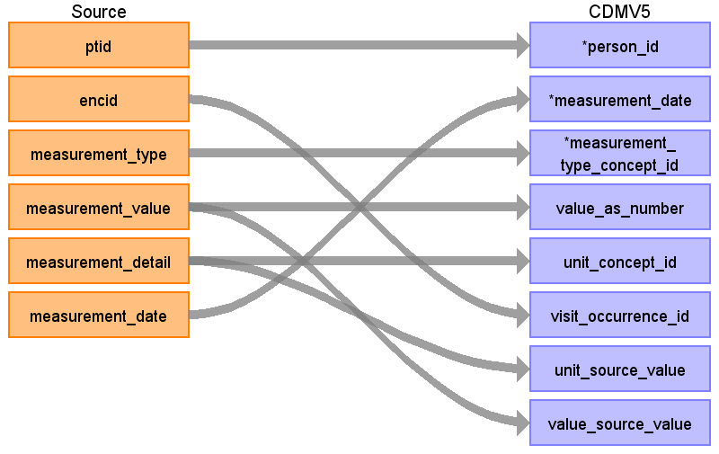

|  |  |  |  |
| --- | --- | --- | --- |
| Destination Field | Source Field | Logic | Comment |
| measurement_id |  |  |  |
| person_id | ptid |  |  |
| measurement_concept_id | measurement_type |  | STCM Lookup JNJ_OPTUM_EHR_LABNAM.csv  This STCM Lookup should be a consolidated list of text values found in the source “labs” and “nlp_measurements” tables so we don’t have duplicate concept_ids. |
| measurement_date | measurement_date |  |  |
| measurement_time |  |  |  |
| measurement_type_concept_id | 45754907 |  | Derived value |
| operator_concept_id |  |  |  |
| value_as_number | measurement_value |  | Only do this if measurement_value is numeric |
| value_as_concept_id | measurement_value |  |  |
| unit_concept_id | measurement_detail |  | Map to UCUM vocabulary using a CASE-SENSITIVE matching |
| range_low |  |  |  |
| range_high |  |  |  |
| provider_id |  |  |  |
| visit_occurrence_id | encid |  |  |
| measurement_source_value |  |  |  |
| measurement_source_concept_id |  |  |  |
| unit_source_value | measurement_detail |  |  |
| value_source_value | measurement_value |  |  |

### Reading from observations

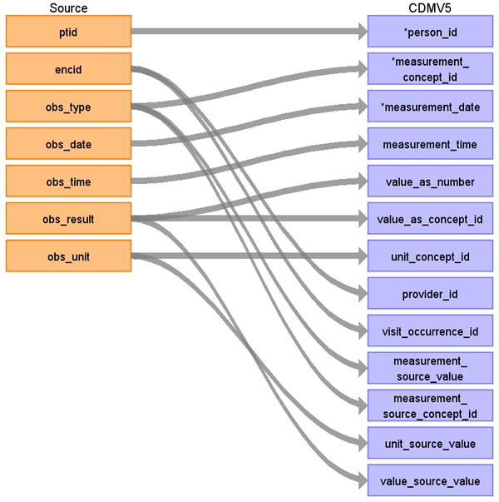

|  |  |  |  |
| --- | --- | --- | --- |
| Destination Field | Source Field | Logic | Comment |
| measurement_id |  |  |  |
| person_id | ptid |  |  |
| measurement_concept_id | obs_type |  | STCM Lookup JNJ_OPTUM_EHR_OBTYPE.csv  Create a source to concept map (STCM) for the native observations that should map to the CDM measurement table. Then when mapping rows to the the CDM Measurement table, only push over the rows that are in the STCM via an inner join. When the target is the CDM observation table, do a left join and bring over the values that are NOT in the STCM. |
| measurement_date | obs_date |  |  |
| measurement_time | obs_time |  |  |
| measurement_type_concept_id | 45754907 |  | Derived value |
| operator_concept_id | 0 |  |  |
| value_as_number | obs_result |  |  |
| value_as_concept_id | obs_result |  |  |
| unit_concept_id | obs_unit |  |  |
| range_low |  |  |  |
| range_high |  |  |  |
| provider_id | encid |  | Map encid to encounter_provider |
| visit_occurrence_id | encid |  |  |
| measurement_source_value | obs_type |  |  |
| measurement_source_concept_id | obs_type |  |  |
| unit_source_value | obs_unit |  |  |
| value_source_value | obs_result |  |  |

### Reading from procedure

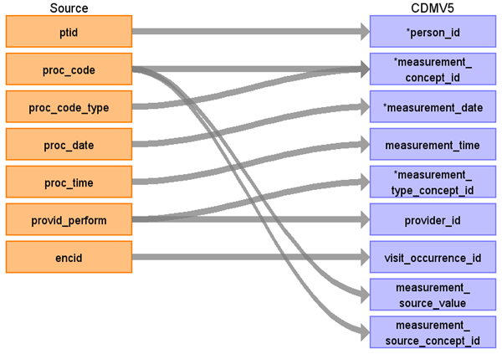

|  |  |  |  |
| --- | --- | --- | --- |
| Destination Field | Source Field | Logic | Comment |
| measurement_id |  |  |  |
| person_id | ptid |  |  |
| measurement_concept_id | proc_code  proc_code_type |  | Lookup to the vocabulary using the proc_code_type to find the proper vocabulary_id |
| measurement_date | proc_date |  |  |
| measurement_time | proc_time |  |  |
| measurement_type_concept_id | provid_perform |  | 44818701  45754907    Derived value |
| operator_concept_id |  |  |  |
| value_as_number |  |  |  |
| value_as_concept_id |  |  |  |
| unit_concept_id |  |  |  |
| range_low |  |  |  |
| range_high |  |  |  |
| provider_id | provid_perform |  |  |
| visit_occurrence_id | encid |  |  |
| measurement_source_value | proc_code |  |  |
| measurement_source_concept_id | proc_code |  |  |
| unit_source_value |  |  |  |
| value_source_value |  |  |  |

## Table name: observation

### Reading from observations

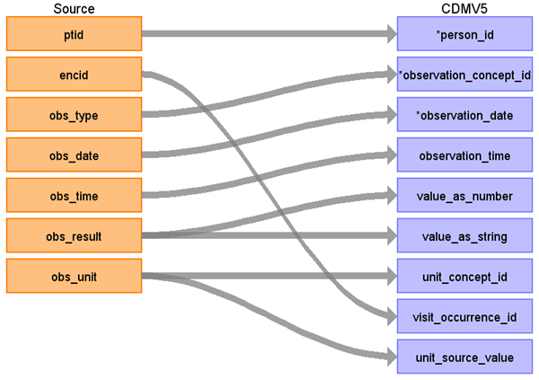

|  |  |  |  |
| --- | --- | --- | --- |
| Destination Field | Source Field | Logic | Comment |
| observation_id |  |  |  |
| person_id | ptid |  |  |
| observation_concept_id | obs_type | CASE WHEN ‘SMOKE’ THEN <concept_id>  CASE WHEN ‘ALCOHOL’ THEN <concept_id>  CASE WHEN ‘EXERCISE’ THEN <concept_id>  ELSE 0 | STCM Lookup JNJ_OPTUM_EHR_OBTYPE.csv  Create a source to concept map (STCM) for the native observations that should map to the CDM measurement table. Then when mapping rows to the the CDM Measurement table, only push over the rows that are in the STCM via an inner join. When the target is the CDM observation table, do a left join and bring over the values that are NOT in the STCM and use 0 for the concept id. |
| observation_date | obs_date |  |  |
| observation_time | obs_time |  |  |
| observation_type_concept_id |  |  | 38000280 |
| value_as_number | obs_result |  | When obs_result can be treated as a decimal, place the value in this field |
| value_as_string | obs_result |  | When the obs_result cannot be treated as a decimal, please the value in this field. |
| value_as_concept_id |  |  |  |
| qualifier_concept_id |  |  |  |
| unit_concept_id | obs_unit |  | Map to UCUM vocabulary using a CASE-SENSITIVE matching |
| provider_id | encid |  |  |
| visit_occurrence_id | encid |  |  |
| observation_source_value |  |  |  |
| observation_source_concept_id |  |  |  |
| unit_source_value | obs_unit |  |  |
| qualifier_source_value |  |  |  |

### Reading from nlp_sds_family

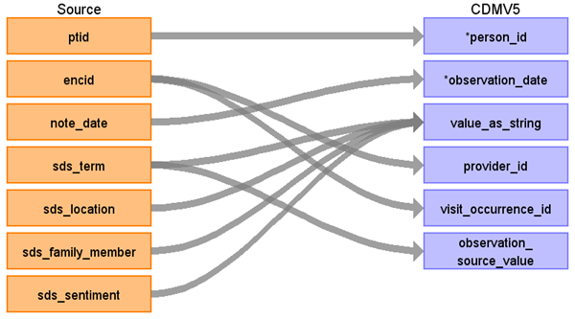

|  |  |  |  |
| --- | --- | --- | --- |
| Destination Field | Source Field | Logic | Comment |
| observation_id |  |  |  |
| person_id | ptid |  |  |
| observation_concept_id |  |  |  |
| observation_date | note_date |  |  |
| observation_time |  |  |  |
| observation_type_concept_id |  | 38000280 |  |
| value_as_number |  |  |  |
| value_as_string | sds_term  sds_location  sds_family_member  sds_sentiment | Concatenate the fields: sds_term, sds_location, sds_family_member and sds_sentiment    Use a semi-colon as the delimiter |  |
| value_as_concept_id |  |  |  |
| qualifier_concept_id |  |  |  |
| unit_concept_id |  |  |  |
| provider_id | encid |  |  |
| visit_occurrence_id | encid |  |  |
| observation_source_value | sds_term |  |  |
| observation_source_concept_id |  |  |  |
| unit_source_value |  |  |  |
| qualifier_source_value |  |  |  |

### Reading from nlp_sds

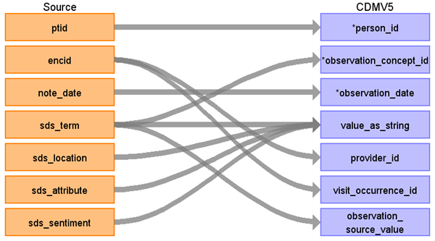

|  |  |  |  |
| --- | --- | --- | --- |
| Destination Field | Source Field | Logic | Comment |
| observation_id |  |  |  |
| person_id | ptid |  |  |
| observation_concept_id | sds_term |  |  |
| observation_date | note_date |  |  |
| observation_time |  |  |  |
| observation_type_concept_id |  | 38000280 |  |
| value_as_number |  |  |  |
| value_as_string | sds_term  sds_location  sds_attribute  sds_sentiment | Concatenate sds_term + sds_location + sds_attribute + sds_sentiment    Use a "semi-colon" for all concatenation |  |
| value_as_concept_id |  |  |  |
| qualifier_concept_id |  |  |  |
| unit_concept_id |  |  |  |
| provider_id | encid |  |  |
| visit_occurrence_id | encid |  |  |
| observation_source_value | sds_term | NLP_SDS |  |
| observation_source_concept_id |  |  |  |
| unit_source_value |  |  |  |
| qualifier_source_value |  |  |  |

### Reading from diagnosis

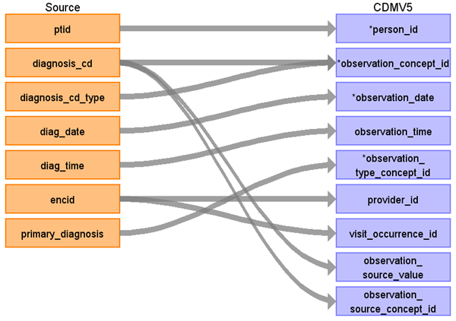

|  |  |  |  |
| --- | --- | --- | --- |
| Destination Field | Source Field | Logic | Comment |
| observation_id |  |  |  |
| person_id | ptid |  |  |
| observation_concept_id | diagnosis_cd  diagnosis_cd_type |  |  |
| observation_date | diag_date |  |  |
| observation_time | diag_time |  |  |
| observation_type_concept_id | primary_diagnosis |  | If primary_diagnosis = ‘1’ then 44786627  Else 44786629 |
| value_as_number |  |  |  |
| value_as_string |  |  |  |
| value_as_concept_id |  |  |  |
| qualifier_concept_id |  |  |  |
| unit_concept_id |  |  |  |
| provider_id | encid |  |  |
| visit_occurrence_id | encid |  |  |
| observation_source_value | diagnosis_cd |  |  |
| observation_source_concept_id | diagnosis_cd |  |  |
| unit_source_value |  |  |  |
| qualifier_source_value |  |  |  |

### Reading from procedure

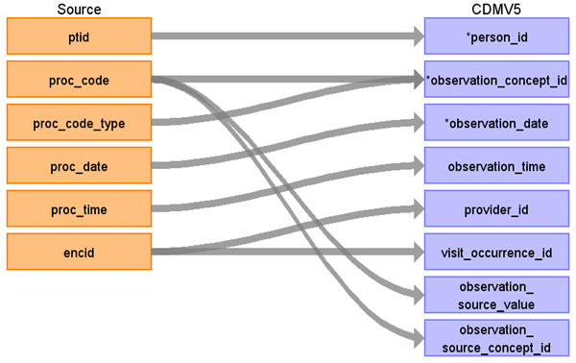

|  |  |  |  |
| --- | --- | --- | --- |
| Destination Field | Source Field | Logic | Comment |
| observation_id |  |  |  |
| person_id | ptid |  |  |
| observation_concept_id | proc_code  proc_code_type | Look for procedures that map to the vocabulary with domain_id = observation |  |
| observation_date | proc_date |  |  |
| observation_time | proc_time |  |  |
| observation_type_concept_id |  |  |  |
| value_as_number |  |  |  |
| value_as_string |  |  |  |
| value_as_concept_id |  |  |  |
| qualifier_concept_id |  |  |  |
| unit_concept_id |  |  |  |
| provider_id | encid |  |  |
| visit_occurrence_id | encid |  |  |
| observation_source_value | proc_code |  |  |
| observation_source_concept_id | proc_code |  |  |
| unit_source_value |  |  |  |
| qualifier_source_value |  |  |  |

### Reading from microbiology

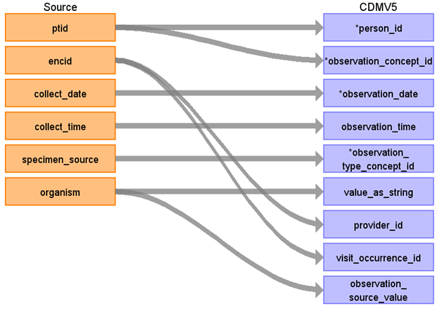

|  |  |  |  |
| --- | --- | --- | --- |
| Destination Field | Source Field | Logic | Comment |
| observation_id |  |  |  |
| person_id | ptid |  |  |
| observation_concept_id | ptid | 4155370 Microbiology |  |
| observation_date | collect_date |  |  |
| observation_time | collect_time |  |  |
| observation_type_concept_id | specimen_source | 44818702 Lab result  44818703 Pathology finding |  |
| value_as_number |  |  |  |
| value_as_string | organism |  |  |
| value_as_concept_id |  |  |  |
| qualifier_concept_id |  |  |  |
| unit_concept_id |  |  |  |
| provider_id | encid |  |  |
| visit_occurrence_id | encid |  |  |
| observation_source_value | organism |  |  |
| observation_source_concept_id |  |  |  |
| unit_source_value |  |  |  |
| qualifier_source_value |  |  |  |

### Reading from nlp_biomarker

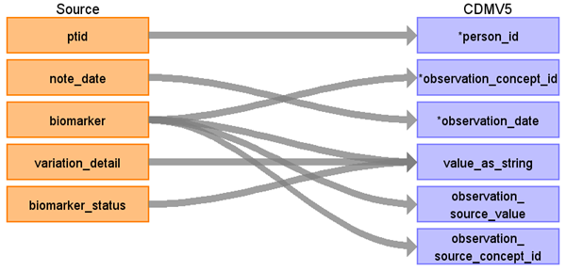

|  |  |  |  |
| --- | --- | --- | --- |
| Destination Field | Source Field | Logic | Comment |
| observation_id |  |  |  |
| person_id | ptid |  |  |
| observation_concept_id | biomarker | 0 |  |
| observation_date | note_date |  |  |
| observation_time |  |  |  |
| observation_type_concept_id |  |  |  |
| value_as_number |  |  |  |
| value_as_string | biomarker_status  variation_detail  biomarker | Concatenate biomarker + variation_detail + biomarker_status |  |
| value_as_concept_id |  |  |  |
| qualifier_concept_id |  |  |  |
| unit_concept_id |  |  |  |
| provider_id |  |  |  |
| visit_occurrence_id |  |  |  |
| observation_source_value | biomarker | BIOMARKER |  |
| observation_source_concept_id | biomarker |  |  |
| unit_source_value |  |  |  |
| qualifier_source_value |  |  |  |

### Reading from Insurance

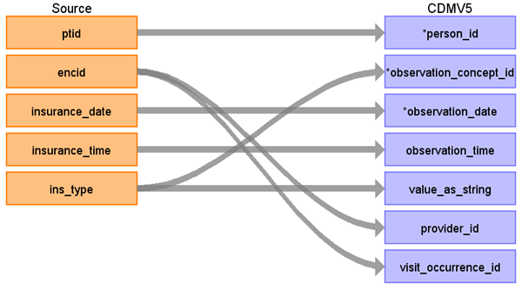

|  |  |  |  |
| --- | --- | --- | --- |
| Destination Field | Source Field | Logic | Comment |
| observation_id |  |  |  |
| person_id | ptid |  |  |
| observation_concept_id | ins_type | 45877222 | Insurance status/requirement |
| observation_date | insurance_date |  |  |
| observation_time | insurance_time |  |  |
| observation_type_concept_id |  |  |  |
| value_as_number |  |  |  |
| value_as_string | ins_type |  |  |
| value_as_concept_id |  |  |  |
| qualifier_concept_id |  |  |  |
| unit_concept_id |  |  |  |
| provider_id | encid |  |  |
| visit_occurrence_id | encid |  |  |
| observation_source_value |  |  |  |
| observation_source_concept_id |  |  |  |
| unit_source_value |  |  |  |
| qualifier_source_value |  |  |  |

## Table Name: CDM_DOMAIN_META

|  |  |  |  |
| --- | --- | --- | --- |
| **CDM_DOMAIN_META** | | | |
| **Destination Field** | **Source Field** | **Applied Rule** | **Comment** |
| DOMAIN_ID | DOMAIN_ID from the table below |  |  |
| DESCRIPTION | DESCRIPTION from the lookup table below |  |  |

## Tables Not Mapped:

|  |  |  |
| --- | --- | --- |
| **Meta Data Lookup Table for OPTUM ONCOLOGY HER** | | |
| **TABLE NAME** | **DOMAIN_ID** | **DESCRIPTION** |
| PERSON | Person |  |
| OBSERVATION_PERIOD | Observation Period |  |
| CARE_SITE | Care Site |  |
| VISIT_OCCURRENCE | Visit |  |
| PROVIDER | Provider |  |
| DEATH | Death |  |
| CONDITION_OCCURRENCE | Condition |  |
| DRUG_EXPOSURE | Drug |  |
| PROCEDURE_OCCURRENCE | Procedure |  |
| MEASUREMENT | Measurement |  |
| OBSERVATION | Observation |  |

### Table name: cdm_source

|  |  |  |  |
| --- | --- | --- | --- |
| SOURCE_DOCUMENTATION_REFERENCE |  | <https://jnj.sharepoint.com/sites/PHM-GCSP-RND/RWE/Pages/DataSourceDetails.aspx?DataSourceItem=36> |  |
| CDM_ETL_REFERENCE |  | http://www.ohdsi.org/web/wiki/  doku.php?id=documentation:example_etls |  |
| SOURCE_RELEASE_DATE |  | SELECT VERSION_DATE  FROM [_Version] | Get from the source tables. |
| CDM_RELEASE_DATE |  | SELECT CONVERT(VARCHAR(10), GETDATE(),102) | Get the date the run completes on. |
| CDM_VERSION | - | V5.0 |  |
| VOCABULARY_VERSION | - | SELECT VOCABULARY_VERSION  FROM vocabulary  WHERE VOCABULARY_ID = 'None' | Taken from the Vocabulary loaded into the CDM. |

### Table name: payer_plan_period

### Table name: procedure_cost

### Table name: visit_cost

### Table name: drug_cost

### Table name: device_cost

### Table name: drug_era

### Table name: dose_era

### Table name: condition_era

### Table name: cohort

### Table name: cohort_definition

### Table name: cohort_attribute

### Table name: attribute_definition

# Appendix

# 1 Code Snippets

## 1.1 Vocabulary Mapping

Use this code to map source codes to concept ids; change the source_vocabulary_id and target_vocabulary_id as needed.

### 1.1.1 Source to Source

WITH CTE_VOCAB_MAP AS (

SELECT c.concept_code AS SOURCE_CODE, c.concept_id AS SOURCE_CONCEPT_ID, c.CONCEPT_NAME AS SOURCE_CODE_DESCRIPTION,

c.vocabulary_id AS SOURCE_VOCABULARY_ID, c.domain_id AS SOURCE_DOMAIN_ID, c.concept_class_id AS SOURCE_CONCEPT_CLASS_ID,

c.VALID_START_DATE AS SOURCE_VALID_START_DATE, c.VALID_END_DATE AS SOURCE_VALID_END_DATE, c.invalid_reason AS SOURCE_INVALID_REASON,

c.concept_ID as TARGET_CONCEPT_ID, c.concept_name AS TARGET_CONCEPT_NAME, c.vocabulary_id AS TARGET_VOCABULARY_ID, c.domain_id AS TARGET_DOMAIN_ID,

c.concept_class_id AS TARGET_CONCEPT_CLASS_ID, c.INVALID_REASON AS TARGET_INVALID_REASON,

c.STANDARD_CONCEPT AS TARGET_STANDARD_CONCEPT

FROM CONCEPT c

UNION

SELECT source_code, SOURCE_CONCEPT_ID, SOURCE_CODE_DESCRIPTION, source_vocabulary_id, c1.domain_id AS SOURCE_DOMAIN_ID, c2.CONCEPT_CLASS_ID AS SOURCE_CONCEPT_CLASS_ID,

c1.VALID_START_DATE AS SOURCE_VALID_START_DATE, c1.VALID_END_DATE AS SOURCE_VALID_END_DATE,stcm.INVALID_REASON AS SOURCE_INVALID_REASON,

target_concept_id, c2.CONCEPT_NAME AS TARGET_CONCEPT_NAME, target_vocabulary_id, c2.domain_id AS TARGET_DOMAIN_ID, c2.concept_class_id AS TARGET_CONCEPT_CLASS_ID,

c2.INVALID_REASON AS TARGET_INVALID_REASON, c2.standard_concept AS TARGET_STANDARD_CONCEPT

FROM source_to_concept_map stcm

LEFT OUTER JOIN CONCEPT c1

ON c1.concept_id = stcm.source_concept_id

LEFT OUTER JOIN CONCEPT c2

ON c2.CONCEPT_ID = stcm.target_concept_id

WHERE stcm.INVALID_REASON IS NULL

)

SELECT *

FROM CTE_VOCAB_MAP

/*EXAMPLE FILTERS*/

WHERE SOURCE_VOCABULARY_ID IN ('ICD9CM')

AND TARGET_VOCABULARY_ID IN ('ICD9CM')

### 1.1.2 Source to Standard Terminology

WITH CTE_VOCAB_MAP AS (

SELECT c.concept_code AS SOURCE_CODE, c.concept_id AS SOURCE_CONCEPT_ID, c.concept_name AS SOURCE_CODE_DESCRIPTION, c.vocabulary_id AS SOURCE_VOCABULARY_ID,

c.domain_id AS SOURCE_DOMAIN_ID, c.CONCEPT_CLASS_ID AS SOURCE_CONCEPT_CLASS_ID,

c.VALID_START_DATE AS SOURCE_VALID_START_DATE, c.VALID_END_DATE AS SOURCE_VALID_END_DATE, c.INVALID_REASON AS SOURCE_INVALID_REASON,

c1.concept_id AS TARGET_CONCEPT_ID, c1.concept_name AS TARGET_CONCEPT_NAME, c1.VOCABULARY_ID AS TARGET_VOCABUALRY_ID, c1.domain_id AS TARGET_DOMAIN_ID, c1.concept_class_id AS TARGET_CONCEPT_CLASS_ID,

c1.INVALID_REASON AS TARGET_INVALID_REASON, c1.standard_concept AS TARGET_STANDARD_CONCEPT

FROM CONCEPT C

JOIN CONCEPT_RELATIONSHIP CR

ON C.CONCEPT_ID = CR.CONCEPT_ID_1

AND CR.invalid_reason IS NULL

AND cr.relationship_id = 'Maps To'

JOIN CONCEPT C1

ON CR.CONCEPT_ID_2 = C1.CONCEPT_ID

AND C1.INVALID_REASON IS NULL

UNION

SELECT source_code, SOURCE_CONCEPT_ID, SOURCE_CODE_DESCRIPTION, source_vocabulary_id, c1.domain_id AS SOURCE_DOMAIN_ID, c2.CONCEPT_CLASS_ID AS SOURCE_CONCEPT_CLASS_ID,

c1.VALID_START_DATE AS SOURCE_VALID_START_DATE, c1.VALID_END_DATE AS SOURCE_VALID_END_DATE,

stcm.INVALID_REASON AS SOURCE_INVALID_REASON,target_concept_id, c2.CONCEPT_NAME AS TARGET_CONCEPT_NAME, target_vocabulary_id, c2.domain_id AS TARGET_DOMAIN_ID, c2.concept_class_id AS TARGET_CONCEPT_CLASS_ID,

c2.INVALID_REASON AS TARGET_INVALID_REASON, c2.standard_concept AS TARGET_STANDARD_CONCEPT

FROM source_to_concept_map stcm

LEFT OUTER JOIN CONCEPT c1

ON c1.concept_id = stcm.source_concept_id

LEFT OUTER JOIN CONCEPT c2

ON c2.CONCEPT_ID = stcm.target_concept_id

WHERE stcm.INVALID_REASON IS NULL

)

SELECT *

FROM CTE_VOCAB_MAP

/*EXAMPLE FILTERS*/

WHERE SOURCE_VOCABULARY_ID IN ('NDC')

AND TARGET_VOCABULARY_ID IN ('RxNORM')

### 1.1.3 Source to Maps to Value

WITH CTE_VOCAB_MAP AS (

SELECT c.concept_code AS SOURCE_CODE, c.concept_id AS SOURCE_CONCEPT_ID, c.concept_name AS SOURCE_CODE_DESCRIPTION, c.vocabulary_id AS SOURCE_VOCABULARY_ID,

c.domain_id AS SOURCE_DOMAIN_ID, c.CONCEPT_CLASS_ID AS SOURCE_CONCEPT_CLASS_ID,

c.VALID_START_DATE AS SOURCE_VALID_START_DATE, c.VALID_END_DATE AS SOURCE_VALID_END_DATE, c.INVALID_REASON AS SOURCE_INVALID_REASON,

c1.concept_id AS TARGET_CONCEPT_ID, c1.concept_name AS TARGET_CONCEPT_NAME, c1.VOCABULARY_ID AS TARGET_VOCABUALRY_ID, c1.domain_id AS TARGET_DOMAIN_ID, c1.concept_class_id AS TARGET_CONCEPT_CLASS_ID,

c1.INVALID_REASON AS TARGET_INVALID_REASON, c1.standard_concept AS TARGET_STANDARD_CONCEPT

FROM CONCEPT C

JOIN CONCEPT_RELATIONSHIP CR

ON C.CONCEPT_ID = CR.CONCEPT_ID_1

AND CR.invalid_reason IS NULL

AND cr.relationship_id = 'Maps To Value'

JOIN CONCEPT C1

ON CR.CONCEPT_ID_2 = C1.CONCEPT_ID

AND C1.INVALID_REASON IS NULL

)

SELECT *

FROM CTE_VOCAB_MAP

/*EXAMPLE FILTERS*/

WHERE SOURCE_CODE = 'V87.43'

## Source tables

### Table: patient

|  |  |  |  |
| --- | --- | --- | --- |
| Field | Type | Most freq. value | Comment |
| ptid | character | List truncated... | Create new integer value unique to PTID |
| birth_yr | character varying | 1930 and Earlier |  |
| gender | character varying | Male |  |
| race | character varying | Caucasian |  |
| ethnicity | character varying | Not Hispanic |  |
| region | character varying | South | ACTION: confirm it's clean mapping from region to division. If it is, then just bring division as it's more granular. |
| division | character varying | South Atl/West South Crl |  |
| avg_hh_income | double precision | 39005.0 |  |
| pct_college_educ | double precision | 26.0 |  |
| deceased_indicator | character varying | 0 |  |
| date_of_death | character |  |  |
| provid_pcp | character varying |  |  |
| idn_indicator | character | 1 |  |
| first_month_active | character varying | 200601 |  |
| last_month_active | character varying | 201506 |  |
| notes_eligible | character | 1 |  |
| has_notes | character | 1 |  |
| sourceid | character varying | S0034 |  |
| source_data_through | character varying | 201506 |  |

### Table: diagnosis

|  |  |  |  |
| --- | --- | --- | --- |
| Field | Type | Most freq. value | Comment |
| ptid | character | List truncated... |  |
| encid | character varying |  |  |
| diag_date | date | 2014-05-02 |  |
| diag_time | timestamp without time zone | 1900-01-01.000000 |  |
| diagnosis_cd | character varying |  |  |
| diagnosis_cd_type | character varying | ICD9 | To save time, create reference table with source concept and standard concept |
| diagnosis_status | character varying | Diagnosis of | Only use 'Diagnosis of' in CONDITION_OCCURRENCE |
| poa | character | 0 |  |
| admitting_diagnosis | character | 0 |  |
| discharge_diagnosis | character | 0 |  |
| primary_diagnosis | character | 0 |  |
| problem_list | character | N |  |

### Table: care_area

|  |  |  |  |
| --- | --- | --- | --- |
| Field | Type | Most freq. value | Comment |
| ptid | character | PT095853463 |  |
| encid | character varying | List truncated... |  |
| carearea | character varying | UNKNOWN CARE AREA |  |
| carearea_date | date |  |  |
| carearea_time | timestamp without time zone | 1900-01-01.000000 |  |

### Table: encounter_provider

|  |  |  |  |
| --- | --- | --- | --- |
| Field | Type | Most freq. value | Comment |
| encid | character varying | List truncated... |  |
| provid | character varying | 70371 |  |
| provider_role | character varying | ATTENDING |  |

### Table: provider

|  |  |  |  |
| --- | --- | --- | --- |
| Field | Type | Most freq. value | Comment |
| provid | character varying | List truncated... |  |
| specialty | character varying | Unspecified |  |
| prim_spec_ind | character | 1 |  |

### Table: visit

|  |  |  |  |
| --- | --- | --- | --- |
| Field | Type | Most freq. value | Comment |
| ptid | character | PT091048451 |  |
| visitid | bigint | List truncated... |  |
| visit_type | character varying | Inpatient |  |
| visit_start_date | date | 2012-08-13 |  |
| visit_start_time | timestamp without time zone | 1900-01-01.000000 | delete the null time 1900-01-01.000000 21,485 23.0 |
| visit_end_date | date | 2014-07-25 |  |
| visit_end_time | timestamp without time zone | 1900-01-01.000000 |  |
| discharge_disposition | character varying | 01 DISCHARGED TO HOME OR SELF CARE |  |
| admission_source | character varying | Referred by physician or self referral; non-healthcare facility point of origin |  |
| drg | character varying |  |  |

### Table: encounter

|  |  |  |  |
| --- | --- | --- | --- |
| Field | Type | Most freq. value | Comment |
| ptid | character | List truncated... |  |
| visitid | bigint |  |  |
| encid | character varying | List truncated... |  |
| interaction_type | character varying | Office or clinic patient | Outpatient, Inpatient, ER, LTC. "Prescriptions and refills" don't sound like a valid encounter. Shouldn't be just going to the pharmacy. "other" --> unknown |
| interaction_date | date | 2014-06-16 |  |
| interaction_time | timestamp without time zone | 1900-01-01.000000 |  |

### Table: nlp_sds

|  |  |  |  |
| --- | --- | --- | --- |
| Field | Type | Most freq. value | Comment |
| ptid | character | List truncated... |  |
| encid | character varying |  |  |
| note_date | date | 2013-04-23 |  |
| sds_term | character varying | pain | usagi. restrict to condition, only use high quality mapping. everything else, drop it. |
| sds_location | character varying |  |  |
| sds_attribute | character varying |  |  |
| sds_sentiment | character varying |  | need to express only 'positive' findings in CONDITION_OCCURRENCE |
| note_section | character varying |  |  |

### Table: medication_administrations

|  |  |  |  |
| --- | --- | --- | --- |
| Field | Type | Most freq. value | Comment |
| ptid | character | PT093154612 |  |
| encid | character varying |  |  |
| drug_name | character varying | SODIUM CHLORIDE 0.9 % |  |
| ndc | character varying | 00338004904 |  |
| ndc_source | character varying | Derived |  |
| order_date | date | 2014-10-07 |  |
| order_time | timestamp without time zone | 1900-01-01.000000 |  |
| admin_date | date |  |  |
| admin_time | timestamp without time zone |  |  |
| provid | character varying |  |  |
| quantity_of_dose | character varying |  |  |
| route | character varying | Intravenous |  |
| strength | character varying |  |  |
| strength_unit | character varying |  |  |
| dosage_form | character varying |  |  |
| dosefreq | character varying |  |  |
| generic_desc | character varying | SODIUM CHLORIDE |  |
| drug_class | character varying | Intravenous nutritional therapy; electrolyte; trace element; metal; vitamin; alone or combinations |  |

### Table: patient_reported_meds

|  |  |  |  |
| --- | --- | --- | --- |
| Field | Type | Most freq. value | Comment |
| ptid | character | PT155237089 |  |
| reported_date | date | 2009-03-27 |  |
| drug_name | character varying |  |  |
| ndc | character varying | 49999035930 |  |
| ndc_source | character varying | Direct |  |
| provid | character varying |  |  |
| route | character varying | Oral |  |
| quantity_of_dose | character varying |  |  |
| strength | character varying |  |  |
| strength_unit | character varying | mg |  |
| dosage_form | character varying | Tabs |  |
| dosefreq | character varying |  |  |
| generic_desc | character varying |  |  |
| drug_class | character varying | Salicylates |  |

### Table: prescriptions_written

|  |  |  |  |
| --- | --- | --- | --- |
| Field | Type | Most freq. value | Comment |
| ptid | character | PT118881881 |  |
| rxdate | date | 2014-02-24 |  |
| rxtime | timestamp without time zone | 1900-01-01.000000 |  |
| drug_name | character varying |  |  |
| ndc | character varying | 00406035705 |  |
| ndc_source | character varying | Direct |  |
| provid | character varying |  |  |
| route | character varying | Oral |  |
| quantity_of_dose | character varying |  |  |
| strength | character varying |  |  |
| strength_unit | character varying | mg |  |
| dosage_form | character varying | Tabs |  |
| dosefreq | character varying |  |  |
| quantity_per_fill | character varying | 30 |  |
| num_refills | double precision | 0.0 |  |
| days_supply | double precision |  |  |
| generic_desc | character varying |  |  |
| drug_class | character varying | HMG & CoA reductase inhibitors (statins) |  |

### Table: nlp_drug_rationale

|  |  |  |  |
| --- | --- | --- | --- |
| Field | Type | Most freq. value | Comment |
| ptid | character | PT191017751 |  |
| encid | character varying |  |  |
| note_date | date | 2013-04-23 |  |
| note_section | character varying | MEDICATIONS |  |
| drug_name | character varying | ASPIRIN |  |
| drug_action | character varying | N/A |  |
| drug_action_preposition | character varying | OF |  |
| reason_general | character varying |  |  |
| sentiment | character varying |  |  |
| sentiment_who | character varying |  |  |

### Table: immunization

|  |  |  |  |
| --- | --- | --- | --- |
| Field | Type | Most freq. value | Comment |
| ptid | character | PT194773862 |  |
| immunization_date | date |  |  |
| immunization_desc | character varying | INFLUENZA VIRUS VACCINE; INACTIVATED |  |
| mapped_name | character varying | Influenza Inactivated Vaccine |  |
| ndc | character varying | 49281001350 |  |
| ndc_source | character varying | Derived |  |
| pt_reported | character |  |  |

### Table: procedure

|  |  |  |  |
| --- | --- | --- | --- |
| Field | Type | Most freq. value | Comment |
| ptid | character | List truncated... |  |
| encid | character varying |  |  |
| proc_date | date | 2012-10-22 |  |
| proc_time | timestamp without time zone | 1900-01-01.000000 |  |
| proc_code | character varying |  |  |
| proc_desc | character varying |  |  |
| proc_code_type | character varying | CPT4 |  |
| provid_perform | character varying |  |  |
| provid_order | character varying |  |  |
| betos_code | character varying |  |  |
| betos_desc | character varying |  |  |

### Table: nlp_measurements

|  |  |  |  |
| --- | --- | --- | --- |
| Field | Type | Most freq. value | Comment |
| ptid | character | PT130234983 |  |
| encid | character varying |  |  |
| note_date | date | 2013-04-23 |  |
| measurement_type | character varying | DBP |  |
| measurement_value | character varying | 2 |  |
| measurement_detail | character varying |  |  |
| note_section | character varying |  |  |
| measurement_date | date |  |  |

### Table: insurance

|  |  |  |  |
| --- | --- | --- | --- |
| Field | Type | Most freq. value | Comment |
| ptid | character | PT130555350 |  |
| encid | character varying | List truncated... |  |
| insurance_date | date | 2008-09-15 |  |
| insurance_time | timestamp without time zone | 1900-01-01.000000 |  |
| ins_type | character varying | Medicare |  |

### Table: labs

|  |  |  |  |
| --- | --- | --- | --- |
| Field | Type | Most freq. value | Comment |
| ptid | character | PT143890838 |  |
| encid | character varying |  |  |
| test_name | character varying | O2 saturation.oximetry |  |
| order_date | date |  |  |
| order_time | timestamp without time zone |  |  |
| collected_date | date |  |  |
| collected_time | timestamp without time zone |  |  |
| result_date | date |  |  |
| result_time | timestamp without time zone | 1900-01-01.000000 |  |
| test_result | character varying | Negative |  |
| relative_indicator | character varying |  |  |
| result_unit | character varying | % |  |
| normal_range | character varying |  |  |
| evaluated_for_range | character | N |  |
| value_within_range | character | U |  |

### Table: observations

|  |  |  |  |
| --- | --- | --- | --- |
| Field | Type | Most freq. value | Comment |
| ptid | character | PT143890838 |  |
| encid | character varying |  |  |
| obs_type | character varying | SBP |  |
| obs_date | date | 2014-06-10 |  |
| obs_time | timestamp without time zone | 1900-01-01.000000 |  |
| obs_result | character varying | 18 |  |
| obs_unit | character varying | mm Hg |  |
| evaluated_for_range | character | N |  |
| value_within_range | character | U |  |

### Table: microbiology

|  |  |  |  |
| --- | --- | --- | --- |
| Field | Type | Most freq. value | Comment |
| ptid | character | PT117858758 |  |
| encid | character varying |  |  |
| order_date | date |  |  |
| order_time | timestamp without time zone | 1900-01-01.000000 |  |
| collect_date | date |  |  |
| collect_time | timestamp without time zone | 1900-01-01.000000 |  |
| receive_date | date |  |  |
| receive_time | timestamp without time zone |  |  |
| result_date | date | 2015-05-22 |  |
| result_time | timestamp without time zone | 1900-01-01.000000 |  |
| result_status | character varying |  |  |
| specimen_source | character varying | Urine |  |
| organism | character varying |  |  |
| mapped_organism_found | character varying |  |  |
| mapped_organism_excluded | character varying |  |  |
| culture_growth | character varying |  |  |
| culture_value | character varying |  |  |
| culture_unit | character varying |  |  |
| antibiotic | character varying |  |  |
| mapped_antibiotic | character varying |  |  |
| sensitivity | character varying |  |  |

### Table: nlp_biomarker

|  |  |  |  |
| --- | --- | --- | --- |
| Field | Type | Most freq. value | Comment |
| ptid | character | PT084542965 |  |
| note_date | date | 2013-04-23 |  |
| biomarker | character varying | CD20 |  |
| variation_detail | character varying |  |  |
| biomarker_status | character varying | positive |  |

### Table: nlp_sds_family

|  |  |  |  |
| --- | --- | --- | --- |
| Field | Type | Most freq. value | Comment |
| ptid | character | PT084524827 |  |
| encid | character varying |  |  |
| note_date | date | 2014-07-23 |  |
| sds_term | character varying | cancer |  |
| sds_location | character varying |  |  |
| sds_family_member | character varying | who=family |  |
| sds_sentiment | character varying |  |  |
| note_section | character varying | family medical history |  |

|  |  |  |  |  |  |  |  |  |  |
| --- | --- | --- | --- | --- | --- | --- | --- | --- | --- |
| 38000175 | Prescription dispensed in pharmacy | Type Concept | Drug Type | Drug Type | S | OMOP generated | 1970-01-01 | 2099-12-31 |  |
| 38000176 | Prescription dispensed through mail order | Type Concept | Drug Type | Drug Type | S | OMOP generated | 1970-01-01 | 2099-12-31 |  |
| 38000177 | Prescription written | Type Concept | Drug Type | Drug Type | S | OMOP generated | 1970-01-01 | 2099-12-31 |  |
| 38000178 | Medication list entry | Type Concept | Drug Type | Drug Type | S | OMOP generated | 1970-01-01 | 2099-12-31 |  |
| 38000179 | Physician administered drug (identified as procedure) | Type Concept | Drug Type | Drug Type | S | OMOP generated | 1970-01-01 | 2099-12-31 |  |
| 38000180 | Inpatient administration | Type Concept | Drug Type | Drug Type | S | OMOP generated | 1970-01-01 | 2099-12-31 |  |
| 38000181 | Drug era - 0 days persistence window | Type Concept | Drug Type | Drug Type | S | OMOP generated | 1970-01-01 | 2099-12-31 |  |
| 38000182 | Drug era - 30 days persistence window | Type Concept | Drug Type | Drug Type | S | OMOP generated | 1970-01-01 | 2099-12-31 |  |
| 44787730 | Patient Self-Reported Medication | Type Concept | Drug Type | Drug Type | S | OMOP generated | 1970-01-01 | 2099-12-31 |  |
| 43542356 | Physician administered drug (identified from EHR problem list) | Type Concept | Drug Type | Drug Type | S | OMOP generated | 1970-01-01 | 2099-12-31 |  |
| 43542357 | Physician administered drug (identified from referral record) | Type Concept | Drug Type | Drug Type | S | OMOP generated | 1970-01-01 | 2099-12-31 |  |
| 43542358 | Physician administered drug (identified from EHR observation) | Type Concept | Drug Type | Drug Type | S | OMOP generated | 1970-01-01 | 2099-12-31 |  |
| 44777970 | Randomized Drug | Type Concept | Drug Type | Drug Type | S | OMOP generated | 1970-01-01 | 2099-12-31 |  |