**RSA**



**ElGamal**

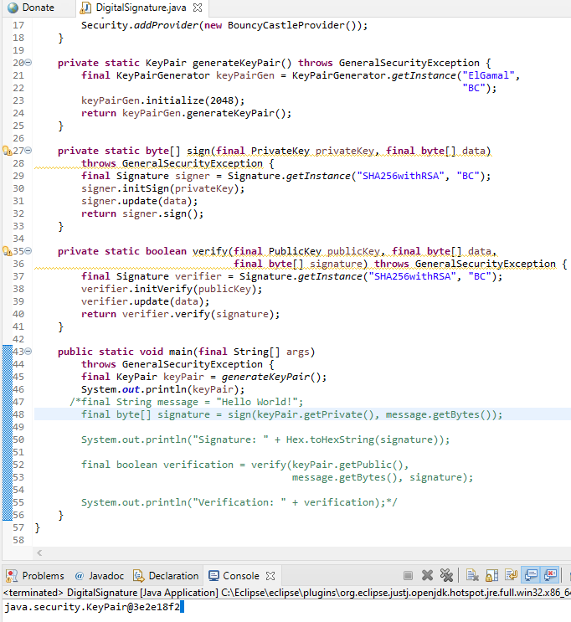

**EC**

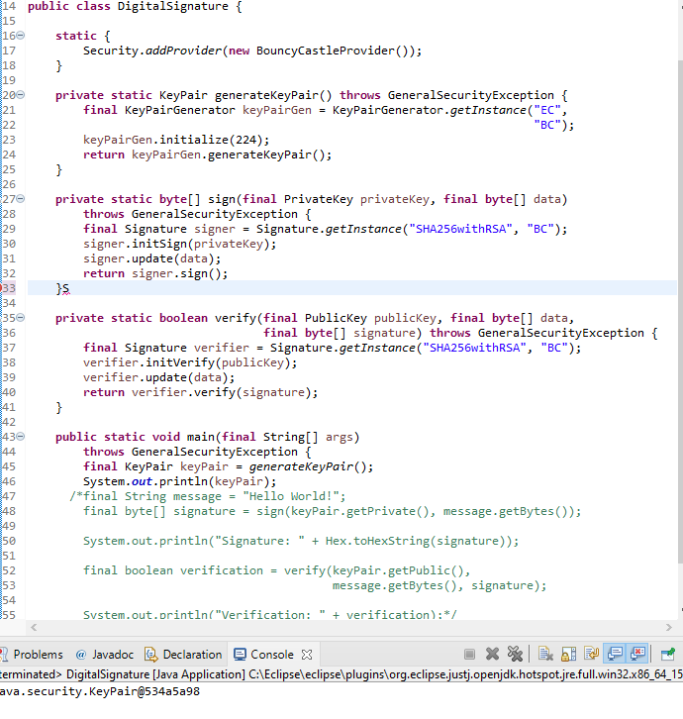

**Public Key Encryption (ElGamal)**

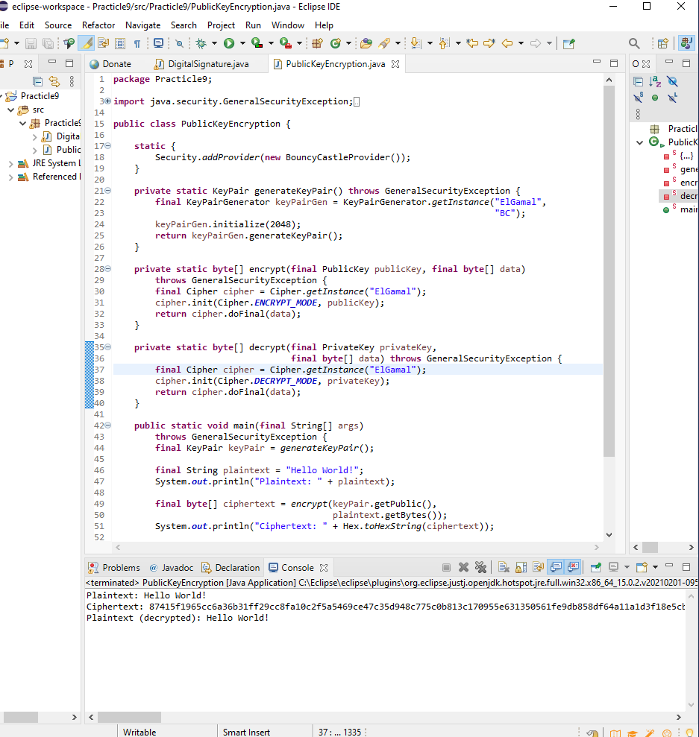

**Public Key Encryption (EC)**

