NB: This tool will only work on networks that have all firewalls disabled; or have firewalls that permit remote File and Print sharing access and remote WMI access.

- Ensure that all PCs are switched on and are connected to the network.
- Log into a networked client PC with domain admin rights
- Extract the CSCLDT tool to a folder on the local drive (or a USB drive)- this will consists of 1 folder and 2 files:
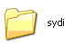 | 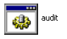 | 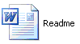
VBS backend files | Audit frontend script | This readme file

- Once you have extracted the files, double click on the audit.cmd script file
- Enter the name of the site you are auditing- e.g. Brentford:
(Avoid spaces and special characters- i.e. CentralLondon instead of Central London)
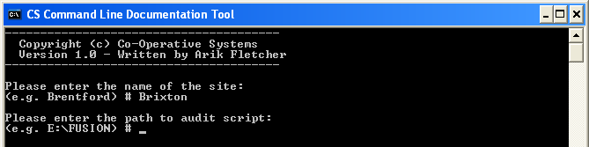
- Enter the full path to where you extracted the CSCLDT files- e.g. C:\Audit
(Avoid spaces and special characters- quit and rename the folder if you’ve used any)
- At this stage the tool will determine what the current IP range is and begin scanning each IP address within the range for active computers-
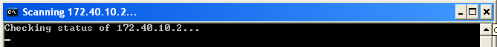
- As active hosts are identified the tool will create a word document in the extracted tool folder under a site-named subfolder- e.g. C:\Audit\Brentford
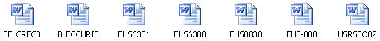

- Once the tool and all the documents have been created; zip up the audit folder and add it to your closeout.

