S
ET
Self Evaluation Test -
4
Newton's Laws of Motion

- A car is moving with uniform velocity on a rough horizontal road. Therefore, according to Newton's first law of motion
(a) No force is being applied by its engine
(b) A force is surely being applied by its engine
(c) An acceleration is being produced in the car
(d) The kinetic energy of the car is increasing
- A person is sitting in a travelling train and facing the engine. He tosses up a coin and the coin falls behind him. It can be concluded that the train is [SCRA 1994]
(a) Moving forward and gaining speed
(b) Moving forward and losing speed
(c) Moving forward with uniform speed
(d) Moving backward with uniform speed
- A block can slide on a smooth inclined plane of inclination kept on the floor of a lift. When the lift is descending with a retardation a, the acceleration of the block relative to the incline is
(a) 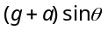 (b) 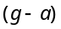
(c) 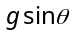 (d) 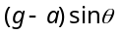
- A 60 kg man stands on a spring scale in the lift. At some instant he finds, scale reading has changed from 60 kg to 50kg for a while and then comes back to the original mark. What should we conclude ?
(a) The lift was in constant motion upwards
(b) The lift was in constant motion downwards
(c) The lift while in constant motion upwards, is stopped suddenly
(d) The lift while in constant motion downwards, is suddenly stopped
- When a body is acted by a constant force, then which of the following quantities remains constant
(a) Velocity (b) Acceleration
(c) Momentum (d) None of these
- A man of weight mg is moving up in a rocket with acceleration 4 g. The apparent weight of the man in the rocket is
(a) Zero (b) 4 mg
(c) 5 mg (d) mg
- A spring balance and a physical balance are kept in a lift. In these balances equal masses are placed. If now the lift starts moving upwards with constant acceleration, then
(a) The reading of spring balance will increase and the equilibrium position of the physical balance will disturb
(b) The reading of spring balance will remain unchanged and physical balance will remain in equilibrium
(c) The reading of spring balance will decrease and physical balance will remain in equilibrium
(d) The reading of spring balance will increase and the physical balance will remain in equilibrium
- As shown in the figure, two equal masses each of 2 kg are suspended from a spring balance. The reading of the spring balance will be
2kg
2kg

(a) Zero
(b) 2 kg
(c) 4 kg
(d) Between zero and 2 kg
- A player kicks a football of mass 0.5 kg and the football begins to move with a velocity of 10 m/s. If the contact between the leg and the football lasts for 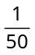sec, then the force acted on the football should be
(a) 2500 N (b) 1250 N
(c) 250 N (d) 625 N
- The engine of a jet aircraft applies a thrust force of 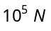 during take off and causes the plane to attain a velocity of 1 km/sec in 10 sec. The mass of the plane is
(a) 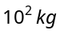 (b) 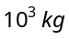
(c) 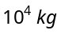 (d) 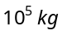
- A force of 50 dynes is acted on a body of mass 5 g which is at rest for an interval of 3 seconds, then impulse is
[AFMC 1998]
(a) 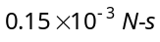 (b) 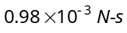
(c) 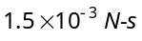 (d) 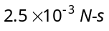
- Two weights 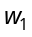 and 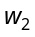 are suspended from the ends of a light string passing over a smooth fixed pulley. If the pulley is pulled up at an acceleration g, the tension in the string will be
(a) 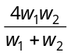
(b) 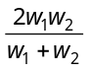
(c) 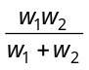
(d) 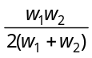
- The masses of 10 kg and 20 kg respectively are connected by a massless spring as shown in figure. A force of 200 N acts on the 20 kg mass. At the instant shown, the 10 kg mass has acceleration 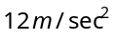. What is the acceleration of 20 kg mass
10 kg
20 kg
200N

(a) (b) 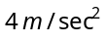
(c) 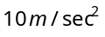 (d) Zero
- Two masses M and m are connected by a weightless string. They are pulled by a force F on a frictionless horizontal surface. The tension in the string will be
T
m
F
M

(a) 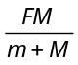 (b) 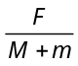
(c) 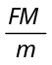 (d) 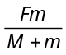
- In the above question, the acceleration of mass m is
(a) 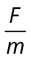 (b) 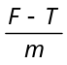
(c) 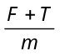 (d) 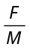
- Three weight A, B and C are connected by string as shown in the figure. The system moves over a frictionless pulley. The tension in the string connecting A and B is (where g is acceleration due to gravity)
5 kg
3 kg
1 kg
C
A
B
(a) g
(b)
(c) 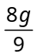
(d) 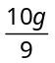

A
S
Answers and Solutions
(SET –4)

- (b) Since, force needed to overcome frictional force.
- (a) The coin falls behind him it means the velocity of train was increasing otherwise the coin fall directly into the hands of thrower.
- (a) Acceleration of block in a stationary lift =
If lift is descending with acc. then it will be (g–a)sinθ.
but in the problem acceleration = – a (retardation)
Acceleration of block = 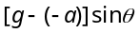 = 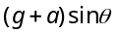
- (c) For upward acceleration apparent weight 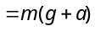
If lift suddenly stops during upward motion then apparent weight = 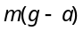 because instead of acceleration, we will consider retardation.
In the problem it is given that scale reading initially was 60 kg and due to sudden jerk reading decreasing and finally comes back to the original mark i.e., 60 kg.
So, we can conclude that lift was moving upward with constant speed and suddenly stops.
- (b) for a given body if constant then a = constant.
- (c) 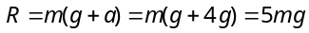
- (d) The fictitious force will act downwards. So the reading of spring balance will increase. In case of physical balance, the fictitious force will act on both the pans, so the equilibrium is not affected.
- (b) In this case, one 2 kg wt on the left will act as the support for the spring balance. Hence its reading will be 2 kg.
- (c) Force on the football 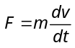
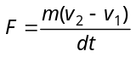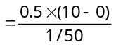.

***

- (b) Acceleration produced in jet = 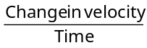
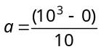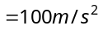
Mass = 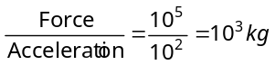.
- (c) Impulse = Force × Time = 50 × 10^{–5} × 3
= 1.5 × 10^{–3} N-s
- (a) 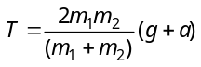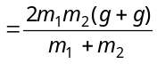
⇒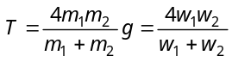
- (b) As the mass of 10 kg has acceleration 12 m/s² therefore it apply 120N force on mass 20kg in a backward direction.
∴Net forward force on 20 kg mass = 200 – 120 = 80N
Acceleration 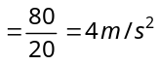.
- (a) = 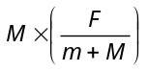
- (b) Net force on mass m, 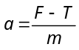
- (d) 

