Cassava Yield Data Analysis
GROUP 2
24 September 2026
Table of Contents

1. Introduction
This report analyses the supplied Cassava Yield Data using R. The objectives are to explore the dataset, identify missing values and outliers, investigate relationships between variables, and test whether fertilizer and tillage are associated with projected cassava yield.
knitr::opts_chunk$set(root.dir = "C:/Users/HP/OneDrive/Desktop/cassava-yield-r-project_1/data/raw")
knitr::opts_chunk$set(echo = TRUE, message = FALSE, warning = FALSE)

Libraries used in this analysis
1. readxl
The readxl library is used to import data from Excel files (.xlsx and .xls) into R.
We are using it to read the Cassava Yield Data Excel workbook so that we can explore and analyze the dataset.
2. dplyr
The dplyr library is used for data manipulation and cleaning. It provides functions for selecting columns, filtering rows, creating new variables, and transforming data.
We are using it to clean the cassava dataset, convert variable types, and prepare the data for analysis.
3. tidyr
The tidyr library is used to organize and reshape data into a tidy format, where each variable has its own column and each observation has its own row.
We are using it to reshape numeric and categorical variables into a suitable format for creating distribution graphs.
4. ggplot2
The ggplot2 library is used to create statistical graphs and visualizations.
We are using it to display variable distributions, boxplots, scatterplots, and bar charts. These visualizations help us identify patterns, relationships, and potential outliers in the data.
6. knitr
The knitr library is used to generate well-formatted reports from R Markdown documents.
We are using it to display tables, including variable summaries, missing-value information, and outlier detection results, in the knitted HTML report.

Summary
Together, these libraries support the complete data analysis process: importing the dataset, cleaning and transforming the data, exploring distributions, visualizing relationships, and presenting statistical findings in an organized HTML report.
packages <- c("readxl", "dplyr", "ggplot2", "tidyr", "knitr")
installed <- rownames(installed.packages())
for (p in packages) {
if (!(p %in% installed)) install.packages(p)
}
library(readxl)
library(dplyr)
library(ggplot2)
library(tidyr)
library(knitr)
df <- read_excel("../data/raw/Cassava_Yield_Data.xlsx",
sheet = "Cassava Data")
names(df) <- trimws(names(df))

2. Understanding the dataset
head(df)
## # A tibble: 6 × 20
## Sesn locn block rep tillage ferT Plants_harvested No_bigtubers
## <dbl> <dbl> <dbl> <dbl> <chr> <chr> <dbl> <dbl>
## 1 2 1 1 1 conv F2150 28 0
## 2 2 1 1 1 conv F1100 28 0
## 3 2 1 1 1 conv F3200 28 2
## 4 2 1 1 1 conv F5300 28 6
## 5 2 1 1 1 conv F4250 28 3
## 6 2 1 2 2 conv F5300 28 6
## # ℹ 12 more variables: Weigh_bigtubers <dbl>, No_mediumtubers <dbl>,
## # Weight_mediumtubers <dbl>, No_smalltubers <dbl>, Weight_smalltubers <dbl>,
## # Totaltuberno <dbl>, AV_tubers_Plant <dbl>, Total_tubweight <dbl>,
## # plotsize <dbl>, HEC <dbl>, TotalWeightperhectare <dbl>,
## # TotalTuberperHectare <dbl>
The dataset contains 115 observations and 20 variables.
dim(df)
## [1] 115 20
names(df)
## [1] "Sesn" "locn" "block"
## [4] "rep" "tillage" "ferT"
## [7] "Plants_harvested" "No_bigtubers" "Weigh_bigtubers"
## [10] "No_mediumtubers" "Weight_mediumtubers" "No_smalltubers"
## [13] "Weight_smalltubers" "Totaltuberno" "AV_tubers_Plant"
## [16] "Total_tubweight" "plotsize" "HEC"
## [19] "TotalWeightperhectare" "TotalTuberperHectare"
str(df)
## tibble [115 × 20] (S3: tbl_df/tbl/data.frame)
## $ Sesn : num [1:115] 2 2 2 2 2 2 2 2 2 2 ...
## $ locn : num [1:115] 1 1 1 1 1 1 1 1 1 1 ...
## $ block : num [1:115] 1 1 1 1 1 2 2 2 2 2 ...
## $ rep : num [1:115] 1 1 1 1 1 2 2 2 2 2 ...
## $ tillage : chr [1:115] "conv" "conv" "conv" "conv" ...
## $ ferT : chr [1:115] "F2150" "F1100" "F3200" "F5300" ...
## $ Plants_harvested : num [1:115] 28 28 28 28 28 28 28 28 28 28 ...
## $ No_bigtubers : num [1:115] 0 0 2 6 3 6 0 0 1 1 ...
## $ Weigh_bigtubers : num [1:115] 0 0 0.2 0.7 0.3 0.5 0 0 0.2 0.1 ...
## $ No_mediumtubers : num [1:115] 61 110 115 60 82 65 91 72 64 56 ...
## $ Weight_mediumtubers : num [1:115] 2.5 4.6 5.2 2.7 3.4 2.7 3.9 3.5 2.6 2.5 ...
## $ No_smalltubers : num [1:115] 319 260 319 303 332 299 289 246 305 308 ...
## $ Weight_smalltubers : num [1:115] 4.7 4 4.4 4.8 4.7 4.5 4.8 4.6 5.4 4.5 ...
## $ Totaltuberno : num [1:115] 380 370 436 369 417 370 380 318 370 365 ...
## $ AV_tubers_Plant : num [1:115] 13.6 13.2 15.6 13.2 14.9 ...
## $ Total_tubweight : num [1:115] 7.2 8.6 9.8 8.2 8.4 7.7 8.7 8.1 8.2 7.1 ...
## $ plotsize : num [1:115] 5.3 5.3 5.3 5.3 5.3 5.3 5.3 5.3 5.3 5.3 ...
## $ HEC : num [1:115] 10000 10000 10000 10000 10000 10000 10000 10000 10000 10000 ...
## $ TotalWeightperhectare: num [1:115] 13585 16226 18491 15472 15849 ...
## $ TotalTuberperHectare : num [1:115] 716981 698113 822642 696226 786792 ...
The fertilizer codes are:
- F2150 = NPK 15:15:15
- F1100 = NPK 17:17:17
- F3200 = NPK 20:10:10
- F5300 = Nitrogen
- F4250 = Phosphorus
Tillage is recorded as conventional (conv) or minimum (minimum).

3. Question 1 — distributions, missing values and outliers

3.1 Variable distributions
summary(df)
## Sesn locn block rep
## Min. :1.000 Min. :1.000 Min. :1.000 Min. :1.000
## 1st Qu.:1.000 1st Qu.:1.000 1st Qu.:1.000 1st Qu.:1.000
## Median :2.000 Median :2.000 Median :2.000 Median :2.000
## Mean :1.522 Mean :1.522 Mean :2.043 Mean :2.043
## 3rd Qu.:2.000 3rd Qu.:2.000 3rd Qu.:3.000 3rd Qu.:3.000
## Max. :2.000 Max. :2.000 Max. :3.000 Max. :3.000
## tillage ferT Plants_harvested No_bigtubers
## Length :115 Length :115 Min. : 5.00 Min. : 0.0
## N.unique : 2 N.unique : 5 1st Qu.:14.00 1st Qu.: 0.0
## N.blank : 0 N.blank : 0 Median :18.00 Median : 0.0
## Min.nchar: 4 Min.nchar: 5 Mean :18.57 Mean : 4.0
## Max.nchar: 7 Max.nchar: 5 3rd Qu.:28.00 3rd Qu.: 5.5
## Max. :28.00 Max. :41.0
## Weigh_bigtubers No_mediumtubers Weight_mediumtubers No_smalltubers
## Min. :0.0000 Min. : 0.00 Min. :0.000 Min. : 37.0
## 1st Qu.:0.0000 1st Qu.: 26.50 1st Qu.:1.300 1st Qu.: 84.0
## Median :0.0000 Median : 44.00 Median :2.500 Median :109.0
## Mean :0.6148 Mean : 49.52 Mean :2.771 Mean :146.3
## 3rd Qu.:0.7000 3rd Qu.: 65.50 3rd Qu.:3.950 3rd Qu.:221.0
## Max. :7.0000 Max. :126.00 Max. :8.100 Max. :376.0
## Weight_smalltubers Totaltuberno AV_tubers_Plant Total_tubweight
## Min. :0.500 Min. : 57.0 Min. : 3.800 Min. : 1.000
## 1st Qu.:1.500 1st Qu.:115.5 1st Qu.: 8.028 1st Qu.: 3.400
## Median :2.100 Median :179.0 Median :10.667 Median : 6.000
## Mean :2.511 Mean :199.8 Mean :10.525 Mean : 5.897
## 3rd Qu.:3.600 3rd Qu.:273.5 3rd Qu.:12.974 3rd Qu.: 8.150
## Max. :5.400 Max. :443.0 Max. :19.200 Max. :14.100
## plotsize HEC TotalWeightperhectare TotalTuberperHectare
## Min. :4.200 Min. :10000 Min. : 2381 Min. :135714
## 1st Qu.:4.200 1st Qu.:10000 1st Qu.: 8095 1st Qu.:275000
## Median :4.200 Median :10000 Median :11905 Median :419048
## Mean :4.487 Mean :10000 Mean :13094 Mean :431822
## 3rd Qu.:5.300 3rd Qu.:10000 3rd Qu.:16422 3rd Qu.:589286
## Max. :5.300 Max. :10000 Max. :33571 Max. :835849
The numeric variables can be visualised with histograms and boxplots.
numeric_vars <- names(df)[sapply(df, is.numeric)]
for (v in numeric_vars) {
print(
ggplot(df, aes(x = .data[[v]])) +
geom_histogram(bins = 20) +
labs(title = paste("Distribution of", v),
x = v, y = "Frequency") +
theme_minimal()
)
}
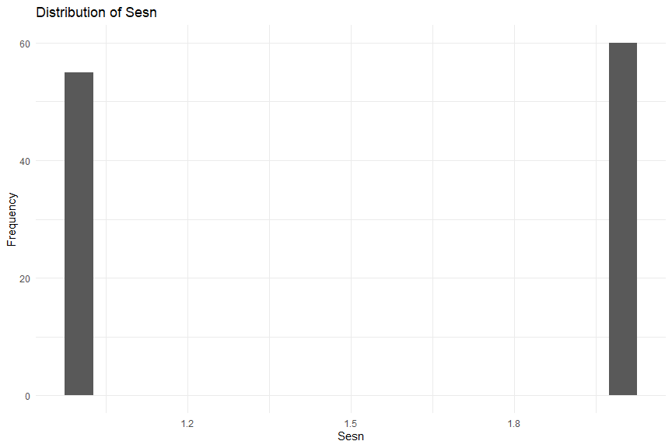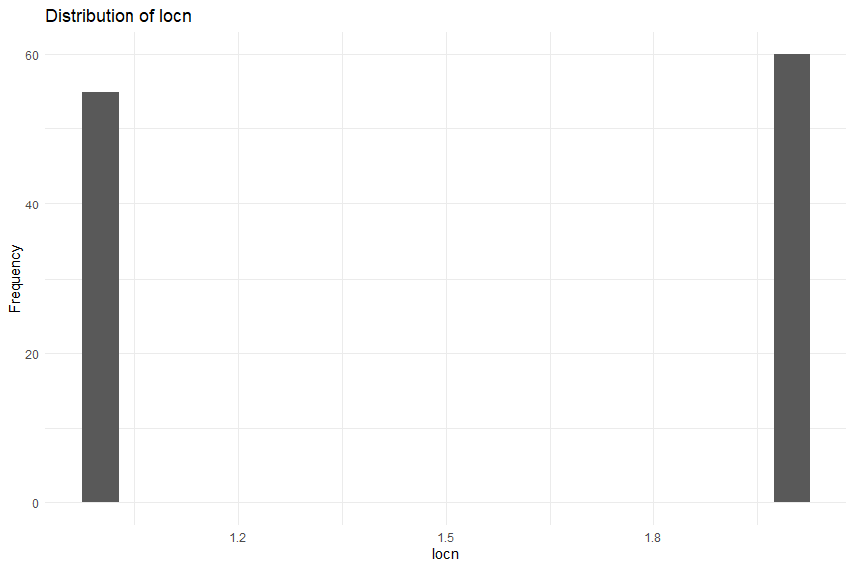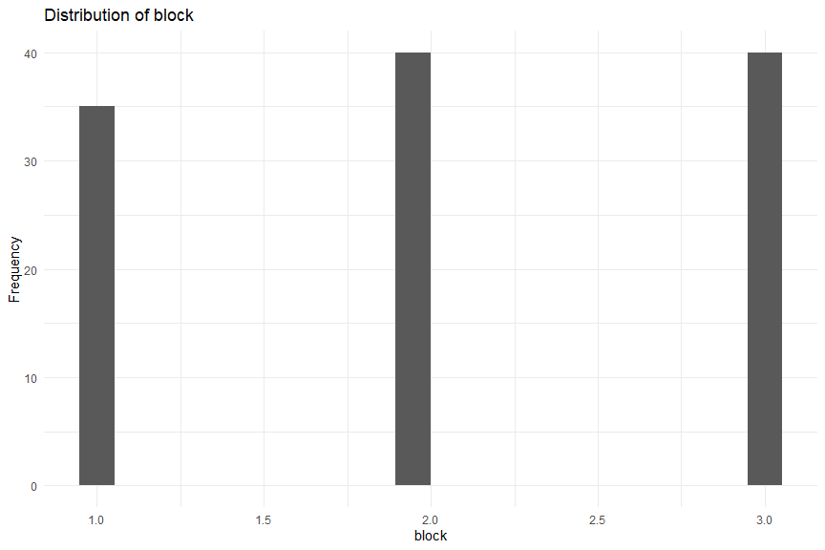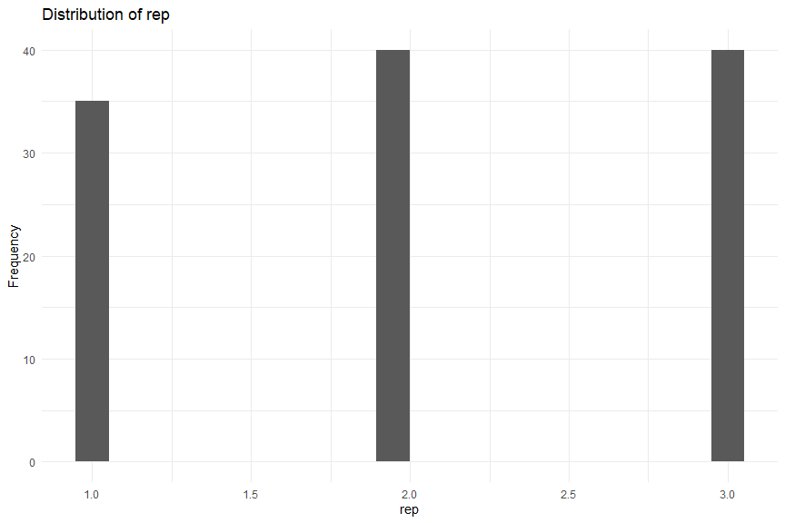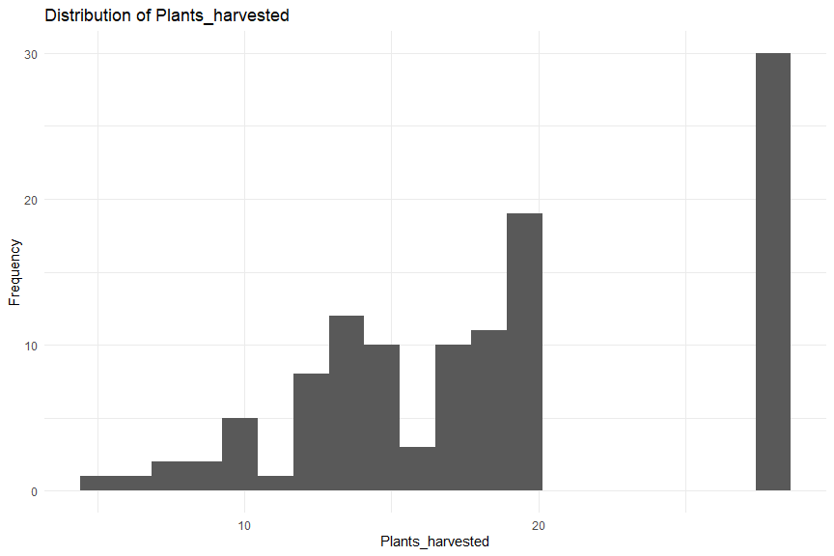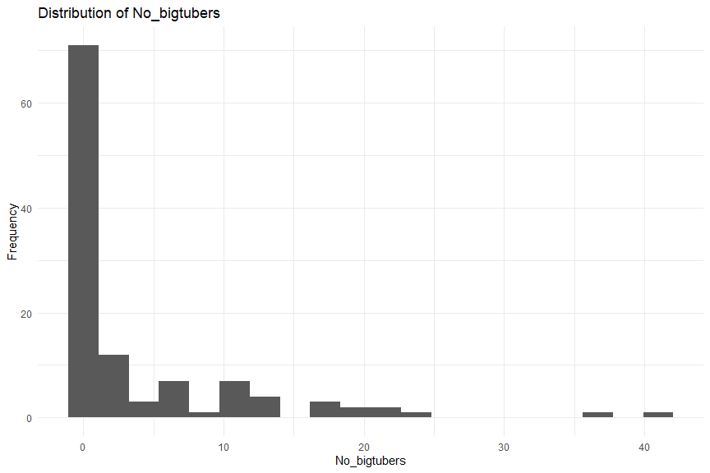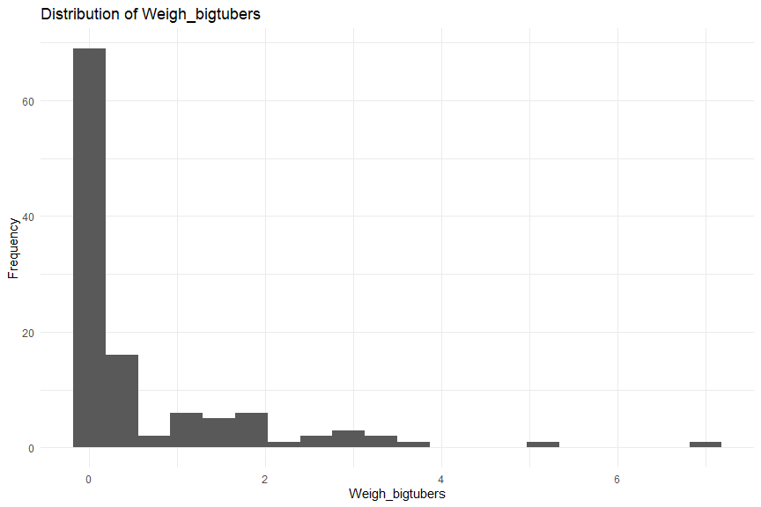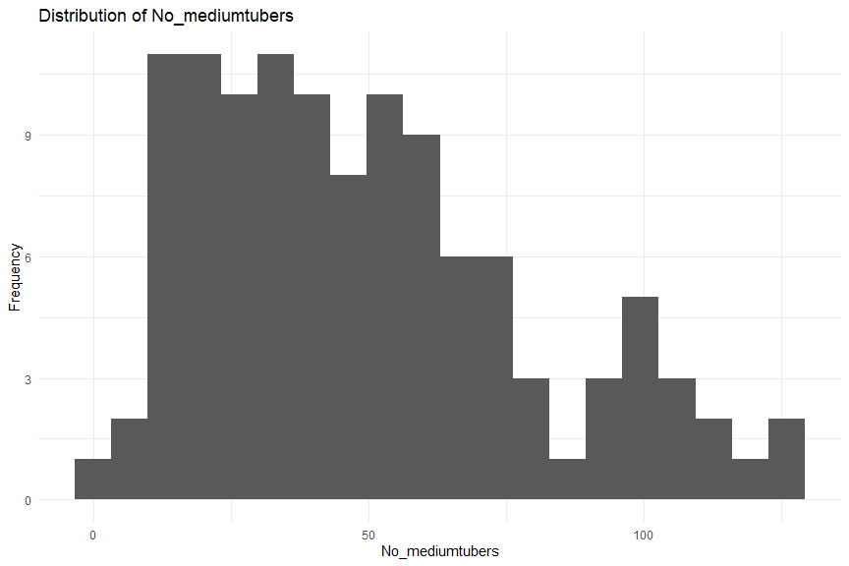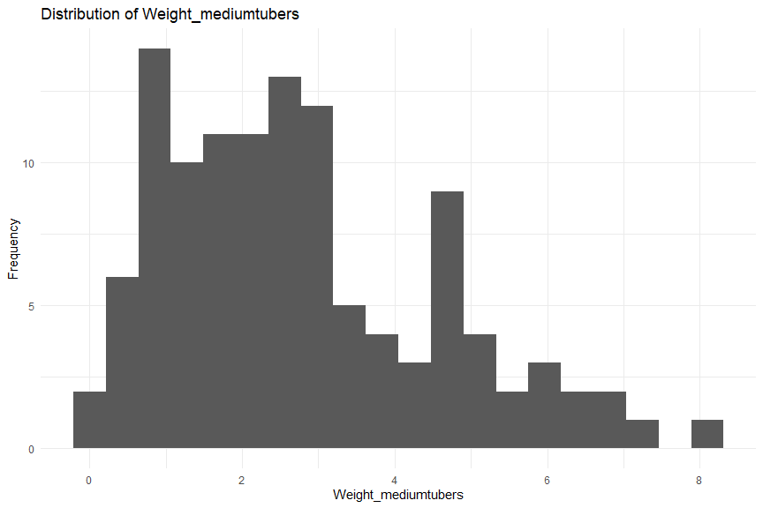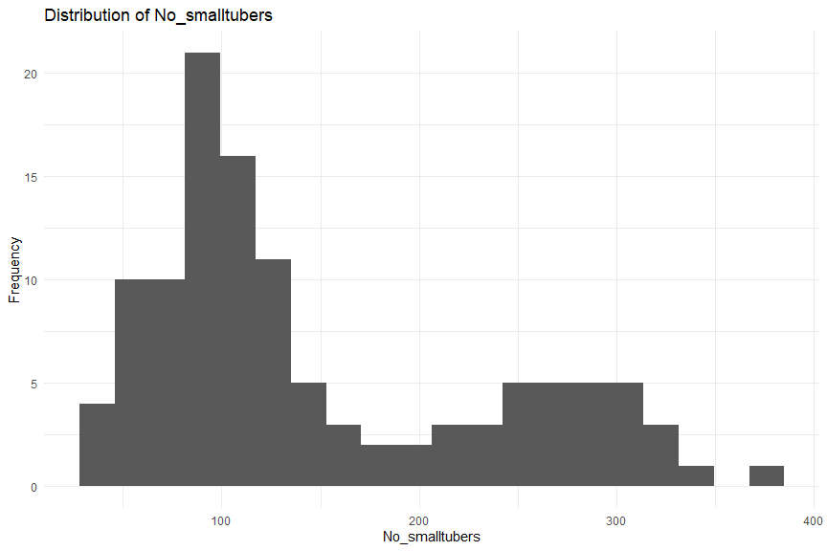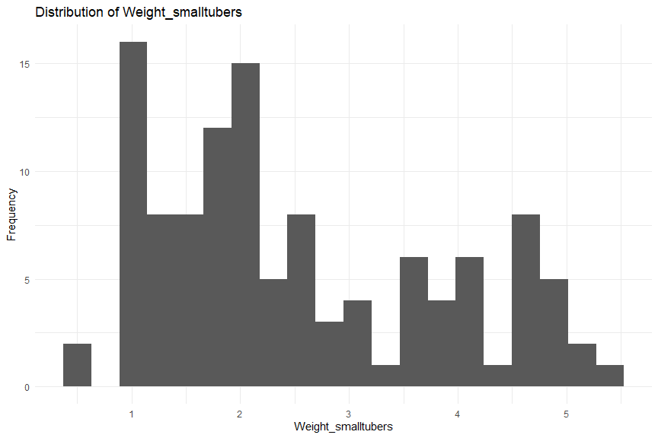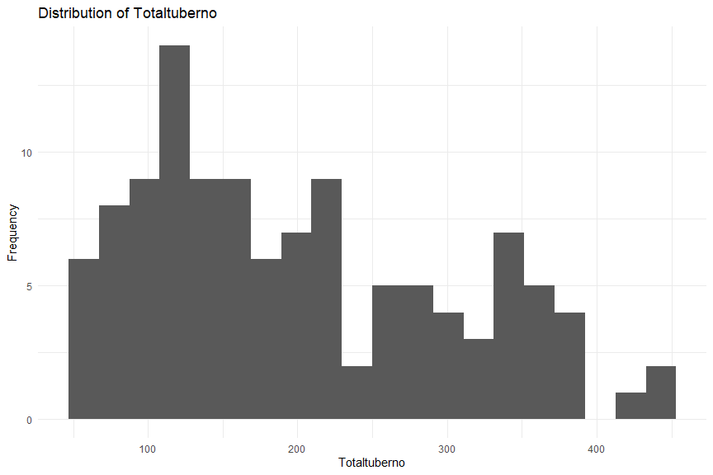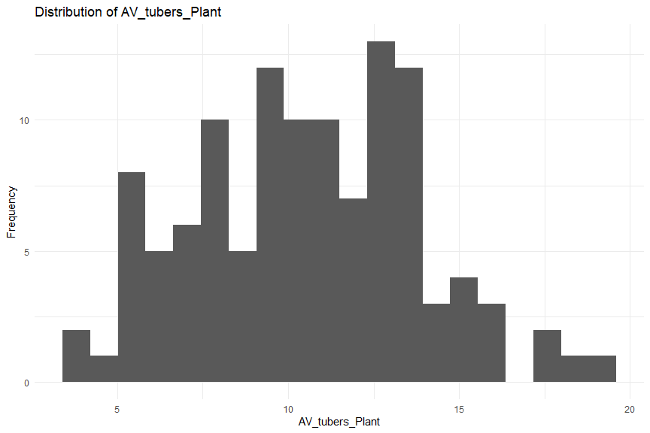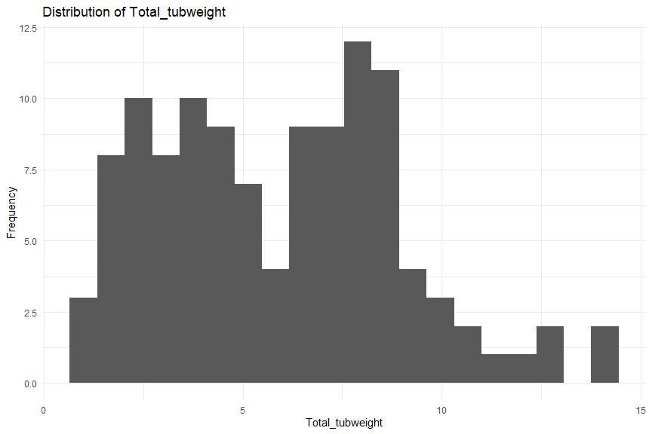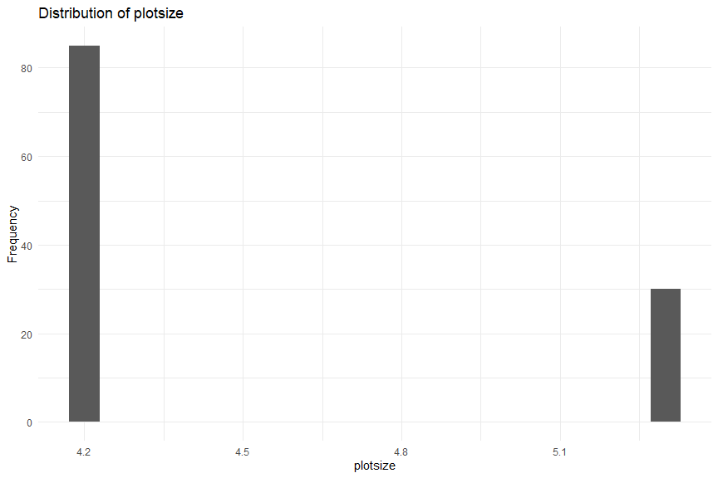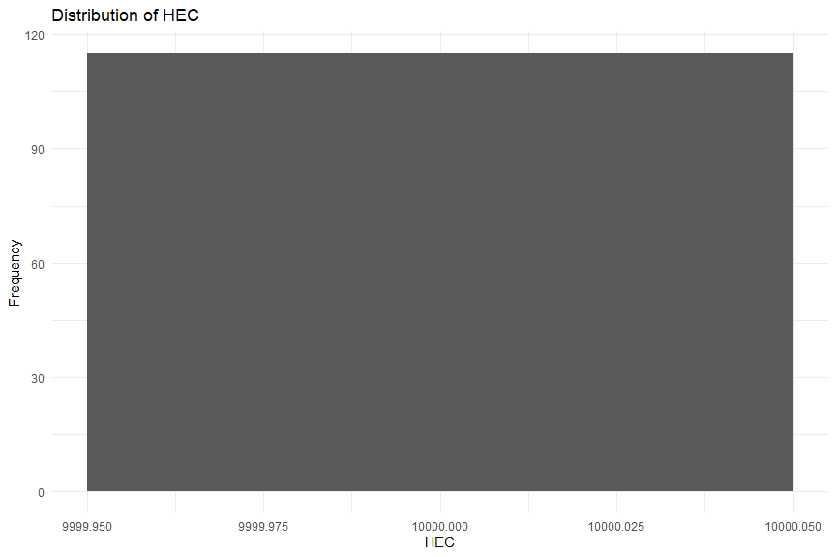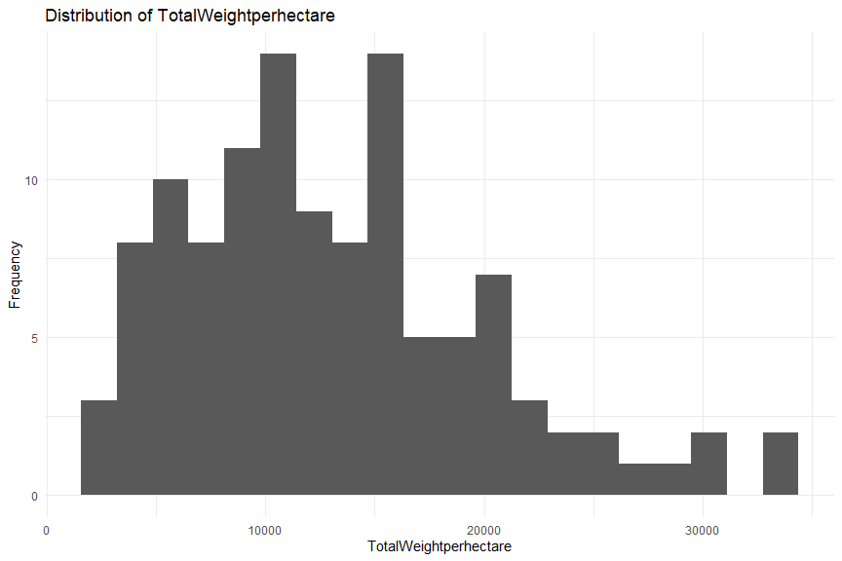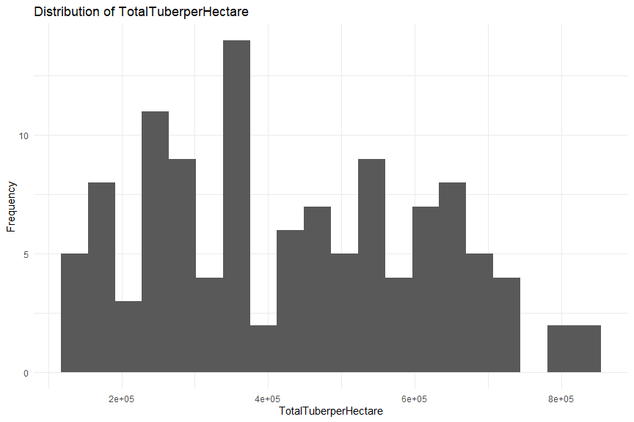

3.2 Missing information
missing_by_variable <- colSums(is.na(df))
missing_by_variable
## Sesn locn block
## 0 0 0
## rep tillage ferT
## 0 0 0
## Plants_harvested No_bigtubers Weigh_bigtubers
## 0 0 0
## No_mediumtubers Weight_mediumtubers No_smalltubers
## 0 0 0
## Weight_smalltubers Totaltuberno AV_tubers_Plant
## 0 0 0
## Total_tubweight plotsize HEC
## 0 0 0
## TotalWeightperhectare TotalTuberperHectare
## 0 0
sum(is.na(df))
## [1] 0
Finding: The supplied dataset contains no missing values. Therefore, no observations needed to be removed or imputed for missingness.
A general missing-value strategy for future datasets would be:
- numeric variables → median imputation when appropriate;
- categorical variables → mode or an explicit "Unknown" category;
- remove rows only when the missingness makes the observation unusable.

3.3 Outliers
The IQR rule defines:
- lower fence = Q1 − 1.5 × IQR
- upper fence = Q3 + 1.5 × IQR
outlier_report <- data.frame(
variable = character(),
Q1 = numeric(),
Q3 = numeric(),
IQR = numeric(),
lower_fence = numeric(),
upper_fence = numeric(),
outlier_count = integer()
)
for (v in numeric_vars) {
x <- df[[v]]
q1 <- quantile(x, 0.25)
q3 <- quantile(x, 0.75)
iqr_value <- q3 - q1
lower <- q1 - 1.5 * iqr_value
upper <- q3 + 1.5 * iqr_value
n_out <- sum(x < lower | x > upper)
outlier_report <- rbind(
outlier_report,
data.frame(
variable = v,
Q1 = q1,
Q3 = q3,
IQR = iqr_value,
lower_fence = lower,
upper_fence = upper,
outlier_count = n_out
)
)
}
outlier_report
## variable Q1 Q3 IQR
## 25% Sesn 1.000000e+00 2.00000 1.000000e+00
## 25%1 locn 1.000000e+00 2.00000 1.000000e+00
## 25%2 block 1.000000e+00 3.00000 2.000000e+00
## 25%3 rep 1.000000e+00 3.00000 2.000000e+00
## 25%4 Plants_harvested 1.400000e+01 28.00000 1.400000e+01
## 25%5 No_bigtubers 0.000000e+00 5.50000 5.500000e+00
## 25%6 Weigh_bigtubers 0.000000e+00 0.70000 7.000000e-01
## 25%7 No_mediumtubers 2.650000e+01 65.50000 3.900000e+01
## 25%8 Weight_mediumtubers 1.300000e+00 3.95000 2.650000e+00
## 25%9 No_smalltubers 8.400000e+01 221.00000 1.370000e+02
## 25%10 Weight_smalltubers 1.500000e+00 3.60000 2.100000e+00
## 25%11 Totaltuberno 1.155000e+02 273.50000 1.580000e+02
## 25%12 AV_tubers_Plant 8.027778e+00 12.97368 4.945906e+00
## 25%13 Total_tubweight 3.400000e+00 8.15000 4.750000e+00
## 25%14 plotsize 4.200000e+00 5.30000 1.100000e+00
## 25%15 HEC 1.000000e+04 10000.00000 0.000000e+00
## 25%16 TotalWeightperhectare 8.095238e+03 16421.83288 8.326595e+03
## 25%17 TotalTuberperHectare 2.750000e+05 589285.71429 3.142857e+05
## lower_fence upper_fence outlier_count
## 25% -5.000000e-01 3.500000e+00 0
## 25%1 -5.000000e-01 3.500000e+00 0
## 25%2 -2.000000e+00 6.000000e+00 0
## 25%3 -2.000000e+00 6.000000e+00 0
## 25%4 -7.000000e+00 4.900000e+01 0
## 25%5 -8.250000e+00 1.375000e+01 13
## 25%6 -1.050000e+00 1.750000e+00 17
## 25%7 -3.200000e+01 1.240000e+02 1
## 25%8 -2.675000e+00 7.925000e+00 1
## 25%9 -1.215000e+02 4.265000e+02 0
## 25%10 -1.650000e+00 6.750000e+00 0
## 25%11 -1.215000e+02 5.105000e+02 0
## 25%12 6.089181e-01 2.039254e+01 0
## 25%13 -3.725000e+00 1.527500e+01 0
## 25%14 2.550000e+00 6.950000e+00 0
## 25%15 1.000000e+04 1.000000e+04 0
## 25%16 -4.394654e+03 2.891173e+04 4
## 25%17 -1.964286e+05 1.060714e+06 0
The supplied data contain IQR outliers in several variables. For example, No_bigtubers, Weigh_bigtubers, No_mediumtubers, Weight_mediumtubers, and TotalWeightperhectare have observations outside their IQR fences.

3.4 Transformation used
Instead of deleting potentially useful observations, this project uses winsorization/capping for selected measurement variables. Values below the lower IQR fence are replaced with the lower fence, while values above the upper fence are replaced with the upper fence.
df_clean <- df
for (v in numeric_vars) {
med <- median(df_clean[[v]], na.rm = TRUE)
df_clean[[v]][is.na(df_clean[[v]])] <- med
}
vars_to_cap <- c(
"Plants_harvested", "No_bigtubers", "Weigh_bigtubers",
"No_mediumtubers", "Weight_mediumtubers", "No_smalltubers",
"Weight_smalltubers", "Totaltuberno", "AV_tubers_Plant",
"Total_tubweight", "plotsize", "TotalWeightperhectare",
"TotalTuberperHectare"
)
for (v in vars_to_cap) {
q1 <- quantile(df_clean[[v]], 0.25)
q3 <- quantile(df_clean[[v]], 0.75)
iqr_value <- q3 - q1
lower <- q1 - 1.5 * iqr_value
upper <- q3 + 1.5 * iqr_value
df_clean[[v]] <- pmax(df_clean[[v]], lower)
df_clean[[v]] <- pmin(df_clean[[v]], upper)
}
sum(is.na(df_clean))
## [1] 0

4. Question 2 — relationships

4.1 Two continuous variables
We investigate TotalTuberperHectare and TotalWeightperhectare.
ggplot(df_clean,
aes(x = TotalTuberperHectare,
y = TotalWeightperhectare)) +
geom_point() +
geom_smooth(method = "lm", se = TRUE) +
labs(
title = "Total Tuber per Hectare vs Total Weight per Hectare",
x = "Total Tuber per Hectare",
y = "Total Weight per Hectare"
) +
theme_minimal()
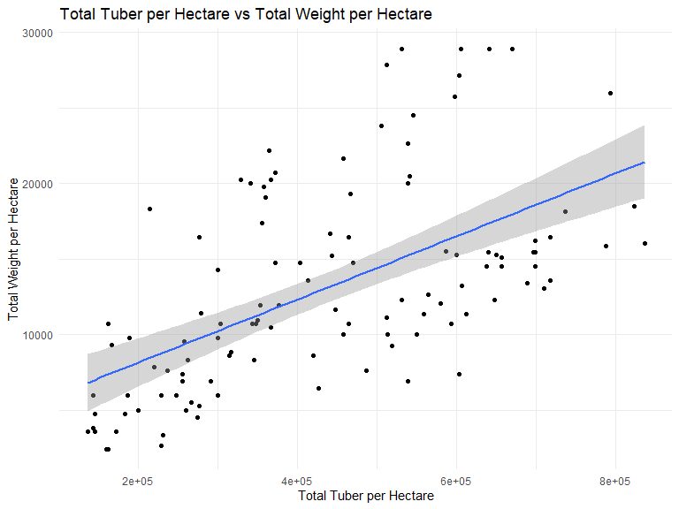
cor_test <- cor.test(
df_clean$TotalTuberperHectare,
df_clean$TotalWeightperhectare,
method = "pearson"
)
cor_test
##
## Pearson's product-moment correlation
##
## data: df_clean$TotalTuberperHectare and df_clean$TotalWeightperhectare
## t = 7.6442, df = 113, p-value = 7.474e-12
## alternative hypothesis: true correlation is not equal to 0
## 95 percent confidence interval:
## 0.4486834 0.6928670
## sample estimates:
## cor
## 0.5838274
Interpretation: The relationship is positive. In the supplied data, the Pearson correlation is approximately r = 0.584 after winsorization, with p < 0.001. This indicates that observations with more tubers per hectare tend to also have greater total tuber weight per hectare.
Correlation does not by itself establish causation.

4.2 One continuous and one categorical variable
We compare TotalWeightperhectare across the two tillage methods.
ggplot(df_clean,
aes(x = tillage,
y = TotalWeightperhectare)) +
geom_boxplot() +
labs(
title = "Total Weight per Hectare by Tillage Method",
x = "Tillage Method",
y = "Total Weight per Hectare"
) +
theme_minimal()
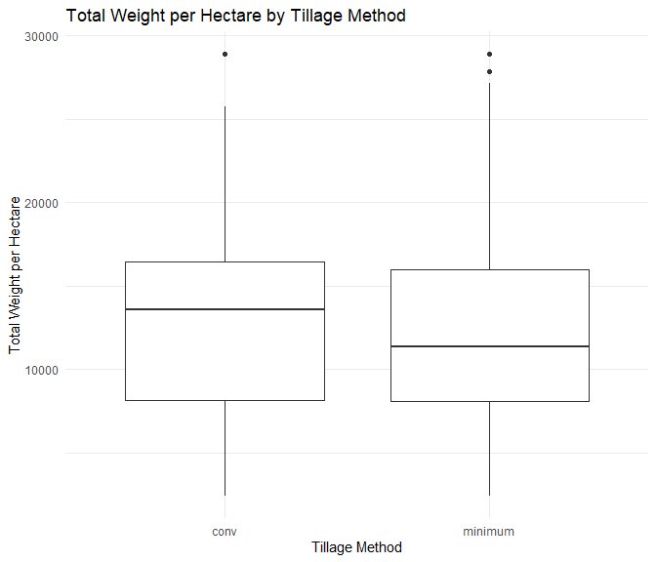
t.test(
TotalWeightperhectare ~ tillage,
data = df_clean
)
##
## Welch Two Sample t-test
##
## data: TotalWeightperhectare by tillage
## t = 0.50239, df = 110.83, p-value = 0.6164
## alternative hypothesis: true difference in means between group conv and group minimum is not equal to 0
## 95 percent confidence interval:
## -1838.572 3087.446
## sample estimates:
## mean in group conv mean in group minimum
## 13288.88 12664.44
A Welch two-sample t-test is appropriate for comparing a continuous outcome across two groups.

4.3 Two categorical variables
We investigate the relationship between tillage and fertilizer.
table(df_clean$tillage, df_clean$ferT)
##
## F1100 F2150 F3200 F4250 F5300
## conv 12 12 12 12 12
## minimum 11 11 11 11 11
ggplot(df_clean, aes(x = ferT, fill = tillage)) +
geom_bar(position = "dodge") +
labs(
title = "Tillage Method by Fertilizer Application",
x = "Fertilizer",
y = "Count",
fill = "Tillage"
) +
theme_minimal()
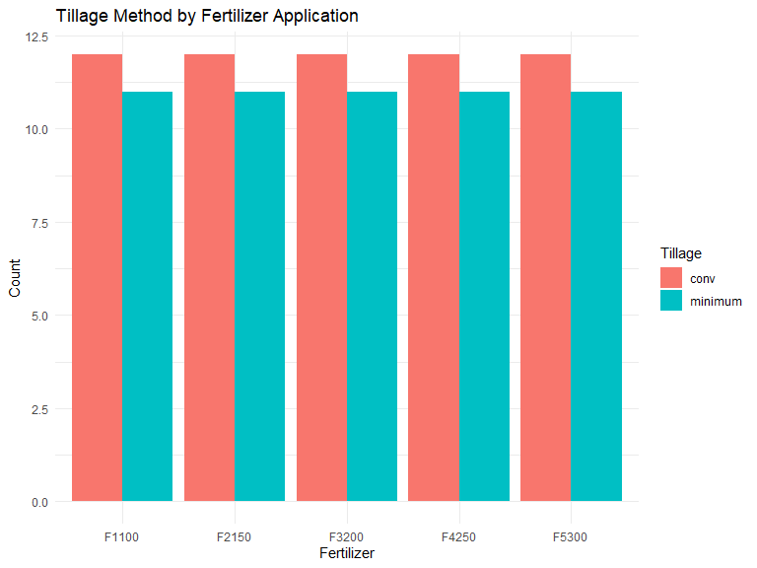
chisq.test(table(df_clean$tillage, df_clean$ferT))
##
## Pearson's Chi-squared test
##
## data: table(df_clean$tillage, df_clean$ferT)
## X-squared = 0, df = 4, p-value = 1
Finding: The design is perfectly balanced: each tillage group has the same number of observations for every fertilizer code. The chi-square test therefore gives p = 1, providing no evidence of an association between tillage and fertilizer in this dataset.

5. Question 3a — fertilizer and projected yield
Because fertilizer has five categories, one-way ANOVA is used.

5.1 Total weight per hectare
ggplot(df_clean,
aes(x = ferT,
y = TotalWeightperhectare)) +
geom_boxplot() +
labs(
title = "Total Weight per Hectare by Fertilizer",
x = "Fertilizer",
y = "Total Weight per Hectare"
) +
theme_minimal()
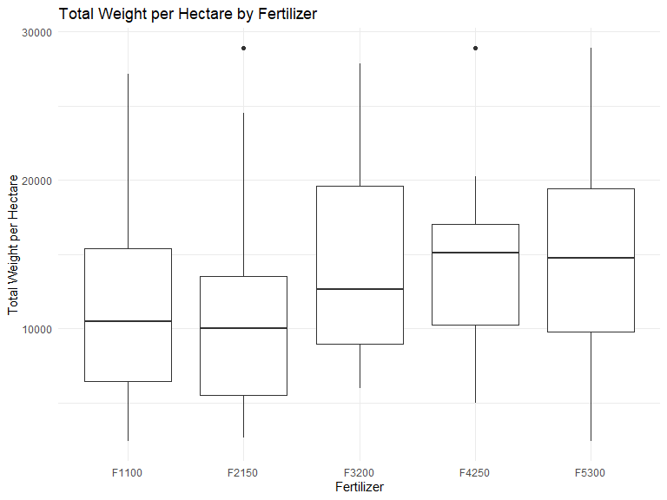
anova_weight <- aov(
TotalWeightperhectare ~ ferT,
data = df_clean
)
summary(anova_weight)
## Df Sum Sq Mean Sq F value Pr(>F)
## ferT 4 3.761e+08 94026969 2.238 0.0695 .
## Residuals 110 4.622e+09 42015657
## ---
## Signif. codes: 0 '***' 0.001 '**' 0.01 '*' 0.05 '.' 0.1 ' ' 1
Interpretation: After the outlier-capping transformation, the ANOVA p-value is approximately 0.070. At the conventional 5% significance level, this does not provide sufficient statistical evidence of an overall fertilizer effect on projected total weight per hectare.
The group means can still be useful descriptively:
df_clean %>%
group_by(ferT) %>%
summarise(
n = n(),
mean_weight = mean(TotalWeightperhectare),
sd_weight = sd(TotalWeightperhectare),
mean_tuber = mean(TotalTuberperHectare),
sd_tuber = sd(TotalTuberperHectare)
)
## # A tibble: 5 × 6
## ferT n mean_weight sd_weight mean_tuber sd_tuber
## <chr> <int> <dbl> <dbl> <dbl> <dbl>
## 1 F1100 23 10897. 5995. 406041. 188793.
## 2 F2150 23 10673. 6390. 408409. 202444.
## 3 F3200 23 14200. 6803. 433146. 172901.
## 4 F4250 23 14677. 6127. 448894. 172560.
## 5 F5300 23 14504. 7035. 462622. 195384.

5.2 Total tuber per hectare
ggplot(df_clean,
aes(x = ferT,
y = TotalTuberperHectare)) +
geom_boxplot() +
labs(
title = "Total Tuber per Hectare by Fertilizer",
x = "Fertilizer",
y = "Total Tuber per Hectare"
) +
theme_minimal()
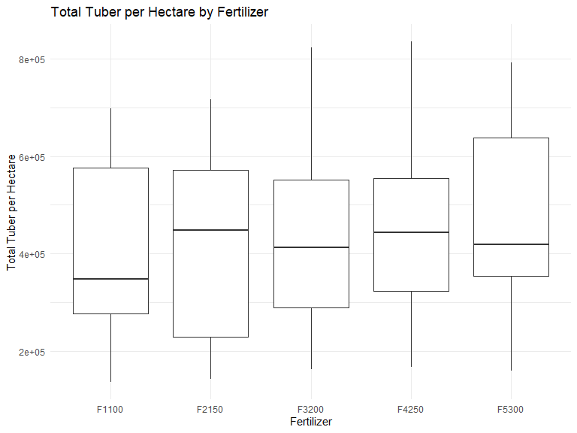
anova_tuber <- aov(
TotalTuberperHectare ~ ferT,
data = df_clean
)
summary(anova_tuber)
## Df Sum Sq Mean Sq F value Pr(>F)
## ferT 4 5.646e+10 1.411e+10 0.404 0.805
## Residuals 110 3.838e+12 3.489e+10
Interpretation: The ANOVA p-value is approximately 0.805, so there is no statistically significant overall fertilizer effect on projected total tuber number per hectare at α = 0.05.

6. Question 3b — tillage and projected yield
There are two tillage groups, so Welch two-sample t-tests are used.

6.1 Total weight per hectare
t.test(
TotalWeightperhectare ~ tillage,
data = df_clean
)
##
## Welch Two Sample t-test
##
## data: TotalWeightperhectare by tillage
## t = 0.50239, df = 110.83, p-value = 0.6164
## alternative hypothesis: true difference in means between group conv and group minimum is not equal to 0
## 95 percent confidence interval:
## -1838.572 3087.446
## sample estimates:
## mean in group conv mean in group minimum
## 13288.88 12664.44
The group means are approximately:
- Conventional: 13,411 weight units per hectare
- Minimum: 12,749 weight units per hectare
The Welch test has p ≈ 0.616, so the difference is not statistically significant at α = 0.05.

6.2 Total tuber per hectare
t.test(
TotalTuberperHectare ~ tillage,
data = df_clean
)
##
## Welch Two Sample t-test
##
## data: TotalTuberperHectare by tillage
## t = 1.3889, df = 112.59, p-value = 0.1676
## alternative hypothesis: true difference in means between group conv and group minimum is not equal to 0
## 95 percent confidence interval:
## -20226.89 115085.18
## sample estimates:
## mean in group conv mean in group minimum
## 454505.8 407076.7
The Welch test has p ≈ 0.168, so the difference in projected total tuber number per hectare is not statistically significant at α = 0.05.

7. Overall findings
Question | Statistical method | Result
Two continuous variables | Pearson correlation | Positive relationship; p < 0.001
Continuous + tillage | Welch t-test | No statistically significant difference for weight
Two categorical variables | Chi-square test | p = 1; perfectly balanced design
Fertilizer → total weight | One-way ANOVA | p ≈ 0.070 after winsorization
Fertilizer → total tuber | One-way ANOVA | p ≈ 0.805
Tillage → total weight | Welch t-test | p ≈ 0.616
Tillage → total tuber | Welch t-test | p ≈ 0.168
These conclusions apply to the supplied 115-observation dataset. They should not automatically be generalized to all cassava farms.

8. Conclusion
The analysis demonstrates a complete R workflow: importing Excel data, inspecting structure, checking missing values, detecting and treating outliers, visualising distributions and relationships, and performing statistical tests.
The dataset has no missing values. Several measurement variables contain IQR-defined outliers, so a winsorization/capping approach was used for the cleaned analysis.
The two yield variables show a positive association. The fertilizer and tillage comparisons do not provide statistically significant evidence at the 5% level for the projected outcomes tested here.
For a stronger agricultural study, a future analysis could account for experimental design factors such as season, location, block, and replication using a more appropriate factorial or mixed-effects model rather than treating every observation as independent.

