

**Goal:** You have an amount of time to get as many points as possible. There are three stages for you to get points in. If you want, you may not get any points in a stage. However, you may never go back a stage. When time runs out, the game is over, and you are told the amount of points you got. You are then reverted to the front end.

**Controls:** The machine has two joysticks. The one on the left is used for controlling the arm, while the one on the right is used for moving the robot.

**Front End:** Concept art: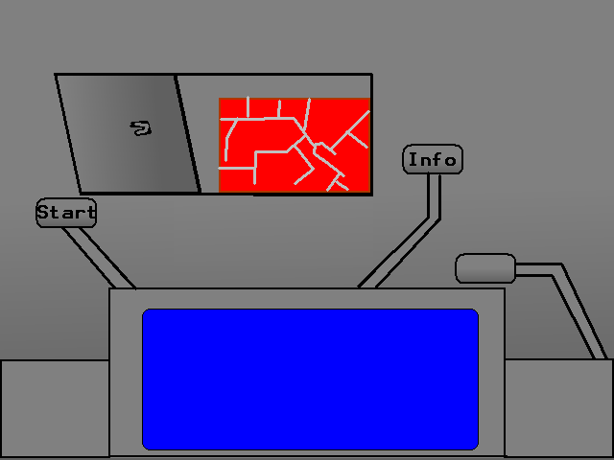

You move either joystick left or right to select which slot you want to use. Then one you are on will be highlighted green. Hit a joystick button to activate the slot you are on. “Start” will launch the game. “Info” will launch a tutorial. The blank one I haven’t decided what to do with yet. Maybe it could show you a score table. The blue-screen shows a spinning picture of the last robot a player built. When the game launches, the screen zooms in on the blue screen, and a GUI for building the robot appears.

**\*UPDATED* Front End:** Concept art:

There are three different graphical stages of this front end. Each one has its on dynamic sky lighting to match the beat of the song it is attached with. When the third and final stage is completed, it reverts back to the initial stage. The one thing all three have in common is the last built robot moving through whatever location it is in (dry desert, Roman city, Roman war). At the top of the screen is asand-stone tablet which has the “start” button, the “Tutorial” button, and the “Score” button ethced onto it. The one that is currently selected will appear to be pressed down on. The three songs are, “Stargate SG1 Credits Theme”, “Civilization 4 Title Theme”, and “Roman Total War Melee Café Theme”.

**Robot Building GUI:** Concept art:

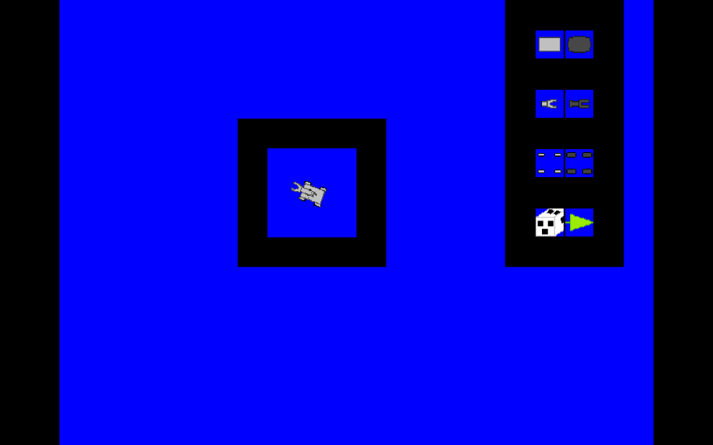

There are three parts of the robot. The Shell, which changes its speed and durability. The Wheels, which changes its speed. And finally, the claw, which changes the durability. There are also four different colors. Metallic Gray, Yellow, Red, and Green. The top left circle is higlighted at the beggining. Move either joystick left, right, top, and down will move which part/paint is selected. Hitting a joystick button will select the item and modify the robot accordingly. At the bottom of the GUI are to buttons. One of which randomizes the robot (obviously the die), and the other (the arrow) move onto the next stage of the game. The example robot rotates 360 degrees at a slow speed.

**Stage 1:** This is a side-scroller where you are moving left or right with the joystick. When the joystick’s button is pressed, assuming it is on top of an object, it picks it up. When pressed again, it drops it, whether into a hole, or onto the floor. The transistor parts are near the far left side of the room, and the transistor holes are near the far right. The door to the next room is at the far right. The left joystick flips the claw left or right. The claw can only move 180 degrees or less.

**Stage 2:** This is a top-down perspective game. You start nearby the transistors. You pick up the nearest one to you by pressing the joystick button. Then, you move the robot towards the end of the room. If you are carrying a transistor (which are found near the far bottom), and the claw is collided with a logic gate (which are near the far top), you may press the joystick button and attatch a tranistor to the gate. Then go back to the beginning, and grab another transistor. The door to the next room is near the far top-right. The left joystick rotates the claw in 360 degrees.

**Stage 3:** In this top-down stage, you do not have free movement. The robot is only capable of moving along the lines on a circuit board. There are parts of the CPU scattered around the bottom half of the screen, but all at the end of a path. You must grab those, and place them at specified places around the top half of the screen.