【实验4-1】【实验4-2】

**A.跟着学习**

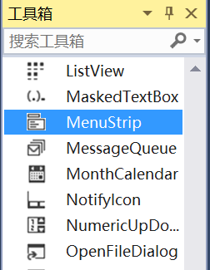 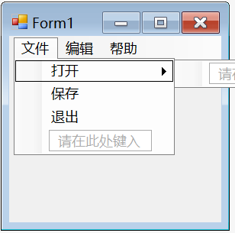

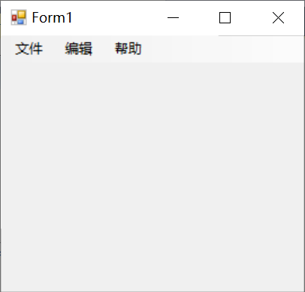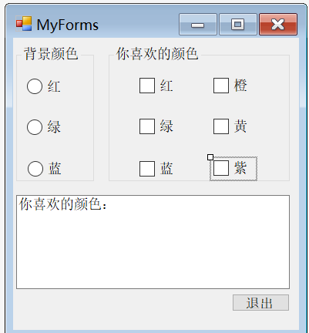

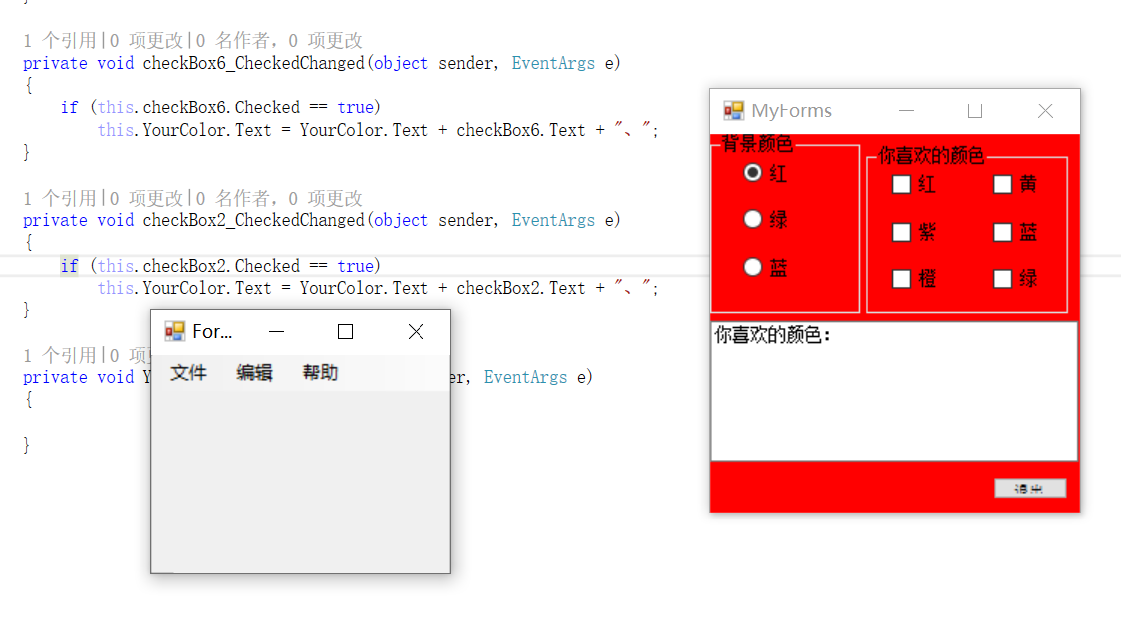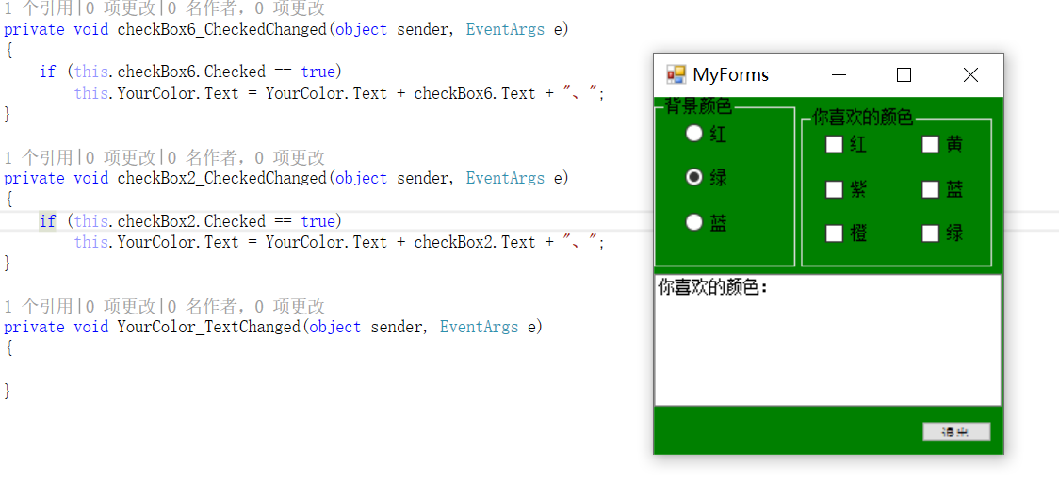

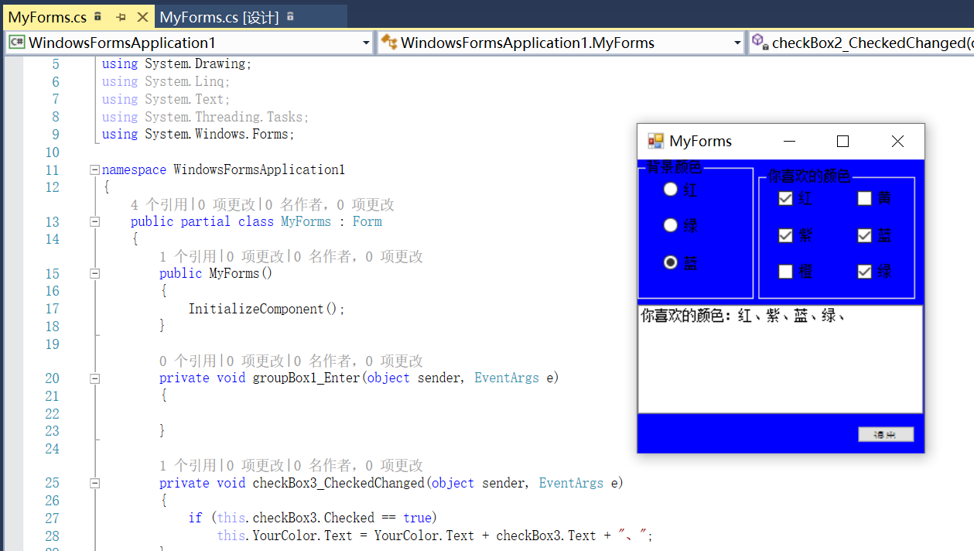

自己思考：

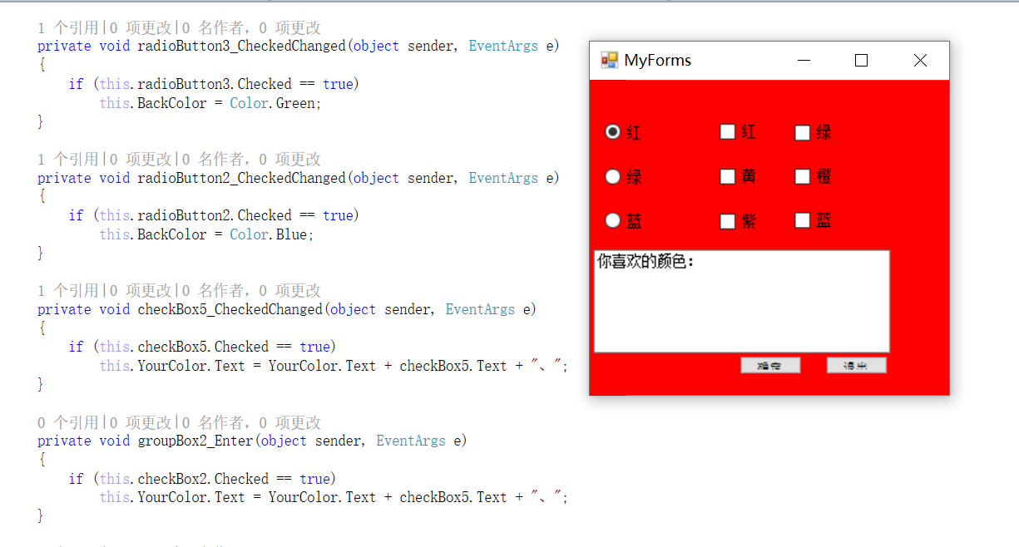

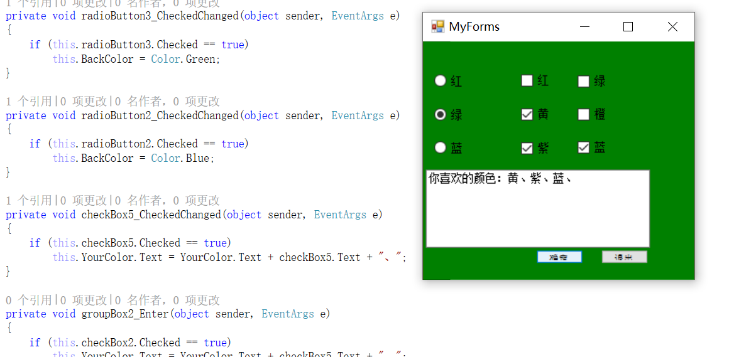

From1:

using System;

using System.Windows.Forms;

namespace WindowsFormsApplication1

{

public partial class Form1 : Form

{

public Form1()

{

InitializeComponent();

}

private void 退出EToolStripMenuItem_Click(object sender, EventArgs e)

{

}

private void 退出ToolStripMenuItem_Click(object sender, EventArgs e)

{

this.Close();

}

private void 打开ToolStripMenuItem_Click(object sender, EventArgs e)

{

MyForms myForm = new MyForms();

myForm.Show();

}

}

}

**MyForms:**

using System;

using System.Drawing;

using System.Windows.Forms;

namespace WindowsFormsApplication1

{

public partial class MyForms : Form

{

public MyForms()

{

InitializeComponent();

private void groupBox1_Enter(object sender, EventArgs e)

{

}

private void checkBox3_CheckedChanged(object sender, EventArgs e)

{

if (this.checkBox3.Checked == true)

this.YourColor.Text = YourColor.Text + checkBox3.Text + "、";

}

private void MyForms_Load(object sender, EventArgs e)

{

}

private void button1_Click(object sender, EventArgs e)

{

this.Close();

}

private void radioButton1_CheckedChanged(object sender, EventArgs e)

{

if (this.radioButton1.Checked == true)

this.BackColor = Color.Red;

}

private void radioButton3_CheckedChanged(object sender, EventArgs e)

{

if (this.radioButton3.Checked == true)

this.BackColor = Color.Green;

}

private void radioButton2_CheckedChanged(object sender, EventArgs e)

{

if (this.radioButton2.Checked == true)

this.BackColor = Color.Blue;

}

private void checkBox5_CheckedChanged(object sender, EventArgs e)

{

if (this.checkBox5.Checked == true)

this.YourColor.Text = YourColor.Text + checkBox5.Text + "、";

}

private void groupBox2_Enter(object sender, EventArgs e)

{

if (this.checkBox2.Checked == true)

this.YourColor.Text = YourColor.Text + checkBox5.Text + "、";

}

private void checkBox1_CheckedChanged(object sender, EventArgs e)

{

if (this.checkBox1.Checked == true)

this.YourColor.Text = YourColor.Text + checkBox1.Text + "、";

}

private void checkBox4_CheckedChanged(object sender, EventArgs e)

{

if (this.checkBox4.Checked == true)

this.YourColor.Text = YourColor.Text + checkBox4.Text + "、";

}

private void checkBox6_CheckedChanged(object sender, EventArgs e)

{

if (this.checkBox6.Checked == true)

this.YourColor.Text = YourColor.Text + checkBox6.Text + "、";

}

private void checkBox2_CheckedChanged(object sender, EventArgs e)

{

if (this.checkBox2.Checked == true)

this.YourColor.Text = YourColor.Text + checkBox2.Text + "、";

}

}

}

【实验4-3】

A.跟着学习：

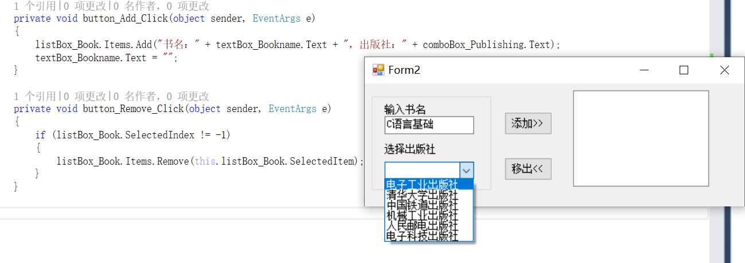

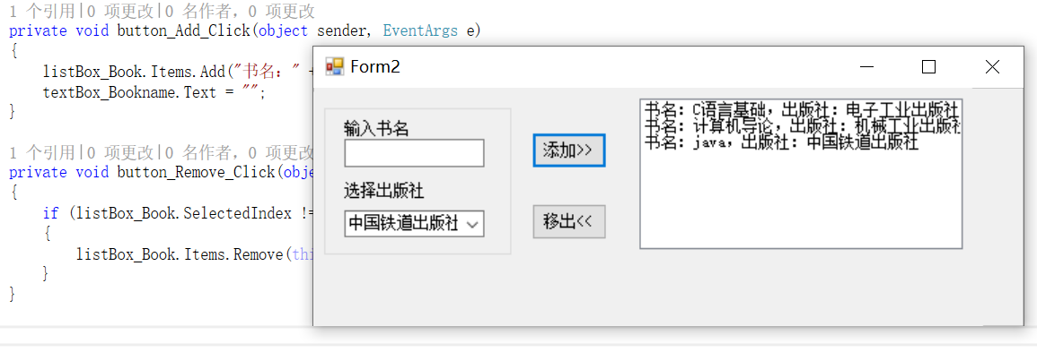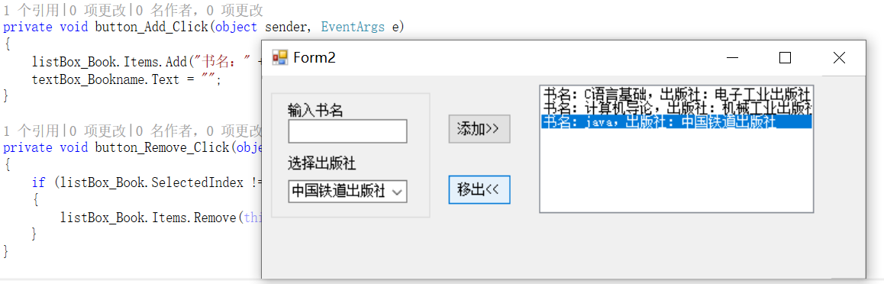

B.自己练习：

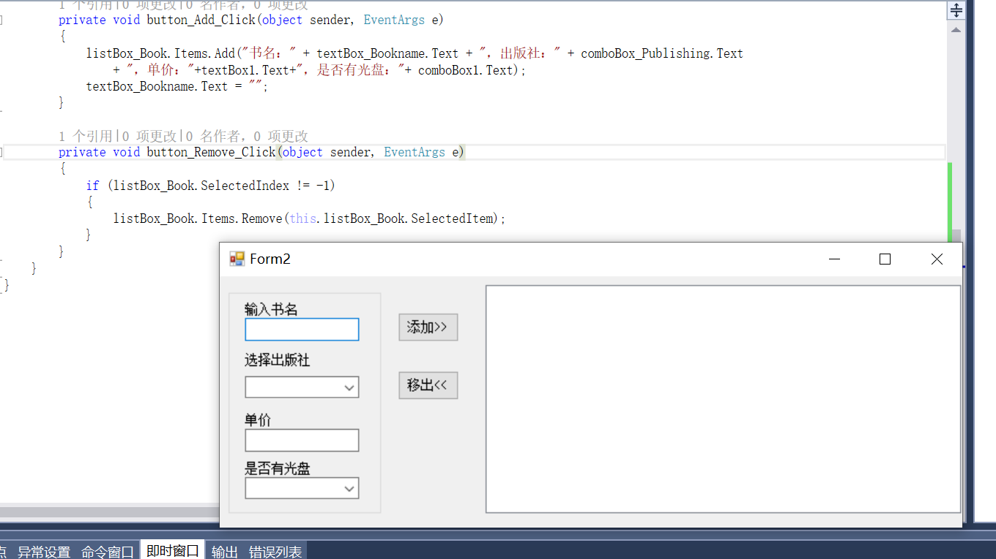

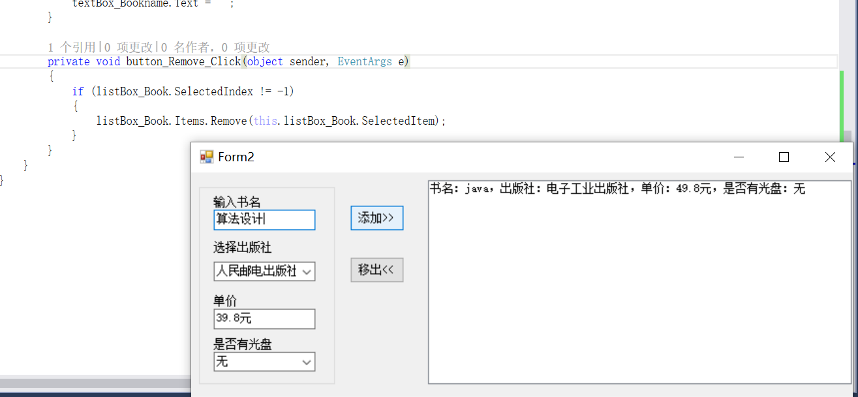

using System;

using System.Windows.Forms;

namespace WindowsFormsApplication1

{

public partial class Form2 : Form

{

public Form2()

{

InitializeComponent();

}

private void groupBox1_Enter(object sender, EventArgs e)

{

}

private void comboBox1_SelectedIndexChanged(object sender, EventArgs e)

{

}

private void listBox1_SelectedIndexChanged(object sender, EventArgs e)

{

}

private void button_Add_Click(object sender, EventArgs e)

{

listBox_Book.Items.Add("书名：" + textBox_Bookname.Text + "，出版社：" + comboBox_Publishing.Text);

textBox_Bookname.Text = "";

}

private void button_Remove_Click(object sender, EventArgs e)

{

if (listBox_Book.SelectedIndex != -1)

{

listBox_Book.Items.Remove(this.listBox_Book.SelectedItem);

}

}

}

}