**第四题**

**1.**

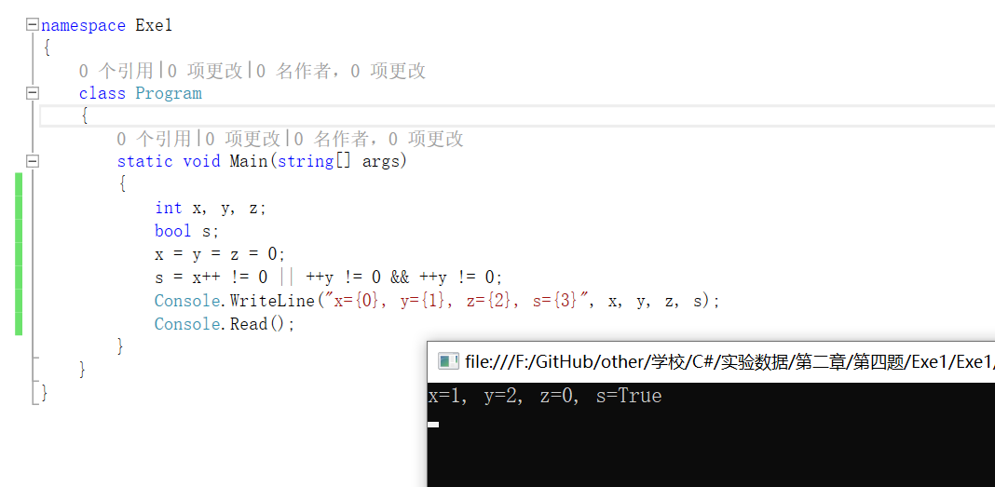

class Program

{

static void Main(string[] args)

{

int x, y, z;

bool s;

x = y = z = 0;

s = x++ != 0 || ++y != 0 && ++y != 0;

Console.WriteLine("x={0}, y={1}, z={2}, s={3}", x, y, z, s);

Console.Read();

}

}

**2.** 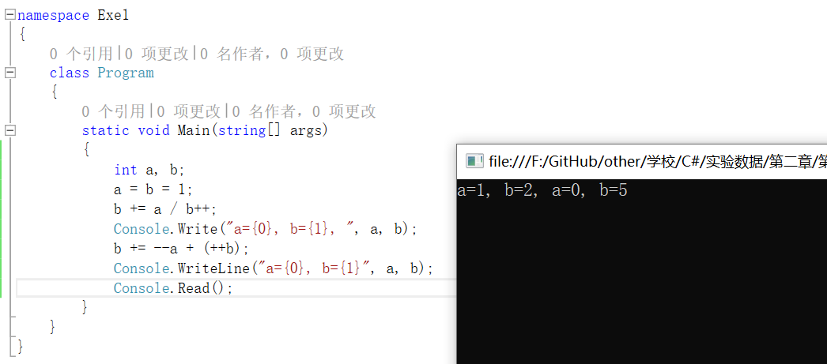

class Program

{

static void Main(string[] args)

{

int a, b;

a = b = 1;

b += a / b++;

Console.Write("a={0}, b={1}, ", a, b);

b += --a + (++b);

Console.WriteLine("a={0}, b={1}", a, b);

Console.Read();

}

}

**3.**

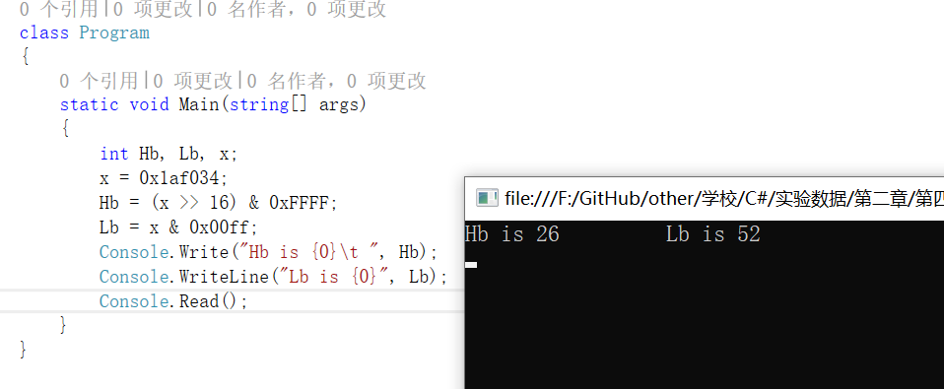

class Program

{

static void Main(string[] args)

{

int Hb, Lb, x;

x = 0x1af034;

Hb = (x >> 16) & 0xFFFF;

Lb = x & 0x00ff;

Console.Write("Hb is {0}\t ", Hb);

Console.WriteLine("Lb is {0}", Lb);

Console.Read();

}

}

**4.**

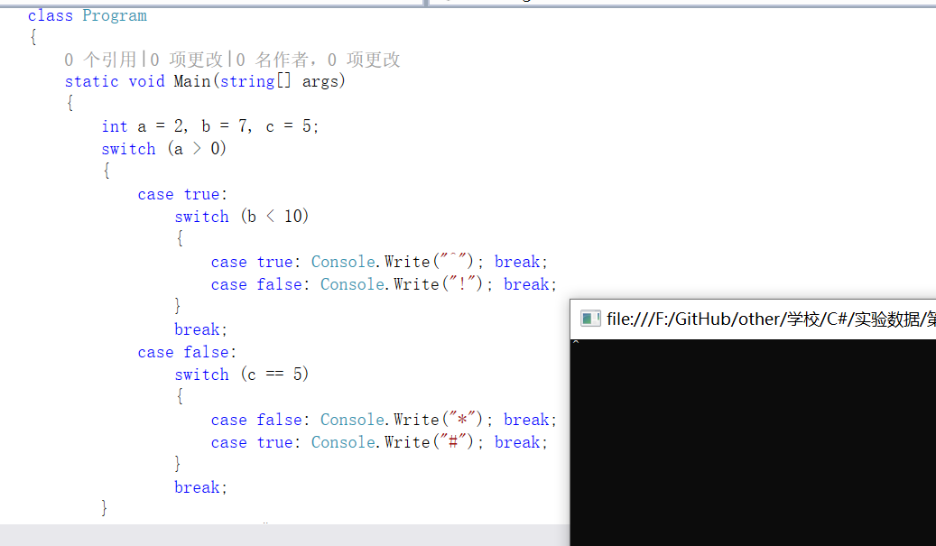

class Program

{

static void Main(string[] args)

{

int a = 2, b = 7, c = 5;

switch (a > 0)

{

case true:

switch (b < 10)

{

case true: Console.Write("^"); break;

case false: Console.Write("!"); break;

}

break;

case false:

switch (c == 5)

{

case false: Console.Write("*"); break;

case true: Console.Write("#"); break;

}

break;

}

Console.WriteLine();

Console.Read();

}

}

**5.**

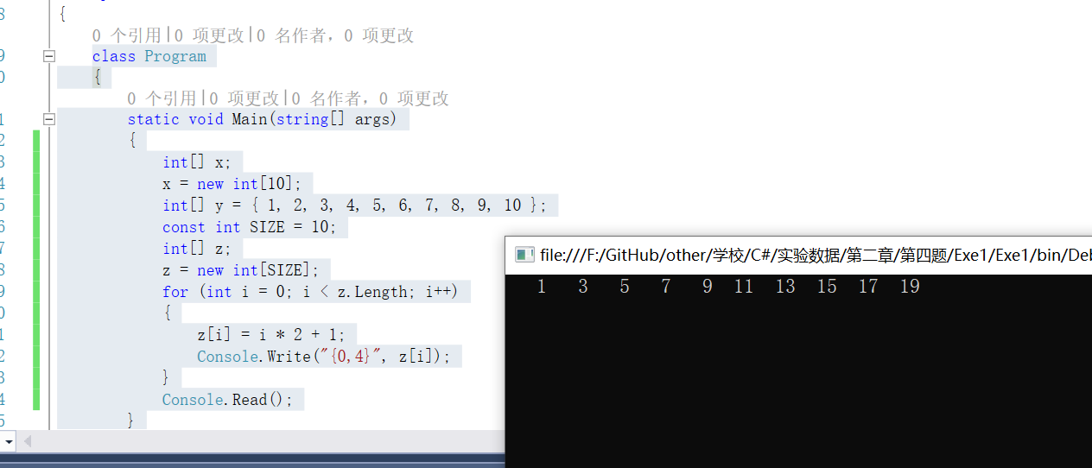

class Program

{

static void Main(string[] args)

{

int[] x;

x = new int[10];

int[] y = { 1, 2, 3, 4, 5, 6, 7, 8, 9, 10 };

const int SIZE = 10;

int[] z;

z = new int[SIZE];

for (int i = 0; i < z.Length; i++)

{

z[i] = i * 2 + 1;

Console.Write("{0,4}", z[i]);

}

Console.Read();

}

}

**6.**

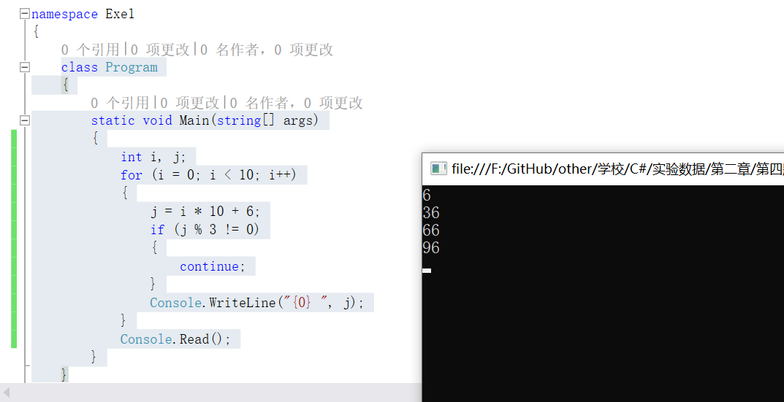

class Program

{

static void Main(string[] args)

{

int i, j;

for (i = 0; i < 10; i++)

{

j = i * 10 + 6;

if (j % 3 != 0)

{

continue;

}

Console.WriteLine("{0} ", j);

}

Console.Read();

}

}

**7.** 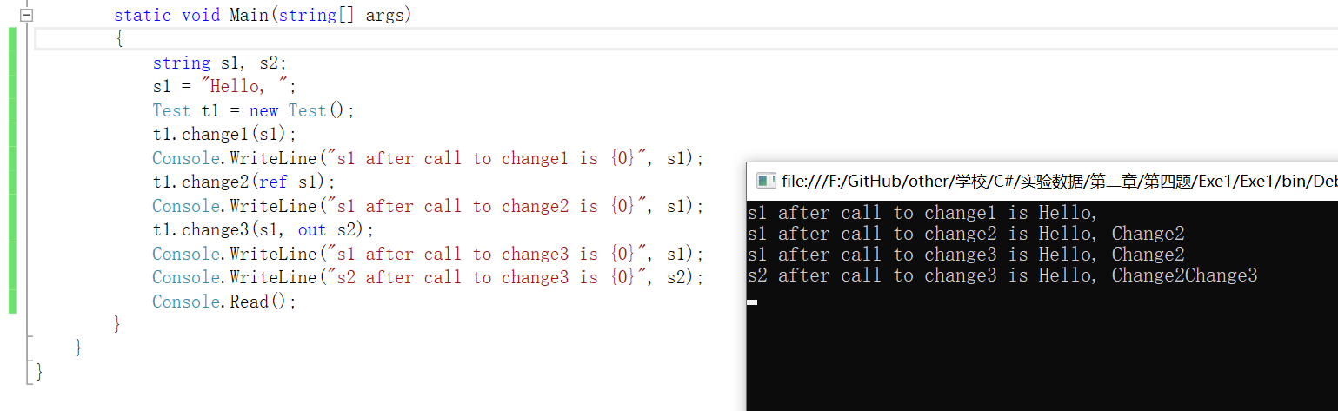

using System;

public class Test

{

public void change1(string s)

{

s = s + "Change1";

}

public void change2(ref string s)

{

s = s + "Change2";

}

public void change3(string s1, out string s2)

{

s1 = s1 + "Change3";

s2 = s1;

}

}

namespace Exe7

{

class Program

{

static void Main(string[] args)

{

string s1, s2;

s1 = "Hello, ";

Test t1 = new Test();

t1.change1(s1);

Console.WriteLine("s1 after call to change1 is {0}", s1);

t1.change2(ref s1);

Console.WriteLine("s1 after call to change2 is {0}", s1);

t1.change3(s1, out s2);

Console.WriteLine("s1 after call to change3 is {0}", s1);

Console.WriteLine("s2 after call to change3 is {0}", s2);

Console.Read();

}

}

}

**第五题**

**1.菲波那切数列数列的前两个数是 1 和 1，从第三个数开始，每个数等于前两个的和。编程计算此数列的前 30 个数且每行输出 5 个数。**

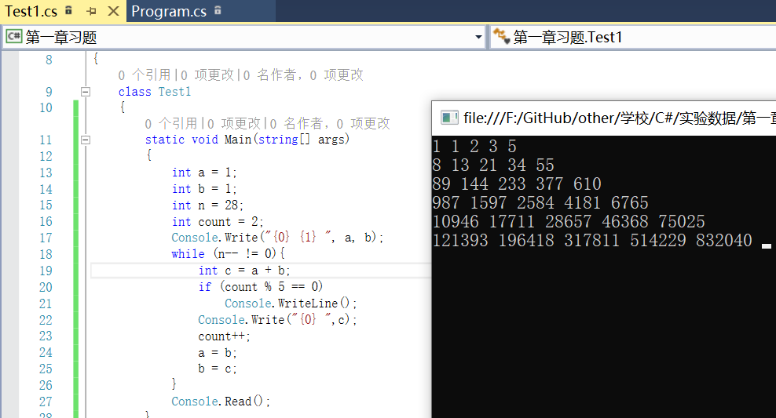

using System;

namespace 第一章习题

{

class Test1

{

static void Main(string[] args)

{

int a = 1;

int b = 1;

int n = 28;

int count = 2;

Console.Write("{0} {1} ", a, b);

while (n-- != 0){

int c = a + b;

if (count % 5 == 0)

Console.WriteLine();

Console.Write("{0} ",c);

count++;

a = b;

b = c;

}

Console.Read();

}

}

}

**2.从键盘上输入一个整数n的值，按下式求出y，并输出n和y的值（y用浮点数表示）：**

y = 1! + 2! + 3! +……+ n！

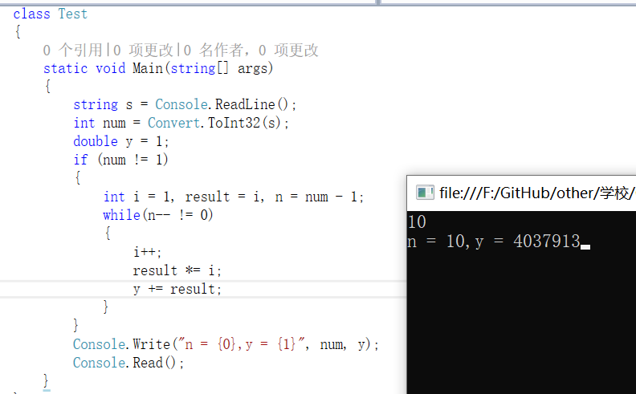

using System;

namespace 第一章习题

{

class Test

{

static void Main(string[] args)

{

string s = Console.ReadLine();

int num = Convert.ToInt32(s);

double y = 1;

if (num != 1)

{

int i = 1, result = i, n = num - 1;

while(n-- != 0)

{

i++;

result *= i;

y += result;

}

}

Console.Write("n = {0},y = {1}", num, y);

Console.Read();

}

}

}

**3.设计一个程序,输出所有的水仙花数。所谓水仙花数是一个三位整数,其各位数字的立方和等于该数的本身。例如,153=1^3 + 5^3 + 3^3。**

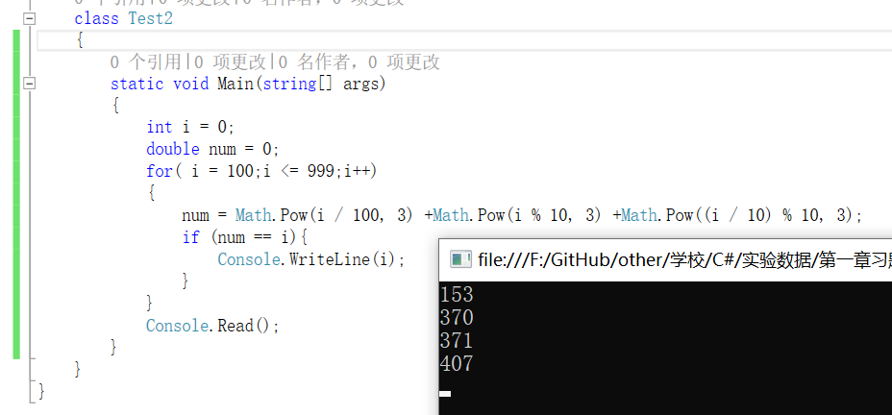

using System;

namespace 第一章习题

{

class Test2

{

static void Main(string[] args)

{

int i = 0;

double num = 0;

for( i = 100;i <= 999;i++)

{

num = Math.Pow(i / 100, 3) +Math.Pow(i % 10, 3) +Math.Pow((i / 10) % 10, 3);

if (num == i){

Console.WriteLine(i);

}

}

Console.Read();

}

}

}

**4.设计一个程序,输入一个四位整数,将各位数字分开,并按其反序输出。例如:输入1234,则输出4321。要求必须用循环语句实现。**

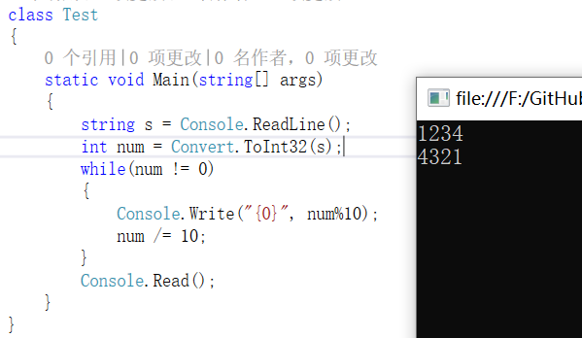

using System;

namespace 第一章习题

{

class Test

{

static void Main(string[] args)

{

string s = Console.ReadLine();

int num = Convert.ToInt32(s);

while(num != 0)

{

Console.Write("{0}", num%10);

num /= 10;

}

Console.Read();

}

}

}

**5.**

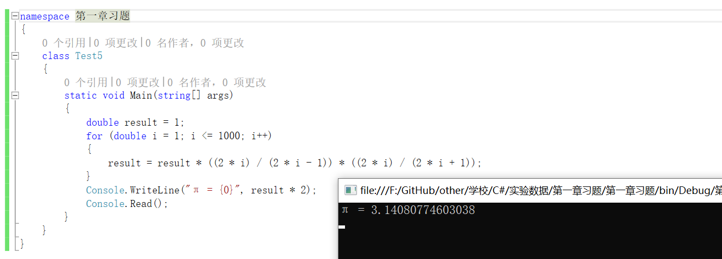

using System;

namespace 第一章习题

{

class Test

{

static void Main(string[] args)

{

double result = 1;

for(double i = 1;i <= 1000; i++)

{

result = result * ((2 * i) / (2 * i - 1)) * ((2 * i) / (2 * i + 1));

}

Console.WriteLine("Pi = {0}",result*2);

Console.Read();

}

}

}

**6.设计一个程序,输入一个十进制数,输出相应的十六进制数。**

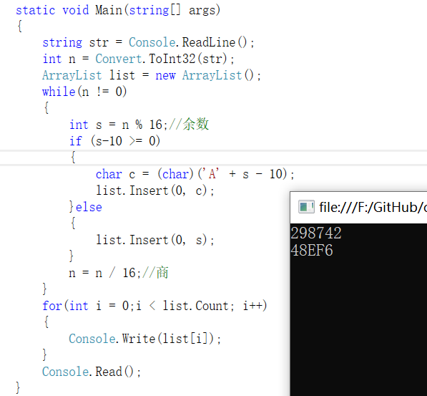

using System;

using System.Collections;

namespace 第一章习题

{

class Test

{

static void Main(string[] args)

{

string str = Console.ReadLine();

int n = Convert.ToInt32(str);

ArrayList list = new ArrayList();

while(n != 0)

{

int s = n % 16;//余数

if (s-10 >= 0)

{

char c = (char)('A' + s - 10);

list.Insert(0, c);

}else

{

list.Insert(0, s);

}

n = n / 16;//商

}

for(int i = 0;i < list.Count; i++)

{

Console.Write(list[i]);

}

Console.Read();

}

}

}

**7.当输入浮点数x和整数n后,求出 Hermite多项式前n项的值。**

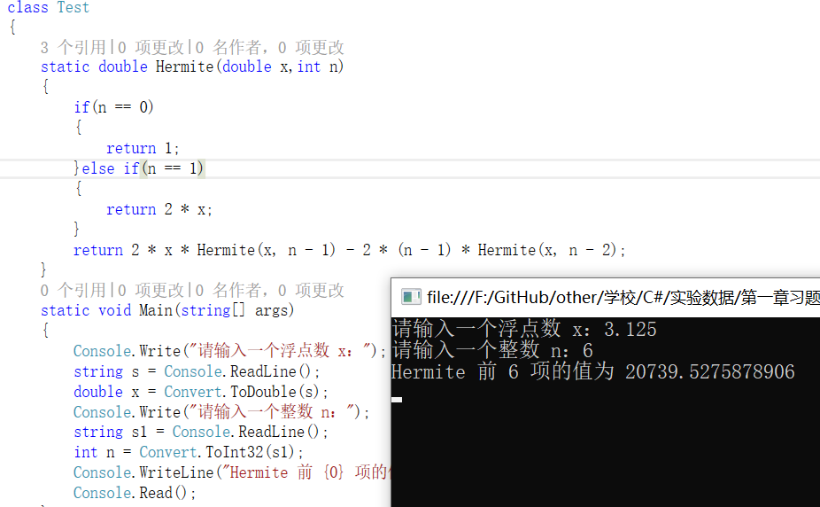

using System;

namespace 第一章习题

{

class Test

{

static double Hermite(double x,int n)

{

if(n == 0)

{

return 1;

}else if(n == 1)

{

return 2 * x;

}

return 2 * x * Hermite(x, n - 1) - 2 * (n - 1) * Hermite(x, n - 2);

}

static void Main(string[] args)

{

Console.Write("请输入一个浮点数 x：");

string s = Console.ReadLine();

double x = Convert.ToDouble(s);

Console.Write("请输入一个整数 n：");

string s1 = Console.ReadLine();

int n = Convert.ToInt32(s1);

Console.WriteLine("Hermite 前 {0} 项的值为 {1}",n, Hermite(x, n));

Console.Read();

}

}

}

**8.找出数组a中最大值的下标,输出下标及最大值。**

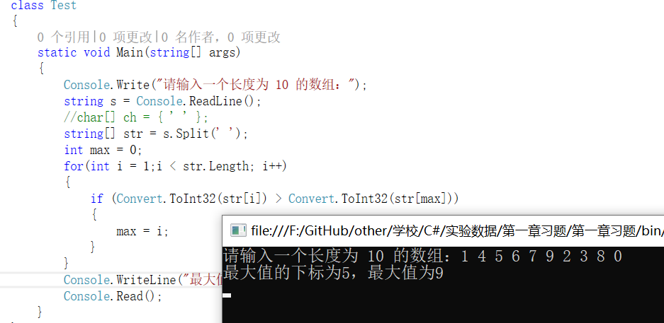

using System;

namespace 第一章习题

{

class Test

{

static void Main(string[] args)

{

Console.Write("请输入一个长度为 10 的数组：");

string s = Console.ReadLine();

string[] str = s.Split(' ');

int max = 0;

for(int i = 1;i < str.Length; i++)

{

if (Convert.ToInt32(str[i]) > Convert.ToInt32(str[max]))

{

max = i;

}

}

Console.WriteLine("最大值的下标为{0}，最大值为{1}",max,str[max]);

Console.Read();

}

}

}

**9.判断s所指的字符串是否是“回文”(即顺读和逆读是相同的字符)。**

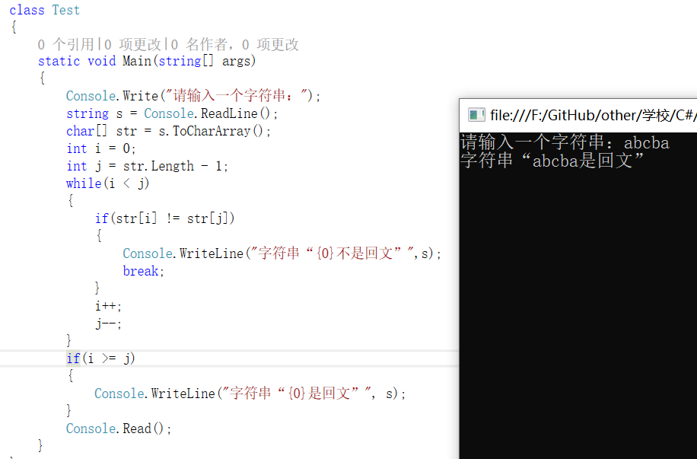

using System;

namespace 第一章习题

{

class Test

{

static void Main(string[] args)

{

Console.Write("请输入一个字符串：");

string s = Console.ReadLine();

char[] str = s.ToCharArray();

int i = 0;

int j = str.Length - 1;

while(i < j)

{

if(str[i] != str[j])

{

Console.WriteLine("字符串“{0}不是回文”",s);

break;

}

i++;

j--;

}

if(i >= j)

{

Console.WriteLine("字符串“{0}是回文”", s);

}

Console.Read();

}

}

}

**10.输入一组非0整数(以0作为结束标志)到一维数组中,求出这一组数的平均值,并统计出正数和负数的个数**。

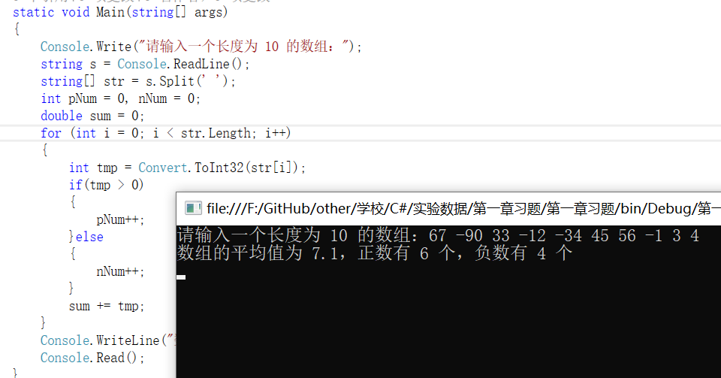

using System;

namespace 第一章习题

{

class Test

{

static void Main(string[] args)

{

Console.Write("请输入一个长度为 10 的数组：");

string s = Console.ReadLine();

string[] str = s.Split(' ');

int pNum = 0, nNum = 0;

double sum = 0;

for (int i = 0; i < str.Length; i++)

{

int tmp = Convert.ToInt32(str[i]);

if(tmp > 0)

{

pNum++;

}else

{

nNum++;

}

sum += tmp;

}

Console.WriteLine("数组的平均值为 {0}，正数有 {1} 个，负数有 {2} 个",sum/10,pNum,nNum);

Console.Read();

}

}

}

**11.设计一个程序,求一个4×4矩阵两对角线元素之和。**

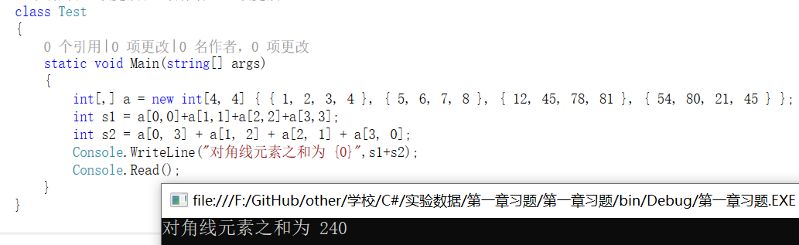

using System;

namespace 第一章习题

{

class Test

{

static void Main(string[] args)

{

int[,] a = new int[4, 4] { { 1, 2, 3, 4 }, { 5, 6, 7, 8 }, { 12, 45, 78, 81 }, { 54, 80, 21, 45 } };

int s1 = a[0,0]+a[1,1]+a[2,2]+a[3,3];

int s2 = a[0, 3] + a[1, 2] + a[2, 1] + a[3, 0];

Console.WriteLine("对角线元素之和为 {0}",s1+s2);

Console.Read();

}

}

}

**12.输入一个字符串,串内有数字和非数字字符,例如“ab2345 345fdf678 jdhfg945”将其中连续的数字作为一个整数,依次存放到另一个整型数组b中。如将2345存放到b[0],345放入b[1],678放入b[2],……统计出字符串中的整数个数,并输出这些整数。**

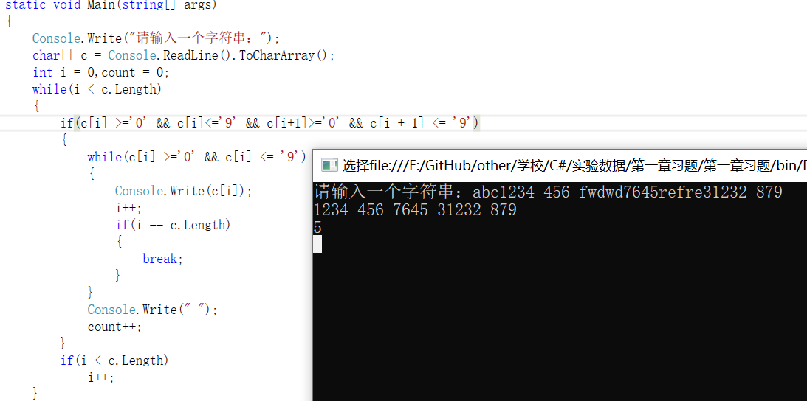

using System;

namespace 第一章习题

{

class Test

{

static void Main(string[] args)

{

Console.Write("请输入一个字符串：");

char[] c = Console.ReadLine().ToCharArray();

int i = 0,count = 0;

while(i < c.Length)

{

if(c[i] >='0' && c[i]<='9' && c[i+1]>='0' && c[i + 1] <= '9')

{

while(c[i] >='0' && c[i] <= '9')

{

Console.Write(c[i]);

i++;

if(i == c.Length)

{

break;

}

}

Console.Write(" ");

count++;

}

if(i < c.Length)

i++;

}

Console.WriteLine();

Console.WriteLine(count);

Console.Read();

}

}

}