【实验5-1】

A.跟着练习

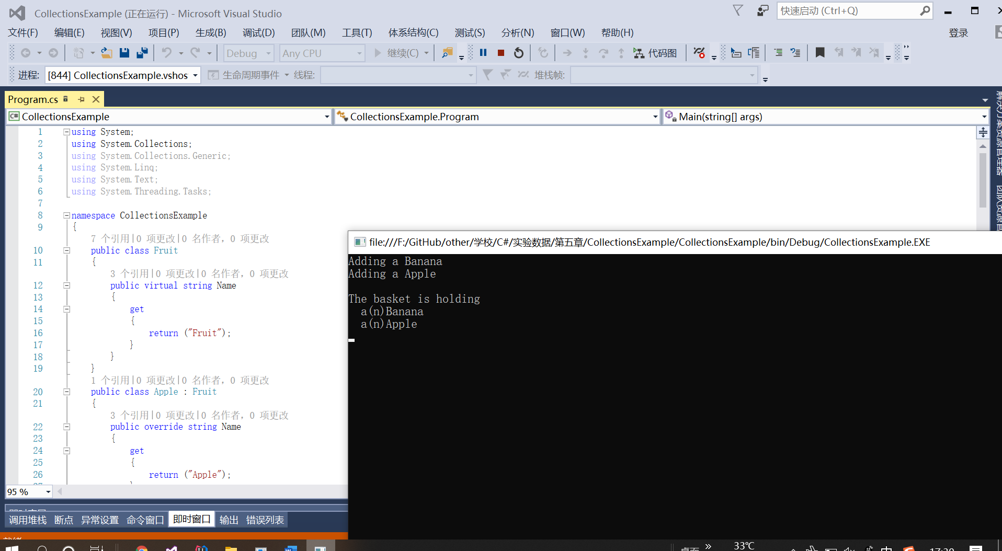

**B.自己思考**

当装入水果超出10个时，程序运行会中断，抛出异常。

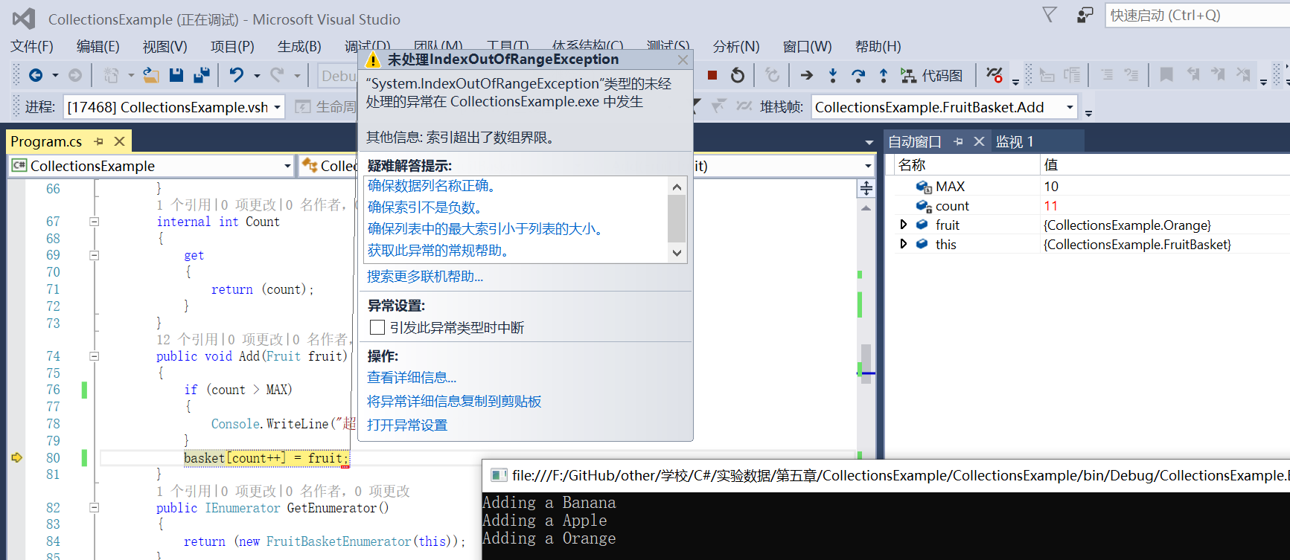

装入橘子在原代码中加入：

public class Orange : Fruit

{

public override string Name

{

get

{

return ("Orange");

}

}

}

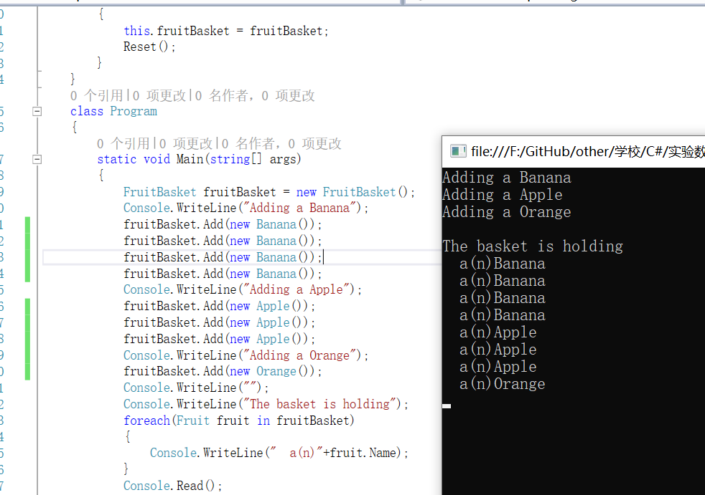

using System;

using System.Collections;

namespace CollectionsExample

{

public class Fruit

{

public virtual string Name

{

get

{

return ("Fruit");

}

}

}

public class Apple : Fruit

{

public override string Name

{

get

{

return ("Apple");

}

}

}

public class Banana : Fruit

{

public override string Name

{

get

{

return ("Banana");

}

}

}

public class Orange : Fruit

{

public override string Name

{

get

{

return ("Orange");

}

}

}

public class FruitBasket : IEnumerable

{

static int MAX = 10;

Fruit[] basket = new Fruit[MAX];

int count = 0;

internal Fruit this[int index]

{

get

{

return (basket[index]);

}

set

{

basket[index] = value;

}

}

internal int Count

{

get

{

return (count);

}

}

public void Add(Fruit fruit)

{

if (count > MAX)

{

Console.WriteLine("超出水果篮容量！");

}

basket[count++] = fruit;

}

public IEnumerator GetEnumerator()

{

return (new FruitBasketEnumerator(this));

}

}

public class FruitBasketEnumerator : IEnumerator

{

FruitBasket fruitBasket;

int index;

public void Reset()

{

index = -1;

}

public object Current

{

get

{

return (fruitBasket[index]);

}

}

public bool MoveNext()

{

if (++index >= fruitBasket.Count)

return (false);

else

return (true);

}

internal FruitBasketEnumerator(FruitBasket fruitBasket)

{

this.fruitBasket = fruitBasket;

Reset();

}

}

class Program

{

static void Main(string[] args)

{

FruitBasket fruitBasket = new FruitBasket();

Console.WriteLine("Adding a Banana");

fruitBasket.Add(new Banana());

Console.WriteLine("Adding a Apple");

fruitBasket.Add(new Apple());

Console.WriteLine("");

Console.WriteLine("The basket is holding");

foreach(Fruit fruit in fruitBasket)

{

Console.WriteLine(" a(n)"+fruit.Name);

}

Console.Read();

}

}

}