**一、数据库设计：**

**1.用户Users：**

CREATE TABLE [dbo].[Users] (

[UsersName] VARCHAR (50) NOT NULL,

[Userspwd] VARCHAR (50) NOT NULL,

PRIMARY KEY CLUSTERED ([UsersName] ASC)

);

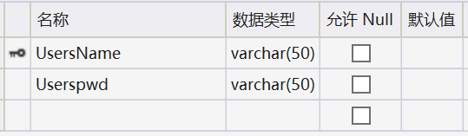

**2.通讯录Contact：**

CREATE TABLE [dbo].[Contact] (

[姓名] VARCHAR (50) NOT NULL,

[性别] CHAR (10) NULL,

[生日] VARCHAR (50) NULL,

[电话] VARCHAR (50) NULL,

[邮箱] VARCHAR (50) NULL,

[地址] VARCHAR (50) NULL,

PRIMARY KEY CLUSTERED ([姓名] ASC)

);

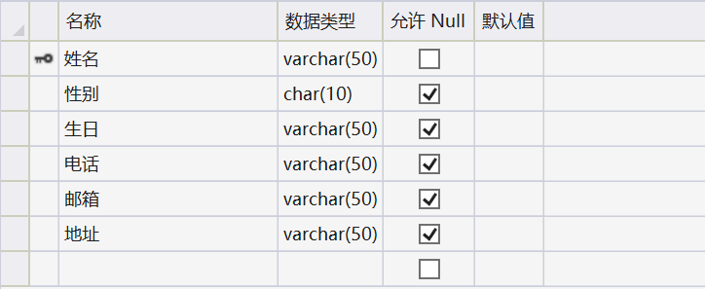

**二、页面功能展示**

**1.注册界面：**

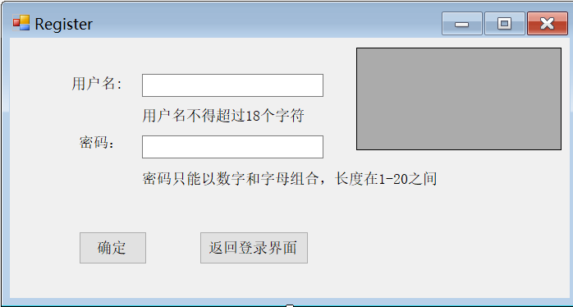

**（1）成功注册：**

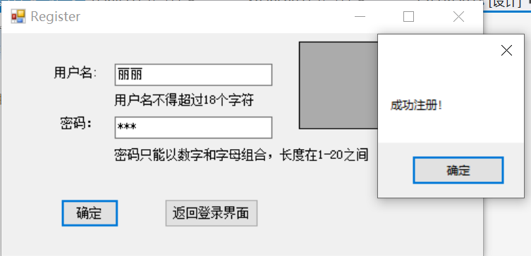

**注册成功后显示当前已有用户：**

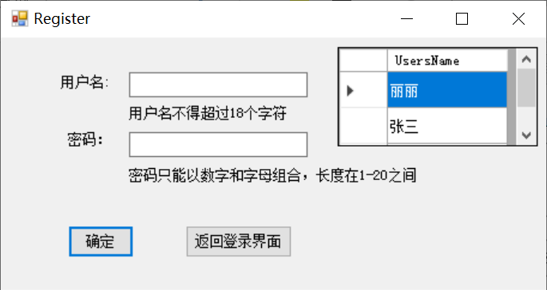

**2.登录界面：**

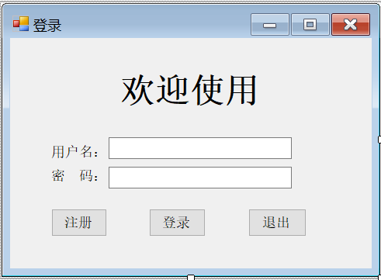

**（1）没有输入用户名和密码：**

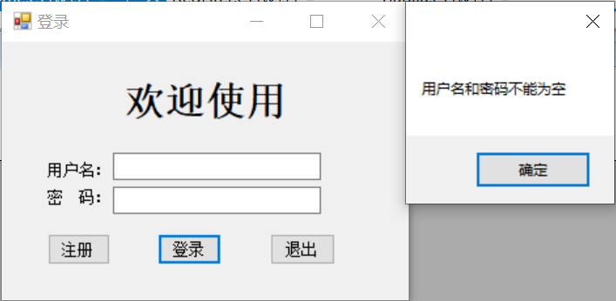

**（2）该用户不存在：**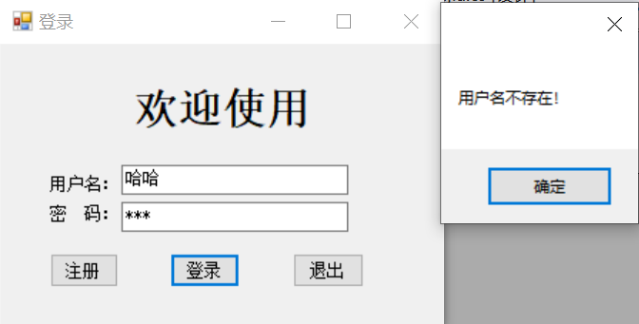

**（3）密码错误：**

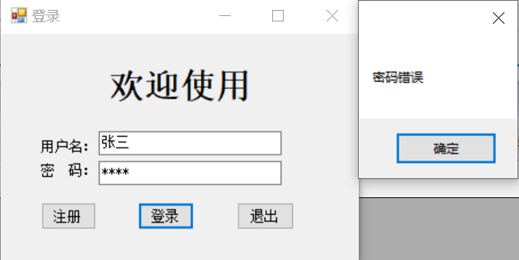

**（4）登录成功：**

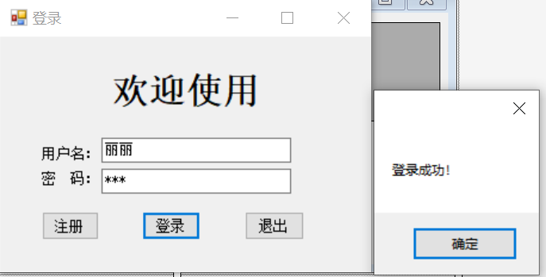

**3.主界面Home：**

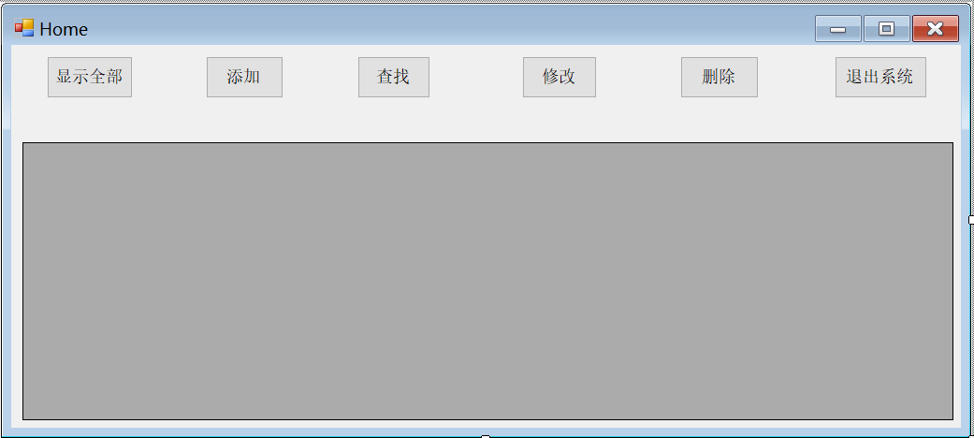

**显示全部：**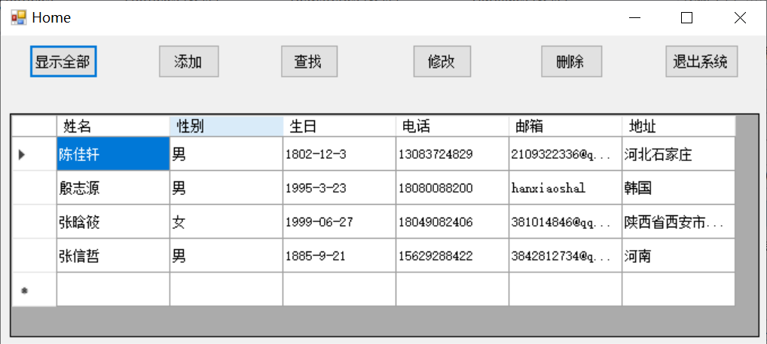

**4.添加界面：**

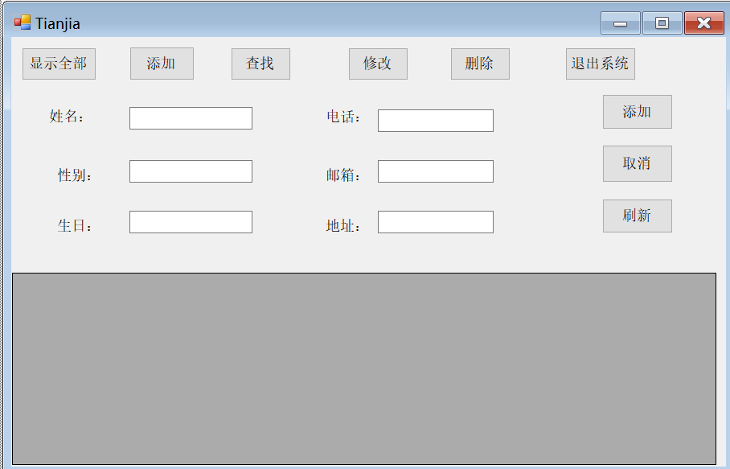

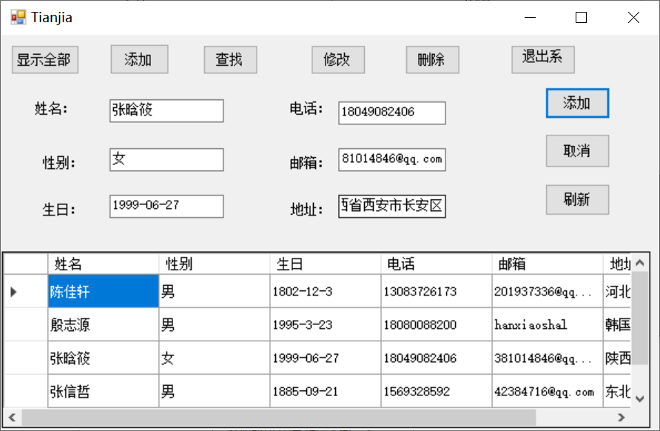

**添加成功后显示今日新增人数：**

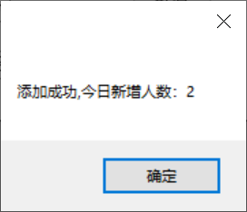

**5.查找界面：**

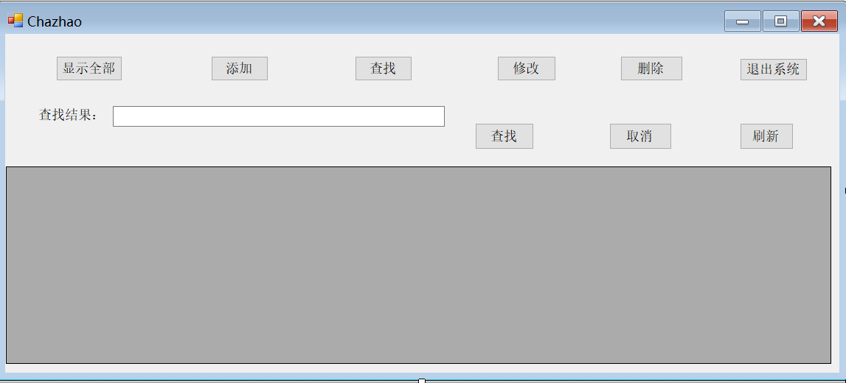

**（1）按姓名查找：**

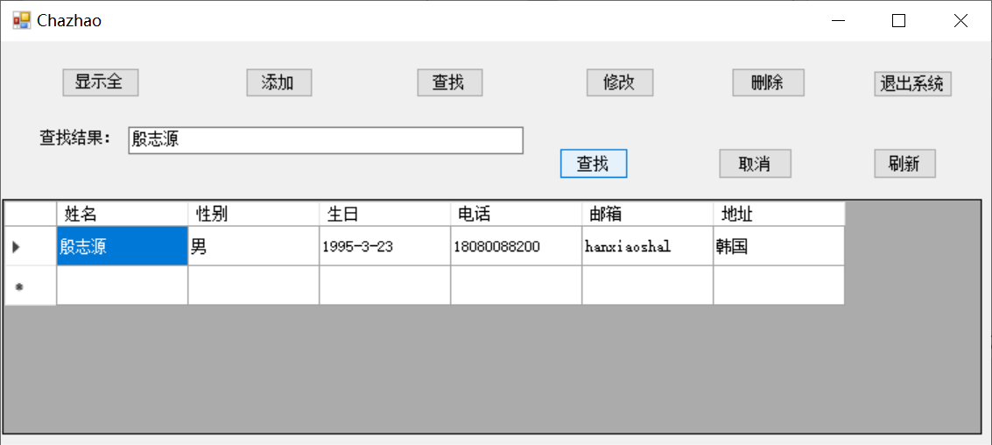

**（2）按电话查找：**

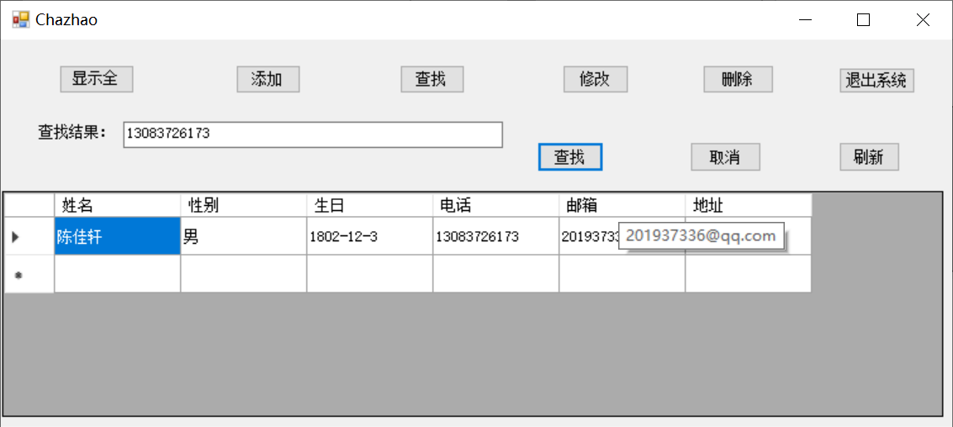

**（3）电话模糊匹配：**

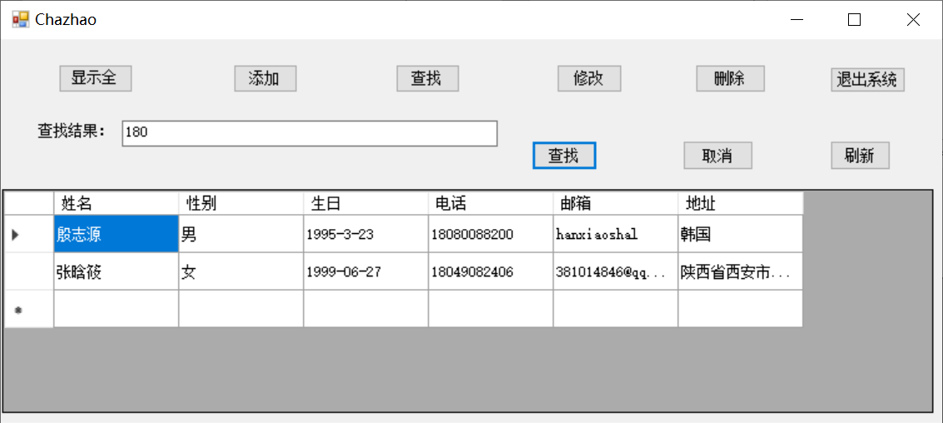

**6.修改界面：**

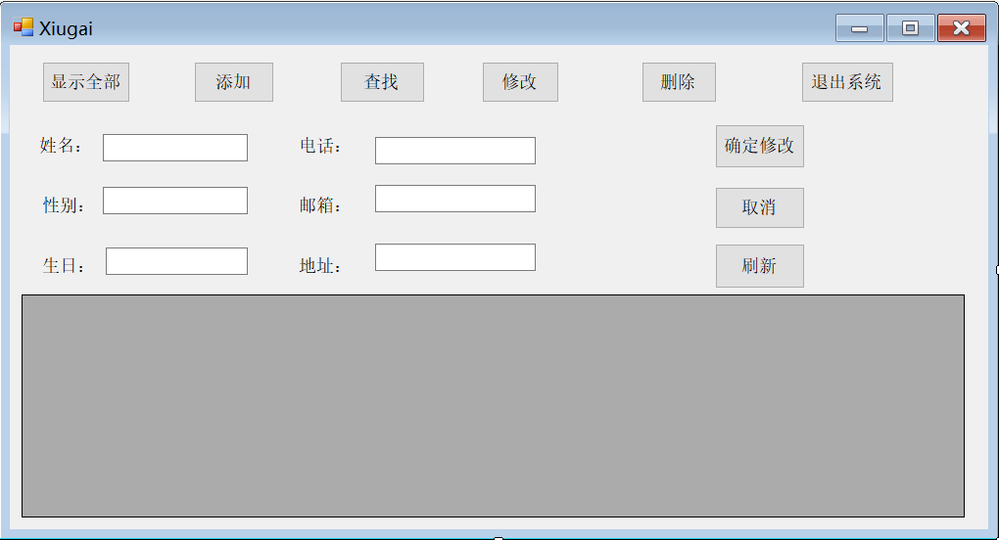

**（1）修改不存在的用户：**

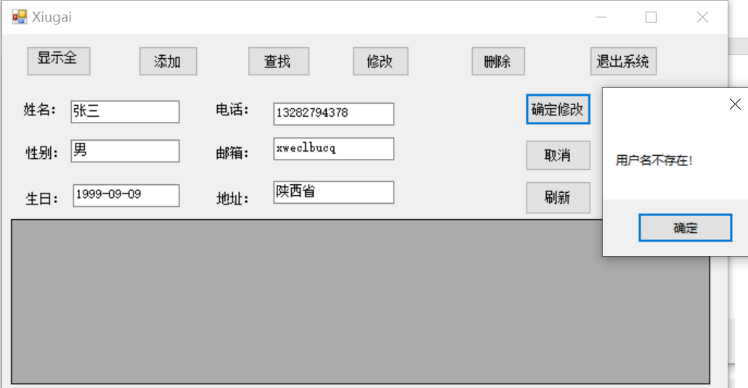

**（2）修改成功**

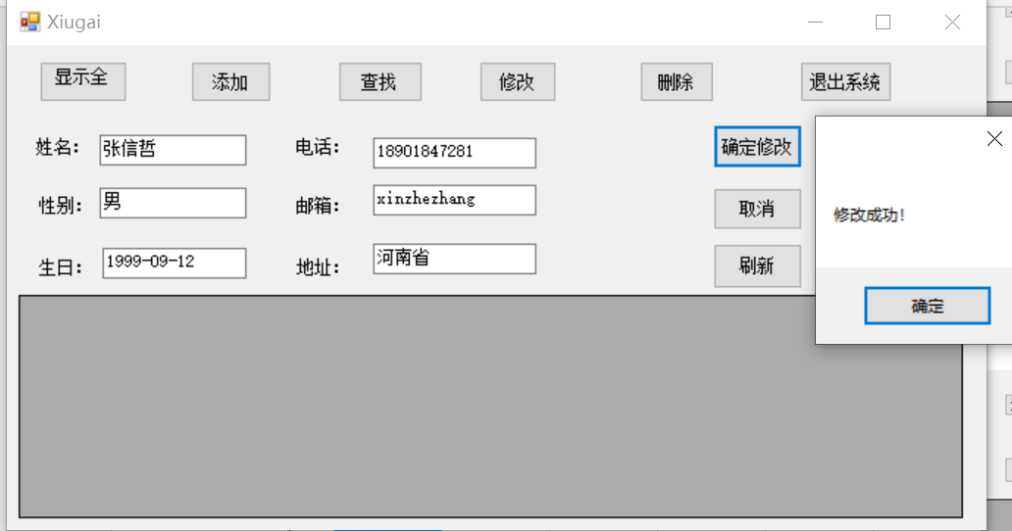 **7.删除界面：**

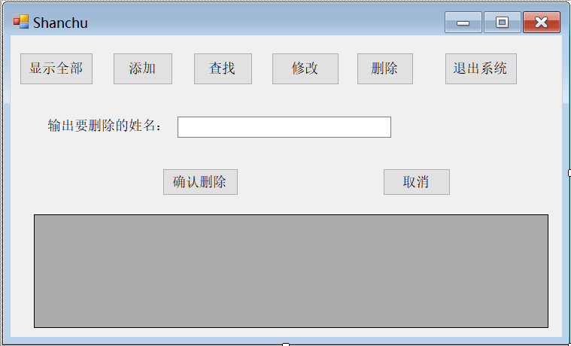

**（1）该用户不存在：**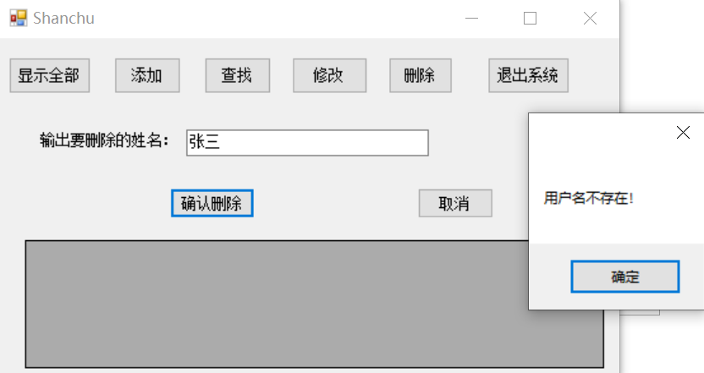

**（2）删除成功：**

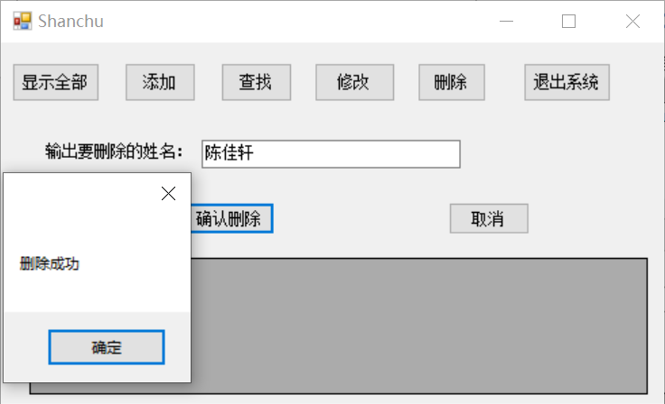

**三、源码**

**Form1.cs**

using System;

using System.Collections.Generic;

using System.ComponentModel;

using System.Data;

using System.Drawing;

using System.Linq;

using System.Text;

using System.Threading.Tasks;

using System.Windows.Forms;

using System.Data.SqlClient;

namespace 课设

{

public partial class From1 : Form

{

public static string count = "0";

public From1()

{

InitializeComponent();

}

private void label3_Click(object sender, EventArgs e)

{

}

private void From1_Load(object sender, EventArgs e)

{

}

public static class DBClass

{

public static String strConn = @"Data Source=(localdb)\MSSQLLocalDB;Initial Catalog=TXLDB;Integrated Security=True";

public static SqlConnection conn = new SqlConnection(strConn);

}

private void button2_Click(object sender, EventArgs e)

{

if (textBox1.Text == "" || textBox2.Text == "")

{

MessageBox.Show("用户名和密码不能为空");

}

else

{

DBClass.conn.Open();

DataSet dsMydataBase = new DataSet();

SqlCommand cmd = new SqlCommand();

cmd.Connection = DBClass.conn;

cmd.CommandText = "select [UsersName] from [Users] where [UsersName] ='" + textBox1.Text + "'";

cmd.CommandType = CommandType.Text;

cmd.ExecuteNonQuery();

if (cmd.ExecuteScalar() == null)

{

MessageBox.Show("用户名不存在！");

textBox1.Clear();

textBox2.Clear();

DBClass.conn.Close();

return;

}

else

{

cmd.CommandText = "select [Userspwd] from [Users] where [UsersName] ='" + textBox1.Text + "'";

cmd.ExecuteNonQuery();

if (textBox2.Text == cmd.ExecuteScalar().ToString())

{

DBClass.conn.Close();

MessageBox.Show(" 登录成功！");

Home ho = new Home();

ho.Show();

this.Hide();

}

else if (textBox2.Text != cmd.ExecuteScalar().ToString())

{

MessageBox.Show("密码错误");

textBox1.Clear();

textBox2.Clear();

DBClass.conn.Close();

}

else

{

Application.Exit();

}

}

}

}

private void button1_Click(object sender, EventArgs e)

{

Register register = new Register();

register.Show();

this.Hide();

}

private void button3_Click(object sender, EventArgs e)

{

Application.Exit();

}

private void textBox2_TextChanged(object sender, EventArgs e)

{

textBox2.PasswordChar = '*';

}

}

}

**Register.cs**

using System;

using System.Collections.Generic;

using System.ComponentModel;

using System.Data;

using System.Drawing;

using System.Linq;

using System.Text;

using System.Threading.Tasks;

using System.Windows.Forms;

using System.Data.SqlClient;

using static 课设.From1;

namespace 课设

{

public partial class Register : Form

{

public Register()

{

InitializeComponent();

}

private void Register_Load(object sender, EventArgs e)

{

}

private void button1_Click(object sender, EventArgs e)

{

try

{

if (textBox1.Text == "" || textBox2.Text == "")

{

MessageBox.Show("用户名和密码不能为空");

}

else

{

DBClass.conn.Open();

SqlCommand cmd = new SqlCommand();

cmd.Connection = DBClass.conn;

cmd.CommandText = "Insert into Users(UsersName,Userspwd) Values('" + textBox1.Text.Trim() + "','" + textBox2.Text.Trim() + "')";

cmd.CommandType = CommandType.Text;

cmd.ExecuteNonQuery();

DBClass.conn.Close();

MessageBox.Show("成功注册！");

DataSet dsMyDataBase = new DataSet();

SqlDataAdapter daBaseInform = new SqlDataAdapter("Select [UsersName] From Users", DBClass.conn);

daBaseInform.Fill(dsMyDataBase, "BaseInform");

dataGridView1.DataSource = dsMyDataBase.Tables["BaseInform"];

textBox1.Clear();

textBox2.Clear();

}

}

catch (Exception ex)

{

MessageBox.Show(ex.Message.ToString() + "打开数据库失败！");

DBClass.conn.Close();

}

}

private void button2_Click(object sender, EventArgs e)

{

From1 L = new From1();

L.Show();

this.Hide();

}

private void textBox2_TextChanged(object sender, EventArgs e)

{

textBox2.PasswordChar = '*';

}

private void dataGridView1_CellContentClick(object sender, DataGridViewCellEventArgs e)

{

}

}

}

**Home.cs**

using System;

using System.Collections.Generic;

using System.ComponentModel;

using System.Data;

using System.Drawing;

using System.Linq;

using System.Text;

using System.Threading.Tasks;

using System.Windows.Forms;

using System.Data.SqlClient;

using static 课设.From1;

namespace 课设

{

public partial class Home : Form

{

public Home()

{

InitializeComponent();

}

private void button2_Click(object sender, EventArgs e)

{

Tianjia L = new Tianjia();

L.Show();

this.Hide();

}

private void button5_Click(object sender, EventArgs e)

{

Shanchu O = new Shanchu();

O.Show();

this.Hide();

}

private void button6_Click(object sender, EventArgs e)

{

Application.Exit();

}

private void button1_Click(object sender, EventArgs e)

{

try

{

DBClass.conn.Open();

DataSet dsMyDataBase = new DataSet();

SqlDataAdapter daBaseInform = new SqlDataAdapter("Select * from Contact", DBClass.conn);

daBaseInform.Fill(dsMyDataBase, "BaseInform");

dataGridView1.DataSource = dsMyDataBase.Tables["BaseInform"];

DBClass.conn.Close();

}

catch (Exception ex)

{

MessageBox.Show(ex.Message.ToString() + "打开数据库失败！");

DBClass.conn.Close();

}

}

private void button3_Click(object sender, EventArgs e)

{

Chazhao M = new Chazhao();

M.Show();

this.Hide();

}

private void button4_Click(object sender, EventArgs e)

{

Xiugai N = new Xiugai();

N.Show();

this.Hide();

}

private void Home_Load(object sender, EventArgs e)

{

}

}

}

**Tianjia.cs**

using System;

using System.Collections.Generic;

using System.ComponentModel;

using System.Data;

using System.Drawing;

using System.Linq;

using System.Text;

using System.Threading.Tasks;

using System.Windows.Forms;

using System.Data.SqlClient;

using static 课设.From1;

namespace 课设

{

public partial class Tianjia : Form

{

public Tianjia()

{

InitializeComponent();

}

private void label1_Click(object sender, EventArgs e)

{

}

private void label2_Click(object sender, EventArgs e)

{

}

private void button1_Click(object sender, EventArgs e)

{

try

{

DBClass.conn.Open();

DataSet dsMyDataBase = new DataSet();

SqlDataAdapter daBaseInform = new SqlDataAdapter("Select * from Contact", DBClass.conn);

daBaseInform.Fill(dsMyDataBase, "BaseInform");

dataGridView1.DataSource = dsMyDataBase.Tables["BaseInform"];

DBClass.conn.Close();

}

catch (Exception ex)

{

MessageBox.Show(ex.Message.ToString() + "打开数据库失败！");

DBClass.conn.Close();

}

}

private void button7_Click(object sender, EventArgs e)

{

if (textBox1.Text == "")

{

MessageBox.Show("请输入要添加的姓名！");

textBox1.Clear();

textBox4.Clear();

textBox2.Clear();

textBox3.Clear();

textBox5.Clear();

textBox6.Clear();

}

else if (textBox1.Text != "")

{

DBClass.conn.Open();

SqlCommand cmd = new SqlCommand();

cmd.Connection = DBClass.conn;

cmd.CommandText = "Insert into Contact(姓名,性别,生日,电话,邮箱,地址) Values('" + textBox1.Text + "','" + textBox2.Text + "','" + textBox3.Text + "','" + textBox4.Text + "','" + textBox5.Text + "','" + textBox6.Text + "')";

cmd.ExecuteNonQuery();

DBClass.conn.Close();

int num = Convert.ToInt32(From1.count) + 1;

From1.count = num.ToString();

MessageBox.Show("添加成功,今日新增人数："+count);

DataSet dsMyDataBase = new DataSet();

SqlDataAdapter daBaseInform = new SqlDataAdapter("Select * From Contact", DBClass.conn);

daBaseInform.Fill(dsMyDataBase, "BaseInform");

dataGridView1.DataSource = dsMyDataBase.Tables["BaseInform"];

}

}

private void button8_Click(object sender, EventArgs e)

{

this.Close();

}

private void button9_Click(object sender, EventArgs e)

{

try

{

DBClass.conn.Open();

DataSet dsMyDataBase = new DataSet();

SqlDataAdapter daBaseInform = new SqlDataAdapter("Select * from Contact", DBClass.conn);

daBaseInform.Fill(dsMyDataBase, "BaseInform");

dataGridView1.DataSource = dsMyDataBase.Tables["BaseInform"];

DBClass.conn.Close();

}

catch (Exception ex)

{

MessageBox.Show(ex.Message.ToString() + "打开数据库失败！");

DBClass.conn.Close();

}

}

private void button2_Click(object sender, EventArgs e)

{

Tianjia L = new Tianjia();

L.Show();

this.Hide();

}

private void button3_Click(object sender, EventArgs e)

{

Chazhao M = new Chazhao();

M.Show();

this.Hide();

}

private void button4_Click(object sender, EventArgs e)

{

Xiugai N = new Xiugai();

N.Show();

this.Hide();

}

private void button5_Click(object sender, EventArgs e)

{

Shanchu O = new Shanchu();

O.Show();

this.Hide();

}

private void button6_Click(object sender, EventArgs e)

{

Application.Exit();

}

private void Tianjia_Load(object sender, EventArgs e)

{

}

}

}

**Chazhao.cs**

using System;

using System.Collections.Generic;

using System.ComponentModel;

using System.Data;

using System.Drawing;

using System.Linq;

using System.Text;

using System.Threading.Tasks;

using System.Windows.Forms;

using System.Data.SqlClient;

using static 课设.From1;

namespace 课设

{

public partial class Chazhao : Form

{

public Chazhao()

{

InitializeComponent();

}

private void Chazhao_Load(object sender, EventArgs e)

{

}

private void button8_Click(object sender, EventArgs e)

{

this.Close();

}

private void button7_Click(object sender, EventArgs e)

{

try

{

if (textBox1.Text == "")

{

MessageBox.Show("查找的姓名不能为空！");

}

else if (textBox1.Text != "")

{

DBClass.conn.Open();

DataSet dsMydataBase = new DataSet();

SqlCommand cmd = new SqlCommand();

cmd.Connection = DBClass.conn;

cmd.CommandText = "select [姓名] from [Contact] where [姓名] ='" + textBox1.Text + "'";

cmd.ExecuteNonQuery();

SqlCommand cmd1 = new SqlCommand();

cmd1.Connection = DBClass.conn;

cmd1.CommandText = "select [电话] from [Contact] where [电话] LIKE '" + textBox1.Text + "%'";

cmd1.ExecuteNonQuery();

if (cmd.ExecuteScalar() == null && cmd1.ExecuteScalar() == null)

{

MessageBox.Show("该用户不存在！");

textBox1.Clear();

DBClass.conn.Close();

return;

}

else

{

string searchString = "";

if (cmd.ExecuteScalar() == null) {

searchString = "select * from Contact where 电话 LIKE '" + textBox1.Text + "%'";

}

else

{

searchString = "select * from Contact where 姓名='" + textBox1.Text + "'";

}

SqlDataAdapter dataSelect = new SqlDataAdapter(searchString, DBClass.conn);

DataTable dt = new DataTable();

dataSelect.Fill(dt);

dataGridView1.DataSource = dt.DefaultView;

this.dataGridView1.RowHeadersVisible = true;

DBClass.conn.Close();

textBox1.Clear();

}

}

}

catch (Exception ex)

{

MessageBox.Show(ex.Message.ToString() + "打开数据库失败！");

DBClass.conn.Close();

}

}

private void button9_Click(object sender, EventArgs e)

{

try

{

DBClass.conn.Open();

DataSet dsMyDataBase = new DataSet();

SqlDataAdapter daBaseInform = new SqlDataAdapter("Select * from Contact", DBClass.conn);

daBaseInform.Fill(dsMyDataBase, "BaseInform");

dataGridView1.DataSource = dsMyDataBase.Tables["BaseInform"];

DBClass.conn.Close();

}

catch (Exception ex)

{

MessageBox.Show(ex.Message.ToString() + "打开数据库失败！");

DBClass.conn.Close();

}

}

private void button1_Click(object sender, EventArgs e)

{

try

{

DBClass.conn.Open();

DataSet dsMyDataBase = new DataSet();

SqlDataAdapter daBaseInform = new SqlDataAdapter("Select * from Contact", DBClass.conn);

daBaseInform.Fill(dsMyDataBase, "BaseInform");

dataGridView1.DataSource = dsMyDataBase.Tables["BaseInform"];

DBClass.conn.Close();

}

catch (Exception ex)

{

MessageBox.Show(ex.Message.ToString() + "打开数据库失败！");

DBClass.conn.Close();

}

}

private void button2_Click(object sender, EventArgs e)

{

Tianjia L = new Tianjia();

L.Show();

this.Hide();

}

private void button3_Click(object sender, EventArgs e)

{

Chazhao M = new Chazhao();

M.Show();

this.Hide();

}

private void button4_Click(object sender, EventArgs e)

{

Xiugai N = new Xiugai();

N.Show();

this.Hide();

}

private void button5_Click(object sender, EventArgs e)

{

Shanchu O = new Shanchu();

O.Show();

this.Hide();

}

private void button6_Click(object sender, EventArgs e)

{

Application.Exit();

}

private void textBox1_TextChanged(object sender, EventArgs e)

{

}

}

}

**Xiugai.cs**

using System;

using System.Collections.Generic;

using System.ComponentModel;

using System.Data;

using System.Drawing;

using System.Linq;

using System.Text;

using System.Threading.Tasks;

using System.Windows.Forms;

using System.Data.SqlClient;

using static 课设.From1;

namespace 课设

{

public partial class Xiugai : Form

{

public Xiugai()

{

InitializeComponent();

}

private void button1_Click(object sender, EventArgs e)

{

try

{

DBClass.conn.Open();

DataSet dsMyDataBase = new DataSet();

SqlDataAdapter daBaseInform = new SqlDataAdapter("Select * from Contact", DBClass.conn);

daBaseInform.Fill(dsMyDataBase, "BaseInform");

dataGridView1.DataSource = dsMyDataBase.Tables["BaseInform"];

DBClass.conn.Close();

}

catch (Exception ex)

{

MessageBox.Show(ex.Message.ToString() + "打开数据库失败！");

DBClass.conn.Close();

}

}

private void button2_Click(object sender, EventArgs e)

{

Tianjia L = new Tianjia();

L.Show();

this.Hide();

}

private void button3_Click(object sender, EventArgs e)

{

Chazhao M = new Chazhao();

M.Show();

this.Hide();

}

private void button4_Click(object sender, EventArgs e)

{

Xiugai N = new Xiugai();

N.Show();

this.Hide();

}

private void button5_Click(object sender, EventArgs e)

{

Shanchu O = new Shanchu();

O.Show();

this.Hide();

}

private void button6_Click(object sender, EventArgs e)

{

Application.Exit();

}

private void button7_Click(object sender, EventArgs e)

{

if (textBox1.Text == "")

{

MessageBox.Show("请输入要修改的姓名！");

textBox1.Clear();

textBox2.Clear();

textBox3.Clear();

textBox4.Clear();

textBox5.Clear();

textBox6.Clear();

}

else if (textBox1.Text != "")

{

DBClass.conn.Open();

DataSet dsMydataBase = new DataSet();

SqlCommand cmd = new SqlCommand();

cmd.Connection = DBClass.conn;

cmd.CommandText = "select [姓名] from [Contact] where [姓名] ='" + textBox1.Text + "'";

cmd.ExecuteNonQuery();

if (cmd.ExecuteScalar() == null)

{

MessageBox.Show("用户名不存在！");

textBox1.Clear();

textBox2.Clear();

textBox3.Clear();

textBox4.Clear();

textBox5.Clear();

textBox6.Clear();

DBClass.conn.Close();

return;

}

else

{

cmd.CommandText = "update Contact set 姓名='" + textBox1.Text + "'," +

"性别='" + textBox2.Text + "'," + "生日='" + textBox3.Text + "'," +

"电话='" + textBox4.Text + "'," + "邮箱='" + textBox5.Text + "'," +

"地址='" + textBox6.Text + "'where 姓名='" + textBox1.Text + "'";

cmd.ExecuteNonQuery();

DBClass.conn.Close();

MessageBox.Show("修改成功！");

DataSet dsMyDataBase = new DataSet();

SqlDataAdapter daBaseInform = new SqlDataAdapter("Select * From Contact", DBClass.conn);

daBaseInform.Fill(dsMyDataBase, "BaseInform");

dataGridView1.DataSource = dsMyDataBase.Tables["BaseInform"];

textBox1.Clear();

textBox2.Clear();

textBox3.Clear();

textBox4.Clear();

textBox5.Clear();

textBox6.Clear();

}

}

}

private void Xiugai_Load(object sender, EventArgs e)

{

}

}

}

**Shanchu.cs**

using System;

using System.Collections.Generic;

using System.ComponentModel;

using System.Data;

using System.Drawing;

using System.Linq;

using System.Text;

using System.Threading.Tasks;

using System.Windows.Forms;

using System.Data.SqlClient;

using static 课设.From1;

namespace 课设

{

public partial class Shanchu : Form

{

public Shanchu()

{

InitializeComponent();

}

private void Shanchu_Load(object sender, EventArgs e)

{

}

private void button2_Click(object sender, EventArgs e)

{

Tianjia L = new Tianjia();

L.Show();

this.Hide();

}

private void button1_Click(object sender, EventArgs e)

{

try

{

DBClass.conn.Open();

DataSet dsMyDataBase = new DataSet();

SqlDataAdapter daBaseInform = new SqlDataAdapter("Select * from Contact", DBClass.conn);

daBaseInform.Fill(dsMyDataBase, "BaseInform");

dataGridView1.DataSource = dsMyDataBase.Tables["BaseInform"];

DBClass.conn.Close();

}

catch (Exception ex)

{

MessageBox.Show(ex.Message.ToString() + "打开数据库失败！");

DBClass.conn.Close();

}

}

private void button3_Click(object sender, EventArgs e)

{

Chazhao M = new Chazhao();

M.Show();

this.Hide();

}

private void button4_Click(object sender, EventArgs e)

{

Xiugai N = new Xiugai();

N.Show();

this.Hide();

}

private void button5_Click(object sender, EventArgs e)

{

Shanchu O = new Shanchu();

O.Show();

this.Hide();

}

private void button6_Click(object sender, EventArgs e)

{

Application.Exit();

}

private void button7_Click(object sender, EventArgs e)

{

if (textBox1.Text == "")

{

MessageBox.Show("请输入要删除的姓名！");

}

else if (textBox1.Text != "")

{

DBClass.conn.Open();

DataSet dsMydataBase = new DataSet();

SqlCommand cmd = new SqlCommand();

cmd.Connection = DBClass.conn;

cmd.CommandText = "select [姓名] from [Contact] where [姓名] ='" + textBox1.Text + "'";

cmd.ExecuteNonQuery();

if (cmd.ExecuteScalar() == null)

{

MessageBox.Show("用户名不存在！");

textBox1.Clear();

DBClass.conn.Close();

return;

}

else

{

cmd.CommandText = "delete from Contact where[姓名]= '" + textBox1.Text + "'";

cmd.ExecuteNonQuery();

DBClass.conn.Close();

MessageBox.Show("删除成功");

DataSet dsMyDataBase = new DataSet();

SqlDataAdapter daBaseInform = new SqlDataAdapter("Select * From Contact", DBClass.conn);

daBaseInform.Fill(dsMyDataBase, "BaseInform");

dataGridView1.DataSource = dsMyDataBase.Tables["BaseInform"];

textBox1.Clear();

}

}

}

private void button8_Click(object sender, EventArgs e)

{

this.Close();

}

}

}