Home - Microsoft Azure, 8 steps

Start url: https://portal.azure.com/#home
Tab Name: Home - Microsoft Azure

Click on the link "Resource groups"
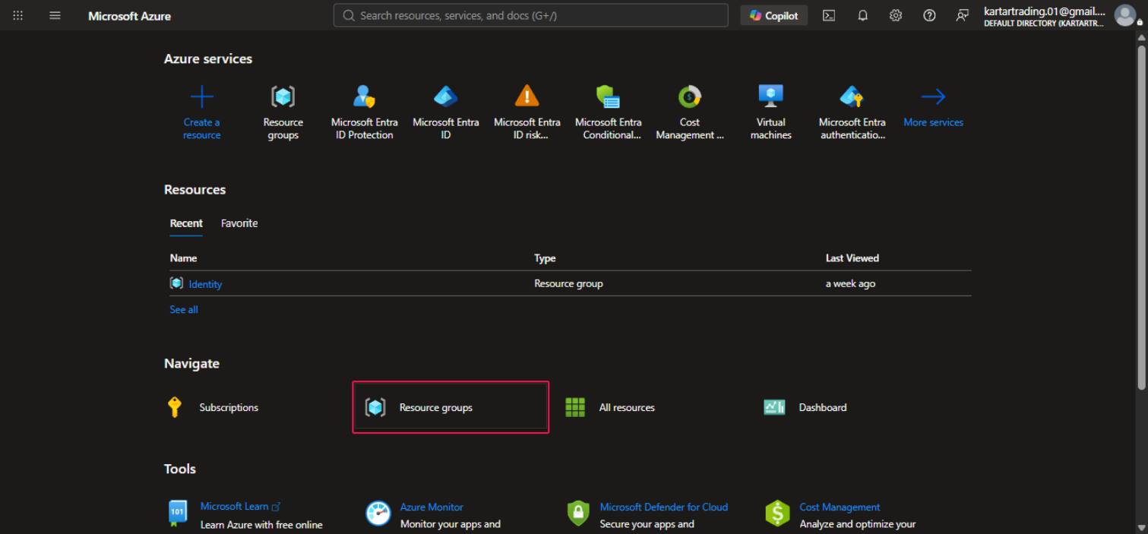

Tab Name:

Click on the link " Create" and Name : RBAC_Demo Resource Group
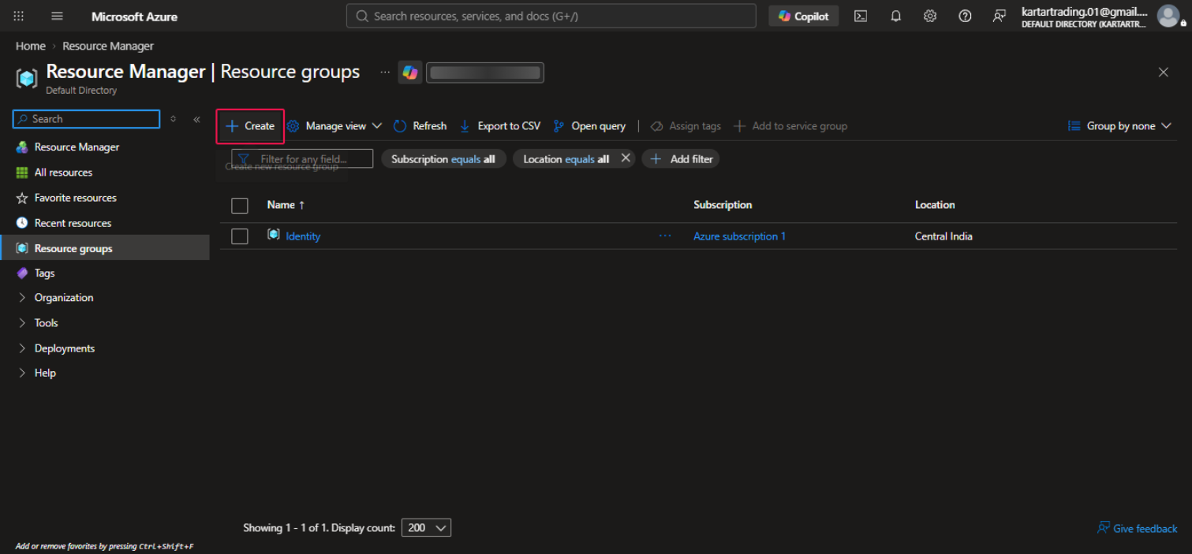

Click on the link "RBAC_Demo"
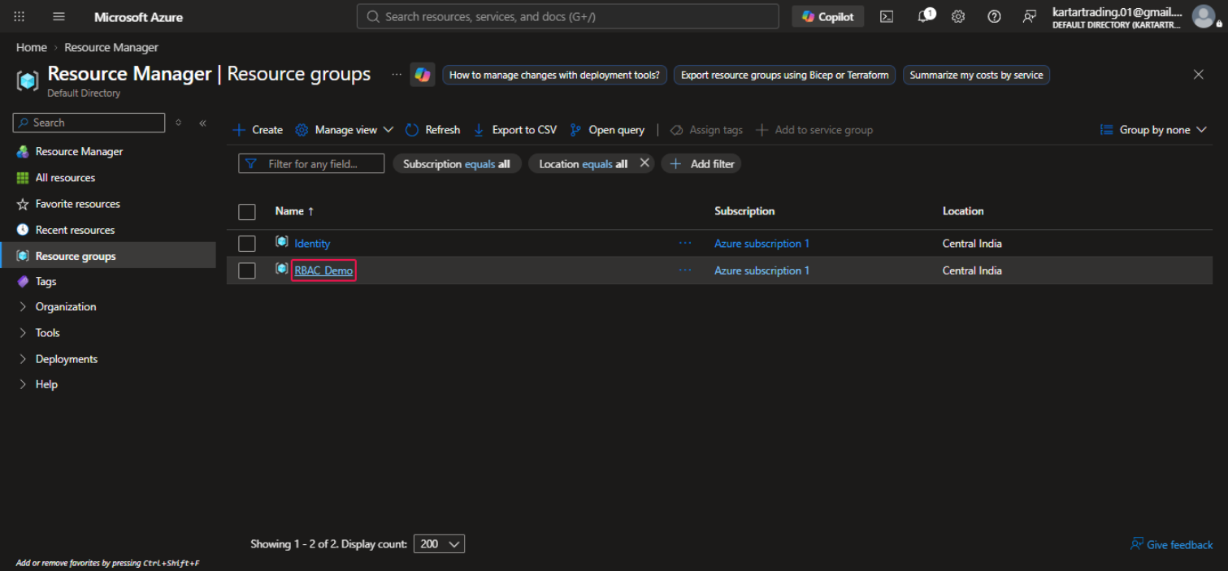

Tab Name: RBAC_Demo - Microsoft Azure

Click on the link "Access control (IAM)"
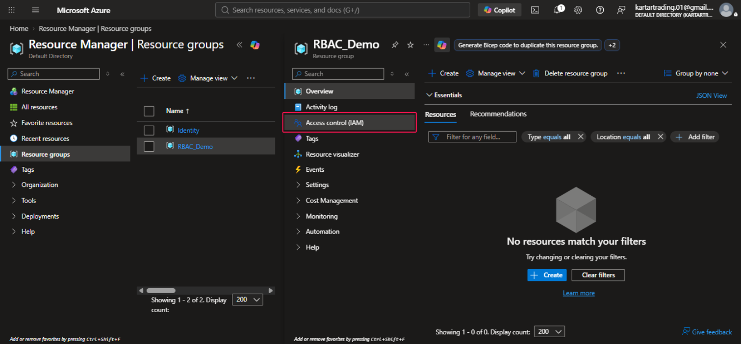

Click on the button "Add"
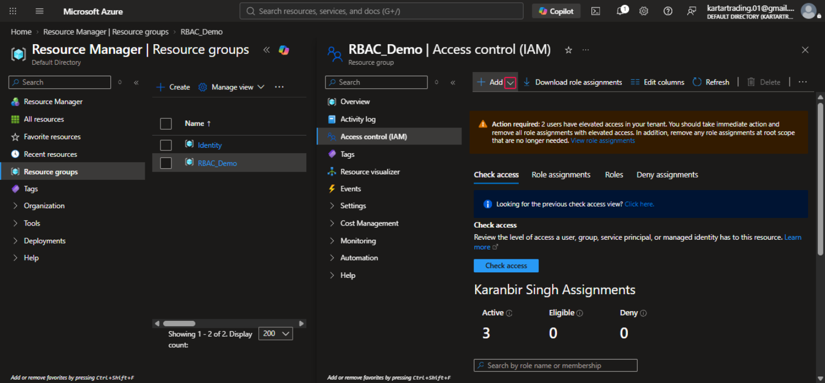

Click on "Add custom role"
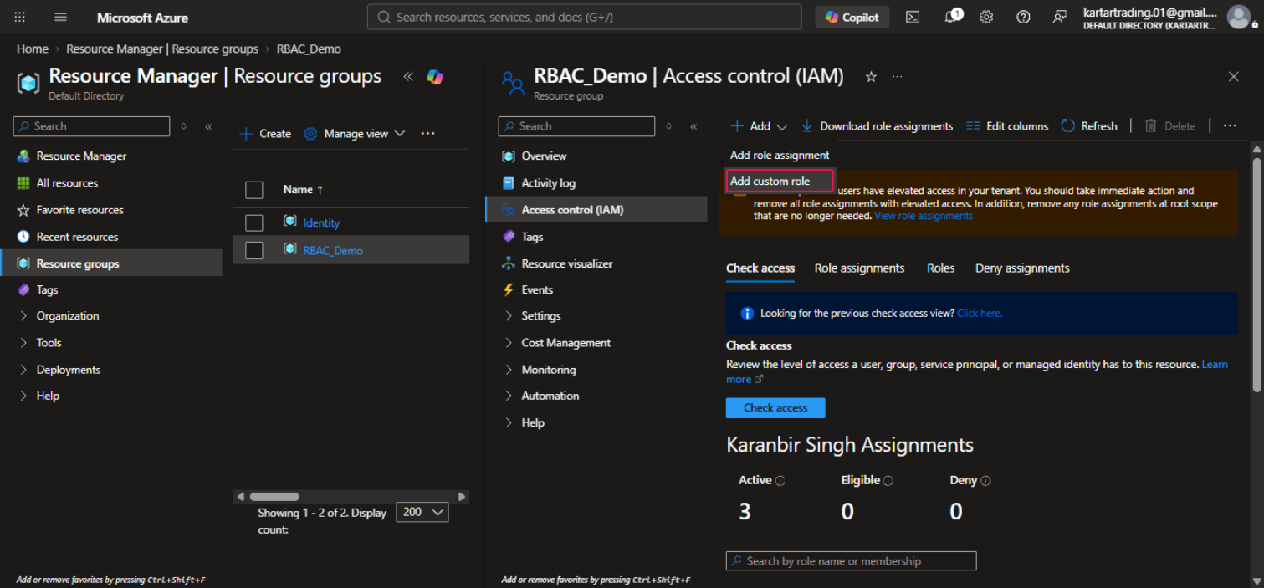

Tab Name: Create a custom role - Microsoft Azure

Click on the button "Create"
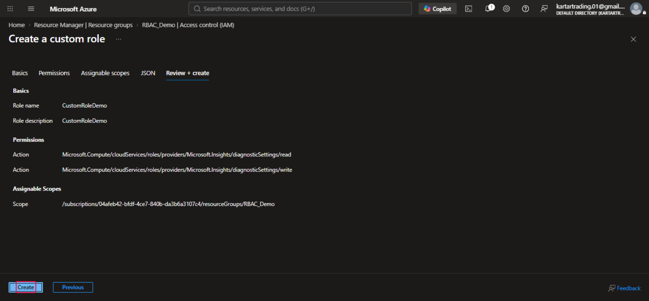

Click on the button "OK"
