Sandra FOUZARI

Victoria GAUTHIER

Danila KILIN

Constance LE FOURN

SOFTWARE ENGINEERING

Arnaud NAUWICK

Ahmed AZOUGH

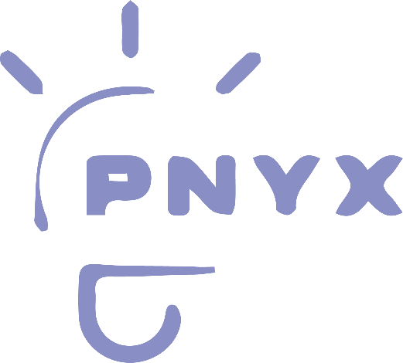**PNYX**

The final report for Software Engineering class

Year: 2022/2023

Semester 7

Class A4 DIA3

Sommaire

Summary of the project: 2

Benchmark: 2

Design Pattern 3

Plan and interfaces: 4

The main page: 4

The sign in/sign up 5

The book submit 6

A team work: 7

The team: 7

The organisation: 8

General retrospective: 8

# 

# Summary of the project:

The main goal of this website is to be help customers and users of streaming platforms to participate in the production of their next favourite series or movies by giving ideas of script, books or fanfiction. With a system of vote from the users of the website, a top 5 stories is selected and offer as a call for tenders of streaming platform, film directors, scriptwriters.

With each month, a theme will be allocated to help organized the different stories, all the books have to be registered before the first of the month with the wanted theme. Once the first of each month is reached, the previous theme is blocked as the votes for its stories. The result page will update the result of the top 5 stories chosen by the website. With the call for tenders, the film professionals will see which story they are interested in and if it is realisable. We, then, help the user to be in contact with the filmmakers to create a contract for their script. If the story chosen is an existing story like book, a Wattpad story, a Webtoon story or scenario, a financial compensation is due as we contact the author of the story.

# Benchmark:

Social media users use to asked in the comment section of their favourite streaming platforms posts. For example, on twitter, Netflix creates posts to have suggestions with the help of their users. However, some of the suggestion can be invizibilized, there is also no proof that the suggestions are read, users aren’t even rewarded for their help to create content.

The only websites already existing talking about his subject are websites giving instruction as how to submit an entire script. We couldn’t find any website that offers to submit already existing stories to use as scenarii.

The only site/app closest to what we are looking for is [Wattpad](https://www.wattpad.com/). Wattpad is a website and an app where you can write stories. Every year, stories from Wattpad become published books with and without the help of the Wattpad app. Wattpad include in his services a vote system that allow the readers to find a book with a better accuracy with key word. This system allows also to build a top ten of books that goes into the publishing industry

# Design Pattern

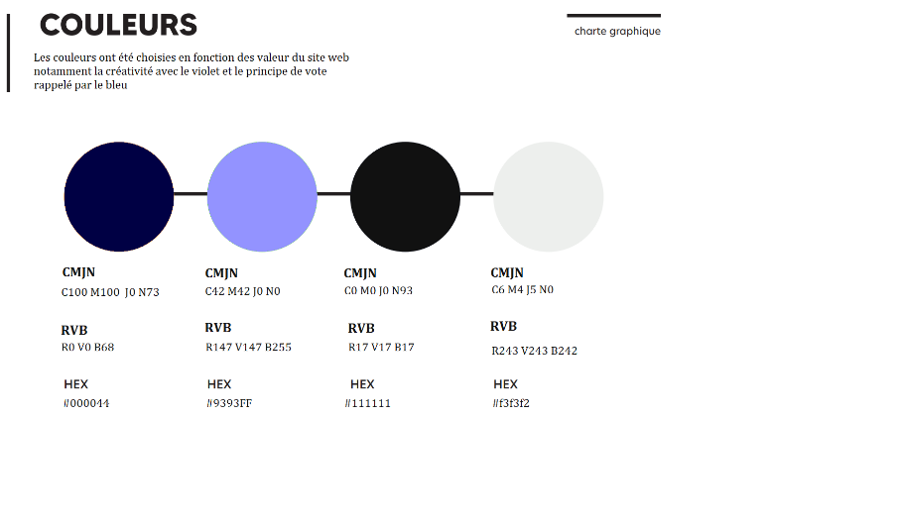

# Plan and interfaces:

Here are some visuals that we created during our class time, some of the visual came to light. The visual are simple, just to see what sort of structure we could use to create the websites, with the different option that would be included on the website.

Link to GitHub to find the source of every page shown below: [GitHub - Const679/software-engineering](https://github.com/Const679/software-engineering)

## The main page:

The welcome page where you arrive. You have access to all the option given on the website.

Final sketch:

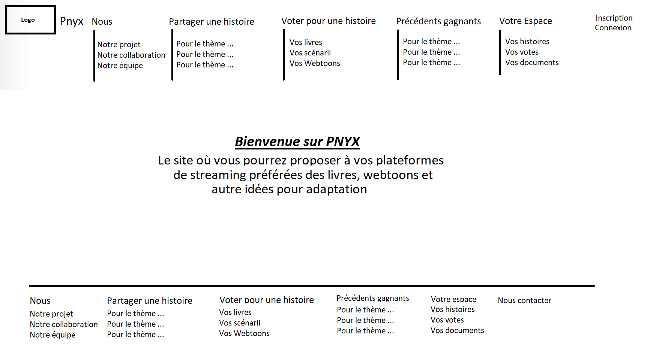

Final page:

## The sign in/sign up

This page allows the users to sign up if they aren’t already logged in with all the information to build the user in the database.

Same goes for the sign in where the info given should allow us to find the user in the database.

Final sketch:

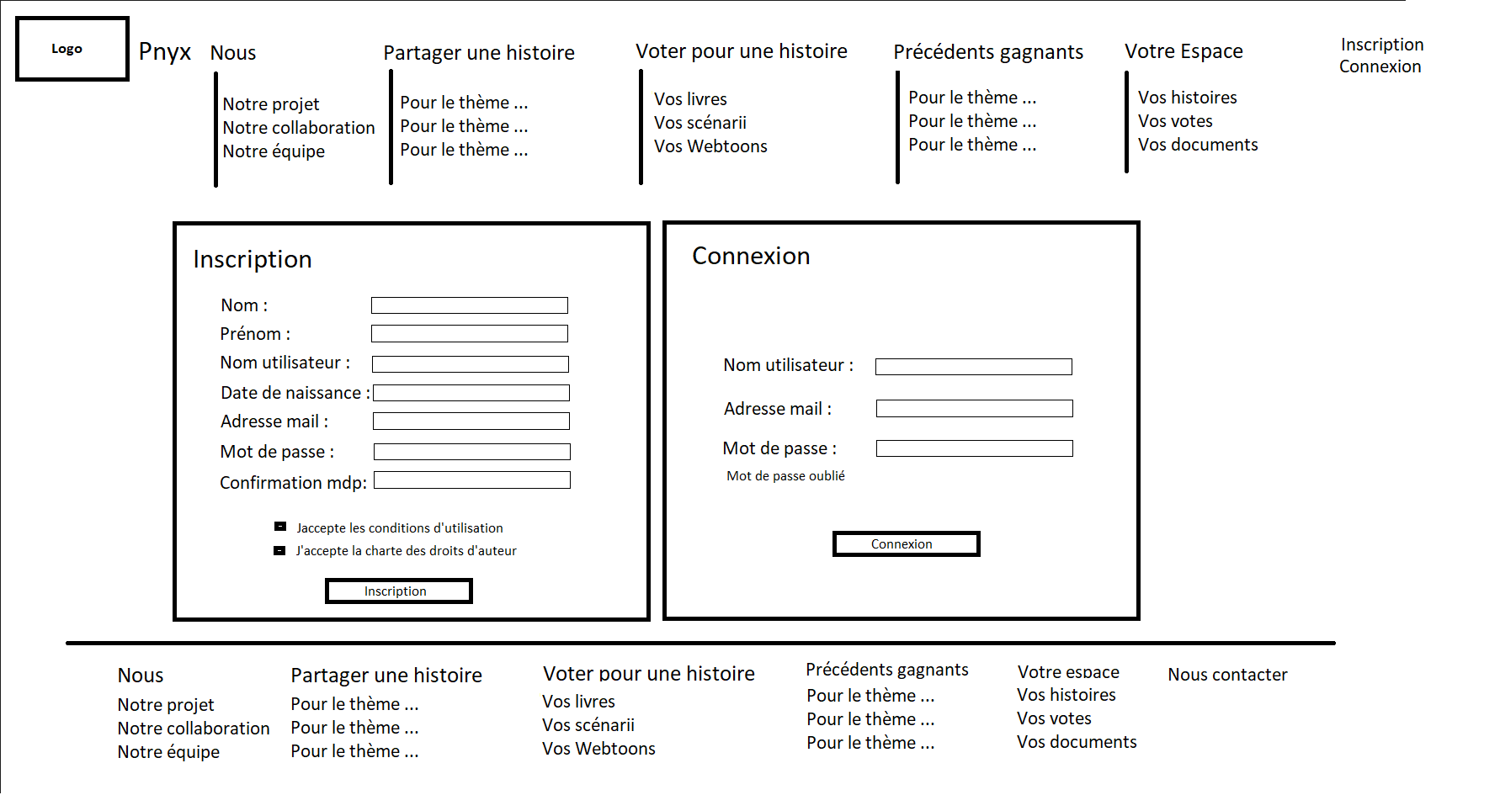

Finale page:

## The book submit

The submit page is a changing. In fact, when checking one of the radio buttons in the “Partager une histoire” section, the expected informations are not the same.

For example, if the user wants to give an Wattpad or a Webtoon, we could be asking the title and user but also the URL link that led to the book. Whereas, for a script, we would be looking for the synopsis and the letter of intent to show publicly, and the script that would be disclosed only for the admin and the professionals if the stories come to be in the top 5 stories.

Final sketch:

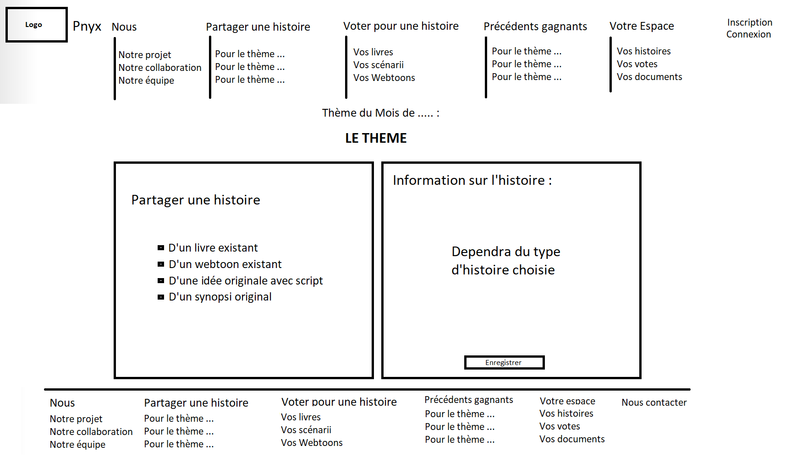

The website should be built as follow:

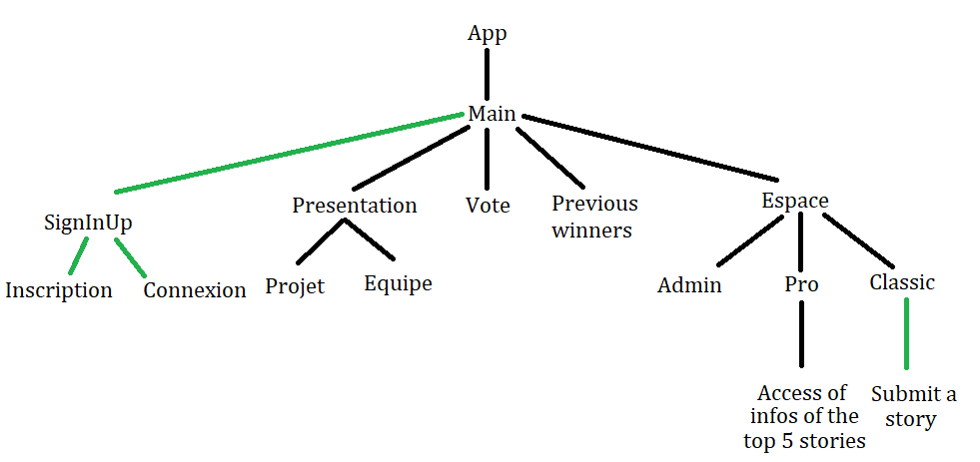

# A team work:

## The team:

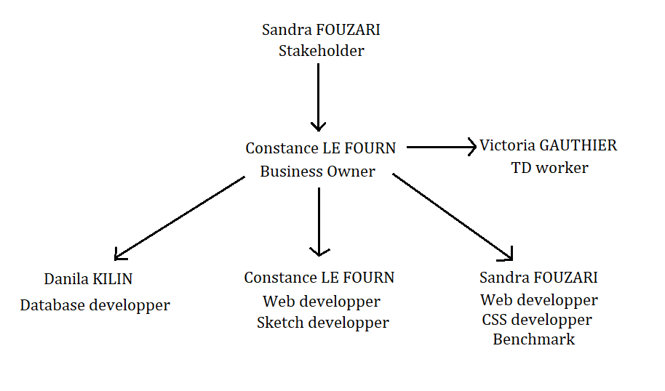

You’ll find an explanatory video with this link :

## The organisation:

Every non assigned tasks has been completed with the entire group.

Link to Jira, an invite has already been send : [Pnyx – Feuille de route - Jira (atlassian.net)](https://projetse2022.atlassian.net/jira/software/projects/PNYX/boards/1/roadmap)

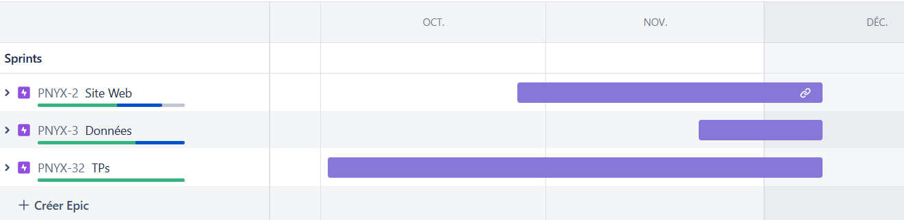

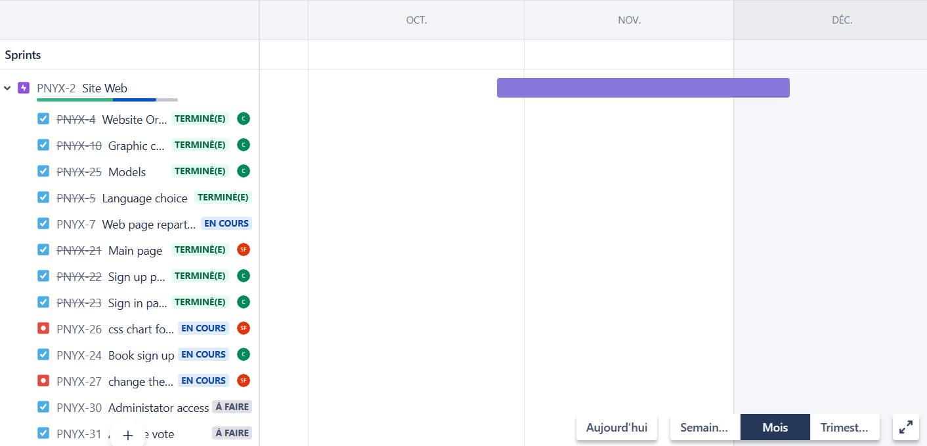

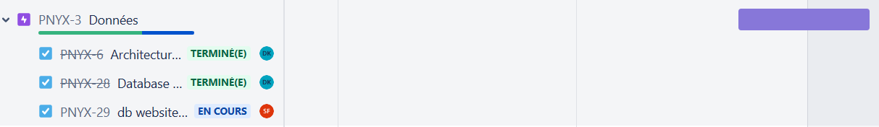

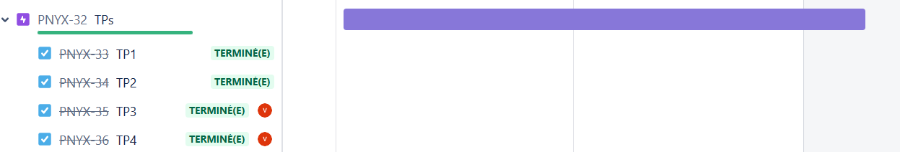

## General retrospective:

The project was too big for the time we were allocated but we succeeded to create the minimum for the project, it is not finish yet and maybe it will never be but the goal of “creatinf a website” for the class is done.

an explanatory demo video would be welcome (the link is to be put on the report)